Differential ID
Ok this is just some of the typical differentials that are used in Alsport and other trikes.
Peerless 100 series
This is probably the most common diff seen. 4 bolt sprocket mounting in a 2 x 2 config, they also have different axle shaft diameters (3/4 to 1”, I think). Many different sprocket and chain sizes. Most trikes I’ve seen used 40 chain (all alsports, I think). New diffs are available. Internally they may all be the same, so parts may swap (not 100% sure). Their set up is like an auto diff with beveled side gears, 2 spiders and a cross pin. Axles are held in by c-clips pocketed into the side gears. Mostly the different model #’s (like 100-241 below) just reference the many axle configurations that were available. Sprockets can be mounted on either side and even sprocket on one side and brake disc on the other. These were also rated to 10hp by peerless, so any machine that had more would often have a heavier Holton diff (next).
Servicing
Remove entire differential assembly from frame. Remove the 4 through bolts, this will split the housings. Once the cases are split, push in on the axle shaft and the c-clip can be removed. Clean all old grease from both case halves, gears and crosspin. Stand one side vertical, replace crosspin along with spider gears, put bolts in place and fill that side case with bentonite grease, position other side case and bolt together.
While other greases may work acceptably, bentonite is the manufacturers recommendation. It is commonly used in mower transmissions and available at mower supply houses (~$35 for 32oz).
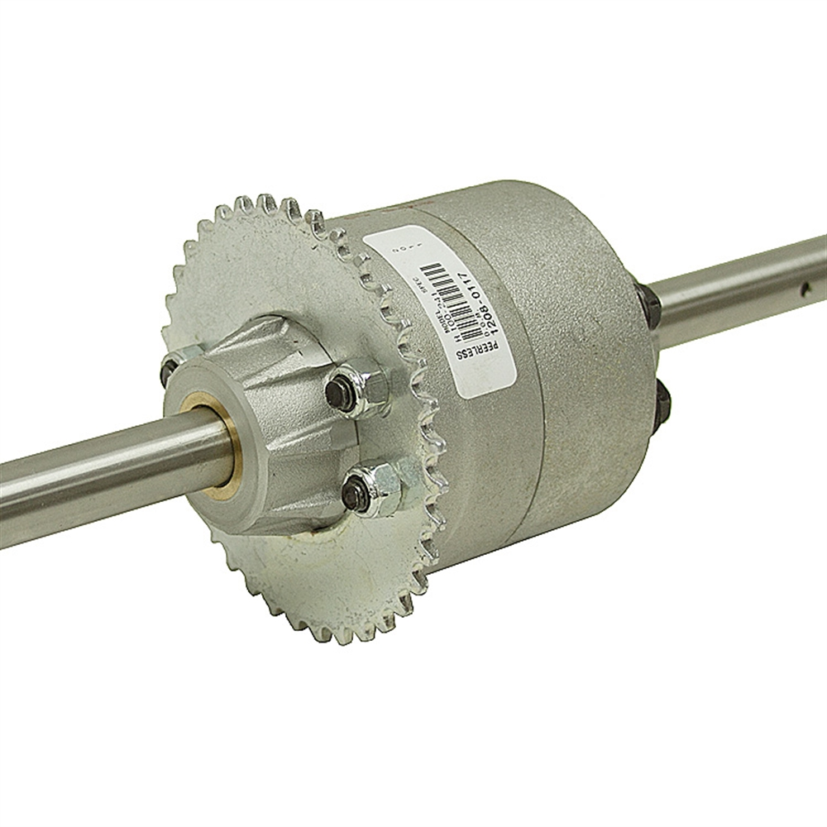
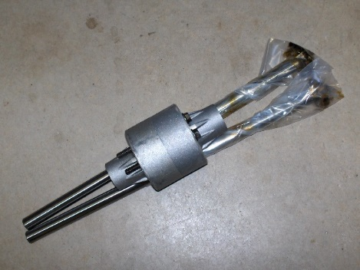

Holton diff
4 bolt sprocket mounting evenly spaced. To be honest, I’ve only ever seen 54t 40 chain sprockets for these. These are larger and heavier than a peerless. They use straight cut gears and springs instead of beveled (pic below).
Servicing
This is basically the same as the peerless. Except instead of a crosspin and spider gears there are straight gears and springs. Position them like in the disassembled pic below, staggering the gears. Add bentonite grease to fill the one side and assemble to the other side. This is done much easier if the second side is clean, as the pins will go into the holes easier without getting airbound from the grease. Be very careful that none of the springs or especially the washers fall out of position.
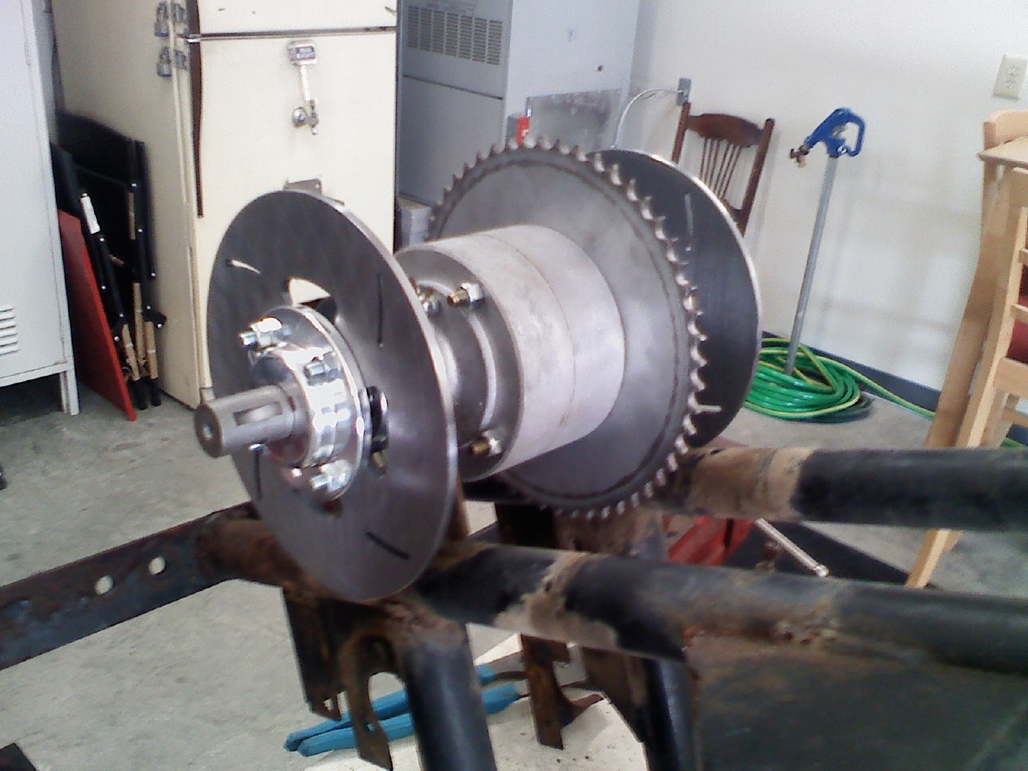
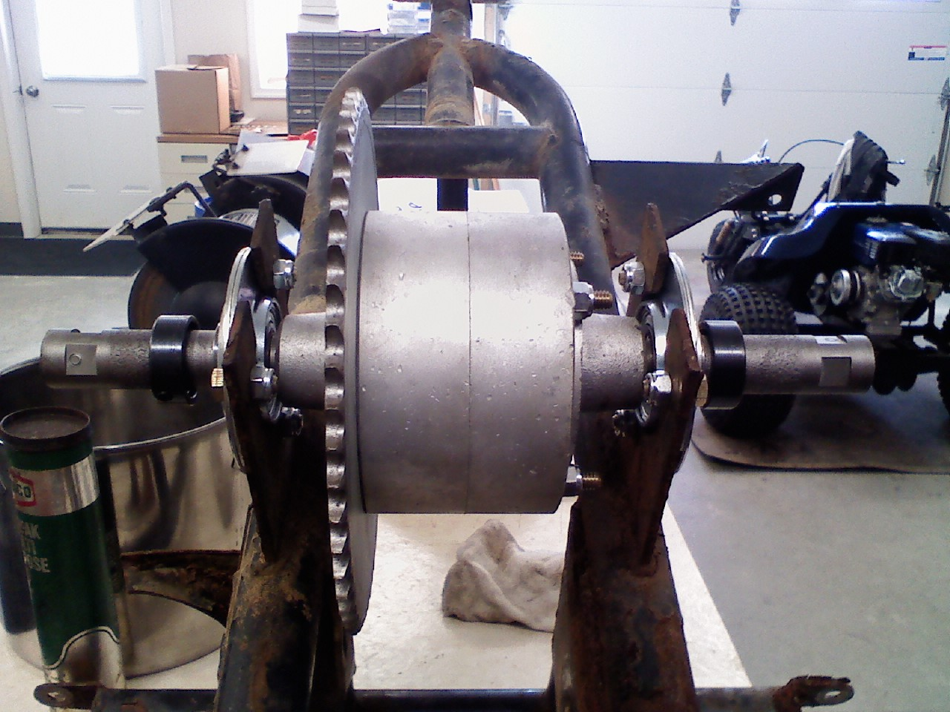

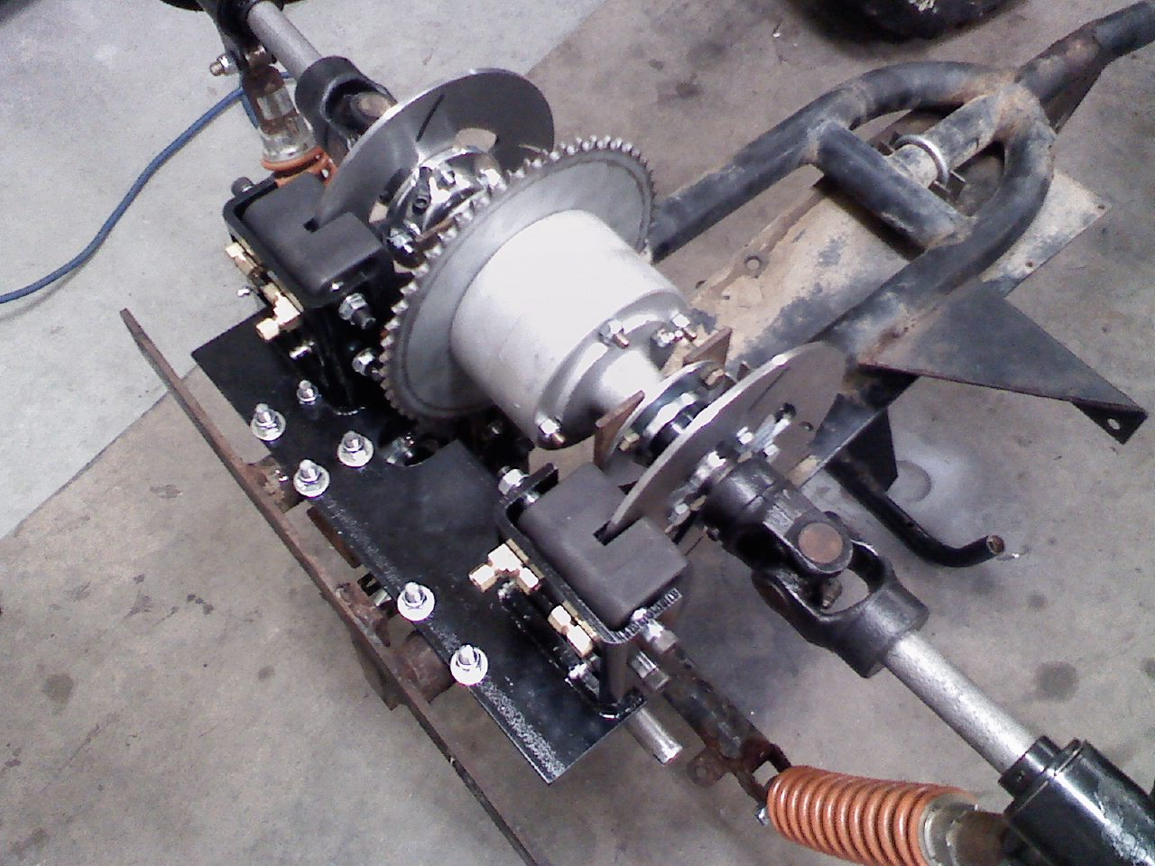
Another from an Alsport TS(23hp TS290)
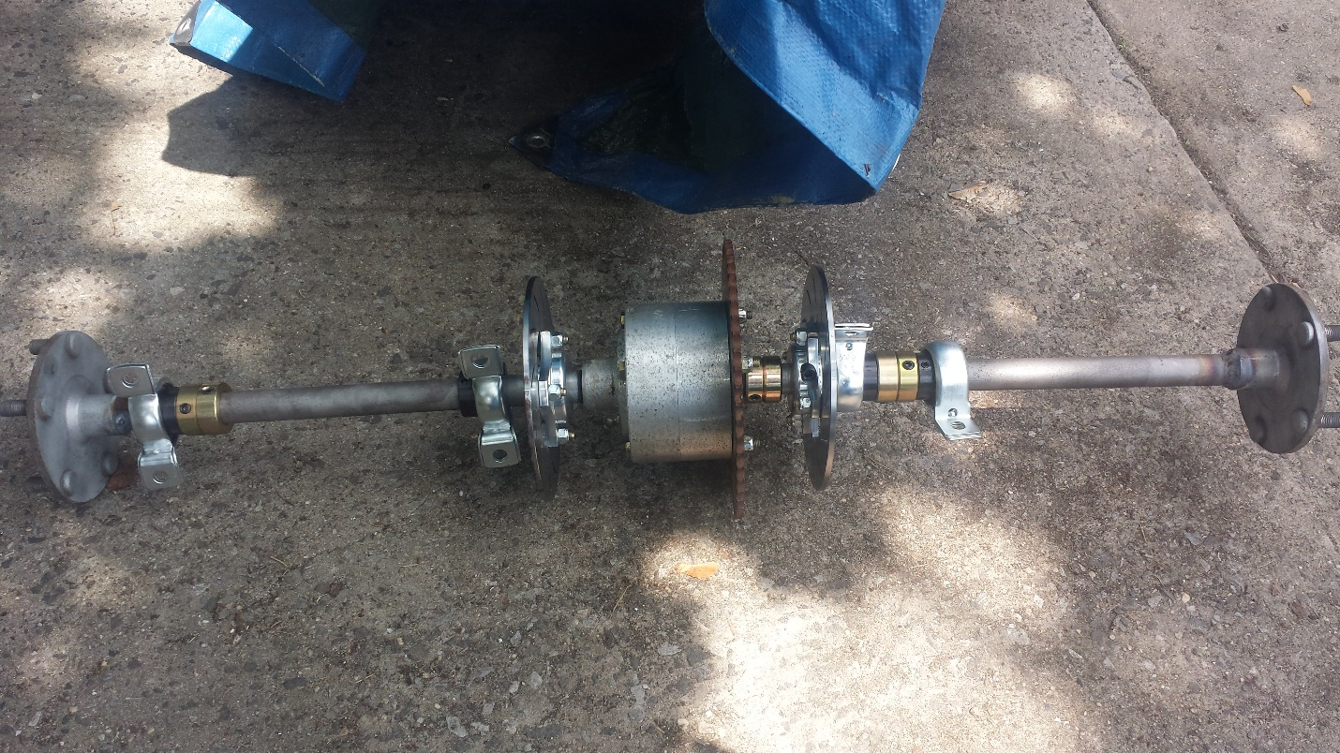
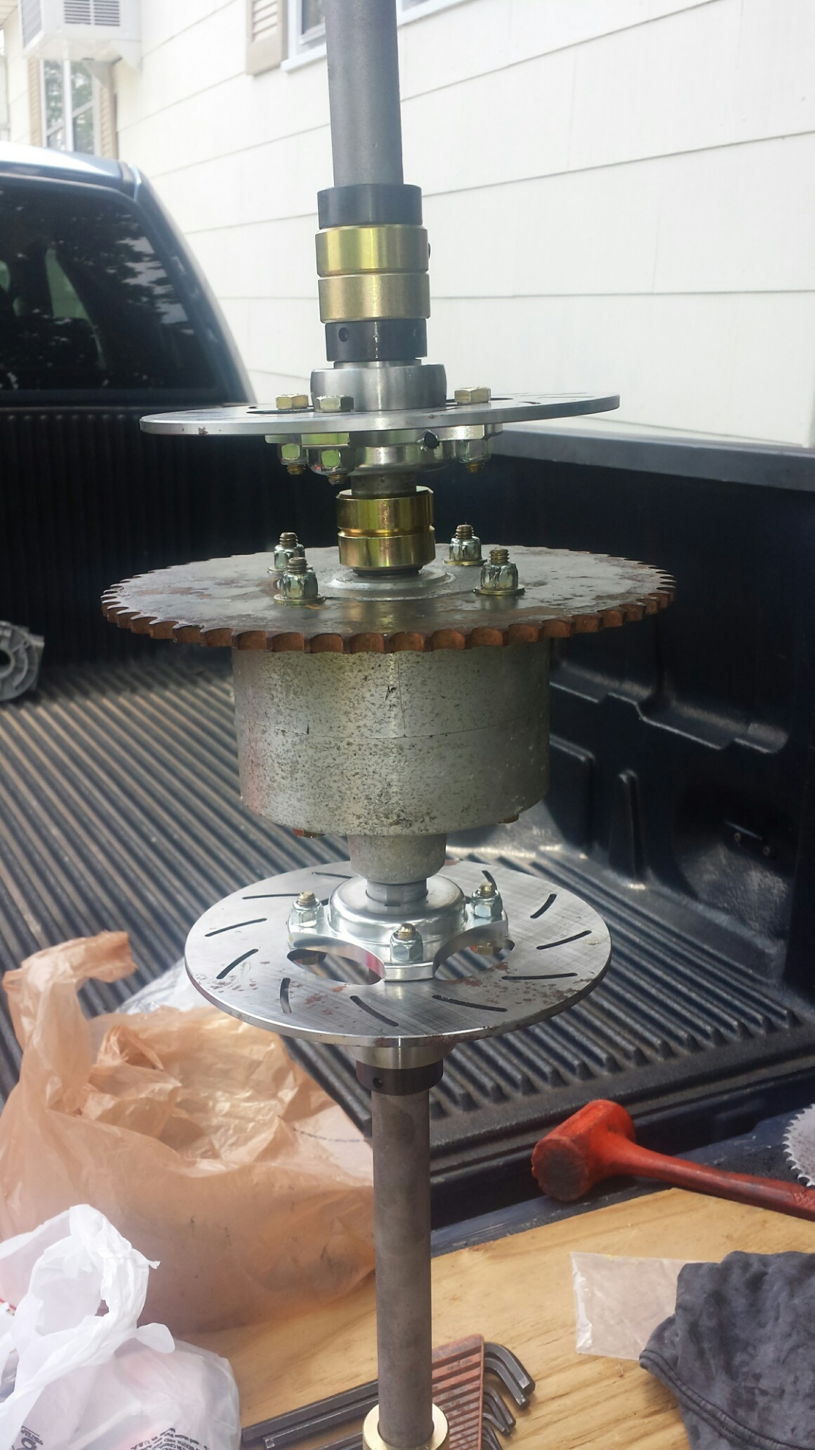
Holton gear arrangement:
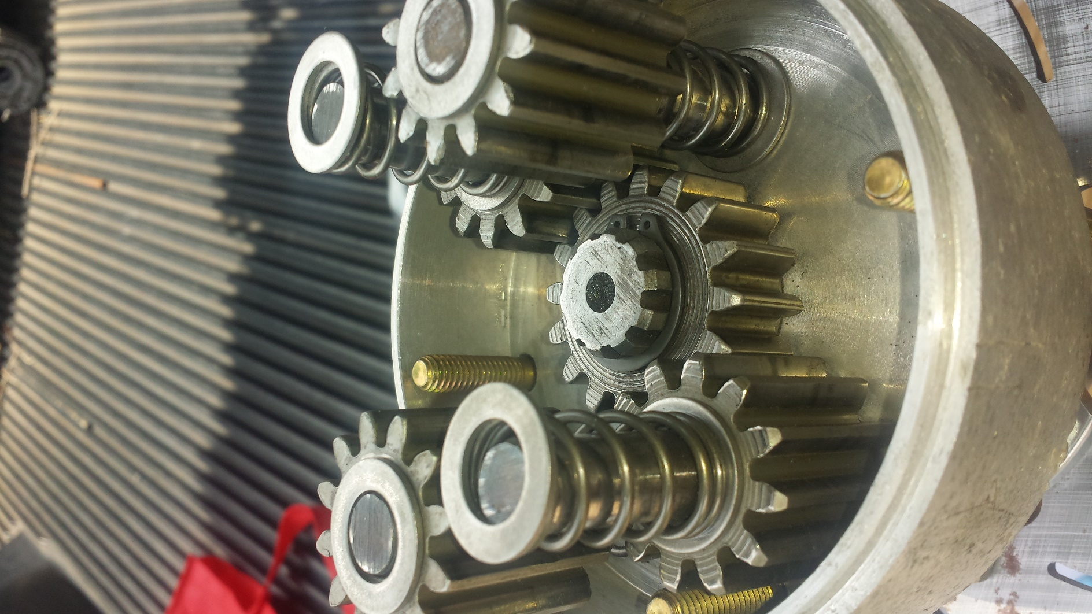
Also, Steel Holton(rare)
This one is actually set up for a Alsport RTS. Never seen one in person. I aasume the internals are like the aluminum cased Holton.