Repairing/rebuilding the peerless 100 differential and its axles.

The Peerless 100 differential is used on most, if not all the early trikes. It has also, in various forms, seen long term service as a driving force for riding lawnmowers. It is a simple device designed to permit each driven wheel to turn independently. It is this ability that permits the trike to corner and turn quickly. As you will see, two bevel gears, connected one to each half of the rear axle, are balanced by a pinion gear set. As you turn the trike, the inside wheel, that is the wheel to the inside of your turn, rotates in a smaller, tighter arc than that of the outside wheel. It is the pinion gear set, one turning very slowly and the other turning much faster, that permits this to happen. Were this a direct drive, solid axle, either the inside wheel would spin, or your turn would have to be done in a huge, easy arc. These 4 gears, two bevel gears and two pinion gears, along with the housing/carrier are all there is to the Peerless 100 differential.

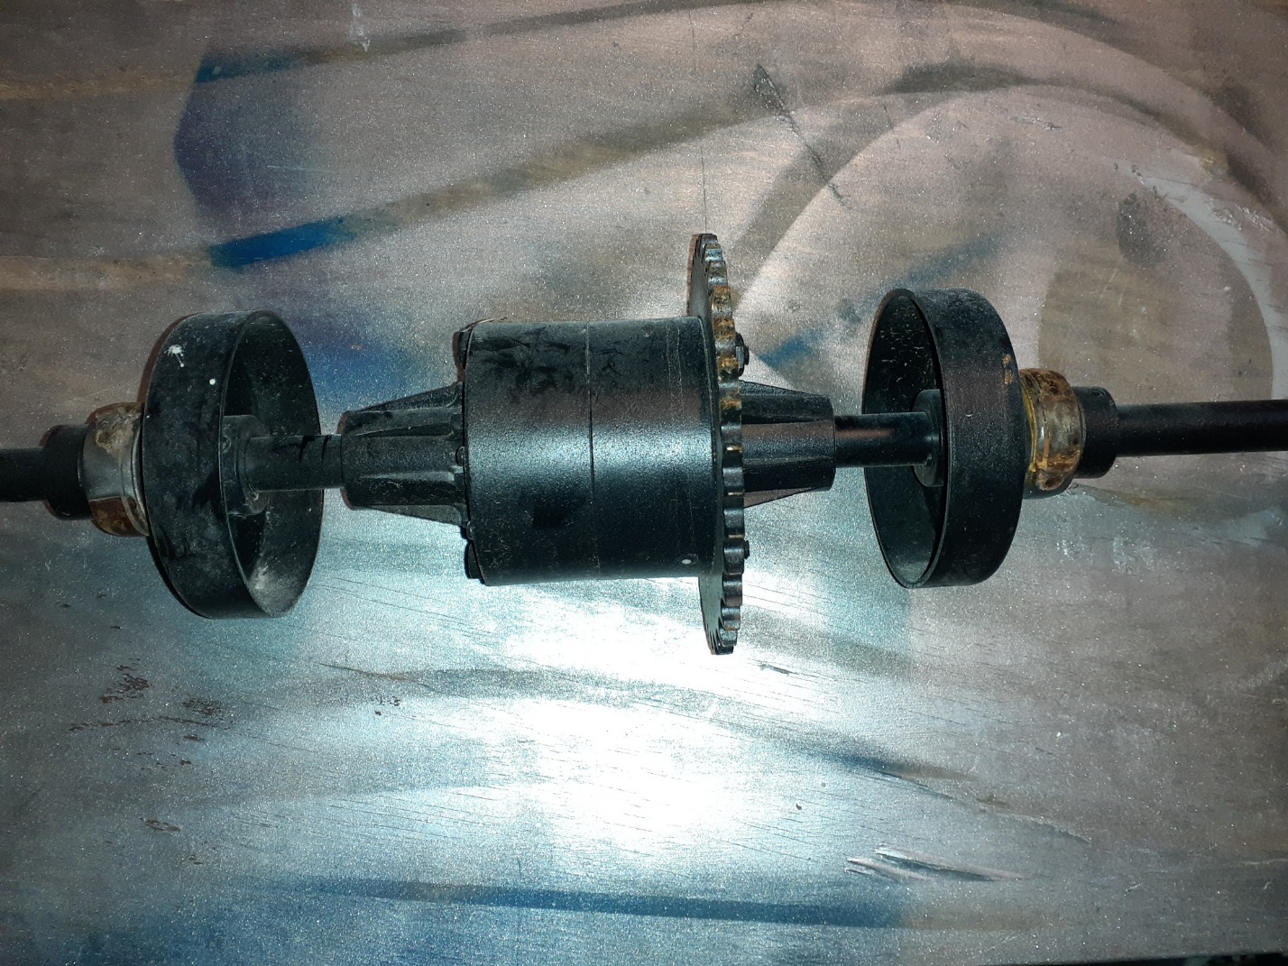

Two begin your repair, first separate the two halves of the differential carrier/case. There are four half inch bolt heads and 4 half inch nuts visible. First, remove the four nuts. Then, remove the bolts. The half of the carrier, on which the nuts are attached is threaded. Back the bolts out with your half inch wrench.
Once the bolts are backed out of the treads, you can separate the two halves. You will have one half with the pinion gear set.

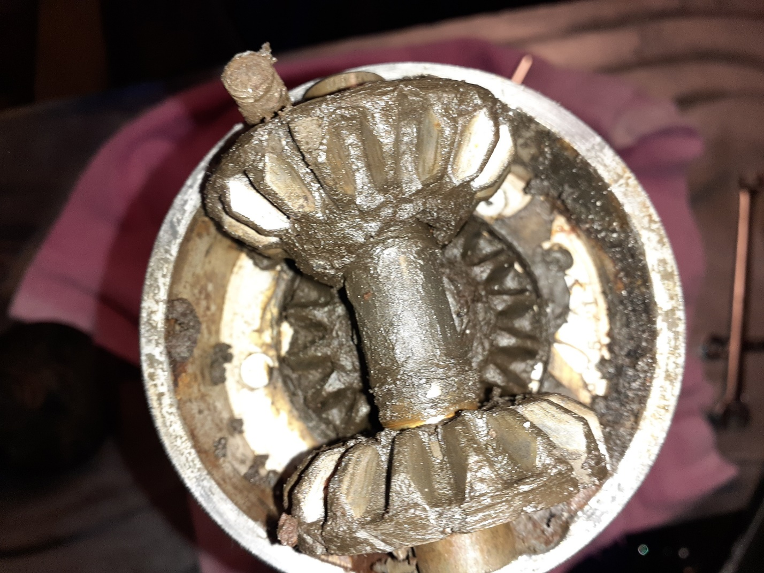

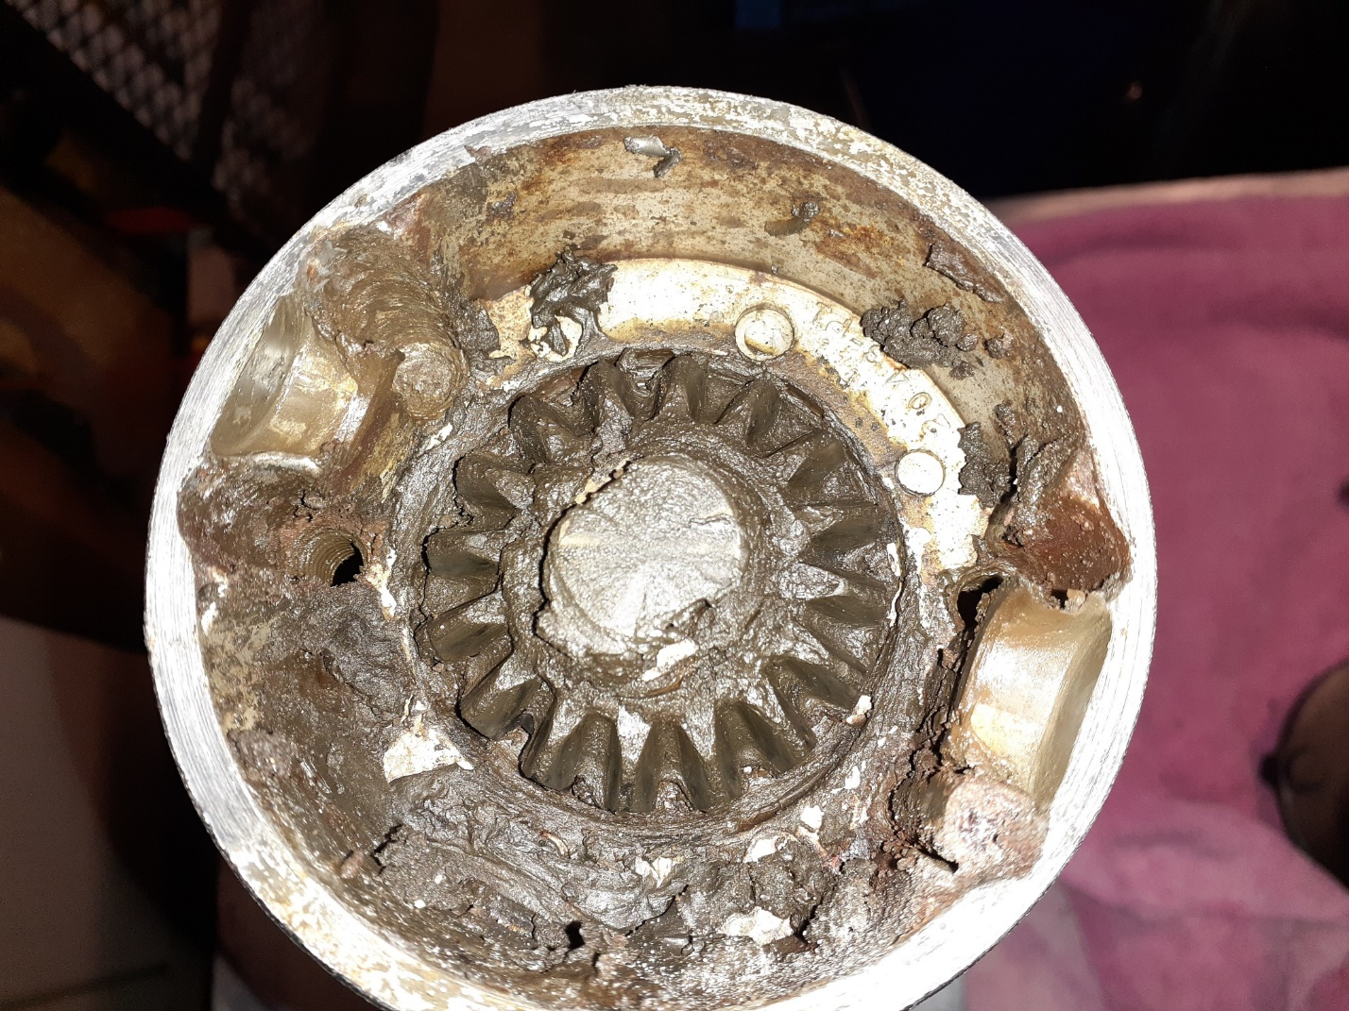

And one half without. The pinion set just lifts out of the carrier. At this point, there is nothing holding it in place. Be careful. There is a thrust washer at each end of the set. Don’t lose them. Nothing holds these gears in place on their shaft. As you can see, in these pictures, even though the grease is most likely the original, for this unit, it still has some pliability and lubricating properties. The greatest need is to cushion the meshing of the gears as the axle rotates. This grease is more than capable of still doing so.

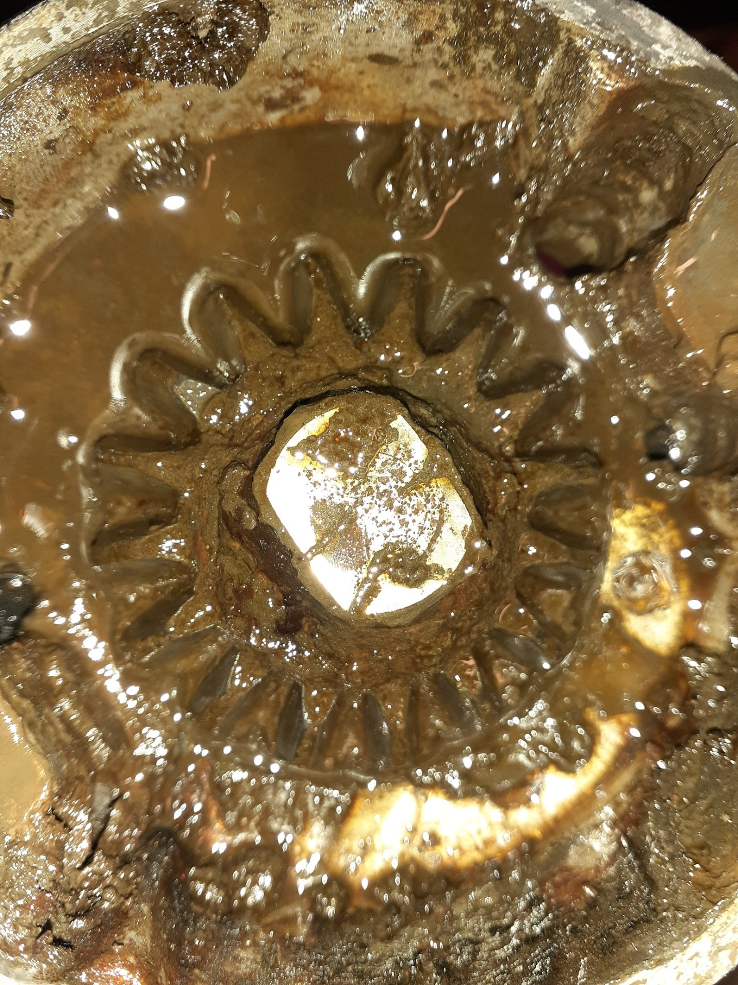

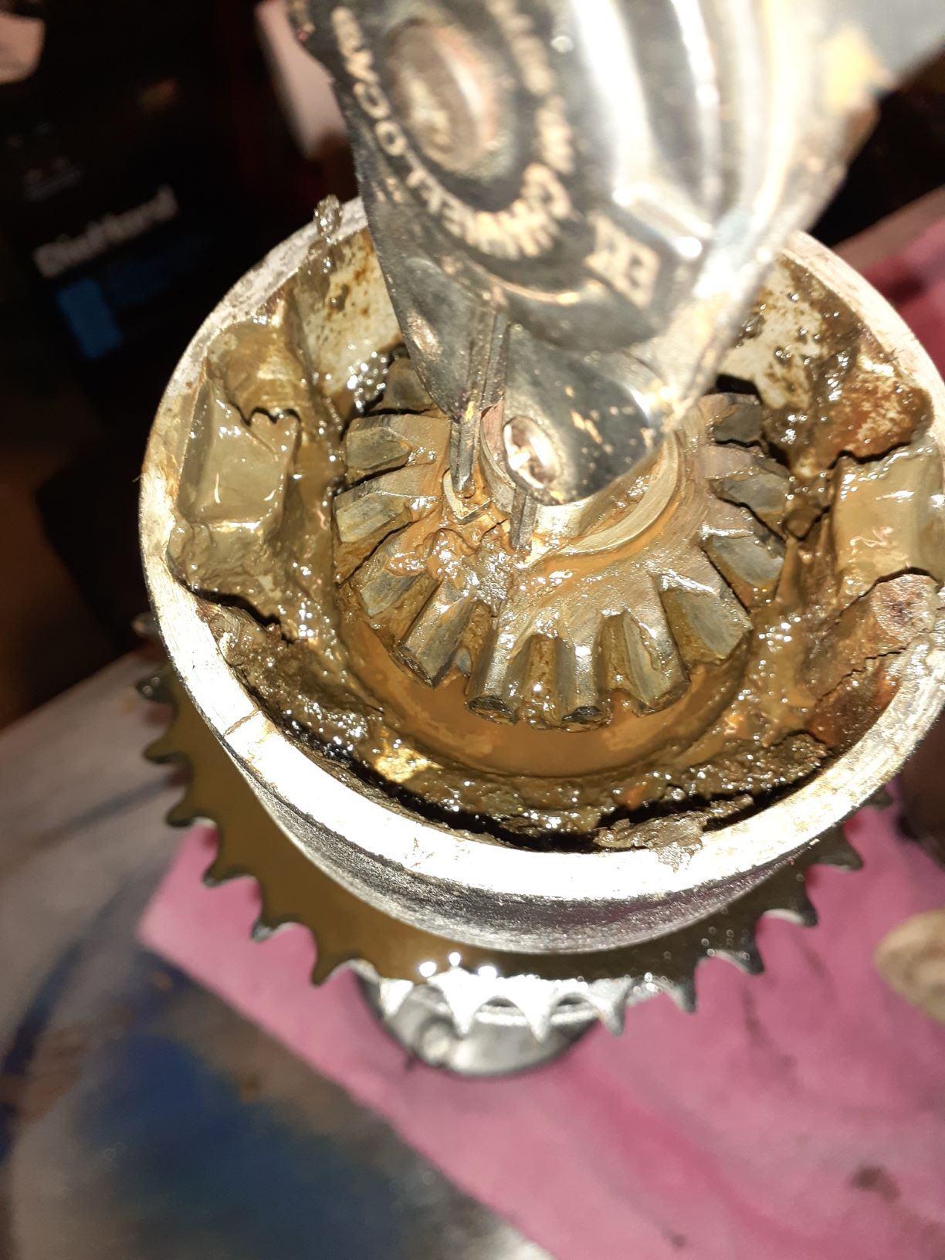

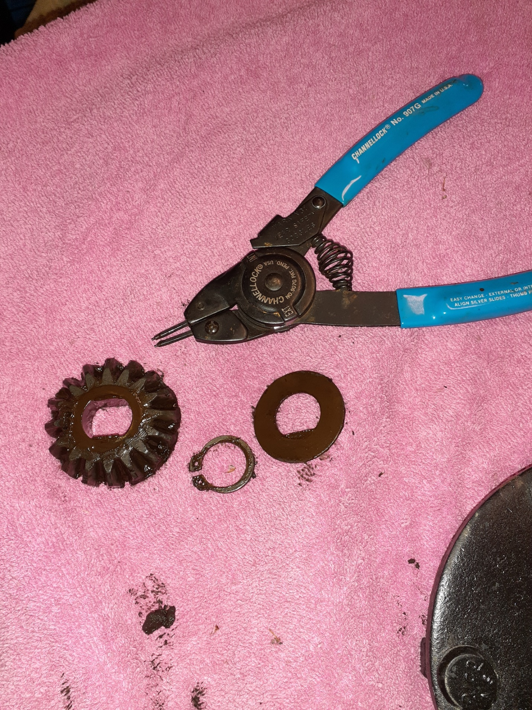
A little spray cleaner and you will start to see the remaining parts of the carrier half. When additional cleaner is used, (I use engine degreaser or brake cleaner for these jobs.) you will find the C clip holding everything in place. Remove it, then the bevel gear, and last the thrust washer under it. When you are done, you should have something like you see above.
Now you can remove the carrier half by simply sliding it off the shaft. Next you will find either a bearing mount, a bearing, or the brake drum, (depending on the trike you are working on). If necessary, remove the bearing bracket, then remove the bearing. The bearings used here have a single set screw. Back it out until you know it is clear of the shaft. Then locate the other hole in the bearing collar and tap it, counter clockwise, with a hammer and punch. These bearing collars are dropped on the bearing collar ring, then rotated clockwise, about a quarter turn. This seats them on the bearing collar ring, where the set screw can then be tightened. To remove them, you must do the opposite. If your axle is like mine, years of paint, dirt, grease, and rust will have accumulated and nothing will slide off easily. Once you know the collar is lose, place the axle on a solid surface with the hub side down. Gently tap, with a hammer, the underside of the bearing. Sometimes a little heat can help. My two outer bearings were so tight, they had to be cut with a chisel and angle grinder. If you are working with the brake drum, before the bearing, the procedure is much the same. Except there are two set screws on the brake drum and a half moon set key under it. Loosen the set screws and as before, tap up the shaft, with a hammer. Sometimes lots of lubricant, like PB Blaster, is necessary.
Once you remove one of the bearings or brake drums, you will be able to see the damage time has done to the shaft. The mounted parts are rusted to the shaft. I have found indentations where the bearing or drum was seated. All that rust, dirt and paint, along with the indentations, can make for a very tight and difficult removal process.
Once you have both bearing sets and the brake drums off of both axle halves, it’s time to assess what you have, what you can reuse, and what you will need to buy. Obviously, new bearings are called for. Don’t go cheap. Those five- or six-dollar bearings you see on line are not worth all the time and effort you have already expended. If you are lucky, they will last one riding season before they fall apart and need replaced. Look for Federal Mogul or other major brands. It’s worth the extra cost to ensure you don’t have to do this every year. The same applies to your bolts. You might as well replace the four bolts that hold the carrier together. In all probability, since there is very little stress on these bolts, grade 5 will work fine. I recommend spending an extra thirty cents a bolt and get grade 8. That way you are assured the bolts are more than strong enough to keep everything together. Inspect the bushings in the carrier halves. If there is uneven wear, replace them. I did not see a need to replace the set screws as they looked to be in good condition. Although, a good argument could be made that they have been stretched and should be replaced.
One extra note. There are two types of quality bearings. Those that have the removable retaining collar and those that have the “built in” retaining collar. As long as it is a quality unit, the retaining collar makes no difference.
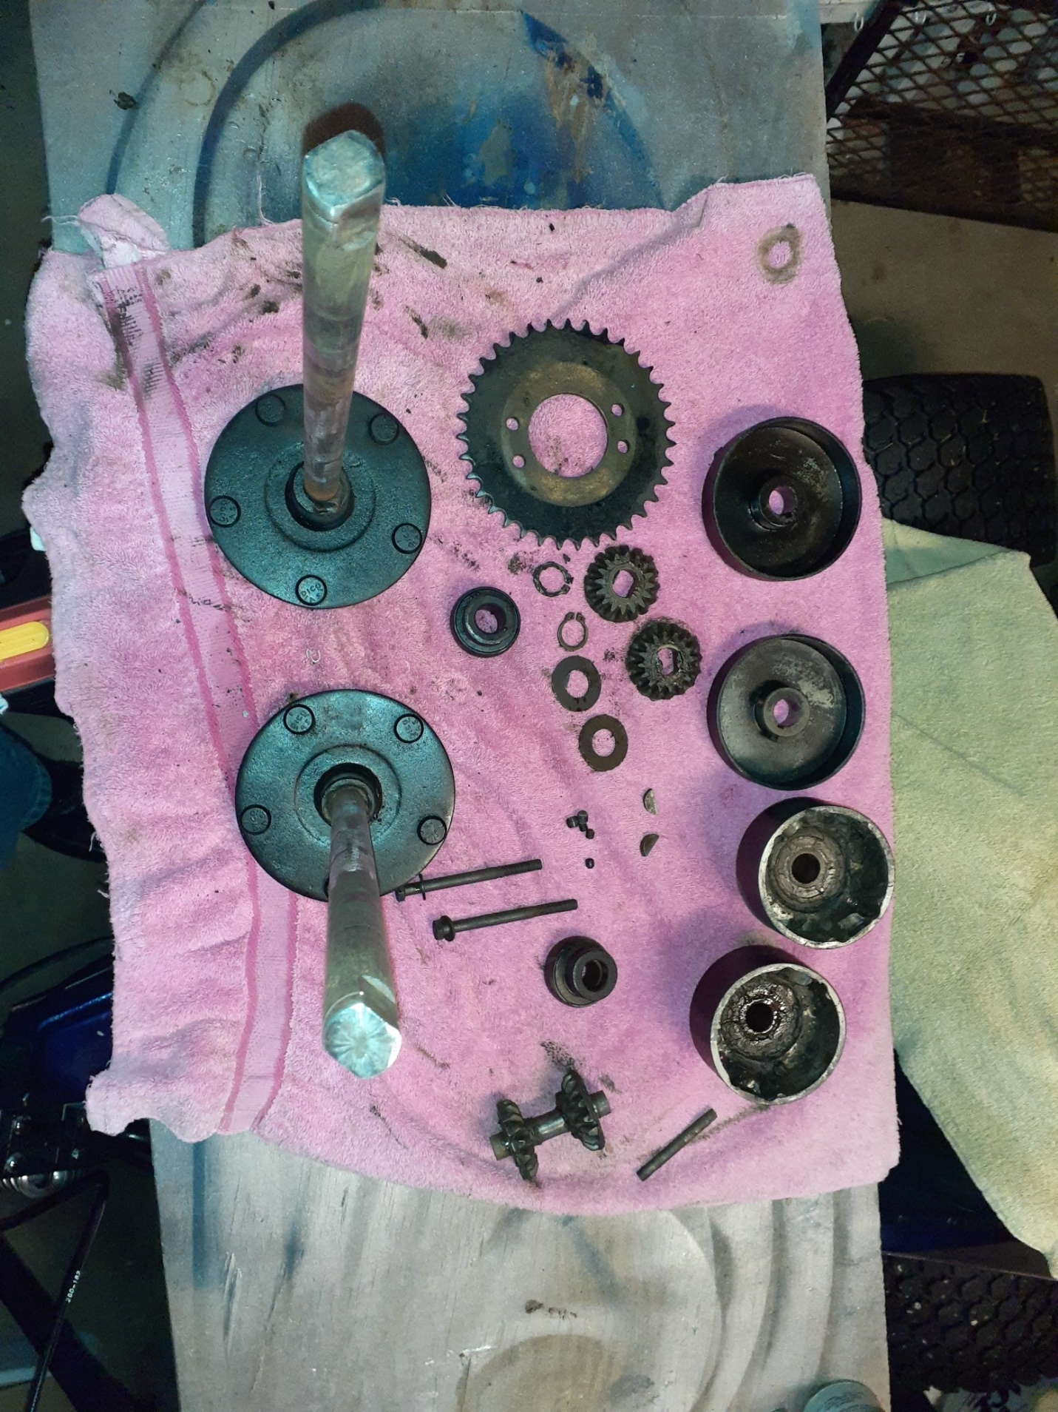 Above is a picture of everything, once it has been removed from the shafts.
Reassembly is just the opposite of the take down. I did not lock down the bearing collars but tightened them enough to keep them from moving around as I worked. You will need to locate them according to where the bearing carriers attach to the frame. The brake drums can be set and locked down as they only go where the half moon keys are and the bands can be adjusted on the mounting bolts.
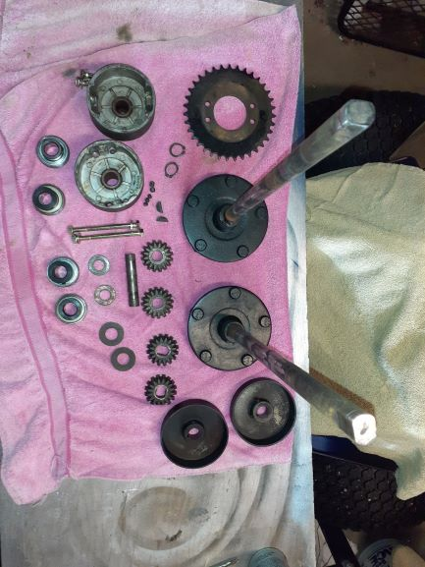
Here’s everything ready to go back together. New bearings and bolts with the original half moons and set screws. I lightly sanded the thrust washers to remove some of the corrosion. I found using a small palm sander made quick work of the paint, dirt, ridges, and burrs on the axle halves.

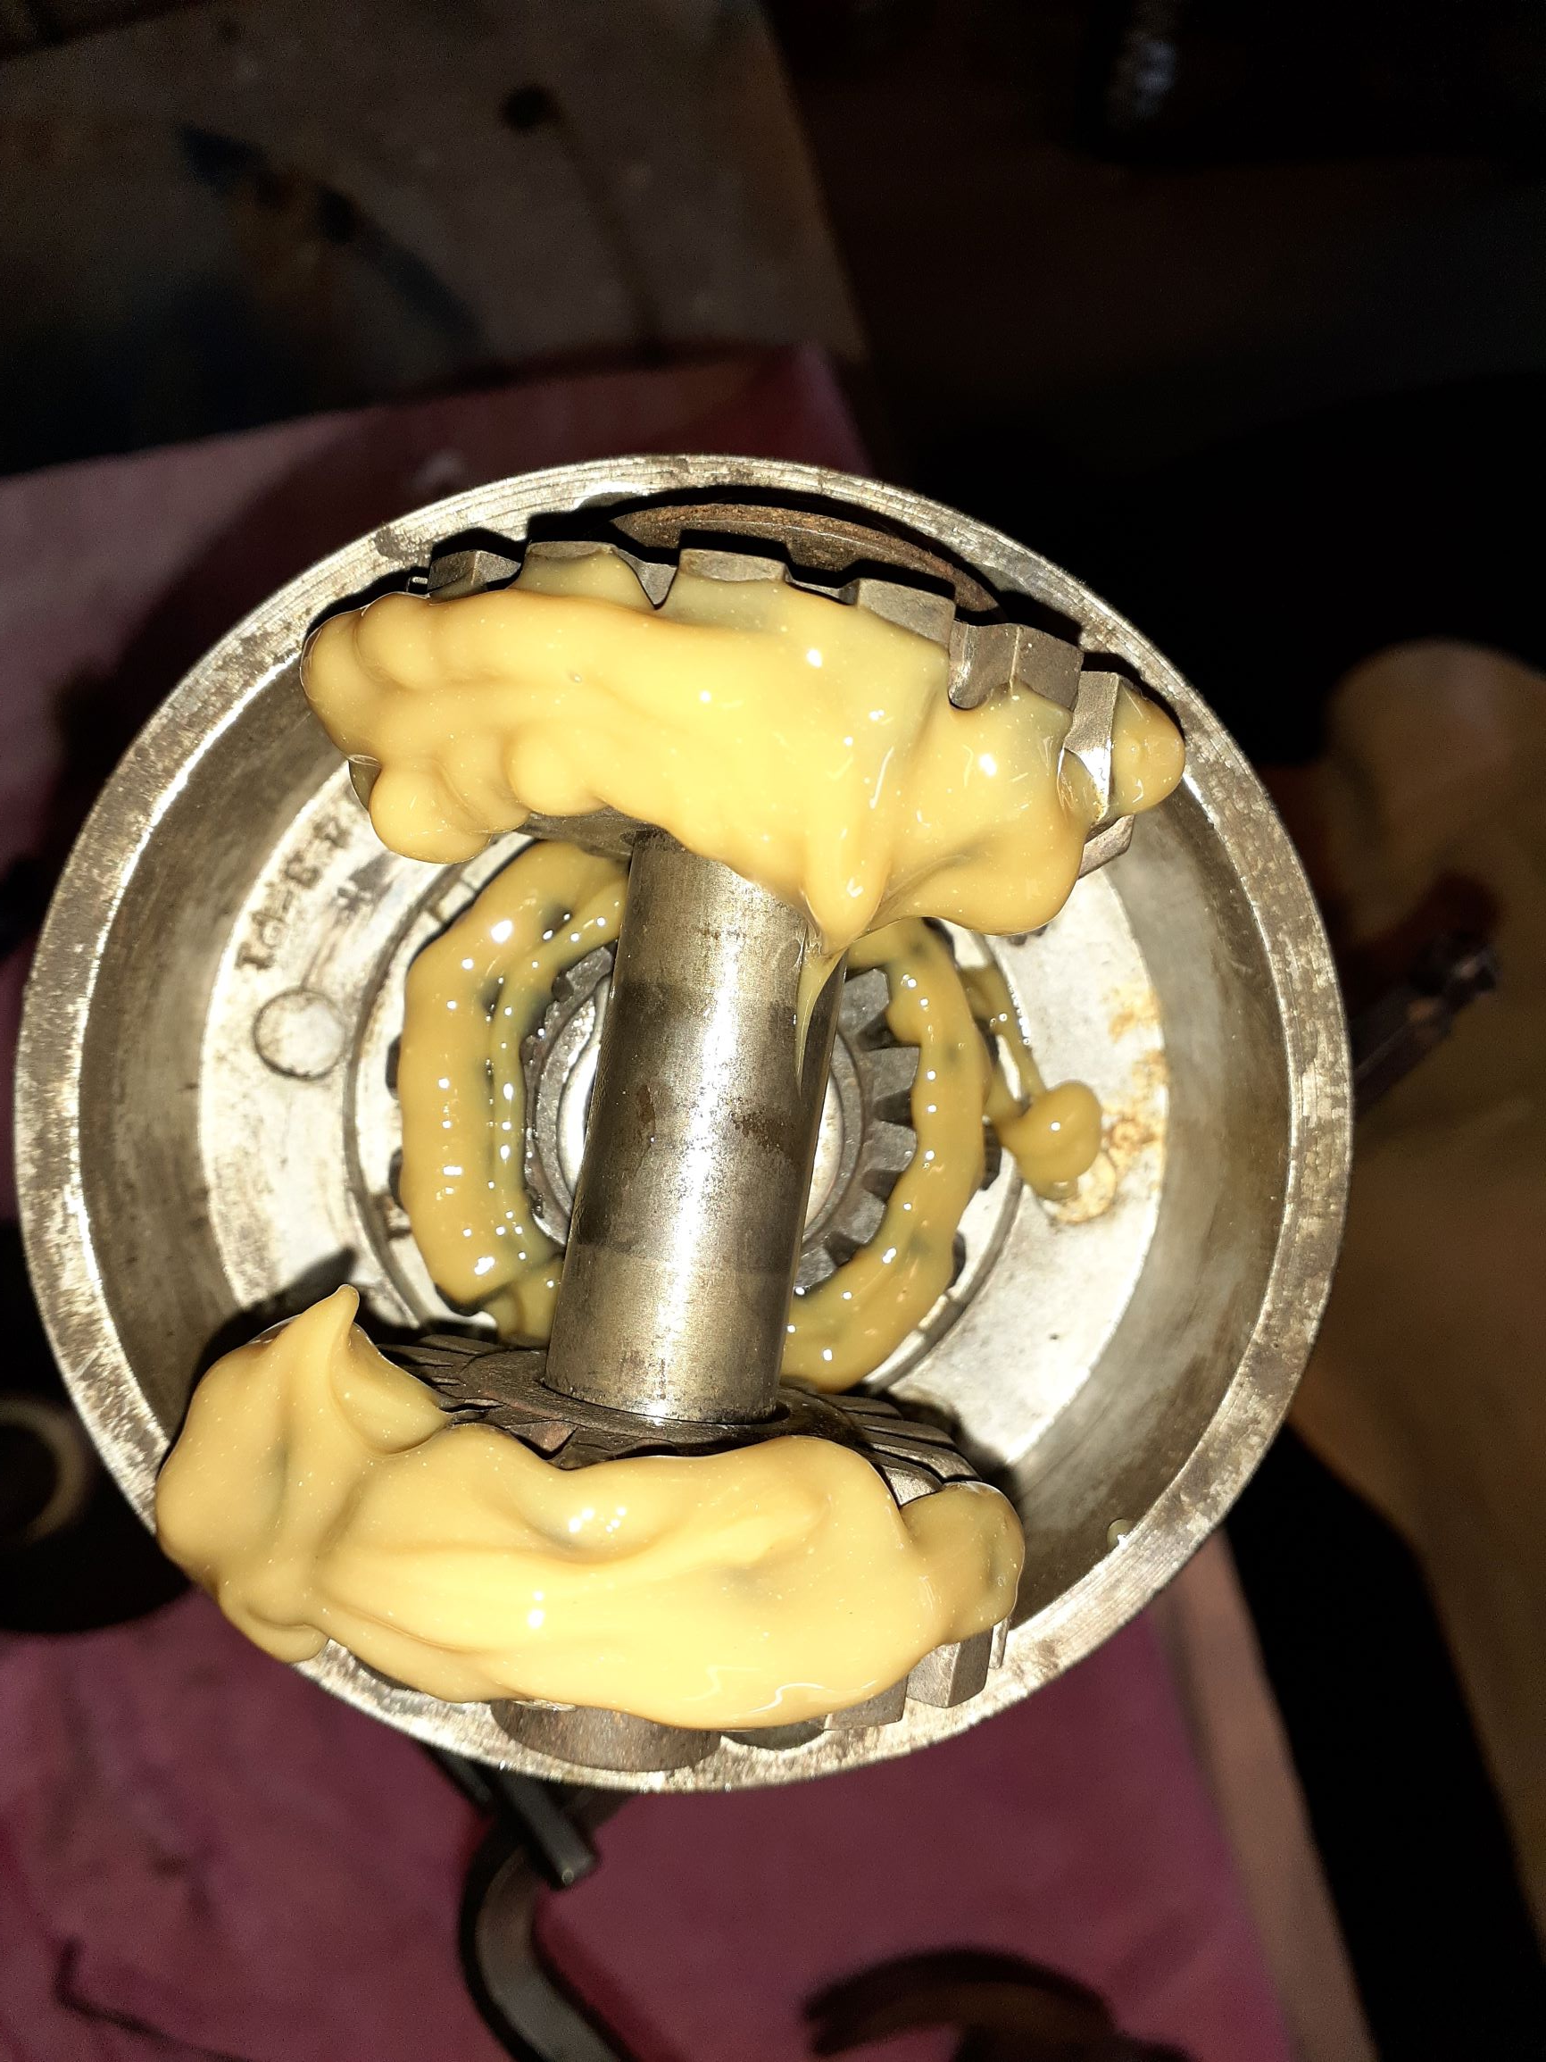
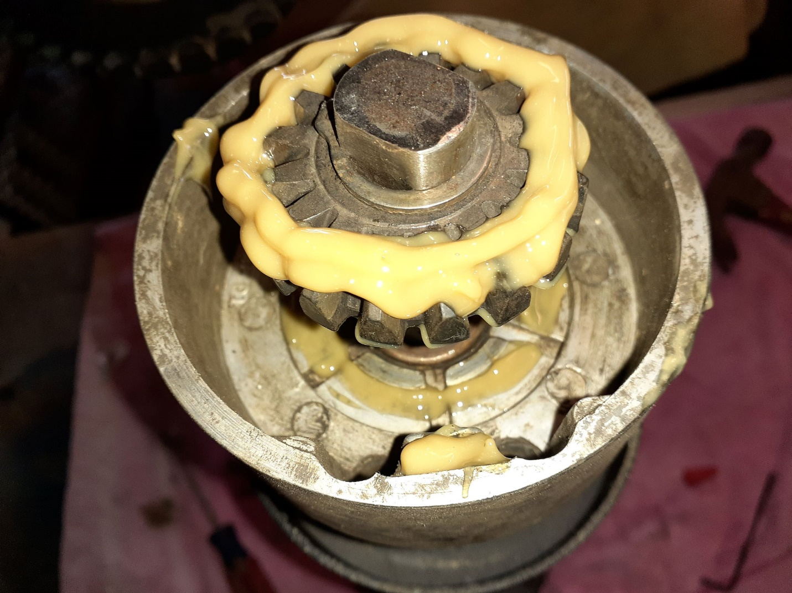
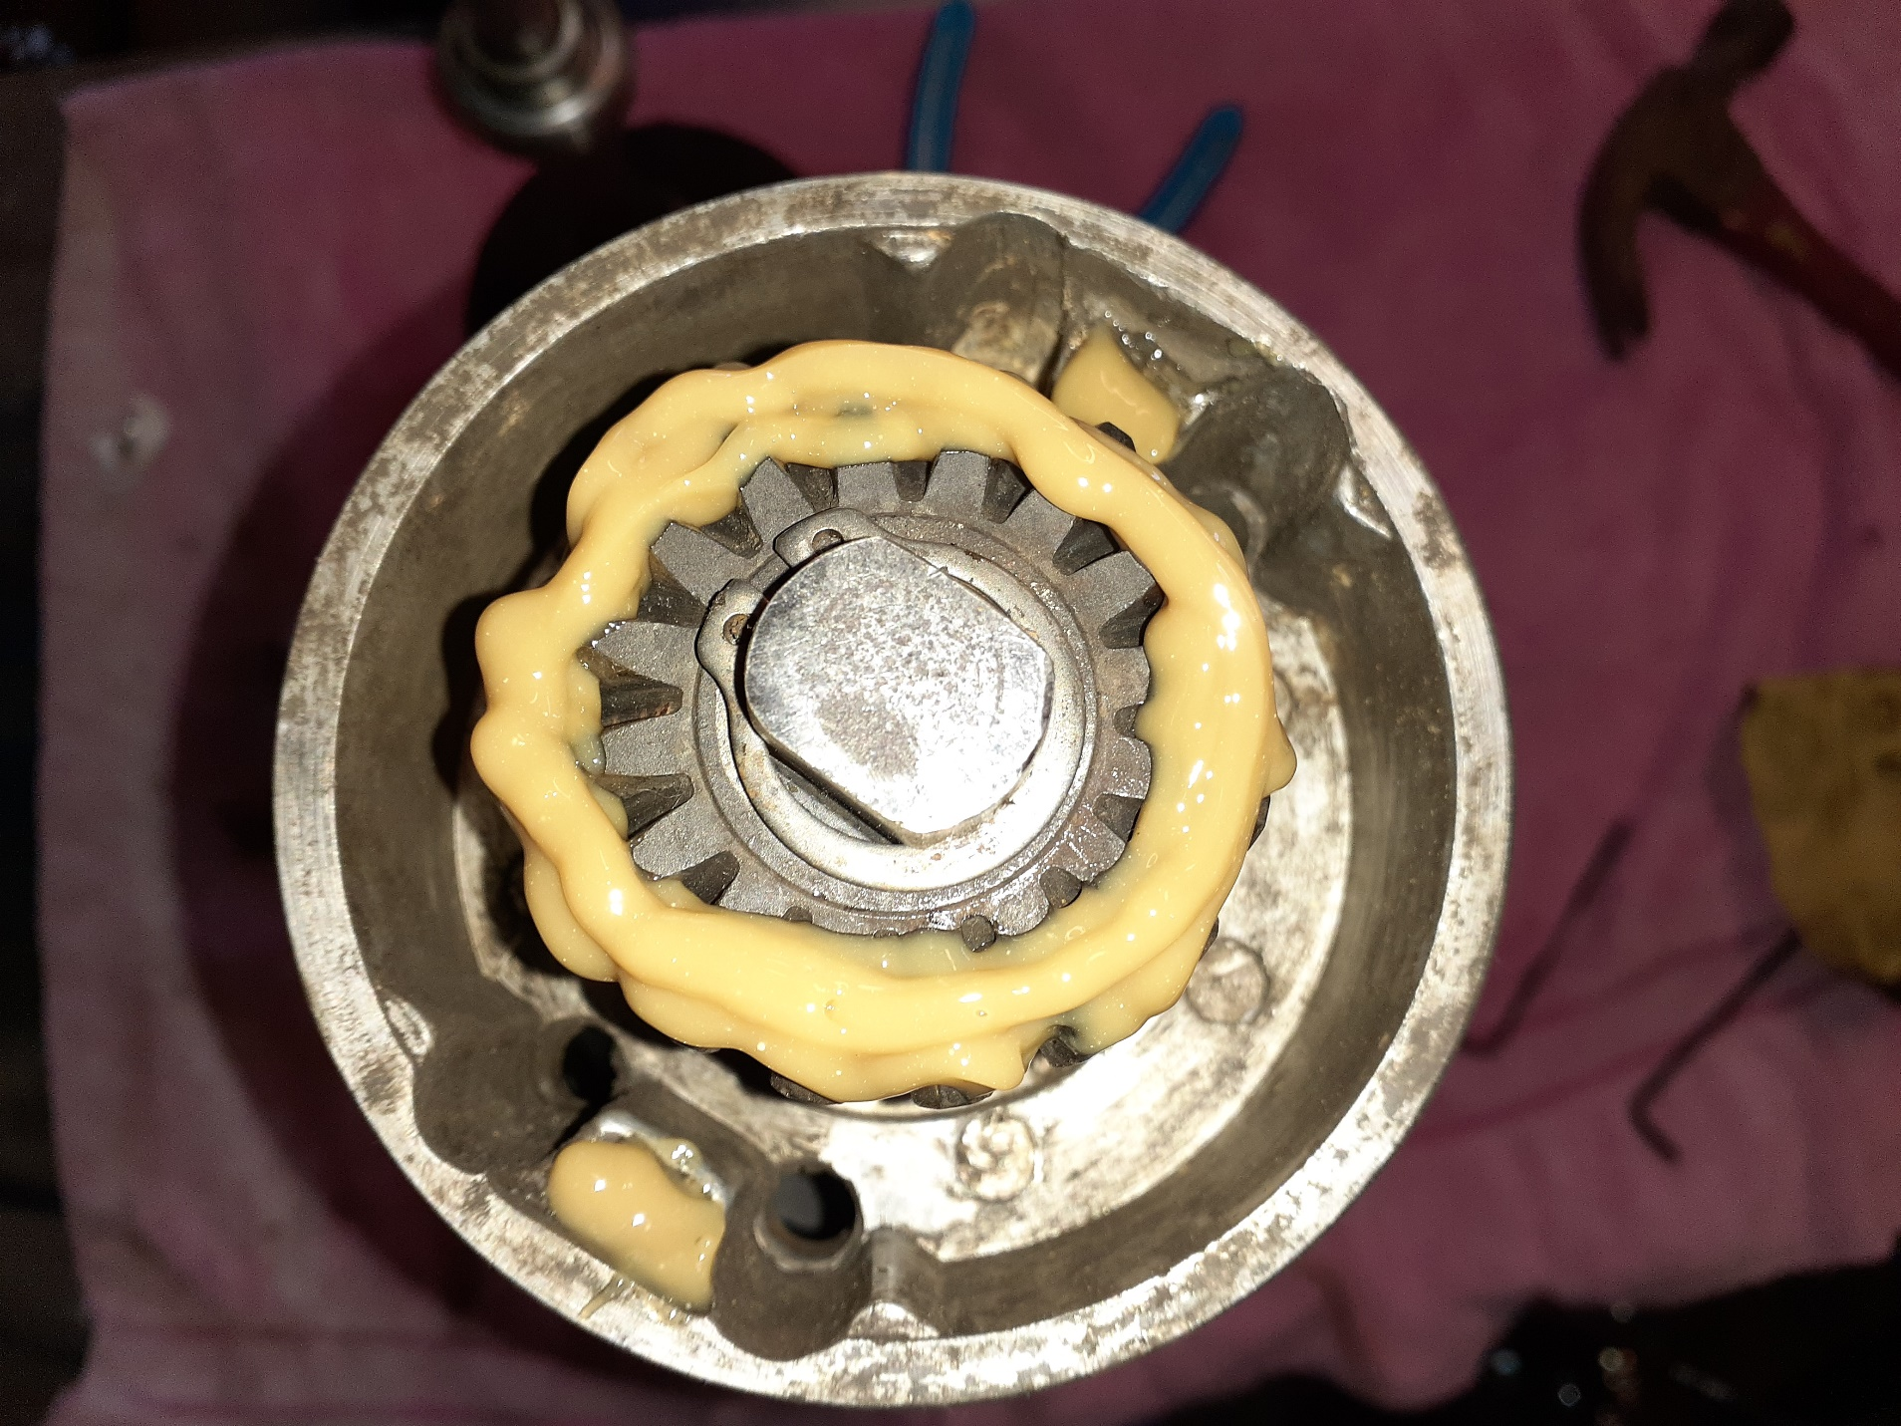

Put your four bolts through the holes in the sprocket then into the carrier housing. Slide these onto the shaft and let them rest against the brake drum/bearing. Drop your bevel gear into place, then lock it down with the C clip. It doesn’t take much grease to do the job. You are not packing these gears like a wheel bearing. Just run a bead or two across the gears. Once you have everything back on each axle half, place the two halves together. Standing one axle on end, place the pinion gear set into the pinion carrier grooves. I found it easier to use something to lodge under the carrier housing keeping it close to where it will finally rest, rather than letting it slide down the shaft. Make sure the thrust washers are on the outside of the gear, between it and the carrier case. Set your second half on to the lower half making sure the bolt holes line up. If the holes line up, your pinion gear set will also line up. Make sure the thrust washer is tight against the face of its gear. Otherwise, it could get in the way when seating the second half. After the outer case is lined up, check to see that your bolts will drop match the second half. Once they are lined up, start to thread them into that half. Just finger tight is all that is necessary. Now is the time to check your grease level. Turn the free axle shaft a few full turns, then lift the two halves apart again. If the grease has spread evenly, over every gear, you have enough. Put the two halves back together. After the four bolts are properly seated, use your wrench to tighten them down into the threaded half of the carrier. After they are tight, run your four nuts onto the visible threads. Finger tighten all four then use your wrench to secure them.
You have just rebuilt your Peerless differential and i’s axles. Now you can put the bearings and their carriers back in place and mount the axle.

