CLIENT INFORMATION FORM

Client Name: ______________________________________________ Date: ___________________ Phone (home): _______________________________ Cell phone or evening: __________________ Address: _________________________________________________________________________________ Email (optional): _________________________________________________________________________________ Emergency Contact: _________________________________________________________________________________ Reason for Session: ______ Relaxation and Stress Reduction ______ Specific Issue: __________________________________________________________________________________ __________________________________________________________________________________ __________________________________________________________________________________ __________________________________________________________________________________ How did you hear about us? __________________________________________________________________________________ Have you ever had an Energy Session (Reiki, Crystal Healing, Healing Touch?) __Yes __No

Are you sensitive to touch? __________________________________________________________________________________ Changes since last session: __________________________________________________________________________________ __________________________________________________________________________________ __________________________________________________________________________________ __________________________________________________________________________________ Observation after Reiki Session / Post Session Notes: __________________________________________________________________________________ __________________________________________________________________________________ __________________________________________________________________________________ __________________________________________________________________________

CONSENT FORM

I _______________________________ (print name), understand that the Reiki, Crystal Healing Sessions provided by Miracle World international, LLC involves a natural hands-on method of energy balancing for the purpose of stress reduction and relaxation. I understand that these treatments are not intended as a substitute for conventional medical care.

Please read and initial the following:

___ I understand that Reiki or Crystal Healing Sessions is not a substitute for medical care or medications, doesn’t interfere it with treatments by licensed medical professionals. I understand that the Reiki or Crystal Healing practitioner does not diagnose illness or disease or prescribe medications. I understand the Reiki or Crystal Healing practitioner recommends to set up appointment with licensed physician or licensed health care professional for any medical issues that I may have. Any intuitive impressions shared with the client are strictly the opinion of the practitioner and should not be considered as medical advice.

___ I understand that during the Reiki or Crystal Healing the practitioner may lay hands on me and that I have indicated my preference in the Intake form.

___ I understand that participation in a Reiki or Crystal Healing Sessions is voluntary, and that at all times, I may choose to end my participation. I understand that the safety, wellbeing and care of myself is ultimately my responsibility. I absolve the Reiki or Crystal Healing practitioner of all liability.

___ Payment is due at time of service or during online scheduling of appointment.

___I understand that a 24-hour cancellation is required to avoid charges for my scheduled session. No show fee in amount of 100% of appointment price will be charged if cancelation made less then in 24 hrs

___ If I have any questions or concerns, I will address these promptly with the Reiki, Crystal Healing practitioner.

___ I hereby happily authorize the Reiki and Crystal Healing practitioner to provide me with the sessions I have signed up for.

Signature: ______________________________________________ Date: ____________________

Guardian’s Signature:_______________________________________________________________________ (If the client is under 18 years of age)

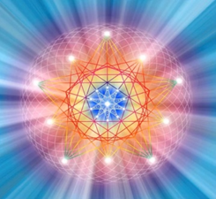

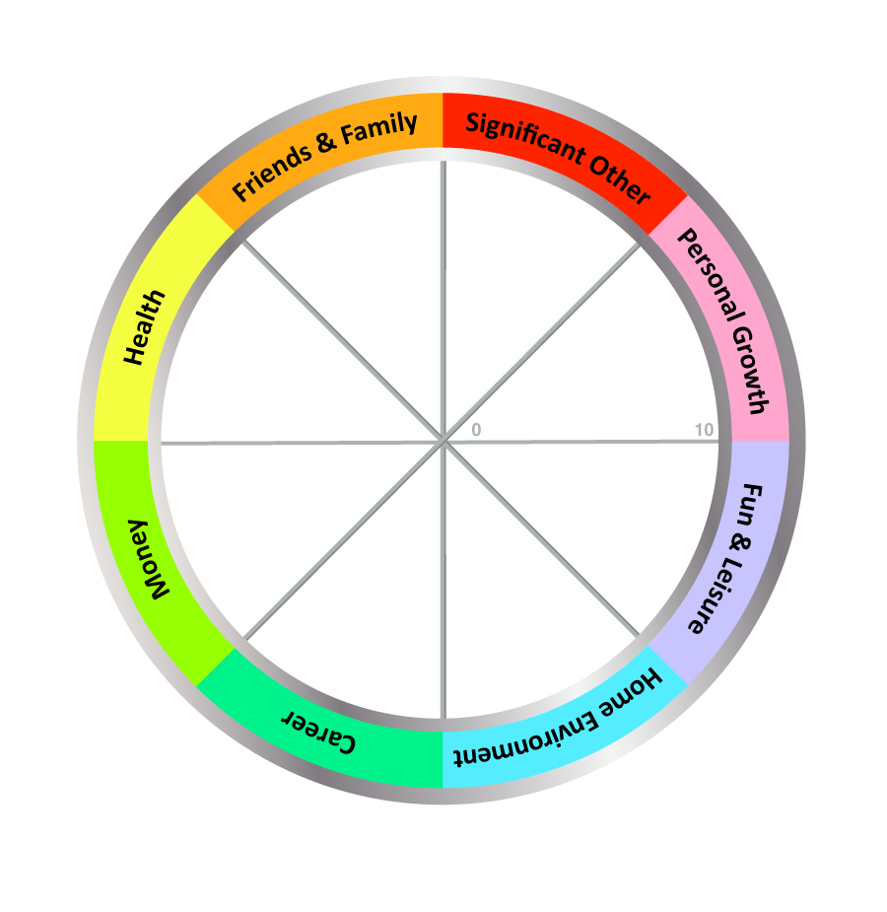

Please, rate your life categories from 1 to 10 ( where 1 means “totally unsatisfied” and 10 – “excellent”)

Self assessment:

|  |  |  |  |  |  |  |  |  |  |
| --- | --- | --- | --- | --- | --- | --- | --- | --- | --- |
| Date  Problem,  issue |  |  |  |  |  |  |  |  |  |
|  |  |  |  |  |  |  |  |  |  |
|  |  |  |  |  |  |  |  |  |  |
|  |  |  |  |  |  |  |  |  |  |
|  |  |  |  |  |  |  |  |  |  |
|  |  |  |  |  |  |  |  |  |  |
|  |  |  |  |  |  |  |  |  |  |
|  |  |  |  |  |  |  |  |  |  |

Please, specify if there is any specific issue that you want to work on during the appointment