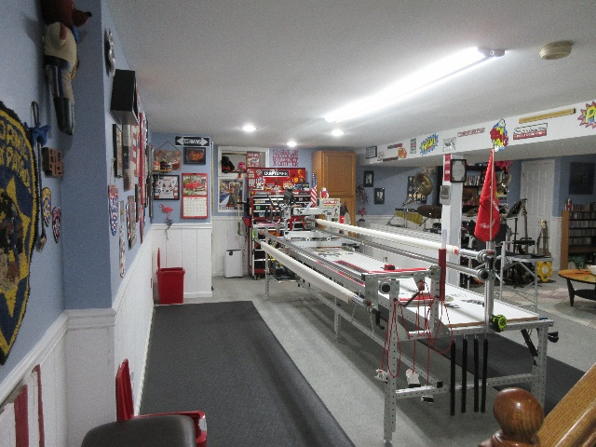
WE QUILT // Les & Elaine Page
1 Pawtucket Rd
West Grove, PA 19390
(Close to State Rd & PA 896 Newark Rd in New London Twp)

i.longarm@yahoo.com
elaine.navarro-page@hotmail.com
www.wequilt.org

Les 757 376-1237 (thee Leatherneck Kilted Quilter)
Elaine 757 376-1238 (Coordinator of Not Forgotten QOV)

We operate a hand guided Innova Longarm using the Innova Panto Vision T2 Pantograph Pattern System.
Price List / 2024
Longarm Quilting Fees
T-Shirt Meander | $.0210/sq. inch .0230 / 102”-124”)
All Over Edge to Edge & Border to Border Pantographs | $.0225/sq. inch - .0245 / ( “ )
Complex Edge to Edge / Tight & busy pattern or multiple patterns | $.0275/sq. inch - .0295 / ( “ )
Custom: Borders and/or Fills/Multiple Patterns or Threads | $.0325+/sq. inch - .0345+ ( “ )
Minimum E2E $50.00 / Minimum Custom $85.00 / * Add .0020 for tops 102”-124” MAXIMUM WIDTH.
⬇There is a charge 0f $6.00 per quilt for Variegated Thread⬇
Packaged Batting Charges are based on battingsupersale.com at time of purchase.
Batting:  Cotton/Poly Batting: 80/20: In stock rolls (Hobbs) | $7.20 yd // .20 cents per linear inch
Polyester Batting & 80/20 Black | Our Cost + 15%
100% Cotton: Natural & Bleached | Our Cost + 15%
Wool Batting | Our Cost + 15%
Binding Service @ .30 Cents per linear inch*
*Customer Provides Binding Fabric: 2 ½” W x Linear Length of Quilt + 10”
If quilter supplies only fabric for binding add .05 cents per inch
Binding is machine sewn to quilt and hand sewn finished.
EX: 60X80 Quilt 2 ½ X 290” Binding (280” x .30 cents per inch = $84.00)

Backing: | Supplied by Topper
Quilt Prep:  Ironing or pressing:  Backing Seems should be ½” pressed open and horizontal if possible. Quilt top seams should be pressed flat and any loose or long threads cut/trimmed. The back should be 10” Wider and longer than the Quilt Top. 5” all around. | Items should be ironed and  pressed when delivered.  No charges are applied to touch up tops or backs before loading on longarm.
Return Shipping:  UPS (No PO Boxes) USPS (If PO Box) | We Pay 50%
Embroidered Label’s
Ready Designs with your text $18.00 (4 lines) / Custom Designs $20.00 and up
Once a design is agreed to allow seven business days for completion of your label. Multiple labels may require additional time.
- We will use your batting if you choose to supply.
- We will use your thread if you choose to supply. We stock Superior Omni and Omni Variegated.
- If we don’t have the pattern you select for your quilt we will purchase it at no charge to the customer. If we are unable to work with that pattern (many digital patterns are designed for computer operated systems) we will inform you and assist you in choosing a pattern we can work with. We have over 300 in our current library.
- The backing should be 10” longer and wider than the Quilt Top. Batting should be at least 6” wider & longer if customer supplies. Minky backing MUST be at least 10”Longer and Wider. For BEST results Selvage edge(s) should be on left and right of Minky. NOT top and bottom.
* Larger tops (102”- 124” wide) require extra handling & equipment changes.
- If you are submitting a Quilt of Valor, there is no longarming charges and we will supply the batting, backing and label from our QOV stock.

