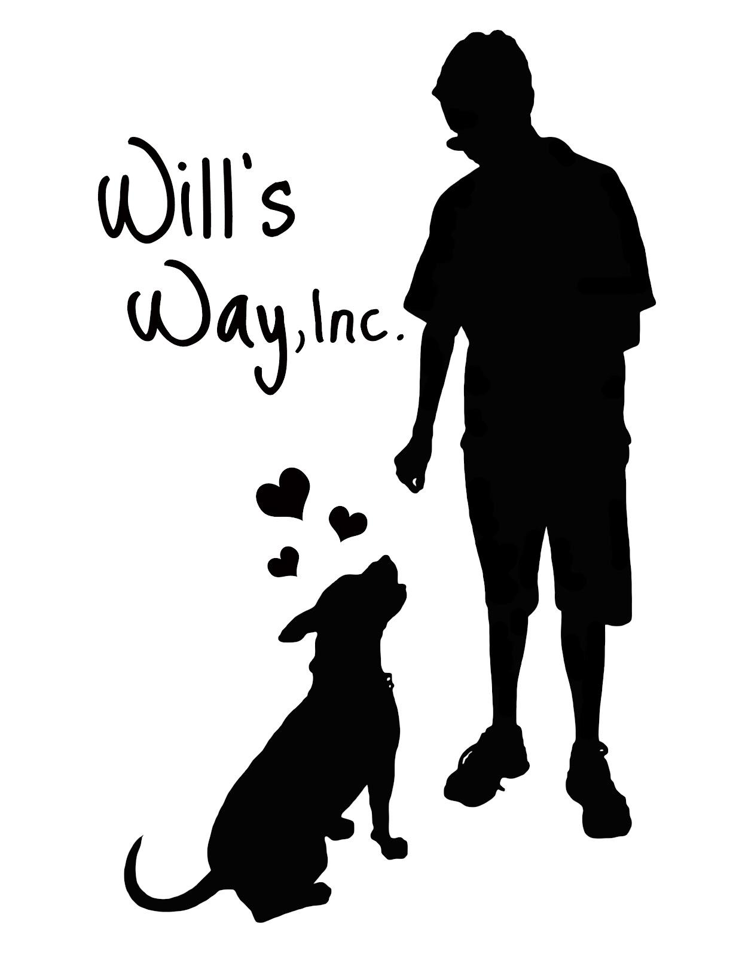
Will’s Way, Inc. Foster/Adoption Application
Please type in the needed information in BOLD and BOLD
the answer of your choice on the multiple choice questions.
WillsWayDogs@gmail.com

Name (s): Ages:
Email: Phone:
Address:

Own or Rent? SIngle Family, Attached, APT? Time at this residence:
Name of HOA/Landlord Phone

Your Energy Level: Training Experience: Little to none Some Experienced Pro

Dogs permitted with the following restrictions:
Is there a fenced-in yard? Height of fence? feet Gate? Dog Door?

Employer: Supervisor: Phone:
Work Schedule?

Hours Dog will be Alone Daily: Where? In crate In a room In home In yard

Would like to adopt (Name/Breed):

I generally like dogs with following characteristics:

Gender: Male Female Either
Age: 8-16 wks 5-6 months 7-14 months 15-24 months 2-5 yrs 6 yrs>
Special Needs: Fine Willing to Discuss No, Thank you
Breed:
Weight: 3-10 # 11-20 # 21-30 # 30-45 # 46-60 # >61 #
Prefer Dogs with an Energy Level that is: Low Medium High Combination of:
Prefer a dog that needs to be Groomed: Never Rarely Doesn’t matter
Housebreaking: OK with a dog that is Not Trained Almost Trained Fully Trained
Obedience: Will Train Needs Some Training Trained Only
MUST be hypoallergenic? Prefer low shedding dog?
Dog Must Be Good With:
Cats Dogs: Small Medium Large Kids: Babies Young Older Children
How my K-9 Kid will live:
Will sleep in a crate in a pet bed in bed with me/us outside
During the day, when I am home, dog will be in a crate in the house outside
During the day, when I am not home, will be in a crate in the house outside
Where the dog will be when I/we are on vacation:

Other animals at the house: (Name, Gender, Breed, Size, Age, Temperament)
1.
2.
3.

Other people living or regularly visiting the house and their age and relationship:
1.
2.
3.

Present Vet: Phone:

People who know me/us well but are not relatives and their phone number:
1.

2.

3.

I/We understand:
There is an on site, virtual or combination of both, home visit as part of the approval process.
Approval for fostering or adopting is at the sole discretion of Will’s Way, Inc.
There is a separate Adopter’s Agreement which will need to be read, terms agreed to and signed.
If we can no longer foster, foster to adopt, or need to surrender, Will’s Way will be given the time needed to find another placement for the dog entrusted to me/us.
This application in its entirety and agree that all statements made by me/us have been answered honestly and truthfully. I/we make this statement under penalty of perjury under the laws of the State of Florida.
Signature Including Middle Name
# 1 Date

# 2 Date
Please text your name and “Application completed” to 561 – 901 – 4456 Thanks!

