TTeeaacchheerr’’ss GGuuiiddee

Dear Educator,
G
Butterflies

et set to watch butterflies emerge from their chrysalises. In KIDS
DISCOVER Butterflies, children will learn about the life cycle of butterflies. Children will also discover what butterflies eat.
This Teacher’s Guide is filled with activity ideas and blackline masters that can help children understand that butterflies go through great changes as they develop.
Thank you for making your classroom a fun and interesting place to learn by using
KIDS DISCOVER.
Sincerely,
KIDS DISCOVER
P.S. We would love to hear from you.
E-mail your comments and
ideas to teachers@kidsdiscover.com

PA G E S WHAT’ S IN BUTTERFLIES

2–3 Baby Animals
4–5 The Egg
6–7 The Caterpillar
8–9 The Chrysalis
10–11 It’s a Butterfly
12–13 Staying Alive
- Off Off and Away
- Glossary

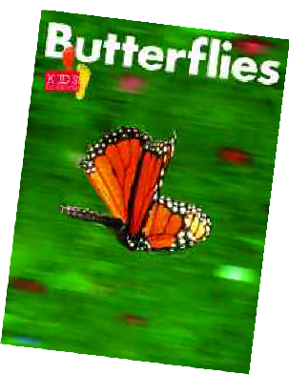

Meeting the Standards
• IN THIS TEACHER’ S GUIDE •
2 Before-Reading Activities
3 Get Set to Read
4 Let’s Talk
5–6 Look Back
7 Picture This!
8 After-Reading Activities
9–12 Answer Keys to Blackline Masters
✔ Visit www.kidsdiscover.com/standards to find out more about how KIDS DISCOVER meets state and national standards.

BEFORE- READING ACTIVITIES

efore reading KIDS DISCOVER Butterflies, access children’s prior knowledge with these activities.
B

Discussion
T
o get children thinking about the topic, ask these questions:
✔ Have you seen butterflies? What did they look like?
✔ How do butterflies change as they become adults? What do caterpillars become?
✔ Do young butterflies look like their parents?
What Do We Know? Word Web raw a word web on the board. Write the word Butterflies in the middle
D
circle. Ask children to tell what they know about butterflies. Write the information in the circles around the middle. Alternatively, offer your own ideas, such as Butterflies cannot fly. Have children tell whether the sentence should be included in the web.
After writing phrases and sentences in the web, review them with children and talk about what they tell us about butterflies.

Get Set to Read (Anticipation Guide)
opy and give children the Get Set to Read blackline master (page 3 of this
C
Teacher’s Guide). Read aloud the directions. Help children identify the pictures. Ask them to circle the pictures of caterpillars and butterflies. Explain that this page will help them find out what they already know about butterflies. Tell them that after they read about butterflies, they will look at this page again and check their choices.

Preview
M
odel how to preview Butterflies. Read aloud the titles. Look at the pictures
and talk about what you see. Ask children if they want to add any words from the preview to their What Do We Know? word web. If children are reading only a few pages at a time, preview just those pages.

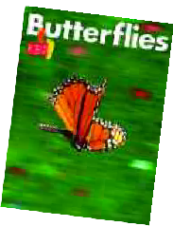

✔ butterfly
✔ egg
✔ larva
✔ pupa

✔ chrysalis
K E Y T E R M S
insect with large colorful wings
an animal part from which a new animal can hatch an early, often wormlike, form of a very young insect the stage in which a caterpillar is inside a hard covering as it changes into a butterfly
the hard covering over a pupa
✔ metamorphosis the change in an insect’s form as it becomes an adult
✔ moths an insect that looks like a less colorful butterfly
✔ insects small animals with six legs and two body parts
✔ nectar sweet liquid in flowers
......................... www.kidsdiscoverteachers.com .........................
KIDS DISCOVER • 149 Fifth Avenue, 10th Floor • New York, NY 10010 • T: 212–677–4457 • F: 212–353–8030

Name Date

Get Set to Read
Butterflies look different at different times of their lives.
They are caterpillars before they become butterflies. Circle the insects that are caterpillars or butterflies.

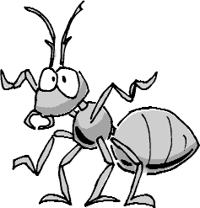
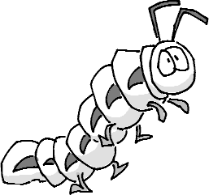

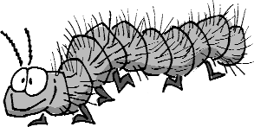
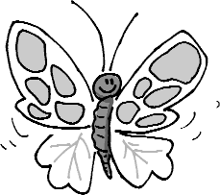

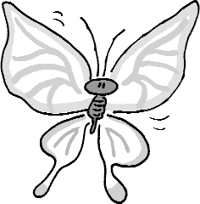
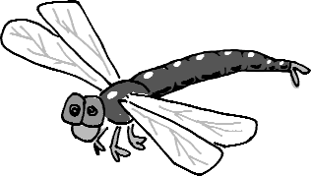

LET’ S TALK
hile reading KIDS DISCOVER Butterflies , use these questions to talk about the topic with children.
W

Pages 2–3
✔ How are baby bears like their parents?
✔ How do baby bears differ from their parents?
✔ What other baby animals look like their parents?
Pages 4–5
✔ Are all butterfly eggs the same shape and color?
✔ Where do butterflies lay their eggs?
✔ Why do you think they lay eggs on plants?
Pages 6–7
✔ What hatches from a butterfly egg?
✔ What happens to a caterpillar as it gets bigger? Why?
✔ Will a caterpillar always be a caterpillar?
Explain.
Pages 8–9
✔ What is inside the chrysalis? How does it change?
✔ What comes out of a chrysalis?
✔ What did the butterfly used to be?
Pages 10–11
✔ Describe the big changes a butterfly goes through in its life.
✔ Why don’t caterpillars lay eggs?
✔ How are moths like butterflies?
Pages 12–13
✔ What do most butterflies eat as food?
✔ Where do butterflies get their food?
✔ What does nectar provide butterflies?
Page 14
✔ Why do butterflies fly south in the fall?
✔ Why do they fly north in the spring?
✔ What do some butterflies do as they are flying north and south?
All pages
✔ What is this KIDS DISCOVER about?
✔ What does it tell us about the lives of butterflies?

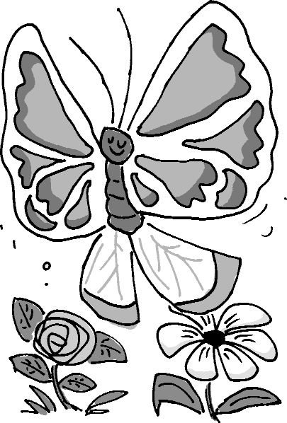
.......................... www.kidsdiscoverteachers.com .........................
KIDS DISCOVER • 149 Fifth Avenue, 10th Floor • New York, NY 10010 • T: 212–677–4457 • F: 212–353–8030

Name Date
Look Back
Choose the best answer for each question. Fill in the circle.

Find your answers on the pages shown next to each question.

  - How are most baby animals like their parents? Look back at pages 2–3.
    - They are the same age as their parents.
    - They look like their parents.
    - They are as tall as their parents.

  - Where do most butterflies lay their eggs? Look back at pages 4–5.

in water
    - in the sand
    - on plants

  - How much food do caterpillars eat? Look back at pages 6–7.

They eat a lot.
    - They eat very little.
    - They do not eat.

  - What happens to a caterpillar before it Look back at pages 8–9.
becomes a butterfly?
    - It becomes a larva.
    - It becomes a pupa.
    - It lays eggs.

10–11.

Look Back (continued)

  - What word means “big change”? Look back at pages

larva
    - metamorphosis
    - pupa

  - Why do butterflies go from flower to flower? Look back at pages 12–13.

to get nectar
    - to lay eggs
    - to find rotting fruit

  - When do butterflies fly north? Look back at page 14.

in fall
    - in spring
    - in winter

  - Draw a picture. Show what hatches from a butterfly egg.

Name Date
Picture This!
In KIDS DISCOVER Butterflies, you look at the changes a butterfly goes through. Think about the life of a butterfly. Cut out the pictures. Paste them in the boxes to show the order of changes in the butterfly.
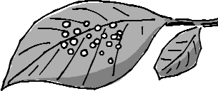

✁
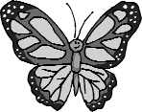 | 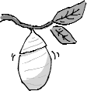 | 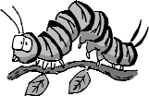

Name Date

Match Words
Draw a line from the word to its picture.

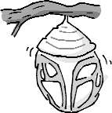
butterfly

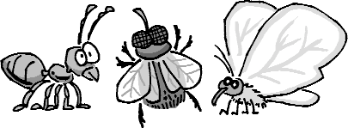
eggs

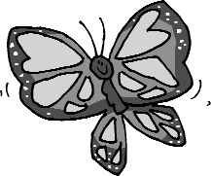
caterpillar

chrysalis
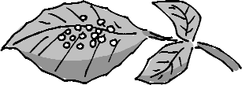

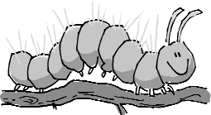
insects

Name Date

Complete Words
Look at the picture. Print letters to complete the picture name.
The words in the box can help you.

chrysalis insects
caterpillar
eggs
butterfly

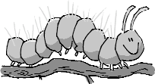c t r i l a r

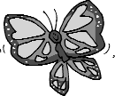 u e r l y

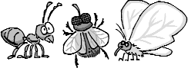i s e s

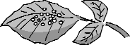e s

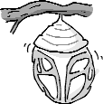c h y l i s

Name Date

Look for Words
Find the words. Draw a line through them. Then circle all the letters you did not use.
Write the letters on the lines. Then read the sentence.

chrysalis insects
caterpillar
eggs
butterfly

E | I | N | S | E | C | T | S | T | H | E | L
G | A | B | U | T | T | E | R | F | L | Y | R
G | C | H | R | Y | S | A | L | I | S | V | A
S | C | A | T | E | R | P | I | L | L | A | R

A caterpillar is _ _ _ _ _ _ _ _ of a butterfly.

AFTER- READING ACTIVITIES

f ter reading KIDS DISCOVER Butterflies , share these activities with children.
A

Ar t
- It’s a creeping caterpillar. Children can make paper bag caterpillars. Have children stuff brown lunch bags with newspaper. They can tape the bags closed and squeeze them into worm shape. They can draw faces on one end and add paper or pipe cleaner legs. Display the caterpillars on a chalk ledge or bookshelf.

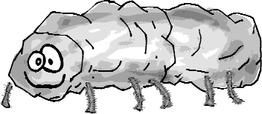

Language Ar ts and Science
- Just what does a hungry caterpillar eat? Have some fun reinforcing scientific concepts with Eric Carle’s delightful The Very Hungry Caterpillar. Children are sure to enjoy learning all about a make- believe caterpillar and the things it eats. After reading the story, talk about why caterpillars need lots of food. Emphasize that the food gives them the energy they need to go through all the changes from caterpillar to butterfly.

Science
- You’ll find butterflies everywhere at a butterfly garden. If a nearby community has an indoor butterfly garden, take children there to visit. If not, find and cut out pictures of butterflies. Display the butterflies all around the room including on windows, plants, and walls. Take children on a walking tour to view the pictures. Emphasize that butterflies are insects and all insects have two body parts and six legs. Point out the colors and patterns on the wings of the butterflies.

Language Ar ts
- Butterfly is a compound word. Write butterfly on the board. Show children how it can be divided into two separate words with different meanings, Point out that it is a compound word, or a word made up of two smaller words. Play a picture-word game with children. Hold up two pictures whose picture names can be combined into a compound word. Children can guess the compound word. For example, display pictures of a dog and of a house. Children can identify doghouse as the compound word represented by the pictures. Examples of words to illustrate: birdhouse, grasshopper, sailboat, football, headband, and horseshoe.

......................... www.kidsdiscoverteachers.com .........................
KIDS DISCOVER • 149 Fifth Avenue, 10th Floor • New York, NY 10010 • T: 212–677–4457 • F: 212–353–8030

Name ANSWER KEY Date
Get Set to Read

Butterflies look different at different times of their lives.
They are caterpillars before they become butterflies. Circle the insects that are caterpillars or butterflies.
After you read KIDS DISCOVER Butterflies, look at the answers on this page. Check your answers.

Name ANSWER KEY Date

Look Back

Choose the best answer for each question. Fill in the circle.

Find your answers on the pages shown next to each question.

- How are most baby animals like their parents? Look back at pages 2–3.
  - They are the same age as their parents.
- They look like their parents. (compare and contrast)

They are as tall as their parents.

- Where do most butterflies lay their eggs? Look back at pages 4–5.

in water
  - in the sand
- on plants (details)

- How much food do caterpillars eat? Look back at pages 6–7.
- They eat a lot. (draw conclusions)

They eat very little.
  - They do not eat.

- What happens to a caterpillar before it Look back at pages 8–9.
becomes a butterfly?
  - It becomes a larva.
- It becomes a pupa. (sequence)

It lays eggs.

10–11.

Look Back (continued)

- What word means “big change”? Look back at pages

larva
- metamorphosis (word meaning)

pupa

- Why do butterflies go from flower to flower? Look back at pages 12–13.
- to get nectar (cause and effect)

to lay eggs
  - to find rotting fruit

- When do butterflies fly north? Look back at page 14.

in fall
- in spring (details)

in winter

- Draw a picture. Show what hatches from a butterfly egg.

Answer: Children’s pictures should show a caterpillar.

In KIDS DISCOVER Butterflies, you look at the changes a butterfly goes through. Think about the life of a butterfly. Cut out the pictures. Paste them in the boxes to show the order of changes in the butterfly.

Draw a line from the word to its picture.

butterfly

eggs

caterpillar

chrysalis

insects

Look at the picture. Print letters to complete the picture name.
The words in the box can help you.

chrysalis insects
caterpillar
eggs
butterfly

c a
t e
r p
i l l a r

b u t t e r f l y

i n s e c t s

e g g s

c h r
y s a

l i s

Find the words. Draw a line through them. Then circle all the letters you did not use.
Write the letters on the lines. Then read the sentence.

chrysalis insects
caterpillar
eggs
butterfly

E I N S E C T S T H E L G A B U T T E R F L Y R G C H R Y S A L I S V A S C A T E R P I L L A R

A caterpillar is t h e l a r v a of a butterfly.

