LIGHT DIFFRACTION AND INTERFERENCE

LAB LIGH 4
From PASCO Scientific Laboratory Notes

INTRODUCTION

That light is a wave phenomena is dramatically observed with a well-collimated monochromatic light beam incidence on a narrow slit or slits. Its bending as it passes an optically opaque edge and phase superposition consequences resulting from its wave affect can be well observed in patterns of varying light intensity by a narrow slit or multiple narrow slits which restrict the light beam width thus high-lighting the observation of the wave interaction behavior. The resulting observed pattern from a single slit is commonly referred to as diffraction while that of multiple slits as interference. Technically, both diffraction and interference are involved in all these resulting patterns, with diffraction the bending effect and interference the superposition effect of the bent rays of waves from different parts of the light beam.

With light passing through a slit and diffraction and interference occurring, the angle to the minima in the diffraction pattern is given by
a sin θ = mλ(m = 1,2,3...)

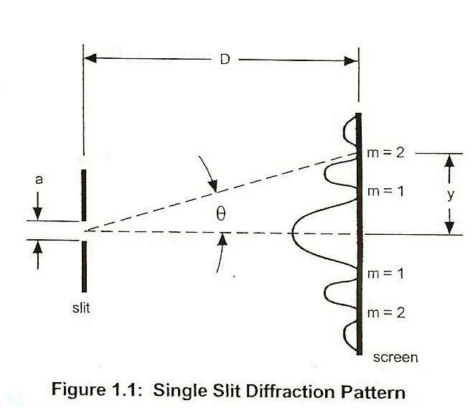
where a is the slit width, θ is the angle from the center of the pattern to the mth minimum,
λ is the wavelength of the light, and m is the order (1 for the first minimum, 2 for the second minimum,… counting from the center out). See Figure 1.1.

Since the angles are usually small, it can be assumed that
sinθ ≈ tanθ
From trigonometry,
tanθ = y
D

where y is the distance on the screen from
the center of the pattern of the mth minimum and D is the distance from the slit to the screen as shown in Figure 1.1. The diffraction equation can thus be solved for the slit width:
a = mλD (m = 1,2,3)
y

Light, Diffraction and Interference
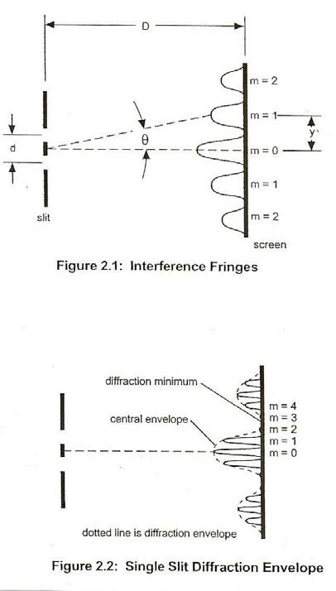
With light passing through two slits, the two light rays emerging from the slits interfere with each other and produce interference fringes. The angle to the maxima (bright fringes) in the interference pattern
is given by
d sin θ = mλ(m = 1,2,3,...)
where d is the slit separation, θ is the angle from the center of the pattern to the mth maximum, λ is
the wavelength of the light, and m is the order (0 for the center maximum, 1 for the first side maximum, 2 for the second side maximum,… counting from the center out). See Figure 2.1

Since the angles are usually small, it can be assumed that
sinθ ≈ tanθ
From trigonometry,
tan θ = y
D
where y is the distance on the screen from the center of the pattern to the mth maximum and D is the distance from the slits to the screen as shown in Figure 2.1. The interference equation can thus be solved for the slit separation:
d = mλD (m = 0,1,2,3,...)
y

While the interference fringes are created by the interference of the light coming from the two slits, there is also a diffraction effect occurring at each slit due to Single Slit diffraction. This causes the envelope as seen in Figure 2.2.

PURPOSE

The purpose of this experiment is to examine the diffraction/interference pattern formed by laser light passing through a single slit and then for the light passing through the double slit and for both verify that the minima of the single slit and that the maxima of the double slit patterns match the positions predicted by theory.

MATERIALS
laser meter stick
PASCO Single Slit Set laser mount arrangement
PASCO Multiple Slit Set meter rule
projection screen white paper to cover screen

PRELIMINARY QUESTIONS

- How does one understand the observed behavior of the varying projected light intensity on a screen resulting from light superimposing from a narrow well- collimated monochromatic beam of light?

- Explain the geometrical basis of the spreading out of the diffraction/interference pattern as it relates to slit width and slit separation (if double slit).

- Why do we not commonly observe diffraction and interference effects as light beams superimpose?

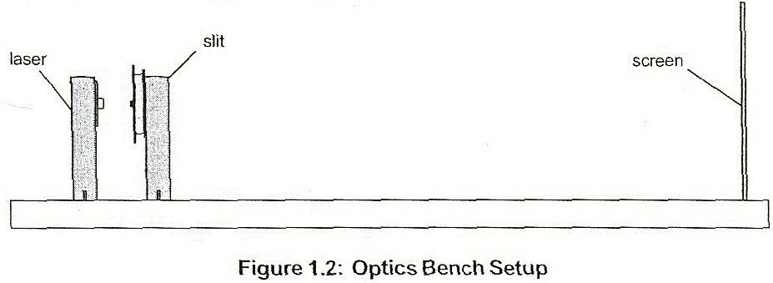

PROCEDURE

- Set up the arrangement mounting the laser about 5 cm in front of and so that its beam is aligned with the single slit (or double slit), as positioned by it mounting, and to project on the screen about 1 to 2 meter beyond the slit(s). Cover the screen with a sheet of white paper. Note Figure 1.2.

- Now with the PASCO Single Slit Set, select the 0.04 mm slit having it centered in the slit holder. Determine and record in Table 1.1, the slit-to-screen distance.

- Turn off room lights and mark the positions of the minima of the diffraction/ interference pattern on the screen.

- Turn on the room lights and measure the distance between the first order (m=1) marks and record the value in Table 1.1 and likewise for second order (m=2) and record.

- Make a sketch of the diffraction/interference pattern to scale.

- Change the slit width to 0.02 mm and 0.08 mm and make sketches to scale of each of these diffraction/interference patterns.

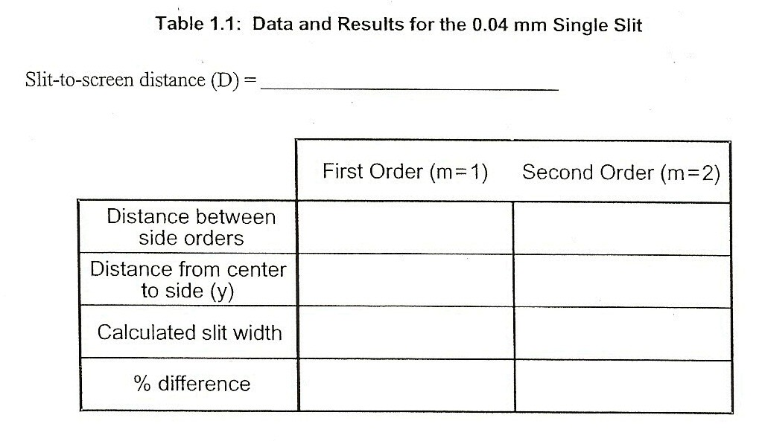

- With the same arrangement as for the single slit (Figure 1.2), replace the PASCO Single Slit Set with the PASCO Multiple Slit Set. Select the double slit with
0.04 mm slit width and 0.25 mm slit separation. Similarly, as for the single
slit adjust alignments to obtain a good projected diffraction/interference pattern.

- As for the single slit, turn off room lights and mark positions now of the maxima and then with room lights on measure the distance between the first order (m=1) marks and record this distance in Table 2.1 and then measure for second order (m=2) and record in the table.

- Make a sketch of the diffraction/interference pattern to scale.

- Change to a double slit with the same slit width (0.04mm) but different slit separation (0.50mm) and make a sketch to scale of this new diffraction/interference pattern.

- Change to another double slit with a slit width of 0.08 mm and the original slit separation (0.25mm) and make a sketch to scale of the is new diffraction/interference pattern.

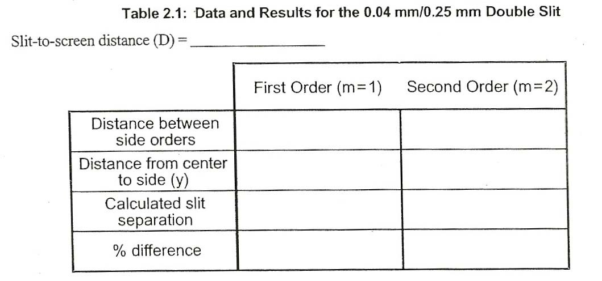

ANALYSIS

Single Slit
- Divide the distances between side orders by two to get the distances from the center of the pattern to the first and second order minima. Record these values of y in Table 1.1.

- Using the average wavelength of the laser (650 nm for the Diode Laser), calculate the slit width twice, once using first order and once using second order. Record the results in Table 1.1.

- Calculate the percent differences between the experimental slit widths and 0.04 mm. Record in Table 1.1.

Double Slit
- Divide the distances between side orders by two to get the distances from the center of the pattern to the first and second order maxima. Record these values of y in Table 2.1.

- Using the average wavelength of the laser (650 nm for the Diode Laser), calculate the slit 1 separation twice, once using first order and once using second order. record the results in Table 2.1.

- Calculate the percent differences between the experimental slit separation and
0.25 mm. Record in Table 2.1.

QUESTIONS

Single Slit
- Does the distance between minima increase or decrease with the slit width is increased? For the intensity pattern observed provide a geometrical rational in terms of wavelength and phase considerations.

Double Slit
- Does the distance between maxima increase, decrease or stay the same when the slit separation is increased?

- Does the distance between maxima increase, decrease, or stay the same when the slit width is increased?

- Does the distance to the minima in the diffraction envelope increase, decrease, or stay the same when the slit separation is increased?

- Does the distance to the first minima in the diffraction envelope increase, decrease or stay the same when the slit width is increased?

- For the double slit varying light intensity pattern explain characteristics observed which relate to single slit effects and those which relate to double slit effects.

