POLLUTION

SECTION 1-A LOT OF LITTER
From Hands on Science by Linda Poore 2003.

OBJECTIVES

Westminster College

By collecting and classifying litter, students learn more about one of the ways in which humans can harm the environment.

MATERIALS
1 plastic glove
1 plastic garbage bag 1 stack newspaper

PREPARATION
Each student will need one plastic glove. Each team of four students will need one plastic garbage bag. Each team’s work area will need to be covered in newspaper. Make sure that each team has plenty of room to sort its trash. You may want to have students work on the floor for this activity.

BACKGROUND INFORMATION
Litter –trash left lying around- is often the students’ first introduction to the idea that people can, and often do, harm the environment. Not only is litter unsightly, but it can harm living organisms. In this activity, students investigate the amount and variety of litter found in their environment.

GUIDING THE ACTIVITY
- Explain to students that in this activity they will be going out onto school grounds to collect litter. Write the word litter on the board and ask, What is litter?

Litter can be defined as unwanted materials in the environment that could harm living things. Instead of a definition, students will probably give examples, such as candy-bar wrappers, cans, and bottles.

The students are likely to mention glass, paper, plastic and aluminum.

Ask students to predict what types of materials the litter found on school grounds might be made of. Write their predictions on the board.

- Divide the class into teams of four. Distribute a plastic glove to each student and a garbage bag to each team. Lead the students outdoors and assign each team an equal-sized area of the schoolyard. Tell the students that they must collect only from their assigned area so that comparisons among the teams can be made later.

Give the teams about 10 minutes to pick up anything from their area that they think does not naturally belong in the environment and to put it in the bag. Tell them to make a mental note of any organisms that appear to be either benefitting from or being harmed by the litter.

SAFETY NOTE:
Warn students to be careful when picking up glass items and to use only their gloved hand to pick up litter. If you do not want your students to pick up glass, give them several scraps of colored construction paper and have them “collect” one scrap to represent each piece of glass found in their area.

- When the students are finished collecting, return to the classroom and ask,

What might be a good way to classify the litter you collected?

Students may suggest classifying by the type of materials the litter is made from, such as metal, plastic, wood, paper, glass and so on, as shown in Figure 1-1. Or, they may want to classify by the original use of the object, such as a container for food, a building material, a toy, clothing and so on.

When the class has determined which method of classification to use, tell each team to sort its litter collection by category, making a separate pile on the newspaper for each. Have one student in each team record the materials found by his or her team.

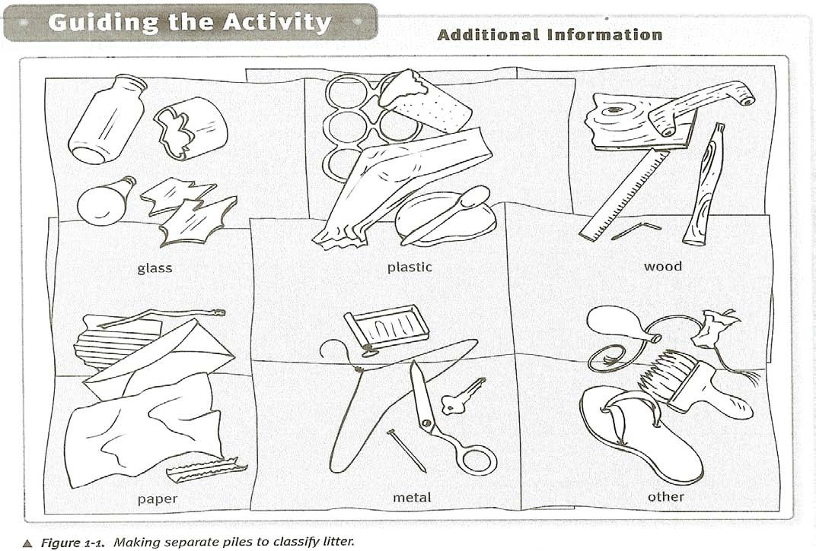

- Encourage teams to share their data, to compare the contents of their piles and to discuss what they have found. Have the teams count the numbers of items in each pile. Record the class totals on the board. Then ask, What area of the schoolyard had the most litter?
Areas where students eat, play, or wait for buses will probably have the most litter.
Visit each team to review the contents of the piles. Point to a particular item and ask, How do you think that piece of litter ended up in the schoolyard?
Students will probably realize that most litter results from careless human behavior.
Encourage students to explain why certain areas of the schoolyard have more litter than other areas. Give them an opportunity to discuss their ideas. Then ask, What can be done to reduce the amount of littering on school grounds?
Students may suggest that some materials-such as glass, aluminum, and paper-can be recycled. Students may also suggest hanging anti-litter posters in hallways, putting trash receptacles outdoors, or organizing a school cleanup campaign.

- At this point many students may be disgusted by the amount of litter they found. Change their focus by asking, Did you notice any living organisms that seemed to benefit from the presence of litter?
Litter may provide the shade needed for certain plants (such as moss) and fungi (such as mushrooms) to grow; bird may use bits of litter as nesting material; small animals or insects may use litter as hiding places; and many plants and animals derive nourishment from discarded food.
Children in this age group are apt to be somewhat indignant about certain negative behaviors such as littering. You may wish to point out that littering is not a new phenomenon. One hundred years ago, people left more than gum wrappers on the sidewalks of New York City. In fact, the walkways were often impassable because of all the sooty refuse from chimneys and furnaces that had been dumped there.

