Cora Joan Healing Hypnosis Session
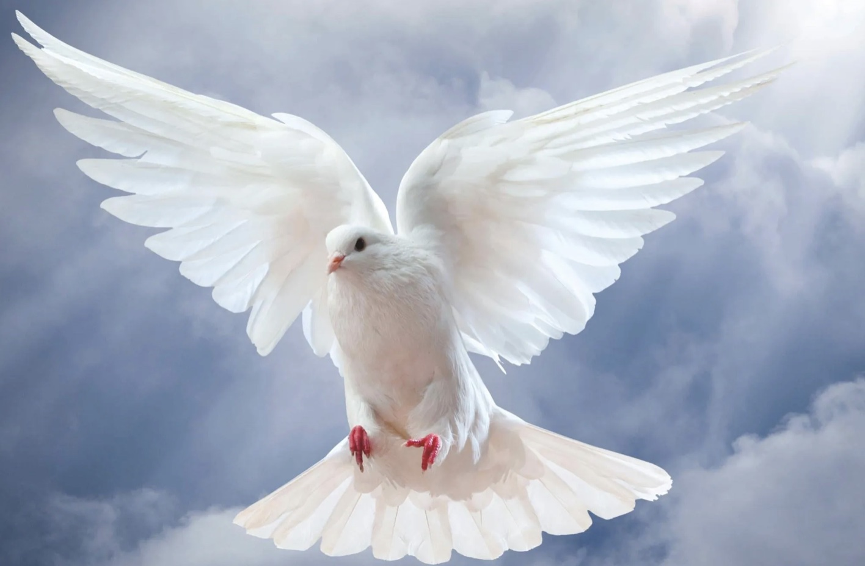
10 Ways to Prepare

In preparation for your session, the guidance below can be very helpful. Once you book a session I will send you a client questionnaire, asking basic health questions. I will also ask for 10 questions you would like to ask the higher self. Please return paperwork and questions at least 24 hours before the session date.

1. This process can take about 3-4 hours and we can split this into two meetings if this helps. Ensure that you have a comfortable place to lay down, and that you are completely relaxed during your session for a deep connection to your higher self.

2. If your session is online, ensure you have a headset with a microphone, or example Apple headphones or a gaming headset. Having the proper technology with a mic will ensure that the volume will be adequate on the recording. The session will be video or audio recorded and sent to you the day after the session.

3. You will need to download the Zoom application prior to the day of your session and test your camera and mic settings. Please make sure your device is fully charged and connected to the mains before we begin.

4. Having some crystals present can aid you to ground and connect. A light crystal such as selenite or quarts and a dark grounding crystal such as Obsidian or tourmaline are perfect. When held in the hands these can aid the flow of energy through the body.

5. Set your intentions for the session and be clear about what you would like to achieve. Do you want to find the root cause of health issues? Do you want to explore your relationship with others or patterns in your life? Do you want more information on your soul family or galactic history? The possibilities are endless. Whatever you decide your higher-self will have already have planned the perfect session for you! And it usually matches what you wanted to achieve!

6. Prepare a list of 10 questions which you would like to seek answers from your higher self in the session. if you have more than this write them all down, and group them together by theme. You may then find they begin to reduce.

5. Practice meditation and perhaps try some guided meditations at home. Can you visualise within meditation? Practice visualising with your eyes closed, and creating images in your mind’s eye. Hypnosis is allowing your imagination to flow and images to come in and out of your awareness without judgment, in a relaxed state. Much like when you read a book and images form in your minds eye. This is how your higher self will communicate with you in hypnosis.

6. Drink water and avoid caffeine on the day of the session to aid you in relaxation. Eat a snack before the session so you are comfortable and do not get disturbed by hunger pangs.

7. Leave expectations at the door. Every session is as unique as you are. Your session will be guided by the higher self and will be exactly what you need at this point on your life path. I love to see how perfect for each individual each session is. This is what makes this all worth while. It is magical!

8. Dress very comfortably in, loose fitting clothing so you can feel as relaxed as possible. Have a blanket handy as this will keep you warm, but also reinforce the feeling of safety which can aid relaxation.

9. All healing is self healing. Your Higher Self initiates the self-healing process and this is aided by Source and the Arch Angels. All trauma and disease can be healed, but this tends to happen in layers over time. It would be too much to release everything in one go. We work to heal what you are ready to release on the day of the session. Often the healing begins in the mind, and then this process manifests in physical health.

10. BEGIN SHIELDING your energetic body and your home EACH MORNING AND NIGHT. This can be as simple as surrounding yourself with (visualising) a golden sphere of Source protection, and asking that only those who support your actual highest good may enter. Ask that your chosen representative (such as AA Micheal) take all others to their perfect place of peace, where they will be best served. We will use a shielding technique at the beginning of your session aided by the Arch Angels and Source so you will always be safe and protected in a session.

See you in your session!
My infinite love and blessings to you, Cora.

