**Gratiot Agricultural Society Fair Program**

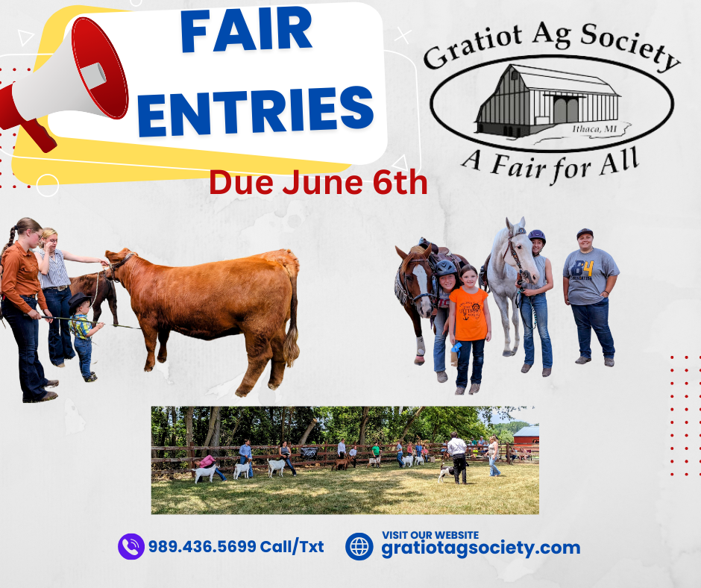

**June 19th – 23rd**

**1**

**Table of Contents**

Welcome to the Gratiot Agricultural Society 3

Fair Schedule 4

Camping Reservation Form 5

Family Fun Event s 6

Cowboy Challenge 7

Strut Your Mutt Dog Show / Windsong Country Band / Egg Extravaganza 8

Non-Fair Week Horse and Beef Shows 9

Superintendent Rules and General Rules for Still Exhibit Entries 11

General Rules for Lives tock Exhibitor Entries 12

G.A.S. Fair Exhibitor Entry Form 13-14

Kiddie Tractor Pull 15

Open Speed Show 16

Pleasure Horse Show & Horse Fun Show Department 1C 17-18

Beef Show Department 2 19

Dairy Cattle Show Department 3 20

Goat Show Department 4 21-22

Sheep Show Department 5 23

Poultry Department 6 24-30

Rabbit s Department 7 31-32

Pocket Pet s Department 9 33

Agriculture Department C 34-35

Food Department D 36-37

Fine Art Department E 38

Photography Department F 39

Hobbies & Craft s Department G 40-41

Collections Department H 42

Needlework Department I… 43

Garment s & Quilt s Department J 44

Kids Creation Department K 45

Fair book Cover Contes t 46

Premium Pay Scale 47

Gratiot Animal Scramble Show 48

Previous Year Scramble Sale Result s & Buyers 49

G.A.S. Scramble & Fair Sponsors 50

Road Sign, Small Animal & Bake Sale Buyers 51

G.A.S Fair Sponsors 52

Farmers Day Dinner Hos ted By The Bigshows Crazy Ideas..........................................................................................................Back Cover

### Welcome to the Gratiot Ag Society

The Gratiot Ag Society welcomes you to the annual Gratiot Ag Expo. Let us be the first to congratulate all the participants and award winners from this year’s fair.

Your participation in the fair has allowed us to continue to grow over the years and add many extras. We hope the changes we have made have enhanced the quality of the fair for its patrons.

The goal of the Gratiot Ag Expo is to bring joy and pleasure to your family.

We would appreciate it if you would give our fair sponsors and

advertisers the benefit of your business. If you benefited from their generosity, please give them your thanks as well.

**President** Stephanie Smith

**Vice President** Hannah Whitford

**Secretary** Lacey Whitford

**Treasurer** Nelda Akers

**Race Secretary** Sandy Washburn

##### Board of Directors

|  |  |  |
| --- | --- | --- |
| Dick Davis | Sami Stahl | Kim Reisterer |
| Chuck Washburn | Chance Boettcher | Ethan Schall |
| Carrie Joliff | Jodi Munk |  |
|  |  |  |

**Gratiot Agricultural Society**

Exhibitor and Special Event s Schedule

Welcome to the annual Gratiot Ag Fair!

Stop in and see this year’s exhibitors and have a chance a t participating in all the family fun event s!!

Tuesday June 20th

5-7PM Campers Check-In

Wednesday June 21st

4-8PM Animal Exhibit Check-In 4-6PM Still Exhibit Check-In

6:30PM Still Exhibit Judging

Thursday June 22nd

10AM Pocket Pet Show Followed by Rabbit Show

2PM Goat Show Followed by

Non-Scramble Sheep Show 4-7PM Scramble Animal Check-In

5:30 Twilight Pleasure Show

6PM Ice Cream Social

7PM Kiddie Pedal Pull

7PM Egg Extravaganza

Friday June 23rd

8:30AM Poultry Show

10AM Scramble Animal Judging 1PM Strut Your Mut Dog Show

6PM Open Horse Speed Show

Saturday June 24th

9AM Beef Show

12PM Dairy Show

6PM Ag Olympics

8PM Kids Dance Party/Movie

Sunday June 25th

10AM Horse Fun Show

12pm Quiz Bowl

2-5PM Youth Still Exhibit Silent Auction 2-5PM Farmers Day Dinner

3PM Small Animal Sale

5PM Scramble Animal Sale

***More information can be found at [www.gratiotagsociety.net](http://www.gratiotagsociety.net/) or follow us on facebook at Gratiot Agricultural Society***

##### Camping Reservation Form

Forms can also be found on our website: [www.gratiotagsociety.net](http://www.gratiotagsociety.net/)

Name: Address: Length of Camping Unit:

Lis t vehicles st aying on your site: ­­­­­­­­­­­­­­­­­­­­­­­­­­­­­­­­­­­­­­­­_________________________________________

License #1: License #2:

Lis t ALL people st aying on your site:

Phone number: Signature:

##### Camping Rules

Camping will be by permit only and on a first come first serve basis.

1. All camping sites will be assigned after fee is received.
2. Only two vehicles permitted per camping site.
3. At least one responsible adult is required in each camp site.
4. You will be towed a t your expense if you do not have a permit.
5. Your permit will be given to you a t fair after your payment has been received.
6. Please do not block fire lanes or driveways or you will be towed a t your expense.
7. No campers/ trailers are to be plugged into any barn or building.
8. Quiet time is from 11 PM to 7 AM.

Weekly camping fees: $50 for electric $25 for non-electric Please make checks payable to Gratiot Agricultural Society

Due in mail June 6th to: Carrie Jolliff @ P.O. Box 181, Ithaca, MI 48847

##### Family Fun Events

Thursday June 22nd

Pleasure Show @ 5.30pm – Horse Arena

Ice Cream Social @ 6PM – Exhibit Barn

Kiddie Pedal Pull @ 7PM - Open to everyone ages 2-12. Come let your kids test their strength on the pedal pulling tractor. Located in the Exhibit Barn

Egg Extravaganza @ 7PM - Come on down to the Exhibitor Barn for some egg peeling and egg dish judging. (See page 8 for more information).

Friday June 23rd

Strut Your Mutt Dog Show @ 1PM - Open to all ages in the community. Let your dog shine in the obstacle course along with best dog overall and owner look-alike

Open Speed Horse Show @ 6PM - Open to all ages. Horses do not need to be stabled at the fairgrounds

Saturday June 24th

Ag Olympics @ 6PM – Free community event for kids! Join us for a fun relay race with an Ag theme.

Kids Dance Party @ 8PM - Kids are invited for a fun evening.

Sunday June 25th

Quiz Bowl @ 12pm -

Youth Still Exhibit Silent Auction @ 2-5PM - Fair exhibitors will have their baked goods, craft s, and other handmade items up for auction.

Farmers Day Dinner @ 2-5PM Still Exhibit Barn-Come get a pulled pork dinner by The Grub Hub. Small Animal Sale @ 3PM – Open to everyone. Come purchase your next year’s rabbit, chicken or goat

Scramble Animal Sale @ 5PM – Open to everyone in the community. Come support the final event of the week.

**More information about these event s along with entry forms can be found on our website [www.gratiotagsociety.net](http://www.gratiotagsociety.net/) or follow us on Facebook a t Gratiot Agricultural Society**

# 

### G.A.S Strut Your Mutt Dog Show

Classes from best trickster to best dog and owner look alike!



Friday June 21st @ 1PM Located a t the covered pavilion

Contact: Lacey Whitford for more info (517) 749-6426

### Egg Extravanganza

Where: The Poultry Barn When: Thursday, June 22nd Time: 7 PM

**Cooked Egg Contest**

**Bring your best egg salad, deviled eggs, or any other dish made with eggs to be judged. There will be ribbons and a cash prize for Junior Exhibitors.**

**Egg Peeling Contest**

**Junior Exhibitors will race to peel 3 eggs. The first one done with the best peeled eggs wins a cash prize.**

**Free entry, but pre-registration is encouraged.**

**Pat Church 989-388-7968**

### Non-Fair Week Shows

Show bill and other event information will be on the G.A.S. Facebook page and website

**Pleasure Show Series**

**May 18th – 8:30am**

**June 8th- 8:30am**

**June 20th – 5:30pm**

**Jody Monk – 989-529-1540**

**Speed Show Series**

Registration at 5PM

Shows start at 6PM

May 18

June 8

June 21

June 29

Please contact Lacey Whitford with questions @ 517-749-6426

All shows a t McNabb Park, Ithaca, MI Hos ted by Gratiot Agricultural Society.

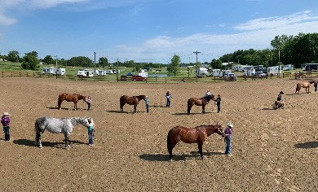

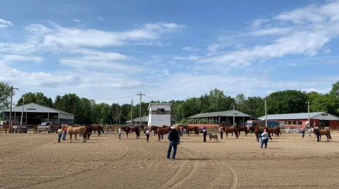

##### Superintendent’s Rules

1. Reserve and assign stalls for all livestock.
2. Be responsible for set-up and clean-up in your department.
3. Do not allow any animals into your building until you have checked it for any health problems, and you have all health papers required.
4. Try and resolve any disagreements within your department. If unresolved report incidents to the Fair board.
5. Work with the Fair board each year to review and make project changes.
6. Report to the Fair board at their request.
7. The superintendent is expected to check their building and make any needs known one week prior to the fair.
8. The superintendent must return the judging sheet and folder to the fair office.
9. Superintendent cannot create new classes without consulting the Fair board.
10. A back-up person must be available whenever the superintendent is not. This rule does not pertain to exhibit building superintendents.
11. Strictly enforce the rule: NO SMOKING ALLOWED IN THE BARNS OR DISPLAY AREA.
12. Assign chore duty and always keep the barn neat for the public.
13. Please remind your exhibitors of the times for the trophy pictures.
14. No drinking on the fairgrounds.
15. Superintendents are not allowed to give their opinions to the judges before or during the judging. You are only there to enter results into the judge’s books.

##### General Rules for Still Exhibit Entries

1. Print name, address, and phone number clearly on entry form.
2. All entry forms are due to the fair office by June 6th.
3. All exhibits are to be checked in on Wednesday June 21st from 4-6PM.
4. All exhibits will be released on Sunday June 25th after the Farmer’s Day Dinner.
5. All exhibits will be judged on Wednesday June 21st @ 6:30PM until finished.
6. Entries of the previous year are not acceptable.
7. Entry fees must be paid before you can enter the fair.
8. Exhibitors are to demonstrate good sportsmanship. The superintendent and/or Fair board reserves the right to refuse entry or request removal from the fair if anyone behaves in an unsportsmanlike manner. Premium money will be forfeited.
9. Youth exhibitors must put their age on tags and entries.
10. Premium checks will be mailed within 45 days of the closing of the fair.
11. Exhibits which have not been claimed by the close of fair release time will be considered abandoned and will be disposed of as management sees fit. Premiums will not be paid on unclaimed items.
12. **Ages will be determined as of January 1st of the current year.**

##### General Rules for Livestock Exhibitor Entries

Horses, Cattle, Goats, and Sheep will be required to pay a $2.00 per head stalling fee.

Chickens and Rabbits are required to pay a $1.00 cage fee.

1. Print name, address, and phone number clearly on entry form.
2. All entries are due to the fair office by June 6th.
3. All livestock will be checked in on Wednesday, June 21st from 4-8pm.
4. Livestock will be released Sunday, June 25th after the scramble sale. Scramble animals will be released no later than Monday, June 26th at 9AM.
5. All exhibits must belong to the exhibitor or his/her immediate family (immediate family is grandparent, parent, or sibling).
6. The exhibitor must be present during the judging to handle their own animal. If needed, see the department rules. Exception is if the exhibitor is exhibiting in another area of the fairground at the time of judging. An unexcused absence will result in the exhibit not being judged, and no premium given.
7. Exhibitors are to demonstrate good sportsmanship. The superintendent and/or Fair Board reserves the right to refuse entry or request removal from the fair if anyone behaves in an unsportsmanlike manner. Premium money will be forfeited.
8. The exhibitor is responsible for the proper care of his/her own animal. The exhibitor must furnish their own water and feed dishes and keep pens clean. Upon departure of the fair, the exhibitor must clean the stalls or premiums will be forfeited, this includes all livestock.
9. The fair does not provide bedding for your animals. If animals are not cared for you will forfeit your premiums.
10. Premiums will be awarded according to the judge’s sheet, not according to the ribbon on your exhibit. Youth can enter open classes of all livestock departments. Premium checks will be mailed within 45 days of the closing of the fair.
11. NO ALCOHOLIC BEVERAGES ARE ALLOWED ON THE FAIRGROUND.
12. G.A.S. will not be responsible for any properties or exhibit not called for by the release time. G.A.S. is not responsible for accidental losses.
13. **Ages determined as of January 1st of the current year**.
14. **Peewee showmen (under 6 years of age) must be prearranged with respective superintendents.**

General fair questions please contact Nelda Akers @ 517-719-8518 or Penny McCormick @ 989-284-7311

##### Gratiot Ag Society Entry Form

###### This form must be filled out for all participants

Today’s Date: Phone Number:

Exhibitor Name: Address: City: State: Zip:

Birthday (mm/dd/yyyy):

**Entries postmarked after June 6th are required to pay a $5.00 late fee per exhibitor**

**Make checks payable to Gratiot Agricultural Society**

**Mail entry forms to PO BOX 181 Ithaca, MI 48847**

**Haul-in fee for horses and cattle $10 per exhibitor

**Haul-in fee for goats, sheep, rabbits and poultry $5 per exhibitor

|  |  |  |  |  |
| --- | --- | --- | --- | --- |
| Animal Type | Number of Animal | Haul-In Fee  **No Fee If Stabled**  **For The Week** | Number of Stalls/Cages | Fee |
| Beef |  |  |  |  |
| Dairy |  |  |  |  |
| Horses |  |  |  |  |
| Goats |  |  |  |  |
| Sheep |  |  |  |  |
| Poultry |  |  |  |  |
| Rabbits |  |  |  |  |
|  |  | Total Haul-In: |  | Total $: |

|  |  |  |  |
| --- | --- | --- | --- |
| Total Stall Fee Horses Only | Total Haul-In Fee | Total Entry Fee | Grand Total |
| $: | $: | $: | $: |

**Exhibitor Name: Circle One: Haul-In Only or Stabled for the Week**

|  |  |  |  |  |  |
| --- | --- | --- | --- | --- | --- |
| Department | Division | Section | Class # | Class as printed in the fair book | Entry Fee |
|  |  |  |  |  |  |
|  |  |  |  |  |  |
|  |  |  |  |  |  |
|  |  |  |  |  |  |
|  |  |  |  |  |  |
|  |  |  |  |  |  |
|  |  |  |  |  |  |
|  |  |  |  |  |  |
|  |  |  |  |  |  |
|  |  |  |  |  |  |
|  |  |  |  |  |  |
|  |  |  |  |  |  |
|  |  |  |  |  |  |
|  |  |  |  |  |  |
|  |  |  |  |  |  |
|  |  |  |  |  |  |
|  |  |  |  |  |  |
|  |  |  |  |  |  |
|  |  |  |  |  |  |
|  |  |  |  |  |  |
|  |  |  |  |  |  |
|  |  |  |  |  |  |
|  |  |  |  |  |  |
|  |  |  |  |  |  |
|  |  |  |  |  |  |
|  |  |  |  |  |  |
|  |  |  |  |  |  |
|  |  |  |  |  |  |
|  |  |  |  |  |  |
|  |  |  |  |  |  |
|  |  |  |  |  |  |
|  |  |  |  |  |  |
|  |  |  |  |  |  |
|  |  |  |  | **Total Fee:** |  |

##### Kiddie Pedal Pull

Superintendent: Dick Davis (989) 620-1574 Date: Thursday, June 20th

Time: 7:00 PM

Place: Exhibit Building

Divisions: 4 and under, 5-7, 8-10, and 11-12

Competition is open to all children ages 2-12.

**NO ENTRY FEE** – sign up at the exhibit barn

Each participant will receive a coupon for a free ice cream cone First place in each class will receive $5.00 in cash prize money

##### Open Speed Show-Department 1E

Superintendent: Lacey Whitford 517-749-6426

Date: Friday, June 21st

Registration: 5:00 PM

Show Starts: 6:00 PM

Entry Fee: $5.00 per class, 8 and under $2.00 per class

Rules:

1. GAS is not responsible for accidents or losses
2. Horse need not be stabled at the fairgrounds
3. All entrants 18 and under are required to wear safety helmets
4. 4-H contest rules apply
5. Age of rider as of January 1st of the current year
6. Ages 8 and under will run clover leaf and down & back after the speed and action class. No premiums will be paid for these classes, they will receive a gift bag.

Divisions: Class Number:

A – Junior 9-12 1035 Pole Bending

B – Intermediate 13-15 1036 Speed and Action

C – Senior 16-19 1037 Indiana Flag Race

D – Open 20 & Over 1038 Clover Leaf

1039 Down and Back

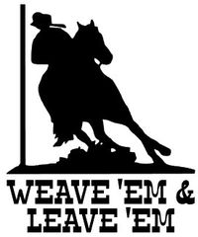

##### G.A.S. Pleasure Horse Show - Department 1C

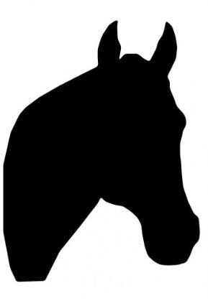Superintendent: Jody Munk

Check- In : June 19th from 4PM - 8PM

Judging: June 20th 5:30pm

Release Time: Sunday, June 25th, after sale

Entry Fee: $5.00 per class

Rules:

1. G.A.S. or Sponsors of G.A.S. are not responsible for accidents or losses.
2. Show will be judged by 4-H rules. Age as of January 1st of the current year.
3. Stalls will be kept clean or premiums will be forfeited.
4. Horses will be stalled under the direction of the superintendent.
5. No double riding or racing.
6. No one under age 18 may show a stallion.
7. All horses must have a current year negative Coggins test, printed and given to superintendent before unloading.
8. All stalls must be cleaned daily and stripped clean prior to the conclusion of the fair. Stalls must be inspected before release or premiums will be forfeited.
9. No horses may leave until release time or premiums will be forfeited.
10. Riders in Lead Line and Pee Wee Walk will not be eligible for any other age division highpoint.
11. Those entering walk trot classes may not compete in any other classes.
12. No horses will be allowed loose in the arena. Must be exercised by lunging or riding.
13. Show attire is optional.
14. Horses must be fed and always have water. Horses with no water will be watered by the superintendent and premiums will be forfeited.
15. Sick, lame, or malnourished horses will be sent home.
16. Refer to all general livestock rules.
17. Haul in fee of $10 for those showing out of their trailer and not staying for fair week.

**Horse Fun Show – Sunday 10am**

Join us for some fun in the horse arena!

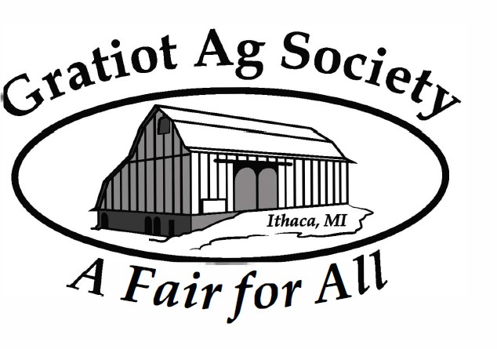



##### G.A.S. Pleasure Horse Show - Department 1C

Superintendent: Jody Monk 989-5291540

Check- In : June 19th from 4PM - 8PM

Judging: June 20th 10AM

Release Time: Sunday, June 23rd after sale

Entry Fee: $6.00 per class

Rules:

1. G.A.S. or Sponsors of G.A.S. are not responsible for accidents or losses.
2. Show will be judged by 4-H rules. Age as of January 1st, 2022.
3. Stalls will be kept clean or premiums will be forfeited.
4. Horses will be stalled under the direction of the superintendent.
5. No double riding or racing.
6. No one under age 18 may show a stallion.
7. All horses must have a 2022 negative Coggins test, printed and given to superintendent before unloading.
8. All stalls must be cleaned daily and stripped clean prior to the conclusion of the fair. Stalls must be inspected before release or premiums will be forfeited.
9. No horses may leave until release time or premiums will be forfeited.
10. Riders in Lead Line and Pee Wee Walk will not be eligible for any other age division highpoint.
11. Those entering walk trot classes may not compete in any other classes.
12. No horses will be allowed loose in the arena. Must be exercised by lunging or riding.
13. Show attire is optional.
14. Horses must be fed and always have water. Horses with no water will be watered by the superintendent and premiums will be forfeited.
15. Sick, lame, or malnourished horses will be sent home.
16. Refer to all general livestock rules.
17. Haul in fee of $10 for those showing out of their trailer and not staying for fair week.

##### Beef Show - Department 2

Superintendent: Stephanie Smith (989) 436-5699

Check-in: Wednesday June 19th, from 4-8 PM if stalling in barn. When hauling in, 1 hour before show.

n

Judging: Saturday, June 22nd @ 9:00AM

Release: Immediately following show

Entry Fee: $10 per head, $5 showmanship

Awards will be given to all exhibitors. Ribbons will be given for showmanship 1st-6th. **There will be no premiums.**

Rules:

1. Exhibitors must show their own animals unless special permission is granted.
2. All registered cattle must have registration, transfer papers, or application for respective breed.
3. Dual registered animals must declare a breed for the show.
4. Cattle must have RFID tags.
5. Cattle infected with communicable disease may not be brought to the fair.
6. Animals must be in control of exhibitor at all times.
7. All bulls over 6 months of age must have a nose ring.
8. Forced administration of fluids to create gut fill is not allowed.
9. Breeding stock classes will be based on date of birth. Market classes with be based on weight.
10. Refer to general livestock rules.
11. Show order: bulls, heifers, steers, showmanship
12. No Lactating Animals allowed on the grounds

Section 14 Breeding Stock

**Youth Div A Open Div B**

|  |  |  |
| --- | --- | --- |
| Maine Anjou | Section 1 | Section 8 |
| Simmentals | Section 2 | Section 9 |
| Chianina/Chiangus | Section 3 | Section 10 |
| Shorthorn | Section 4 | Section 11 |
| Angus | Section 5 | Section 12 |
| Hereford | Section 6 | Section 13 |
| All Other Breeds | Section 7 | Section 14 |

**Section 15 Group Classes (not breed specific)**

**Div A Div B**

1097 3074 Cow and Calf (exhibitor bred & owned) 1098 3075 Pair of Females, any age (bred & owned) 1099 3076 Pair of Calves, 1 Bull & 1 Heifer, owned

Bull – classes 1088,1089,3065,3066 Heifers – classes 1090,1091,3067,3068

1100 3077 Pair of Yearlings, 1 Bull, 1 Heifer, owned Bulls – classes 1085-1087,3062-3064 Heifers – classes 1092-1094,3069-3071

1101 3078 Get of Sire, 3 animals, any age, both sexes represented, 1 farm ownership

|  |  |  |
| --- | --- | --- |
| **Div A** | **Div B** | **Bulls** |
| 1085 | 3062 | Bull, Sr Yrlg, Sep1-Dec31, 2 Yr Prior |
| 1086 | 3063 | Bull, Jr Yrlg, Jan1-Apr30 Prev Yr |
| 1087 | 3064 | Bull Summer Yrlg, May1-Aug31 Prev Yr |
| 1088 | 3065 | Sr Bull Calf, Sep1-Dec31 Prev Yr |
| 1089 | 3066 | Jr Bull Calf Calved after Jan1 Current Yr |
| **Div A** | **Div B** | **Females** |
| 1090 | 3067 | Jr Heifer Calf after Jan1 of Current Yr |
| 1091 | 3068 | Sr Heifer Calf Sep1-Dec31 Prev Yr |
| 1092 | 3069 | Heifer SummerYrlg May1-Aug31Prev Yr |
| 1093 | 3070 | Heifer Yrlg, Jan1-Apr30 Prev Yr |
| 1094 | 3071 | Heifer Sr Yrlg, Sep1-Dec31, 2Yr Prior |
| 1095 | 3072 | Heifer Calved Jan1-Aug31, 2Yr Prior |
| 1096 | 3073 | Cow, Calved before Jan1, 2Yr Prior |

1102 3079 Pair of Bulls, any age, bred & owned 1103 3080 Best 6 Head, 1 Farm Ownership

**Section 16 Market Steers & Heifers**

1104 Light Weight

1105 Medium Weight

1106 Heavy Weight

**Section 17 Showmanship - All Breeds**

3081 Open Showmanship 21 & over

|  |  |
| --- | --- |
| 1107 | Senior Showmanship 17-21 |
| 1108 | Intermediate Showmanship 13-16 |
| 1109 | Junior Showmanship 9-12 |
| 1110 | Beginner Showmanship 8 and under |

##### Dairy Cattle Show - Department 3

Superintendent: Dick Davis (989-620-1574)

Check-in: Wednesday June 19th 4-8 PM

Haul-in Time: When hauling in, register 1 hour before show.

Judging: Saturday, June 22nd 1PM

Release: Sunday, June 25th, after Scramble Sale

Entry Fee: $10 per class

Ribbons will be given to 1st-6th place in each age section. No premiums for showmanship. See Premiums page for pay scale.

**Rules:** 1. Limited to two head per exhibitor per class.

* 1. Refer to general livestock rules.
  2. NO LACTATING ANIMALS ALLOWED ON THE GROUNDS

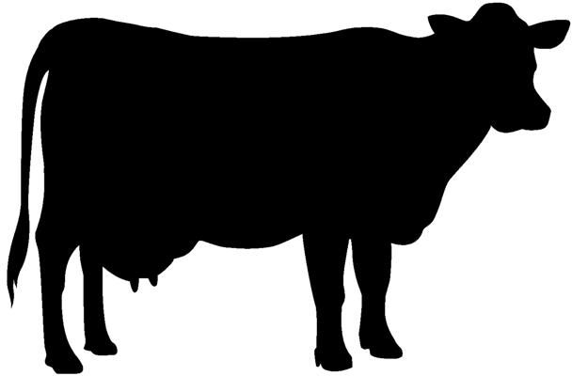**All sections in this division have the same classes and premiums Youth Div. A (6-18) Open Div. B (19 and over)**

Ayrshire Section 1 Section 7

Brown Swiss Section 2 Section 8

Guernsey Section 3 Section 9

Holstein Section 4 Section 10

Jersey Section 5 Section 11

Milking Shorthorns Section 6 Section 12

|  |  |  |
| --- | --- | --- |
| **Junior Animals** | | |
| **Div A** | **Div B** |  |
| 1128 | 3106 | Dairy Junior Feeder, after Dec 31, 2021 |
| 1129 | 3107 | Dairy Senior Feeder, after Jun 30, 2021 |
| 1130 | 3108 | Spring Heifer Calf born after February 28, 2022 |
| 1131 | 3109 | Winter Heifer Calf born after November 30, 2021 and before March 1, 2022 |
| 1132 | 3110 | Fall Heifer Calf born after August 31, 2021 and before December 1, 2021 |
| 1133 | 3111 | Summer Yearling Heifer born after May 31, 2021 and before September 1, 2021 |
| 1134 | 3112 | Spring Yearling Heifer born after March 1, 2020 and before March 1, 2021 |
| 1135 | 3113 | Winter Yearling Heifer born after December 1, 2020 and before March 1, 2021 |
| 1136 | 3114 | Fall Yearling Heifer born after August 31, 2020 and before December 1, 2020 |
| **Senior Animals** | | |
| **Div A** | **Div B** |  |
| 1137 | 3115 | Two Year Old Milking Cow, born after September 1, 2019 and before August 31, 2020 |
| 1138 | 3116 | Three Year Old Milking Cow, born after September 1, 2018 and before August 31, 2019 |
| 1139 | 3117 | Four Year Old Milking cow, born after September 1, 2017 and before August 31, 2018 |
| 1140 | 3118 | Aged Cow, born before August 31, 2018 |
| 1141 | 3119 | Dry Cow, must not be in milk and have had at least one calf |
| **Group Classes** | | |
| **Div A** | **Div B** |  |
| 1142 | 3120 | Pair of Females, 2 females bred & owned by exhibitor |
| 1143 | 3121 | Dam and Daughter, Cow and one of her daughters |
| 1144 | 3122 | Three Females, Three females exhibited by the same farm |
| 1145 | 3123 | Dairy Herd, Any 5 dairy animals owned by one farm |

**Section 13 Showmanship, all breeds Div A**

1148 Senior Showmanship (Age 14-18)

1149 Junior Showmanship (Age 9-13)

1150 Beginner Showmanship (Age 6-8)

##### Goat Show – Department 4

Superintendent:

Check-in: Wednesday, June 19th, from 4-8 PM

Haul-in Time: When hauling in, register 1 hour before show.

Judging: Thursday, June 20th, @ 2PM

Release: Sunday, June 23rd, after Scramble Sale

Entry Fee: $5.00 per class, $5 for showmanship, no fee for Fun Class

**Small Animal Auction:** Sunday June 23rd @ 3PM

Ribbons will be given to 1st-6th place. There will be no premiums for the Fun Class or Showmanship. See Premiums page for pay scale. Only youth may sell in the Auction. Only those animals stabled may sell. Limited one entry per exhibitor. Goats will be sold as a single lot. Sign up for sale at check-in.

**Rules:**

1. Animals showing signs of illness, abscesses, injury, or infestation will not be allowed.
2. Goats must have been treated for lice and fleas 2 weeks prior to Fair.
3. All goats must be inspected by the superintendent or other Fair officials before being penned.
4. Goats may be shown with or without horns. Dehorned goats must be completely healed. Small scurs 1/2½ inch in size are allowed.
5. Hooves must be trimmed, and body clipping must be done before the Fair. No clipping or trimming is allowed at the Fair other than touch ups.
6. Superintendents reserve the right to change or combine classes.
7. All milking goats will be milked before 8 AM the day of show.
8. Pens must be cleaned as necessary. Animals must always have water available. Goats not receiving adequate daily care may be sent home and premiums forfeited.
9. Bucks may be brought in for judging the day of the show and taken home the same day. Young bucks (under 4 months) are allowed to stay with their mothers.
10. Exhibitors must show in showmanship to be eligible to sell in the auction.
11. Specify on entry blank the number of goats entered and the number of pens needed.
12. Goats must have a scrapie tag. Tattooed goats must have registration on grounds.
13. Refer to general livestock rules.

**Div. A Youth (6-18) Div. B Open (19 and over)**

**Dairy Goats**

Alpine Section 1 Section 12

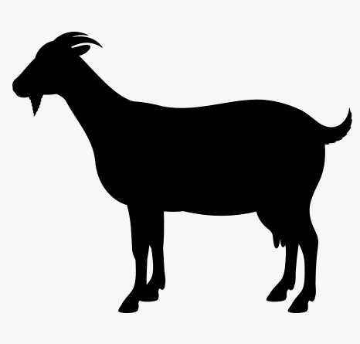LaMancha Section 2 Section 13

Nubian Section 3 Section 14

Saanen Section 5 Section 16

Toggenburg Section 6 Section 17

Nigerian Dwarf Section 26 Section 27

Mixed Breed Dairy Section 8 Section 19

|  |  |  |
| --- | --- | --- |
| **Div A** | **Div B** | **Description** |
| 1154 | 3132 | Junior Doe Kid, Born after Apr1 of Current Year |
| 1155 | 3133 | Junior Buck Kid, Born after Apr1 of Current Year |
| 1156 | 3134 | Senior Doe Kid, Born between Jan1-Mar31 of This Yr |
| 1157 | 3135 | Senior Buck Kid, Born between Jan1-Mar31 of This Yr |
| 1158 | 3136 | Dry Yearling Doe, Born between Jan1-Dec31 of Last Yr |
| 1159 | 3137 | Yearling Buck, Born between Jan1-Dec31 of Last Yr |
| 1160 | 3138 | Jr Milker, Fresh Under 3 Years |
| 1161 | 3139 | Sr Milker, Fresh Over 3 Years |
| 1162 | 3140 | Dry Doe, Not Fresh 2 Years & Over |
| 1163 | 3141 | Best Udder |
| 1164 | 3142 | Dam and Daughter |

* Grand and Reserve Champion classes- 1154-1162 **21**

**Meat/Mixed Breed Goat Div. A Youth Div.B Open**

Pygmy Section 9 Section 20

Boer Section 10 Section 21

Kiko Section 11 Section 22 Mixed Breed Meat GoatSection 12 Section 23 Angora Section 13 Section 24

**Div A Div B Description**

1165 3143 Junior Doe Kid, Born after Apr1 of Current Year 1166 3144 Junior Buck Kid, Born after Apr1 of Current Year

1167 3145 Senior Doe Kid, Born between Jan1-Mar31 of Current Year 1168 3146 Senior Buck Kid, Born between Jan1-Mar31 of Current Year 1169 3147 Yearling Doe, Born between Jan1-Dec31 of Last Year

1170 3148 Yearling Buck, Born between Jan1-Dec31 of Last Year 1171 3149 Adult Doe, 2 Years & Older

* Grand and Reserve Champion classes- 1165-1171

**Market Goats Section 14**

* Wethers & Does only
* Does shown in market class cannot be shown in a breed class

**Div A Div B Description**

1172 3150 Market Goat, Born after Jan1 of Current Year

**Non-Market Wethers Section 15**

* Any Breed eligible

**Div A Div B Description**

1173 3151 Pet Wether

1174 3152 Working Wether

**Showmanship Section 16 Div A Div B Description**

1175 Ages 8 & Under

1176 Ages 9-13

1177 Ages 14-18

3156 Ages 19 & Over

|  |  |  |
| --- | --- | --- |
| **Fun Class**  **Div A Div B** | **Description** | **Section 17** |
| 1178 | Youth Costume |  |
| 1179 | Trail ages 8 & Under |  |
| 1180 | Trail ages 9-13 |  |
| 1181 | Trail ages 14-18 |  |
| 3157 | Trail ages 19 & Over |  |

##### Sheep Show – Department 5

Superintendent:

Check-in: Wednesday June 19th, from 4-8 PM

Haul-in Time: When hauling in, register 1 hour before show. Judging: Thursday, June 20th, following sheep 3PM

Release: Sunday, June 25th, after Scramble Sale

Entry Fee: $5.00 per class, $5 for showmanship, no fee for costume class

Ribbons will be given to 1st-6th place. There will be no premiums given for the Costume Class or Showmanship. See Premiums page for pay scale.

**Rules:**

1. Animals showing signs of illness, abscesses, injury, or infestation will not be allowed.
2. All sheep must be inspected by the superintendent or other Fair official before being penned.
3. Hooves must be trimmed, and body clipping must be done before the Fair. No clipping or trimming is allowed at the Fair other than touchups.
4. Superintendents reserve the right to change or combine classes.
5. Pens must be cleaned as necessary. Animals must always have water available. Sheep not receiving adequate daily care may be sent home.
6. Specify on entry blank the number of sheep entered and the number of pens needed.
7. All sheep must be tagged with the appropriate scrapie tag or will not be allowed on premises.
8. Refer to general livestock rules.

**Div. A Youth Div. B Open (6-18) (19 & over)**

Columbia Section 1 Section 11

Border Cheviot Section 2 Section 12

Suffolk Section 3 Section 13

Shetland Section 4 Section 14 All Other Meat Breeds Section 5 Section 15 All Other Wool Breeds Section 6 Section 16 Commercial/Crossbred Section 7 Section 17

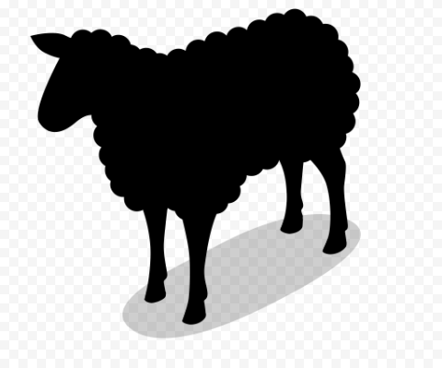**Div A Div B Description**

**Costume Class Section 24**

**Div A Div B Description**

1216 Ages 8 & under

1217 Ages 9-13

1218 Ages 14-18

3190 Ages 19 & over

**Showmanship Section 32**

|  |  |  |  |  |
| --- | --- | --- | --- | --- |
| 1201 | 3177 | Yearling Ram, 1 Yr and under 2 Yr | **Div A Div B** | **Description** |
| 1203 | 3178 | Ram Lamb, after Jan1 of Current Yr | 1213 | Ages 8 & under |
| 1205 | 3181 | Yearling Ewe, 1 Yr and under 2 Yr | 1214 | Ages 9-13 |
| 1208 | 3184 | Ewe Lamb, after Jan1 of Curent Yr | 1215 | Ages 14-18 |
| 1212 | 3188 | Market Lamb | 3191 | Ages 19 & over |

***2024 G.A.S. SCRAMBLE SHOW RULES***

SUPERINTENDENT: SCRAMBLE COMMITTEE (JARED WHITFORD 989-666-2666)

**JUDGING: FRIDAY, JUNE 21, 2024 AT 10 A.M.**

**SALE DAY: SUNDAY, JUNE 23, 2024 AT 5 P.M.**

**RELEASE TIME: SUNDAY, JUNE 23, 2024 AT 9 P.M.**

**BUYERS PICTURES** WILL BE TAKEN WHEN THE SCRAMBLE ANIMALS ARE CHECKED

**IN,** **ON THURSDAY, JUNE 20, 2024, BETWEEN THE HOURS OF 4 P.M. AND 8 P.M.**

**PLEASE DRESS ACCORDINGLY & USE THE DRIVEWAY ON THE SOUTH OF THE BARN!!**

***MICHIGAN DEPARTMENT OF AGRICULTURAL***

***Starting March 1, 2007, all cattle must be identified with RFID electronic***

***ear tags prior to movement from a premises.***

**SHOWMANSHIP CLASSES- ALL SCRAMBLE ANIMALS WILL HAVE SHOWMANSHIP**

**PRECEDING THEIR RESPECTIVE CLASSES.**

**FEEDER CALVES PIGS**

**JUNIOR JUNIOR**

**INTERMEDIATE**

**SENIOR SENIOR**

**SCRAMBLE FEEDER CALF SHOW**

**CLASSES: LIGHT WEIGHT HEAVY WEIGHT**

**SCRAMBLE FEEDER CALF SHOW - FOLLOWING THE PIG SHOW**

**RULES:**

**1**. FEEDER STEERS THAT WERE CAUGHT IN THE SCRAMBLE MUST BE RETURNED, SHOWN AND SOLD.

**2**. FEEDER STEERS MUST BE ON THE FAIRGROUNDS THURSDAY, JUNE 22, 2023 – **ENTRY TIME: 4 P.M.**

**TILL 8 P.M.**, AND REMAIN ON EXHIBIT UNTIL SUNDAY, JUNE 25, 2023 – **RELEASE TIME 9 P.M.**

**SCRAMBLE PIG SHOW – FIRST TO SHOW 10 AM**

**CLASSES: LIGHT WEIGHT MEDIUM WEIGHT HEAVY WEIGHT**

**RULES:**

**1**. PIGS THAT WERE CAUGHT IN THE SCRAMBLE MUST BE RETURNED, SHOWN AND SOLD.

**2**. PIGS MUST BE ON THE FAIRGROUNDS THURSDAY, JUNE 20, 2024 – **ENTRY TIME: 4 P.M.**

**TILL 8 P.M.**, AND REMAIN ON EXHIBIT UNTIL SUNDAY, JUNE 23, 2024 – **RELEASE TIME 9 P.M.**

------------------------------------------------------------------------------------------------------------------------------------------------

***DICK BRAMAN SPORTSMANSHIP TROPHY***

***WILL BE AWARDED TO THE SCRAMBLE EXHIBITOR THAT SHOWS THE MOST SPORTSMANSHIP AND WILLINGNESS TO HELP OTHER EXHIBITORS WITH***

***THEIR ANIMALS AND KEEPING THE BARN CLEAN.***

------------------------------------------------------------------------------------------------------------- ***SCOTT ACKER OVERALL SHOWMANSHIP TROPHY***

***WILL BE AWARDED TO THE SCRAMBLE EXHIBITOR THAT SHOWS THE MOST SKILLS WITH THEIR ANIMAL IN SHOWMANSHIP AND KNOWLEDGE OF THEIR PROJECT AREA.***

-------------------------------------------------------------------------------------------------------------

***2023 SCRAMBLE SALE RESULTS***

**GRAND CHAMPION PIG**

**SELLER’S NAME:**  RUTH AUBIN

**BUYER:** FARM BUREAU INSURANCE - ALLEN AGENCY $4.25 PER LB.

**RESERVE GRAND CHAMPION PIG**

**SELLER’S NAME:** VIVIAN ROSE $3.50 PER LB.

**BUYER:** MAC MIDDLETON

**BEST RATE OF GAIN PIG**

**SELLER’S NAME:** ALLIE MONK

**BUYER:**  EARTHWORKS $3.50 PER LB.

**SPARKS PICKLE COMPANY PLACED A MINIMUM BID OF $4.00 LB. ON ALL PIGS.**

**FITZ & SON FARMS AND CLINTON VET. DONATED PIGS BACK TO THE FAIR TO**

**RE-SELL.**



**GRAND CHAMPION FEEDER CALF & BEST RATE OF GAIN FEEDER**

**SELLER’S NAME:** MORIAH SLAVIK

**BUYER:**  APPLEBEE OIL & PROPANE $4.25 PER LB.

**RESERVE GRAND CHAMPION**

**SELLER’S NAME:** SARAH MUNGER

**BUYER:** FITZPATRICK FARMS $2.50 PER LB.

**BEST RATE OF GAIN**

**SELLER’S NAME:** MACIE AKERS

**BUYER:** SLAVIK FARMS / UMBARGER SHOW FEED $2.75 PER LB.



**2023 G.A.S. SCRAMBLE SALE BUYERS & SPONSORS**

**SPARKS PICKLE, APPLEBEE OIL & PROPANE, HUB’S D & J TIRE SERVICE, FARM BUREAU INSURANCE-ALLEN AGENCY, EARTHWORKS, COMMERCIAL BANK, BELLINGAR PACKING, MAPLE RAPIDS LUMBER, GREGG’S TRUCKING LLC, MAC MIDDLETON, MISENHELDER WELDING, DOWNTOWN AUTO, MOBILE SEED SERVICE, POHL CUSTOM COUNTERTOP & CABINETRY, CLINTON VET, ALMA TIRE, JOHN MONROE, ADAM’S PLUMBING & HEATING, JOHN DENSMORE, KALMBACH FEEDS, AKERS WASTE REMOVAL, RANDY & COLLEEN WHITFORD, ITHACA RESCUE SQUAD, WHITMORE OPERATIONS INC., SLAVIK SHOW CATTLE, FITZ & SON FARMS, HARVEYS MILLING COMPANY, FITZPATRICK FARMS INC., TRIPLE G FARMS, ANDERSON & GIRLS ORCHARD, MAUREEN DEMPSEY, C & C PROPANE, JOE GROMBIR MILK HAULING, BARDEN FUNERAL HOME, CHAFFIN FAMILY FARMS, HARVEY’S MILLING, RANDY& CHERYL REEVES, FITZPATRICK RANCH, MILLS EXCAVATING, OVID ELEVATOR, SLAVIK FARMS / UMBARGER SHOW FEED, PRICE’S PRECISION EXCAVATING, LARRY COON, WAGON WHEEL RESTAURANT, PENNY MCCORMICK, TRIDENT MANUFACTURING, E & S GRAPHICS, INC. ELLEN’S EQUIPMENT, THOMPSON SEILER & KOLB, PLLC, BURFORD PLUMBING & HEATING, ZFS ITHACA, LLC, ABC FIRE EXTINGUISHER SALES & SERVICE, HEARTHSTONE OVEN & SPARTAN INSURANCE AGENCY, LLC.**

##### Poultry – Department 6

Superintendent: Densmore (989)302-0195 Pat Church (989-388-7968)

Check-in: Wednesday June 19th, from 4-8 PM

Haul-in Time: When hauling in, register 1 hour before show. Judging: Friday, June 21st, @ 8:30 AM

Release: Sunday, June 23rd, after Scramble Sale Entry Fee: $3.00 per class, no fee for showmanship

**Small Animal Auction: Sunday June 25th, @ 3 PM**

Ribbons will be given to 1st-6th place. There will be no premiums given for showmanship. See Premiums page for pay scale. Only youth may sell animals in the auction. Only items exhibited in Section 1 and stabled

for the week will be allowed to sell in the auction. Youth selling exhibits in the auction are encouraged to invite businesses, friends, and family to the auction.

**Rules:**

1. Birds should be Pullorum tested before the fair. Testing will be available at the fairgrounds during check-in for birds being exhibited in the fair only. The cost will be $0.50 per bird for youth and $1.00 per bird for open exhibitors. Refer to the general livestock rules for the current requirements.
2. All exhibits must be free of infectious diseases. Any birds showing signs of illness will be removed.
3. Birds may not be caged until checked in by the superintendent or other Fair official before being penned.
4. Birds should be 4 ½ months old except for in meat classes.
5. All birds must remain on display for the duration of the fair. Removing birds early will result in the loss of premiums unless prior permission was given.
6. The Superintendent reserved the right to limit or turn away entries, if required due to space limitations and caging. Pre-enter as soon as possible.
7. Youth may enter both youth and open classes however the same bird may not compete in both divisions.
8. All classes will be judged using the APA Standard of Perfection as a guide and reference.
9. Only the owners and show staff are allowed to handle the birds, anyone caught handling someone else’s birds without permission will be asked to remove their birds from the poultry barn and will forfeit premiums.
10. G.A.S. is not responsible for any damages or losses, every precaution will be taken to prevent problems.
11. Judges and superintendent decisions are final.
12. Any problems that are not covered by the above rules will be dealt with by the superintendent or the fair board on an individual basis.
13. **Class changes due to mis-entry will be limited to Youth only.**
14. Refer to general livestock rules.

**Age Definitions:**

Cock Male Over 1 Year

Cockerel Male Under 1 Year

Old Drake Male Duck Over 1 Year

Young Drake Male Duck Under 1 Year

Old Gander Male Goose Over 1 Year

Young Gander Male Goose Under 1 Year

Hen. Female Over 1 Year

Pullet Female Under 1 Year

Old Duck Female Duck Over 1 Year

Young Duck Female Duck Under 1 Year

Old Goose Female Goose Over 1 Year

Young Goose Female Goose Under 1 Year

**Youth Production Section 1**

**Div A Description**

1000 Egg Pullets – 3 Females, 10 wks or older 1001 Chicken Fryers – 3 of one sex, 2 ½ - 5lbs 1002 Chicken Roasters – 3 of one sex, Over 5 lbs

1003 Duck Meat Pen – 3 of one sex, 4lbs minimum per bird 1004 Turkey – Single Bird 15lb5/31/2024

Due to avian influenza there will be no poultry and eggs at the 2024

G.A.S. Fair. Participants must submit a photo or a drawing of there bird on

Wednesday June 19, 4-8 pm during small animal check in. Decorating a cage is

also welcomed. Showmanship will be held on Friday June 1, 8:30 am with a

stuffed animal chicken. One will be provided or participants are welcome to

bring there own. You must participate in the showmanship to sell on Sunday

June 23, 3 pm at the small animal sale. Participants will use there photo or

drawing to sell. Once you sell you must make arrangements with your buyer to

deliver the product to them at a later time. It is very important to recruit buyers

by handing out letters. There will not be judging of large fowl, small fowl,

commercial layer, commercial meat, duck fowl, turkey fowl, and eggs. We are

sorry for any inconvenience that this has caused, but we encourage all

participants to sign up and be ran as normal without poultry and eggs.

**Youth Large Fowl Section 2**

|  |  |  |  |  |  |  |  |
| --- | --- | --- | --- | --- | --- | --- | --- |
| **American** |  |  | **Cock** | **Hen** |  | **Cockerel** | **Pullet** |
| Plymouth Rocks – Any Variety | **Div A** |  | 1005 | 1006 |  | 1007 | 1008 |
| Wyandotte – Any Variety | **Div A** |  | 1009 | 1010 |  | 1011 | 1012 |
| Rhode Island Reds – Any Variety | **Div A** |  | 1013 | 1014 |  | 1015 | 1016 |
| Americans – Any Other Am. Breed | **Div A** |  | 1017 | 1018 |  | 1019 | 1020 |
| **Asiatic** |  |  |  |  |  |  |  |
| **Brahmas – Any Variety** | **Div A** |  | 1021 | 1022 |  | 1023 | 1024 |
| Cochins – Any Variety | **Div A** |  | 1025 | 1026 |  | 1027 | 1028 |
| Langshan – Any Variety **Div A** |  | 1029 | 1030 |  | 1031 | 1032 |  |
| **English** |  |  |  |  |  |  |  |
| Australorp **Div A** 1033 | | | 1034 | | 1035 | | 1036 |
| Orpington – Any Variety **Div A** 1037 | | | 1038 | | 1039 | | 1040 |
| **English – Any other English BreedDiv A** 1041 | | | 1042 | | 1043 | | 1044 |
| **Mediterranean** |  | |  |  | |  | |
| Leghorns – Any Variety | **Div A** 1045 | | 1046 | 1047 | | 1048 | |
| Andalusian – Any Variety | **Div A** |  | 1049 | 1050 |  | 1051 | 1052 |
| Mediterranean – Any Other Med. Breed | **Div A** |  | 1053 | 1054 |  | 1055 | 1056 |
| **Continental** |  |  |  |  |  |  |  |
| Hamburg – Any Variety | **Div A** |  | 1057 | 1058 |  | 1059 | 1060 |
| Polish – Any Variety | **Div A** |  | 1061 | 1062 |  | 1063 | 1064 |
| Continental – Any other Cont. Breed | **Div A** |  | 1065 | 1066 |  | 1067 | 1068 |
| **Any Other Standard Breed** |  |  |  |  |  |  |  |
| Phoenix – Any Variety | **Div A** |  | 1069 | 1070 |  | 1071 | 1072 |
| Ameraucana – Any Variety | **Div A** |  | 1073 | 1074 |  | 1075 | 1076 |
| AOSB – Any Other Standard Breed | **Div A** |  | 1077 | 1078 |  | 1079 | 1080 |
| **Youth Bantams Section 3** |  |  |  |  |  |  |  |
| **Modern Games** |  |  | **Cock** | **Hen** |  | **Cockerel** | **Pullet** |
| Modern Games – Any Variety | **Div A** |  | 1081 | 1082 |  | 1083 | 1084 |
| **Old English Games** |  |  |  |  |  |  |  |
| Black Breasted Red | **Div A** |  | 1085 | 1086 |  | 1087 | 1088 |
| Silver Duckwing | **Div A** |  | 1089 | 1090 |  | 1091 | 1092 |
| Spangled | **Div A** |  | 1093 | 1094 |  | 1095 | 1096 |
| Wheaton | **Div A** |  | 1097 | 1098 |  | 1099 | 1100 |
| Red Pyle | **Div A** |  | 1101 | 1102 |  | 1103 | 1104 |
| AOV | **Div A** |  | 1105 | 1106 |  | 1107 | 1108 |
| **Single Comb Clean Legged** |  |  |  |  |  |  |  |
| Leghorns – Any Variety **Div A** |  | 1109 | 1110 |  | 1112 | 1113 |  |
| New Hampshire | **Div A** |  | 1114 | 1115 |  | 1116 | 1117 |
| Plymouth Rocks – Any Variety | **Div A** |  | 1118 | 1119 |  | 1120 | 1121 |
| Rhode Island Reds | **Div A** |  | 1122 | 1123 |  | 1124 | 1125 |
| Any Other Single Comb Clean Legged | **Div A** |  | 1126 | 1127 |  | 1128 | 1129 |

|  |  |  |  |  |  |
| --- | --- | --- | --- | --- | --- |
| **Rose Comb Clean Legged** | **Cock** | **Hen** |  | **Cockerel** | **Pullet** |
| Hamburg – Any Variety **Div A** | 1130 | 1131 |  | 1132 | 1133 |
| Rose Combs – Any Variety **Div A** | 1134 | 1135 |  | 1136 | 1137 |
| Sebright – Any Variety **Div A** | 1138 | 1139 |  | 1140 | 1141 |
| Wyandotte – Any Variety **Div A** | 1142 | 1143 |  | 1144 | 1145 |
| Any Other Rose Comb Clean Legged **Div A** | 1146 | 1147 |  | 1148 | 1149 |
| **Feathered Legged** |  |  |  |  |  |
| Brahmas – Any Variety **Div A** | 1150 | 1151 |  | 1152 | 1153 |
| Cochins – Black **Div A** 1154 | 1155 |  | 1156 | 1157 |  |
| Cochins – Blue **Div A** | 1158 | 1159 |  | 1160 | 1161 |
| Cochins – Barred **Div A** | 1162 | 1163 |  | 1164 | 1165 |
| Cochins – AOV **Div A** | 1166 | 1167 |  | 1168 | 1169 |
| Silkie – Any Variety **Div A** | 1170 | 1171 |  | 1172 | 1173 |
| Any Other Feathered Legged Breed **Div A** | 1174 | 1175 |  | 1176 | 1177 |
| **Any Other Comb Clean Legged** |  |  |  |  |  |
| Ameraucana – Any Variety **Div A** | 1178 | 1179 |  | 1180 | 1181 |
| Polish – Any Variety **Div A** | 1182 | 1183 |  | 1184 | 1185 |
| Any Other Comb Clean Legged Breed **Div A** | 1186 | 1187 |  | 1188 | 1189 |

**Youth Ducks Section 4 Old Drake Old Duck Yg. Drake Yg. Duck**

|  |  |  |  |  |  |  |  |  |  |  |
| --- | --- | --- | --- | --- | --- | --- | --- | --- | --- | --- |
| Heavy Duck – Any Breed |  | **Div A** |  | 1190 |  | 1191 |  | 1192 |  | 1193 |
| Medium Duck – Any Breed |  | **Div A** |  | 1194 |  | 1195 |  | 1196 |  | 1197 |
| Light Duck – Any Breed | **Div A** |  | 1198 |  | 1199 |  | 1200 |  | 1201 |  |
| Bantam Duck – Any Breed |  | **Div A** |  | 1202 |  | 1203 |  | 1204 |  | 1205 |

**Youth Geese Section 5 Old Gander Old Goose Yg.Gander Yg.Goose**

|  |  |  |  |  |  |
| --- | --- | --- | --- | --- | --- |
| Heavy Geese – Any Breed | **Div A** | 1206 | 1207 | 1208 | 1209 |
| Medium Geese - Any Breed | **Div A** | 1210 | 1211 | 1212 | 1213 |
| Light Geese – Any Breed | **Div A** | 1214 | 1215 | 1216 | 1217 |
| **Youth Turkeys Section 6** |  | **Old Tom** | **Old Hen** | **Yg. Tom** | **Yg. Hen** |
| Turkeys – Any Breed | **Div A** | 1218 | 1219 | 1220 | 1221 |
| **Youth Guineas Section 7** |  | **Old Cock** | **Old Hen** | **Yg. Cock** | **Yg. Hen** |
| Guineas – Any Variety | **Div A** | 1222 | 1223 | 1224 | 1225 |
| **Youth Wild Fowl Section 8** |  | **Old Cock** | **Old Hen** | **Yg. Cock** | **Yg. Hen** |
| Wild Fowl – Any Type | **Div A** | 1226 | 1227 | 1228 | 1229 |
| **Youth Eggs Section 9** |  |  |  |  |  |
| White Eggs **Div A** | 1230 |  | **Showmanship** |  | **Section 10** |
| Brown Eggs **Div A** | 1231 |  |  |  |  |
| Colored Eggs **Div A** | 1232 |  | Ages 8 & under | **Div A** | 1235 |
| Waterfowl Eggs**Div A** 1233 |  |  | Ages 9-13 | **Div A** | 1236 |
| Wild Fowl Eggs **Div A** 1234 |  |  | Ages 14-18 | **Div A** | 1237 |

**Open Large Fowl Section 11**

|  |  |  |  |  |  |
| --- | --- | --- | --- | --- | --- |
| **American** |  | **Cock** | **Hen** | **Cockerel** | **Pullet** |
| Jersey Giants – Any Variety | **Div B** | 3001 | 3002 | 3003 | 3004 |
| Rhode Island – Any Variety | **Div B** | 3005 | 3006 | 3007 | 3008 |
| Plymouth Rocks – Any Variety | **Div B** | 3009 | 3010 | 3011 | 3012 |
| Wyandotte – Any Variety | **Div B** | 3013 | 3014 | 3015 | 3016 |
| Dominique | **Div B** | 3017 | 3018 | 3019 | 3020 |
| New Hampshire | **Div B** | 3021 | 3022 | 3023 | 3024 |
| Any Other American Breed | **Div B** | 3025 | 3026 | 3027 | 3028 |
| **Asiatic**  Brahma – Any Variety | **Div B** | 3029 | 3030 | 3031 | 3032 |
| Cochin – Any Variety | **Div B** | 3033 | 3034 | 3035 | 3036 |
| Langshan – Any Variety | **Div B** | 3037 | 3038 | 3039 | 3040 |
| **English**  Black Australorp | **Div B** | 3041 | 3042 | 3043 | 3044 |
| Cornish – Any Variety | **Div B** | 3045 | 3046 | 3047 | 3048 |
| Dorking – Any Variety | **Div B** | 3049 | 3050 | 3051 | 3052 |
| Orpington – Any Variety | **Div B** | 3053 | 3054 | 3055 | 3056 |
| Sussex – Any Variety | **Div B** | 3057 | 3058 | 3059 | 3060 |
| Any Other English Breed | **Div B** | 3061 | 3062 | 3063 | 3064 |
| **Mediterranean**  Ancona – Any Variety | **Div B** | 3065 | 3066 | 3067 | 3068 |
| Blue Andalusian | **Div B** | 3069 | 3070 | 3071 | 3072 |
| Butter Cup | **Div B** | 3073 | 3074 | 3075 | 3076 |
| Leghorn – Any Variety | **Div B** | 3077 | 3078 | 3079 | 3080 |
| Minorca – Any Variety | **Div B** | 3081 | 3082 | 3083 | 3084 |
| White Faced Black Spanish | **Div B** | 3085 | 3086 | 3087 | 3088 |
| Any Other Mediterranean Breed | **Div B** | 3089 | 3090 | 3091 | 3092 |
| **Continental**  Hamburg – Any Variety | **Div B** | 3093 | 3094 | 3095 | 3096 |
| Campines – Any Variety | **Div B** | 3097 | 3098 | 3099 | 3100 |
| Welsummer | **Div B** | 3101 | 3102 | 3103 | 3104 |
| Polish – Any Variety | **Div B** | 3105 | 3106 | 3107 | 3108 |
| Houdan – Any Variety | **Div B** | 3109 | 3110 | 3111 | 3112 |
| Faverolles – Any Variety | **Div B** | 3113 | 3114 | 3115 | 3116 |
| Any Other Continental Breed | **Div B** | 3117 | 3118 | 3119 | 3120 |
| **All Other Standard Breeds**  Modern Game – Any Variety | **Div B** | 3121 | 3122 | 3123 | 3124 |
| Old English Game – Any Variety | **Div B** | 3125 | 3126 | 3127 | 3128 |
| Sumatra – Any Variety | **Div B** | 3129 | 3130 | 3131 | 3132 |
| Phoenix – Any Variety | **Div B** | 3133 | 3134 | 3135 | 3136 |
| Naked Neck – Any Variety | **Div B** | 3137 | 3138 | 3139 | 3140 |
| Araucana AOV | **Div B** | 3141 | 3142 | 3143 | 3144 |
| Silver Ameraucana | **Div B** | 3145 | 3146 | 3147 | 3148 |
| Ameraucana – Any Variety | **Div B** | 3149 | 3150 | 3151 | 3152 |
| Any Other – AOSB | **Div B** | 3153 | 3154 | 3155 | 3156 |

|  |  |  |  |  |
| --- | --- | --- | --- | --- |
| **Open Bantams Section 12** |  | | | |
| **Modern Games** | **Cock** | **Hen** | **Cockerel** | **Pullet** |
| Modern Game – Any Variety **Div B** | 3157 | 3158 | 3159 | 3160 |
| **Old English Games**  Black Breasted Red **Div B** | 3161 | 3162 | 3163 | 3164 |
| Crele **Div B** | 3165 | 3166 | 3167 | 3168 |
| Cuckoo **Div B** | 3169 | 3170 | 3171 | 3172 |
| Quail **Div B** | 3173 | 3174 | 3175 | 3176 |
| Silver Duckwing **Div B** | 3177 | 3178 | 3179 | 3180 |
| Red Pyle **Div B** | 3181 | 3182 | 3183 | 3184 |
| Wheaton **Div B** | 3185 | 3186 | 3187 | 3188 |
| Old English – AOV **Div B** | 3189 | 3190 | 3191 | 3192 |
| **Single Comb Clean Legged**  Japanese – Any Variety **Div B** | 3193 | 3194 | 3195 | 3196 |
| Leghorn – Any Variety **Div B** | 3197 | 3198 | 3199 | 3200 |
| New Hampshire **Div B** | 3201 | 3202 | 3203 | 3204 |
| Orpington – Any Variety **Div B** | 3205 | 3206 | 3207 | 3208 |
| Phoenix – Any Variety **Div B** | 3209 | 3210 | 3211 | 3212 |
| Plymouth Rock- Any Variety **Div B** | 3213 | 3214 | 3215 | 3216 |
| Rhode Island Reds **Div B** | 3217 | 3218 | 3219 | 3220 |
| All Other SCCL Breed **Div B** | 3221 | 3222 | 3223 | 3224 |
| **Rose Comb Clean Legged**  Belgian Bearded D’Anvers - Any Breed **Div B** | 3225 | 3226 | 3227 | 3228 |
| Dominique **Div B** | 3229 | 3230 | 3231 | 3232 |
| Hamburg – Any Variety **Div B** | 3233 | 3234 | 3235 | 3236 |
| Leghorns – Any Variety **Div B** | 3237 | 3238 | 3239 | 3240 |
| Rhode Island Reds **Div B** | 3241 | 3242 | 3243 | 3244 |
| Rose Comb – Any Variety **Div B** | 3245 | 3246 | 3247 | 3248 |
| Sebright – Any Variety **Div B** | 3249 | 3250 | 3251 | 3252 |
| Wyandotte – Any Variety **Div B** | 3253 | 3254 | 3255 | 3256 |
| Any Other RCCL Breed **Div B** | 3257 | 3258 | 3259 | 3260 |
| **All Other Comb Clean Legged**  Ameraucana – Any Variety **Div B** | 3261 | 3262 | 3263 | 3264 |
| Araucana – Any Variety **Div B** | 3265 | 3266 | 3267 | 3268 |
| Cornish – Any Variety **Div B** | 3269 | 3270 | 3271 | 3272 |
| Polish – Any Variety **Div B** | 3273 | 3274 | 3275 | 3276 |
| Sumatra – Any Variety **Div B** | 3277 | 3278 | 3279 | 3280 |
| Any Other AOCCL Breed **Div B** | 3281 | 3282 | 3283 | 3284 |
| **Feather Legged**  **Booted – Any Variety Div B** | 3285 | 3286 | 3287 | 3288 |
| Belgian Bearded D’Uccle - Any Variety **Div B** | 3289 | 3290 | 3291 | 3292 |
| Brahma – Any Variety **Div B** | 3293 | 3294 | 3295 | 3296 |
| Cochin – Any Variety **Div B** | 3313 | 3314 | 3315 | 3316 |
| Faverolle – Any Variety **Div B** | 3317 | 3318 | 3319 | 3320 |
| Silkie – Any Variety **Div B** | 3321 | 3322 | 3323 | 3324 |
| Langshan – Any Variety **Div B** | 3325 | 3326 | 3327 | 3328 |
| Any Other Feather Legged Breed **Div B** | 3329 | 3330 | 3331 | 3332 |

**Open Ducks Section 13**

|  |  |  |  |  |
| --- | --- | --- | --- | --- |
| **Heavy Breeds** | **Old Drake** | **Old Hen** | **Yg. Drake** | **Yg. Hen** |
| Aylesbury **Div B** | 3333 | 3334 | 3335 | 3336 |
| Muscovy – Any Variety **Div B** | 3337 | 3338 | 3339 | 3340 |
| Pekin **Div B** | 3341 | 3342 | 3343 | 3344 |
| Rouen **Div B** | 3345 | 3346 | 3347 | 3348 |
| Silver Appleyard **Div B** | 3349 | 3350 | 3351 | 3352 |
| **Medium Breeds**  Cayuga **Div B** | 3353 | 3354 | 3355 | 3356 |
| Crested **Div B** | 3357 | 3358 | 3359 | 3360 |
| Swedish **Div B** | 3361 | 3362 | 3363 | 3364 |
| Buff **Div B** | 3365 | 3366 | 3367 | 3368 |
| Saxony **Div B** | 3369 | 3370 | 3371 | 3372 |
| **Light Breeds**  Runners – Any Variety **Div B** | 3373 | 3374 | 3375 | 3376 |
| Campbell **Div B** | 3377 | 3378 | 3379 | 3380 |
| Magpie **Div B** | 3381 | 3382 | 3383 | 3384 |
| Welsh Harlequin **Div B** | 3385 | 3386 | 3387 | 3388 |
| **Bantam Breeds**  Call – Any Variety **Div B** | 3389 | 3390 | 3391 | 3392 |
| East Indies **Div B** | 3393 | 3394 | 3395 | 3396 |
| Mallards – Any Variety **Div B** | 3397 | 3398 | 3399 | 3400 |
| **Open Geese Section 14** |  |  |  |  |
| **Heavy Breeds** | **Old Gander Old** | **Goose** | **Yg. Gander** | **Yg. Goose** |
| African – Any Variety **Div B** | 3401 | 3402 | 3403 | 3404 |
| Emden **Div B** | 3405 | 3406 | 3407 | 3408 |
| Toulouse – Any Variety **Div B** | 3409 | 3410 | 3411 | 3412 |
| **Medium Breeds**  American Buff **Div B** | 3413 | 3414 | 3415 | 3416 |
| Pilgrim **Div B** | 3417 | 3418 | 3419 | 3420 |
| Saddleback Pomeranians - Any Variety **Div B** | 3421 | 3422 | 3423 | 3424 |
| Sebastopol **Div B** | 3425 | 3426 | 3427 | 3428 |
| **Light Breeds**  Chinese – Any Variety **Div B** | 3429 | 3430 | 3431 | 3432 |
| Tufted Roman **Div B** | 3433 | 3434 | 3435 | 3436 |
| Canada **Div B** | 3437 | 3438 | 3439 | 3440 |
| Egyptian **Div B** | 3441 | 3442 | 3443 | 3444 |
| **Open Turkeys Section 15** | **Old Tom** | **Old Hen** | **Yg. Tom** | **Yg. Hen** |
| All Breeds **Div B** | 3445 | 3446 | 3447 | 3448 |
| **Open Guineas Section 16** | **Old Cock** | **Old Hen** | **Yg. Cock** | **Yg. Hen** |
| All Varieties **Div B** | 3449 | 3450 | 3451 | 3452 |

|  |  |  |  |  |  |
| --- | --- | --- | --- | --- | --- |
| **Open Wild Fowl** | **Section 17** | **Old Cock** | **Old Hen** | **Yg. Cock** | **Yg. Hen** |
| All Breeds | **Div B** | 3453 | 3454 | 3455 | 3456 |
| **Open Production** | **Section 18** |  |  |  |  |
| Egg Pullets – 3 Fema  **Open Eggs** | les 10 wks & older Div B 3557  **Section 19** | | | | |
| White Eggs | **Div B** | 3461 | | | |
| Brown Eggs | **Div B** | 3462 | | | |
| Colored Eggs | **Div B** | 3463 | | | |
| Waterfowl Eggs | **Div B** | 3464 | | | |
| Wildfowl Eggs | **Div B** | 3465 | | | |

**\*\*ALL FRIZZLES WILL SHOW WITH THEIR ORIGINATING BREED (EX. Frizzled Polish show as Polish)**

**American Breeds**

Plymouth Rocks, Dominique, Wyandotte, Javas, Rhode Island Reds/Whites, Buckeyes, Chantecler, Jersey Giants, Lamona, New Hampshire, Hollands, Delaware.

**Asiatic Breeds**

Brahmas, Cochins, Langshan. English Breeds

Dorking, Red Caps, Cornish, Orpington, Sussex, Australorp.

**Mediterranean Breeds**

Leghorns, Minorca, Spanish, Andalusian, Ancona, Sicilian Buttercups, Catalana.

**Continental Breeds**

Hamburg, Campines, Lakenvelder, Barnevelder, Welsummer, Polish, Houdan, Faverolle, Crevecoeur, La Fleche.

**All Other Standard Breed**

Modern Game, Old English Game, Malays, Sumatra, Aseel, Shamo, Yokohama, Phoenix, Cubalaya, Sultans, Naked Necks, Araucana, Ameraucana.

**Single Comb Clean Legged**

Ancona, Andalusians, Australorp, Catalana, Campines, Delaware, Dorking, Dutch, Hollands, Japanese, Javas, Jersey Giants, Lakenvelder, Lamona, Leghorns, Minorca, Naked Necks, New Hampshire, Orpington, Phoenix, Plymouth Rocks, Rhode Island Reds/Whites, Spanish, Sussex.

**Rose Comb Clean Legged**

Ancona, Belgian Bearded D’Anvers, Dorking, Dominique, Hamburg, Leghorns, Minorca, Red Caps, Rhode Island Red Rose Comb, Sebright, Wyandotte.

**All Other Clean Comb Legged**

Ameraucana, Araucana, Buckeyes, Chantecler, Cornish, Crevecoeur, Cubalaya, Houdan, La Fleche, Malays, Polish, Shamo, Sicilian Buttercups, Sumatra, Yokohama.

**Feather Legged Breeds**

Booted, Brahmas, Cochins, Faverolle, Langshan, Silkie, Sultan.

**Heavy Ducks**

Pekins, Aylesbury, Rouen, Muscovy, Silver Appleyard.

**Medium Ducks**

Cayuga, Crested, Swedish, Buff, Saxony.

**Light Ducks**

Runners, Campbells, Magpies, Welsh, Harlequins.

**Bantam Ducks**

Calls, East Indies, Mallards.

**Heavy Geese**

Toulouse, Emden, Africans.

**Medium**

Sebastopol, Pilgrims, American Buff,

Saddleback, Pomeranians.

**Light Geese**

Chinese, Tufted Romans, Canada, Egyptians.

##### Rabbits – Department 7

Superintendent: Carrie Jolliff (989) 708-3777

Check-in: Wednesday June 19th, from 4-8 PM

Haul-in Time: When hauling in, register 1 hour before show. Judging: Thursday, June 20th after pocket pets

Release: Sunday, June 23rd after Scramble Sale Entry Fee: $5.00 per class, $5 for showmanship

Ribbons will be given to 1st-6th place. There will be no premiums given for showmanship. See Premiums page for pay scale.

Small Animal Auction: Sunday, June 26th @ 3PM. Limit of 2 entries per exhibitor for the auction. Youth selling in the auction are encouraged to invite businesses, friends, and family to the auction.

**Rules:**

1. Specify the number of pens desired, number of rabbits, and include the sex and breed on the entry form.
2. All stock must be permanently tattooed in the left ear and be legible. Judge will enforce the ear tattoo rule.
3. Fancy rabbits must have a pedigree.
4. All rabbits must be inspected by the superintendent or other Fair official before being penned.
5. Sick rabbits (runny noses, ear mites, sniffles, etc.) will not be allowed to enter. If a rabbit gets sick it will be

sent home as to not contaminate other animals, premium will be lost.

1. Meat pens must be 3 rabbits between 3 and 5 lbs., not over 70 days old, uniform size, breed, variety, and

color. Meat pen rabbits may not be shown in breed competition.

1. Single Fryer (3 to 5 lbs.) or Single Broiler (5lbs and up) consists of 1 rabbit not over 70 days of age.
2. Meat rabbits are judged on meat type only.
3. Rabbits must be entered in breed class to be entered in fur class.
4. No substitution will be allowed except in the same class and sex. THIS CHANGE MUST BE MADE BEFORE THE FOLDER GOES TO THE JUDGING TABLE.
5. No breeding of stock in the showroom.
6. Each exhibitor will be responsible for keeping their cages and rabbits fed and watered.
7. Only rabbits staying for the week may be sold in the small animal auction.
8. Exhibitors must show in showmanship to be eligible to sell in the auction.
9. Once an animal is put in the small animal auction it belongs to the fair. If the buyer does not want the animal after the sale, anyone may purchase it from the fair board.
10. Refer to general livestock rules.

**Definition – 4-class and 6-class:**

Any breed having an ideal, senior weight of 9 lbs. or under is classified as a 4-class. This is specified on pg.

30 of the 1991-1995 Standard of Perfection.

Any breed having a minimum ideal, senior weight of 9 lbs. or over is classified as a 6-class.

**Rabbit Showmanship Attire:**

All exhibitors will wear long sleeve white shirt, long black pants, and shoes while showing their rabbit. The

rabbit judge will have the final decision on attire and weather is a factor.

**All section in this division have the same classes and premiums.**

|  |  |  |  |  |
| --- | --- | --- | --- | --- |
| English Angora | | | **Div. A Youth (6-18)**  Section 1 | **Div. B Open (19 and over)**  Section 16 |
| Dutch | | | Section 2 | Section 17 |
| Netherland Dwarf | | | Section 3 | Section 18 |
| Florida | | | Section 4 | Section 19 |
| Holland Lop | | | Section 5 | Section 20 |
| Mini Lop | | | Section 6 | Section 21 |
| Rex | | | Section 7 | Section 22 |
| Mini Rex | | | Section 8 | Section 23 |
| Lionhead | | | Section 9 | Section 24 |
| All Other Breed | | | Section 10 | Section 25 |
| **Div A** | **Div B** | **Description** | | |
| 1335 | 3305 | Senior Buck 7 Months & Over | | |
| 1336 | 3306 | Senior Doe 7 Months & Over | | |
| 1337 | 3307 | Junior Buck Under 6 Months | | |
| 1338 | 3308 | Junior Does Under 6 Months | | |

**Division A Youth Division B Open**

Californian Section 10 Section 25

English & French Lop Section 11 Section 26

New Zealand Section 12 Section 27

Satin Section 13 Section 28

Any Other Breed Section 14 Section 29

Mixed Breeds Section 15 Section 30

Himalayan Section 16 Section 31

Fancy rabbits will not be judged breed for breed.

Mixed rabbits will not be judged breed for breed, but have the same class number

**Div A Div B Description**

1335 3305 Senior Buck 8 Months & Over

**Showmanship Section 33**

|  |  |  |  |  |  |
| --- | --- | --- | --- | --- | --- |
| 1336 | 3306 | Senior Doe 8 Months & Over | **Div A** | **Div B** | **Description** |
| 1339 | 3309 | Intermediate Buck 6-7 Months | 1350 |  | Ages 8 & under |
| 1340 | 3310 | Intermediate Doe 6-7 Months | 1351 |  | Ages 9-13 |
| 1337 | 3307 | Junior Buck Under 6 Months | 1352 |  | Ages 14-18 |
| 1338 | 3308 | Junior Doe Under 6 Months |  | 3320 | Ages 19 & over |
| **Meat Pens (refer to rules 6-8) Section 31** | | | | | |
| 1345 | Meat Pen | | | | |
| 1346 | Single Fryer Meat Rabbit | | | | |
| 1347 | Single Broiler Meat Rabbit | | | | |

**Fur Class Section 32**

**Div A Div B Description**

1348 3318 Normal

1349 3319 Fancy (Rex, Satin, Angora)

##### Pocket Pets – Department 9

Superintendent: Carrie Jolliff (989) 708-3777

Check-in: Thursday, June19th @10 AM

Judging: Thursday, June19th, @ 10:30 AM

Release: After Judging

Entry Fee: $3.00 per class, $3 for showmanship

Ribbons will be given to 1st-6th place. There will be no premiums given for showmanship. See Premiums page for pay scale.

**Rules:**

1. Cavies are the only open class. Exhibitors are permitted to bring up to 15 cavies with a max of 3 per class.
2. All pocket pets will be shown at exhibitor risk.
3. All pocket pets must be brought to the check-in area before entering the show area.
4. You must bring your own cage or pen for your pocket pet. Anyone bringing in dirty cages or pens will be marked down one place. All pockets will be judged and will go home after judging. None will stay on the fairgrounds.
5. Specify color, sex, and breed of the exhibit.
6. No one is to handle exhibits except the exhibitor, judge, or superintendent.
7. Refer to general livestock rules.

|  |  |  |  |
| --- | --- | --- | --- |
| **Cavies** | | **Div. A Youth (6-18)** | **Div. B Open (19 and over)** |
| Abyssinian | | Section 1 | Section 7 |
| American | | Section 2 | Section 8 |
| Peruvian | | Section 3 | Section 9 |
| Any Other | | Section 4 | Section 10 |
| **Div A** | **Div B** | **Description** | |
| 1355 | 3325 | Junior Boar Up to 4 months (12-22 oz) | |
| 1356 | 3326 | Junior Sow Up to 4 months (12-22 oz) | |
| 1357 | 3327 | Intermediate Boar 4-6 months (23-30 oz) | |
| 1358 | 3328 | Intermediate Sow 4-6 months (23-30 oz) | |
| 1359 | 3329 | Senior Boar Over 6 months (30 oz & over) | |
| 1360 | 3330 | Senior Sow Over 6 months (30 oz & over) | |
| **Hamster (all types) Section 5** | | | |

|  |  |  |
| --- | --- | --- |
| 1361 | Male |  |
| 1362 | Female |
| **Gerbils**  1363 | Male | **Section 6** |
| 1364 | Female |  |
| **Any Other** | **Pocket Pet** | **Section 7** |
| 1365 | Any Other | Pocket Pet |

**Showmanship Section 11**

|  |  |  |
| --- | --- | --- |
| **Div A** | **Div B** | **Description** |
| 1365 |  | Ages 6-8 |
| 1366 |  | Ages 9-13 |
| 1367 |  | Ages 14-18 |
|  | 3331 | Ages 19 & over |

33

Superintendent:

##### AGRICULTURE – Department C

Check-in: Wednesday, June 19th from 4-6 PM

Judging: Wednesday, June 19th @ 6:30 PM Release Time: Sunday, June 23rd after Scramble Sale Entry Fee: $2.00 per class

See Premiums page for pay scale.

**Rules:**

Flowers:

1. You may not enter the same arrangement in more than one class.
2. Flowers and plants must be free of parasites.
3. Living plants must be in a saucer to contain water overflow.
4. Containers must be furnished by exhibitor.
5. Exhibitors must identify each class entered on entry tags and attach to exhibit.

Floriculture:

1. Bring your own containers-they can be baskets, gallon jugs, or paper plates.
2. Sheaf or bundle samples or small grains must not be less than 3” in diameter below heads.
3. The entries shall consist of 4 quarts of seed or grains except for ear corn which should be 3 ears. The grain, corn, and/or seeds will be from the previous year crop season.
4. Exhibitors should select their entries based on uniformity, clean and bright appearance, free of disease, weed, and other crop seed, and foreign matter. They should be representative of their variety.
5. Refer to general non-livestock rules.

**Division A Youth Division B Open Flower Class Section 1**

|  |  |  |  |
| --- | --- | --- | --- |
| **Flower Arrangement Fresh Section 5** | | | |
| 1398 Fresh Flower Arrangement | | 3414 | Five or More Flowers Arranged with Greens in |
| 1399 Flower Arrangement-Silk-Natural-Wood-Fiber | |  | a Simple Vase |
| 1340 Blooming Plant | | 3415 | Same as Above Arranged in a Woven Basket |
| 1401 Green Planter : | | 3416 | Five Roses Arranged in Vase with Greens |
| 1402 Floor Planter | | 3417 | Any Other |
| 1403 Annuals 3 Blooms | |  |  |
| 1404 Perennials 3 Blooms | | **Flower** | **Arrangements Section 6** |
| 1405 Bulbs 3 | | 3418 | Cup and Saucer Arrangement |
| 1406 Roses, All Kinds 1407 Exotic Plants | | 3419 | Basket Arrangement |
|  | | 3420 | Tall Line Arrangement |
| **Annuals Section 2** | | 3421 | Low Center Piece Arrangement |
|  | | 3422 | Hanging Arrangement |
| 3390 Any Kind | | 3423 | Any Other |
| **Perennial 3 Bloom Section 3 Blooming Plants Section 7** | | | |
|  |  | 3424 | African Violets |
| 3391 | Any Kind (Not Roses) | 3425 | Begonias |
| 3392 | Hybrid Roses 3 Blooms | 3426 | Cactus |
| 3393 | Floribunda Roses 3 Blooms | 3427 | Geraniums |
|  |  | 3428 | Any Other |

**Bulbs 3 Bloom Section 4**

3394 Any Kind

**Green Plants No Blooms Section 8**



|  |  |
| --- | --- |
| 3429 | Hanging Baskets |
| 3430 | Terrarium |
| 3431 | Green Planter |
| 3432 | Ferns |
| 3433 | Any Other |

**Exotic Plants Section 9**

3434 Any Plant, Specify

**Farm Crops Section 10**

|  |  |  |
| --- | --- | --- |
| **Div A** | **Div B** | **Description** |
| 1740 | 3782 | White Beans |
| 1741 | 3783 | Colored Beans |
| 1742 | 3784 | Soybeans |
| 1743 | 3785 | Shelled Corn |
| 1744 | 3786 | Ear Corn (3 Ears) |
| 1745 | 3787 | Popcorn (3 Ears) |
| 1746 | 3788 | Shelled Popcorn |
| 1747 | 3789 | Oats |
| 1748 | 3790 | Sheaf of Oats |
| 1749 | 3791 | White Wheat |
| 1750 | 3792 | Red Wheat |
| 1751 | 3793 | Sheaf of Wheat (Red or White) |
| 1752 | 3794 | 1 Bale Section of Clover/Alfalfa |
| 1753 | 3795 | Rye |
| 1754 | 3796 | Sheaf of Rye |
| 1755 | 3797 | 1 Bale Section of Straw |
| 1756 | 3798 | Indian Corn |
| 1757 | 3799 | Any Other |

**Vegetable Section 11**

|  |  |  |
| --- | --- | --- |
| **Div A** | **Div B** | **Description** |
| 1759 | 3801 | Peas |
| 1760 | 3802 | Radishes |
| 1761 | 3803 | Herb Baskets (6 Herbs) |
| 1762 | 3204 | Onion (Winter) |
| 1763 | 3805 | Lettuce |
| 1764 | 3806 | Any Other |

**Fruits Section 12**

|  |  |  |
| --- | --- | --- |
| **Div A** | **Div B** | **Description** |
| 1765 | 3807 | Strawberries (Pint) |
| 1766 | 3808 | Raspberries (Pint) |
| 1767 | 3809 | Blueberries (Pint) |
| 1768 | 3810 | Rhubarb (6 Stalks, No Leaves) |
| 1769 | 3811 | Any Other |

Superintendent:

##### Food – Department D

Check-in: Wednesday, June 19th from 4-6 PM

Judging: Wednesday, June 19th @ 6:30 PM

Release: Sunday, June 23rd after Scramble Sale

Entry Fee: $2.00 per class See Premiums page for pay scale.

**Rules:**

1. **No mixes or commercially prepared food can be used except in the special section.**
2. Recipes must be included with each food item except canned goods.
3. Cover with foil or waxed paper (no plastic until after judging.
4. Canned goods must name the method used in processing.
5. Refer to general non-livestock rules.

* Red Star Yeast will be awarding packages of yeast and coupons as well as flexible cutting board, Red Star

apron, and a Red Star measuring beaker in the bread baking category.

**Division A Youth Division B Open Yeast Bread Section 1**

**Cakes (Put on Heavy Cardboard Section 4 or Paper Plate)**

|  |  |  |  |  |  |
| --- | --- | --- | --- | --- | --- |
| **Div A** | **Div B** | **Description** |  | | |
| 1409 | 3445 | Yeast Loaf –Made w/ Bread Machine | **Div A** | **Div B** | **Desciption** |
| 1410 | 3446 | Yeast Loaf – White Flour | 1426 | 3462 | Layer or Loaf |
| 1411 | 3447 | Yeast Loaf – Whole Wheat Flour | 1427 | 3463 | Angel Food, Sponge, Jelly Roll, etc. |
| 1412 | 3448 | Yeast Loaf – Any Whole Grain Flour | 1428 | 3464 | Pound Cake |
| 1413 | 3449 | Sweet Rolls – Any Flour (3 Rolls) | 1429 | 3465 | Any Other Item |
| 1414 | 3450 | Yeast Coffee Cake |  |  |  |
| 1415 | 3451 | Yeast Rolls – White Flour (3 Rolls) | **Decorated Cake (Put on Cake Plate Section 5** | | |
| 1416  1417 | 3452  3453 | Yeast Rolls – Whole Wheat Flour (3 Rolls)  Any Other Yeast Item | **or Styrofoam)**  Judged 15% of cake, 85% on Decoration, if Decoration is on Styrofoam 100% will be judged on | | |
|  |  |  | Decoration. | | |
| **Quick** | **Bread** | **Section 2** |  | | |
|  |  |  | **Div A** | **Div B** | **Description** |
| **Div A** | **Div B** | **Description** | 1430 | 3466 | Birthday |
| 1418 | 3454 | Quick Bread | 1431 | 3467 | Special Occasion |
| 1419 | 3455 | Muffins (3) | 1432 | 3468 | Any Other Item |
| 1420 | 3456 | Biscuits (3) |  |  |  |
| 1421 | 3457 | Coffee Cake (Not Yeast) | **Cookies** | | **Section 6** |
| 1422 | 3458 | Specialty Bread (Doughnuts, cream |  | |  |



|  |  |  |
| --- | --- | --- |
| **Div A** | **Div B** | **Description** |
| 1433 | 3469 | Drop (3) |
| 1434 | 3470 | Bar (3) |
| 1435 | 3471 | Rolled (3) |
| 1436 | 3472 | Fancy Cut Out (Frosted or unfrosted) |
| 1437 | 3473 | Any Other (3) |
| 1443 | 3474 | Brownies (3) |

|  |  |  |
| --- | --- | --- |
| 1423 | 3459 | Puff, etc.)  Any Other Item |
| **Pies** |  | **Section 3** |
| **Div A** | **Div B** | **Description** |
| 1424 | 3460 | Two Crust Pie |
| 1425 | 3461 | Cream or One Crust Pie |

**No Bake Cookies Section 7**

**Div A Div B Description**

1438 3475 No Bake Cookies (3)

**Special Section Section 8**

This may include a commercially prepared food item

in the recipe (pudding, jello, bisquick, fruit filling, etc.)

**Div A Div B Description**

1439 3517 Any Item

**Candies Section 9**

**Sauces Section 12**

3498 Spaghetti Sauce

3499 Chili Sauce

3500 Barbecue Sauce

3501 Any Other

**Juices Section 13**

3502 Any Fruit Juice 3503 Any Vegetable Juice

**Jam/Jellies Section 14**

|  |  |  |  |  |
| --- | --- | --- | --- | --- |
| **Div A** | **Div B** | **Description** | 3504 | Fruit Marmalade |
| 1440 | 3476 | Cooked Fudge | 3505 | Any Regular Jam |
| 1441 | 3477 | Uncooked Fudge | 3506 | Any Frozen Jam |
| 1422 | 3478 | Any Other Item | 3507 | Any Frozen Jelly |
|  |  |  | 3508 | Any Regular Jelly |

###### Canned Goods – All classes are open

Please remove canning rings before entering. Canned goods may be opened at the judge’s discretion. State the canning method used. All fruit, fruit juices, acid vegetables, and 2nd juices can be finished by the water bath method or by a pressure cooker. Use standard canning jars, no tinted jars please. Pickles are to be processed according to your recipes.

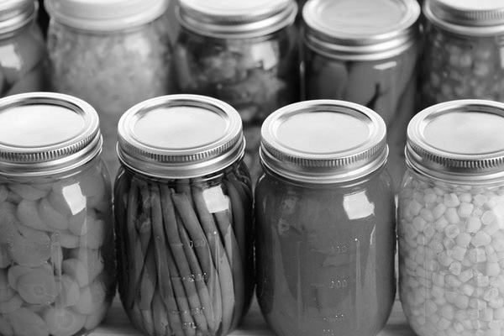**Canned Fruit and Vegetables Section 10**

|  |  |
| --- | --- |
| 3479 | Raspberries |
| 3480 | Cherries |
| 3481 | Peaches |
| 3482 | Plums |
| 3483 | Pears |
| 3484 | Applesauce |
| 3485 | Any Other Fruit |
| 3486 | String Beans |
| 3487 | Corn |
| 3488 | Peas |
| 3489 | Tomatoes |
| 3490 | Carrots |
| 3491 | Beets |
| 3492 | Any Other Vegetables |

**Canned Meat Section 11**

**Spiced Fruit or Vegetable Section 15**

|  |  |
| --- | --- |
| 3509 | Pickled Beets |
| 3510 | Bread and Butter Pickles |
| 3511 | Dill Pickles |
| 3512 | Mixed Pickles |
| 3513 | Sweet Pickles |
| 3514 | Relish |
| 3515 | Any Other Pickles |
| 3516 | Any Spiced Fruit |

|  |  |
| --- | --- |
| 3493 | Beef |
| 3494 | Pork |
| 3495 | Chicken |
| 3496 | Mincemeat |
| 3497 | Any Other |

##### Fine Arts – Department E

Superintendent:

Check-in: Wednesday, June 19th from 4-6 PM

Judging: Wednesday, June 19th @ 6:30 PM

Release: Sunday, June 23rd after Scramble Sale

Entry Fee: $2.00 per class

See Premiums page for pay scale.

**Rules:**

1. Superintendent has the right to accept or reject any item entered.
2. All art work must be framed. Matte or backed ready to hang.
3. Awards may be withheld if the judge considers the exhibit of insufficient merit.
4. Refer to general non-livestock rules.

**Sculpture Section 4**

|  |  |  |  |
| --- | --- | --- | --- |
| **Division A Youth Division B Open** | **Div A** | **Div B** | **Description** |
| **Oil & Acrylic Painting Section 1** | 1528 | 3623 | Clay, Wood |
|  | 1529 | 3524 | Wire, Metal |
| Div A Div B Description | 1530 | 3525 | Casting, Carving |
| 1500 3595 Landscapes – All Varieties  1501 3596 Still Life | 1531 | 3526 | Any Other |

1502 3597 Abstract/Textures

1503 3598 Portrait

**Graphics Section 5**

|  |  |  |  |  |  |
| --- | --- | --- | --- | --- | --- |
| 1504 | 3599 | Building/Structure | **Div A** | **Div B** | **Description** |
| 1505 | 3600 | Animal/Fish/Bird | 1532 | 3627 | Computer |
| 1506 | 3601 | Flowers | 1533 | 3628 | Any Other |
| 1509 | 3604 | Any Other |  |  |  |

**Watercolor Painting Section 2**

**Ceramics Section 6 Div A Div B Description**

**Other Section 3**

**Div A Div B Description**

1520 3615 Pencil Sketch

1521 3616 Pastels

written on a 3x5 card.

|  |  |  |  |  |  |
| --- | --- | --- | --- | --- | --- |
| **Div A** | **Div B** | **Description** | 1534 | 3634 | Pottery |
| 1510 | 3605 | Landscapes – All Varieties | 1535 | 3635 | Glazed Work |
| 1511 | 3606 | Still Life | 1536 | 3636 | Bisques Staining |
| 1512 | 3607 | Abstract/Textures | 1537 | 3637 | Plaster Painting |
| 1513 | 3608 | Portrait |  |  |  |
| 1514 3609 Building/Structure **Creative Writing Section 7**  1515 3610 Animal/Fish/Bird 1. Topic may be anything the exhibitor chooses. | | | | | |
| 1516 | 3611 | Flowers | 2. All entries must be typed on 8 ½ x 11 paper. | | |
| 1519 | 3614 | Any Other | 3. Name, address, age, & phone number must be | | |

1. Place entries inside a folder (transparent).
2. Collection will be judged as whole unit.
3. Entries will be judged on neatness, spelling attractiveness, grammar, & originality.

|  |  |  |  |  |  |
| --- | --- | --- | --- | --- | --- |
| 1522 | 3617 | Ink **11 & under 12-18** | | | |
| 1523 | 3618 | Mixed Media | 1570 | 1575 | Poem-Collection |
| 1524 | 3619 | Charcoal | 1571 | 1576 | Poem-Large |
| 1525 | 3620 | Air Brushing | 1572 | 1577 | Poem-Small |
| 1526 | 3621 | Chalk | 1573 | 1578 | Short Story or Stories |
| 1527 | 3622 | Any Other | 1574 | 1579 | Any Other |

Superintendent:

##### Photography – Department F

Check-in: Wednesday, June 19th from 4-6 PM

Judging: Wednesday, June 19th @ 6:30 PM

Release: Sunday, June 23rd after Scramble Sale

Entry Fee: $2.00 per class

Ribbons will be given for 1st-3rd place. See Premiums page for pay scale.

**Rules:**

1. Youth: Write age and type of camera used on a 3x5 card. This is very important.
2. All photographs must have been taken by the exhibitor and photographs may not be entered that have competed in previous years.
3. Do not put captions on pictures.
4. A collection consists of 4-6 pictures mounted on a board no larger than 16” x 22”. The pictures cannot be smaller than 3” x 3” and no larger than 8” x 10”. They may include a variety of sizes. The same prints may not be entered in more than one class.
5. All collections should be related in some way. The collection may be all black & white or all color.
6. Optional: Transparent material, such as saran wrap, may be used to keep prints clean.
7. The superintendent and fair board have the right to accept or reject any entries.
8. Colored mat board may be used to compliment your photo. The mat size should be proportional to the photo size. No corner mounts – please use photo cement. Poster boards may be used. Tags must be taped to the upper left-hand corner, so they can be viewed from the front.
9. Refer to general non-livestock rules.

**Division A Youth Division B Open Color Enlargements Section 1**

|  |  |  |
| --- | --- | --- |
| Div A | Div B | Description |
| 1598 | 3640 | Portrait |
| 1599 | 3641 | Sports (Recreational) |
| 1600 | 3642 | Animals |
| 1601 | 3643 | Still Life |
| 1602 | 3644 | Scenery (Landscapes, Buildings) |
| 1603 | 3645 | Candid (Children at Play) |
| 1604 | 3646 | Special Effects |
| 1605 | 3647 | Extreme Close-Up |
| 1606 | 3648 | Any Others |

**Black & White Enlargements Section 2**

|  |  |  |
| --- | --- | --- |
| **Div A** | **Div B** | **Description** |
| 1607 | 3649 | Portrait |
| 1608 | 3650 | Sports (Recreational) |
| 1609 | 3651 | Animals |
| 1610 | 3652 | Still Life |
| 1611 | 3653 | Scenery (Landscapes, Buildings) |
| 1612 | 3654 | Candid (Children at Play) |
| 1613 | 3655 | Special Effects |
| 1614 | 3656 | Extreme Close-Up |

**Color Collection Section 3 Div A Div B Description**

**Black & White Collections Section 4 Div A Div B Description**

|  |  |  |
| --- | --- | --- |
| 1620 | 3660 | Portrait |
| 1621 | 3661 | Sports (Recreational) |
| 1622 | 3662 | Animals |
| 1623 | 3663 | Still Life |
| 1624 | 3664 | Scenery (Landscapes, Buildings) |
| 1625 | 3665 | Candid (Children at Play) |
| 1626 | 3666 | Special Effects |
| 1627 | 3667 | Extreme Close-Up |
| 1628 | 3668 | Any Others |

|  |  |  |
| --- | --- | --- |
| 1629 | 3669 | Portrait |
| 1630 | 3670 | Sports (Recreational) |
| 1631 | 3671 | Animals |
| 1632 | 3672 | Still Life |
| 1633 | 3673 | Scenery (Landscapes, Buildings) |
| 1634 | 3674 | Candid (Children at Play) |
| 1635 | 3675 | Special Effects |
| 1636 | 3676 | Extreme Close-Up |
| 1637 | 3677 | Any Others |

Superintendent:

##### Hobbies and Crafts – Department G

Check-in: Wednesday, June 19th from 4-6 PM

Judging: Wednesday, June 19th@ 6:30 PM

Release: Sunday, June 23rd after Scramble Sale

Entry Fee: $2.00 per class

Ribbons will be given to 1st-3rd place. See Premiums page for pay scale.

**Rules:**

1. All must be original design.
2. Judging will be based on arrangement, educational value, and variety.
3. Scorecard will be used as a guide of 30% main idea, 25% neatness, 25% ability, 20% technique.
4. Refer to general non-livestock rules.

**Division A Youth Division B Open Toy Making Section 1**

**Woodworking Section 5 Div A Div B Description**

|  |  |  |  |  |  |
| --- | --- | --- | --- | --- | --- |
| Div A | Div B | Description | 1682 | 3724 | Carving Relief |
| 1660 | 3702 | Wooden Article | 1683 | 3725 | Furniture |
| 1661 | 3703 | Stuffed – Any Type | 1684 | 3726 | Wall Decorations |
| 1662 | 3704 | Puppets | 1685 | 3727 | Antique Refinishing |
| 1663 | 3705 | Novelty | 1686 | 3728 | Turned – Any Lathe Work |
| 1664 | 3706 | Mobiles | 1687 | 3729 | Wind Mobiles – Lawn Ornaments |
| 1665 | 3707 | Original | 1688 | 3730 | Chainsaw Art |
| 1666 | 3708 | Dolls – Any Type | 1689 | 3731 | Band Saw Art |
| 1693 | 3754 | Any Other | 1690 | 3732 | Doll House, Room, Store |
|  |  |  | 1691 | 3733 | Miniature Furniture |

**Wall Hangings & Rugs Section 2 Div A Div B Description**

1668 3710 Hooked – Any Types

1692 3734 Other

**Christmas Ornaments Section 6**

|  |  |  |  |  |  |  |
| --- | --- | --- | --- | --- | --- | --- |
| 1669 | 3711 | Punches | **Div A** | | **Div B** | **Description** |
| 1670 | 3712 | Woven | 1694 | | 3736 | Beaded – Original |
| 1671 | 3713 | Any Other | 1695 | | 3737 | Calico |
|  |  |  | 1696 | | 3738 | Wooden |
| **Ceramics** | | **Section 3** | | 1697 | 3739 | Stained Glass Effect |
|  | |  | | 1698 | 3740 | Ceramic, Pottery, Stoneware, Plaster |

|  |  |  |
| --- | --- | --- |
| **Div A** | **Div B** | **Description** |
| 1672 | 3714 | Under Glaze |
| 1673 | 3715 | Over Glaze |
| 1674 | 3716 | Stain |
| 1675 | 3718 | Any Other |

**Country Painting Section 4**

|  |  |  |
| --- | --- | --- |
| **Div A** | **Div B** | **Description** |
| 1677 | 3719 | Tole – Oil |
| 1678 | 3720 | Stenciling |
| 1679 | 3721 | Fabric |
| 1681 | 3723 | Metal |

1699 3741 Crocheted, Knitted

**Glass Art Section 7**

|  |  |  |  |  |  |
| --- | --- | --- | --- | --- | --- |
| **Div A** | **Div B** | **Description** | 1707 | 3749 | Household Accessory |
| 1702 | 3744 | Stained Glass Effect | 1708 | 3750 | Window Panel |
| 1703 | 3745 | Stained Glass Lead | 1709 | 3751 | Wall Hanging |
| 1704 | 3746 | Etched Glass | 1710 | 3752 | Original |
| 1705 | 3747 | Lamp Shade | 1711 | 3753 | Miscellaneous |
| 1706 | 3748 | Window Decoration – Sun Catcher |  |  |  |

**Techniques Section 8**

|  |  |  |  |  |  |
| --- | --- | --- | --- | --- | --- |
| **Div A** | **Div B** | **Description** | **Div A** | **Div B** | **Description** |
| 1715 | 3757 | Trash to Treasure | 1726 | 3768 | Punch: Copper, Tin, Brass, Alum. |
| 1716 | 3758 | Wood Burning | 1727 | 3769 | Calligraphy |
| 1717 | 3759 | Candles | 1728 | 3770 | Jewelry – Any Item |
| 1718 | 3760 | String Art | 1729 | 3771 | Leather – Any Item |
| 1719 | 3761 | Copper Tooling | 1730 | 3772 | Weaving – Any Item |
| 1720 | 3762 | Pompom Creations | 1731 | 3773 | Model – Any Item |
| 1721 | 3763 | Piercing – Lampshade Etch | 1732 | 3774 | Model – Any Item by Hand |
| 1722 | 3764 | Paper Sniping | 1733 | 3775 | Model – Any Item by Kit |
| 1723 | 3765 | Basketry Coiled | 1734 | 3776 | Padded Picture Frames or Albums |
| 1724 | 3766 | Caning | 1735 | 3777 | Any Other Suitable Item |
| 1725 | 3767 | Basketry Woven | 1736 | 3778 | Collections |

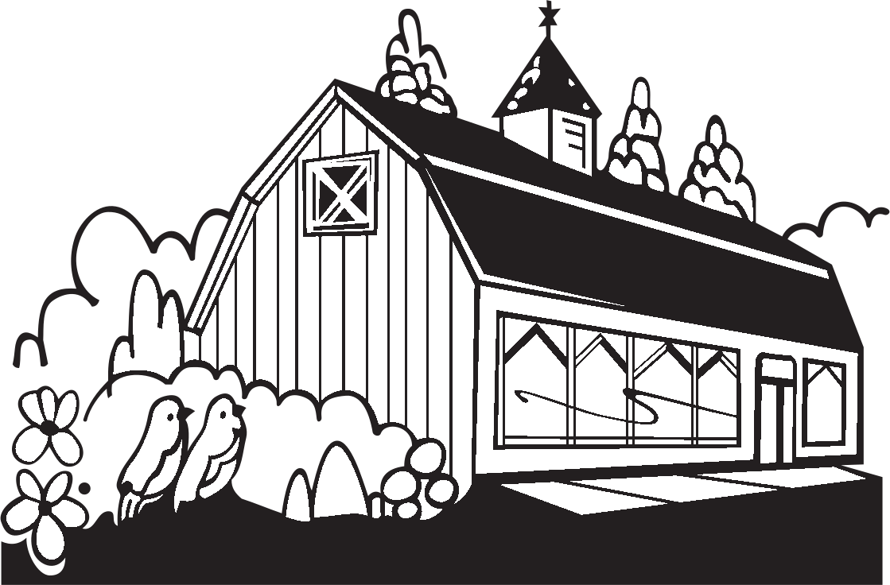

Superintendent:

##### Collections – Department H

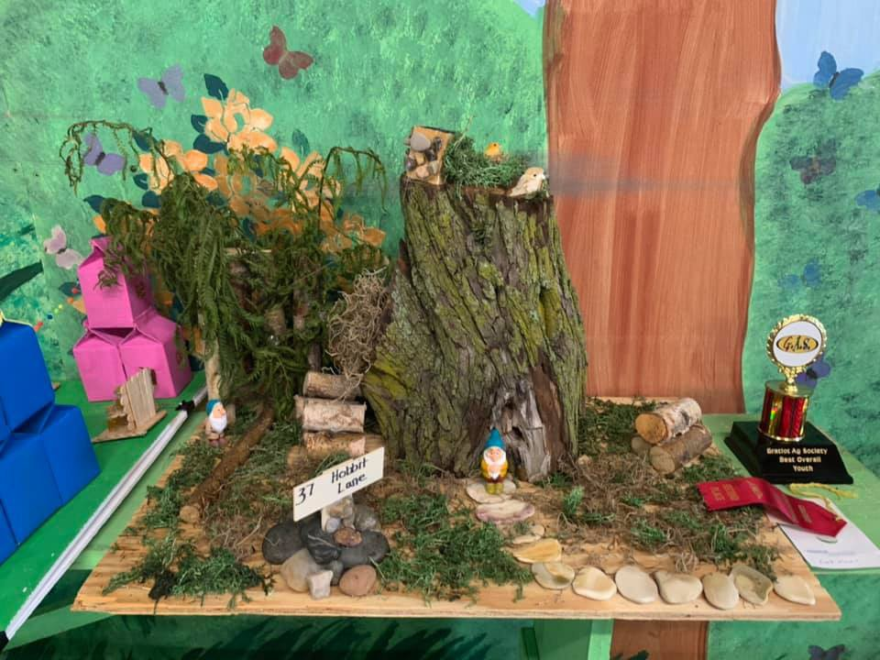Check-in: Wednesday, June 19th from 4-6 PM

Judging: Wednesday, June 19th@ 6:30 PM

Release: Sunday, June 23rd after Scramble Sale

Entry Fee: $2.00 per class

Ribbons will be given to 1st-3rd place. See Premiums page for pay scale.

**Rules:**

1. Exhibits will be judged on uniqueness, age, and condition.
2. Entry cannot be entered in any other department.

**Division A Youth Division B Open**

|  |  |  |
| --- | --- | --- |
| **Div A** | **Div B** | **Description** |
| 1940 | 3340 | Thimbles |
| 1941 | 3341 | Toys |
| 1943 | 3342 | Miniatures |
| 1944 | 3344 | Oldies |
| 1945 | 3345 | Collections – Stickers |
| 1946 | 3346 | Rocks |
| 1947 | 3347 | Post Cards |
| 1951 | 3351 | Animals (Stuffed, plastic, etc.) |
| 1952 | 3352 | Badges, Patches, Buttons |
| 1957 | 3353 | Dolls |
| 1958 | 3358 | Cookbooks |
| 1961 | 3359 | Cards |
| 1962 | 3362 | Miscellaneous |
| 1963 | 3363 | Toy Farm Display |

Superintendent:

##### Needlework – Department I

Check-in: Wednesday, June 19th from 4-6 PM

Judging: Wednesday, June 19th @ 6:30 PM

Release: Sunday, June 23rd after Scramble Sale

Entry Fee: $2.00 per class

Ribbons will be given for 1st-3rd place. See Premiums page for pay scale.

**Rules:**

1. Needlework will be judged for beauty, degree of perfection, complexity, creativity, and suitability.
2. No articles are to be offered for sale or premiums will be forfeited.
3. Refer to general non-livestock rules.

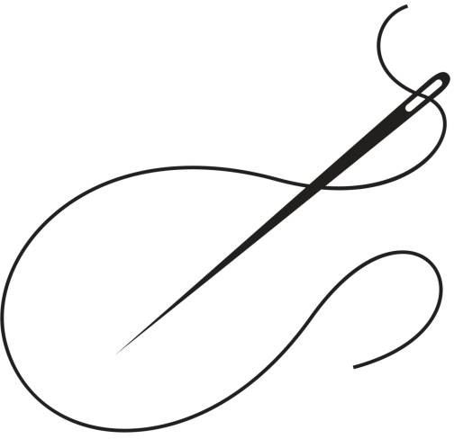**Div. A Youth (6-18) Div. B Open (19 and over) Knitted, Crocheted, or Tatted (Large) Section 1**

**Miscellaneous Needlework & Sewing Section 3 Div A Div B Description**

1835 3877 Crewel – Yarn

|  |  |  |  |  |  |  |
| --- | --- | --- | --- | --- | --- | --- |
| **Div A** | **Div B** | **Description** | | 1836 | 3878 | Embroidery |
| 1800 | 3842 | Knitted Sweater -One Color | | 1839 | 3881 | Candle wicking |
| 1801 | 3843 | Crocheted Sweater -One Color | | 1840 | 3882 | Hoop Art |
| 1802 | 3844 | Knitted Sweater -2 or More Colors | | 1841 | 3883 | Punch Needle |
| 1803 | 3845 | Crocheted Sweater-2 or More Colors | | 1842 | 3884 | Pillow Making |
| 1804 | 3846 | Crocheted Tablecloth or Bedspread | | 1843 | 3885 | Machine Embroidery |
| 1805 | 3847 | Knitted Afghan | | 1844 | 3886 | Potholder (Set of 2) |
| 1806 | 3848 | Crocheted Afghan | |  |  |  |
| 1807 3849 Machine Knitted Item **Counted Cross Stitch Section 4** | | | | | | |
| 1808 | 3850 | Knitted Baby Afghan | | **Div A** | **Div B** | **Description** |
| 1809 | 3851 | Crocheted Baby Afghan | | 1849 | 3891 | Any Picture |
| 1810 | 3852 | Any Suitable Item | | 1850 | 3892 | Any Pillow |
|  |  |  | | 1851 | 3893 | Sampler |
| **Knitted, Crocheted, or Tatted (Small)** | | | **Section 2** | 1852 | 3894 | Original Design |
|  | | |  | 1853 | 3895 | Any Other |
| **Div A Div B Description**  1815 3857 Knitted Baby Sweater **Plastic Canvas Section 5** | | | | | | |
| 1816 | 3858 | Crocheted Baby Sweater | | **Div A** | **Div B** | **Description** |
| 1817 | 3859 | Knitted Baby Set | | 1854 | 3896 | One Large Item |
| 1818 | 3860 | Crocheted Baby Set | | 1855 | 3897 | Two Medium Items |
| 1819 | 3861 | Knitted Hat & Mitten or Scarf Set | | 1856 | 3898 | Five Small Items |
| 1820 | 3862 | Crocheted Hat & Mitten or Scarf Set | |  |  |  |
| 1821 | 3863 | Knitted Hat | | **Golden Years** | | **Division 65+ Section 6** |
| 1822 | 3864 | Crocheted Hat | | 3900 | | Knitted Afghan |
| 1823 | 3865 | Knitted Pillow | | 3901 | | Crocheted Afghan |
| 1824 | 3866 | Crocheted Pillow | | 3902 | | Knitted Wearing Apparel |
| 1825 | 3867 | Crocheted Doily | | 3903 | | Crocheted Wearing Apparel |
| 1826 | 3868 | Tatted Doily | | 3904 | | Crocheted Doily |
| 1827 | 3869 | Knitted Craft Item (potholder, etc.) | | 3905 | | Tatted Doily |
| 1828 | 3870 | Crocheted Craft Item (potholder, etc) | | 3906 | | Apron |
| 1829 | 3871 | Doll Clothes | | 3907 | | Rug |
| 1830 | 3872 | Machine Knitted Item | | 3908 | | Crocheted Table Cloth/Bed Spread |
| 1831 | 3873 | Any Other Suitable Item | | 3909 | | Miscellaneous Sewn Item |
|  |  |  | | 3910 | | Any Other Suitable Item |

Superintendent:

##### Garments and Quilts – Department J

Check-in: Wednesday, June 19th from 4-6 PM

Judging: Wednesday, June 19th @ 6:30 PM

Release: Sunday, June 23rd after Scramble Sale

Entry Fee: $2.00 per class

Ribbons will be given for 1st-3rd place. See Premiums page for pay scale.

**Rules:**

1. Garments may be refused if they are not clean.
2. Items may not be offered for sale or premiums will be forfeited.
3. Entries must be the work of the exhibitor and must not have been entered in the fair before.
4. Scorecard will be used as a guide of 50% workmanship, 30% appearance, and 20% quality.
5. Refer to general non-livestock rules.

**Division A Youth Division B Open**

**Quilting Section1**

|  |  |  |
| --- | --- | --- |
| **Div A** | **Div B** | **Description** |
| 1858 | 3915 | Pieced Quilt – Hand Quilted |
| 1859 | 3916 | Pieced Quilt – Machine/Tied Quilted |
| 1860 | 3917 | Embroidered Quilt – Hand Quilted |
| 1861 | 3918 | Embroidered Quilt – Machine/Tied |
|  |  | Quilted |
| 1862 | 3919 | Baby Quilt – Hand Quilted |
| 1863 | 3920 | Baby Quilt – Machine/Ties Quilted |
| 1864 | 3921 | Wall Hanging |
| 1865 | 3922 | Pillow |
| 1866 | 3923 | Heirloom Quilts (Must be at least 25 |
|  |  | Years Old) |
| 1867 | 3924 | Any Other Suitable Item |

**Garment Making Section 2**

|  |  |  |
| --- | --- | --- |
| **Div A** | **Div B** | **Description** |
| 1870 | 3927 | Infant’s Garment |
| 1871 | 3928 | Child’s Garment (3-12 yrs) |
| 1872 | 3929 | Shirt/Blouse |
| 1873 | 3930 | Doll Clothes |
| 1874 | 3931 | Slacks or Jeans |
| 1875 | 3932 | Pant Suit |
| 1876 | 3933 | Jumper |
| 1877 | 3934 | Nightwear |
| 1878 | 3935 | Casual Dress |
| 1879 | 3936 | Formal Dress |
| 1880 | 3937 | Jacket or Coat |
| 1881 | 3938 | Tailored Suit (2 or More Pieces) |
| 1882 | 3939 | Vest |
| 1883 | 3940 | Skirt |
| 1884 | 3941 | Jogging Suit |
| 1885 | 3942 | Any Other Suitable Item |

**Sweatshirt and Sweat Suits Section 3**

|  |  |  |
| --- | --- | --- |
| **Div A** | **Div B** | **Description** |
| 1888 | 3945 | Appliquéd |
| 1889 | 3946 | Ruffles, Cuffs, Collar, Yoke, etc. |
| 1890 | 3947 | Counted Cross Stitch/Waste Canvas |
| 1891 | 3948 | Burlap Panel |
| 1892 | 3949 | Crocheted or Knitted Yoke |
| 1893 | 3950 | Punch Needle |
| 1894 | 3951 | Painted Sweatshirt |
| 1895 | 3952 | Any Other Suitable Item. |



Superintendent:

##### Kids Creation – Department K

Check-in: Wednesday, June 19th from 4-6 PM

Judging: Wednesday, June 19th @ 6:30 PM

Release: Sunday, June 23rd after Scramble Sale

Entry Fee: $2.00 per class

Ribbons will be given for 1st-3rd place. See Premiums page for pay scale.

**Rules:**

1. Exhibitors are allowed to enter one item in each class.
2. Any exhibit entered in this department may not be entered in any other department.
3. All entries must have a name on the item.
4. Articles are judged by the age of the youth.
5. Refer to general non-livestock rules.

**Division A Youth(6-18) Division B Open (19 and over) Creative Crafts Section 1**

|  |  |  |  |  |  |
| --- | --- | --- | --- | --- | --- |
| **Div A** | **Div B** | **Description** | | | |
| 1444 | 1456 | Carving (Wood, Soap, Styrofoam, etc.) | | | |
| 1445 | 1457 | Metal Crafts (Tin Punch, Copper, Tooling, etc.) | | | |
| 1446 | 1458 | String Art | | | |
| 1447 | 1459 | Pompom Crafts, Felt Crafts | | | |
| 1448 | 1460 | Candles | | | |
| 1449 | 1461 | Basketry or Mats (Woven) | | | |
| 1450 | 1462 | Jewelry – Any Kind | | | |
| 1451 | 1463 | Scrap or Throw Away Crafts | | | |
| 1455 | 1467 | Sculpture (Clay, Wax, Bread Dough Plaster, etc.) | | | |
| 1468 | 1469 | Any Other | | | |
| 1470  1472 | 1471  1473 | Egg Decorating  (One egg per entry, blown or boiled; can be painted and decorated) Painted or Inked Egg | | | |
|  |  | (One egg per entry, blown or boiled; must be painted or inked only, NO DECORATIONS) | | | |
| **Art** | **Section 2** | |  |  |  |
| **0-4 yrs** | **5-7 yrs** | | **8-10 yrs** | **11-15 yrs** | **Description** |
| 1540 | 1548 | | 1556 | 1564 | Colored Pencils |
| 1541 | 1549 | | 1557 | 1565 | Crayons |
| 1542 | 1550 | | 1558 | 1566 | Cartoon |
| 1543 | 1551 | | 1559 | 1567 | Finger Paint |
| 1544 | 1552 | | 1560 | 1568 | Pencil Sketch |
| 1545 | 1553 | | 1561 | 1569 | Felt Markers |
| 1546 | 1554 | | 1562 | 1570 | Water Colors |
| 1547 | 1555 | | 1563 | 1571 | Any Other |



## Fair Book Cover Contest

Department K

Section 3

Class #1575

Youth Ages 0-15

This class is for the next year’s fair book cover. Exhibitors are asked to create a cover page on 8 ½x 11 in. paper. Please no dates, however the year 2023 is acceptable.

##### Must be colorful and have an agricultural theme.

**We will need the original copy for scanning purposes and will be returned

**before** the fair is over**

*Congratulations to*

**Lilyana Reinsmith of Riverdale, MI**

**on being this year’s 2023 Fair Book Cover Contest Winner!!**

#### Premium Pay Scale

**Payback for $5.00 class**

Class Size

1st

2nd 3rd

4th

5th

Our premiums are set up in a jackpot style, meaning of all the entries, 75% is paid back to classes, below is a table of how we will divide the entries per class into the placing.

**Payback 75%**

**Payback for $2.00 class**

|  |  |  |  |  |  |  |  |  |  |  |  |  |
| --- | --- | --- | --- | --- | --- | --- | --- | --- | --- | --- | --- | --- |
| Class Size | 1st | 2nd | 3rd | 4th | 5th | Class Size | | 1st | 2nd | 3rd | 4th | 5th |
| 1 | **75%** |  |  |  |  |  | 1 | **$1.50** |  |  |  |  |
| 2 | **56%** | **19%** |  |  |  |  | 2 | **$2.24** | **$0.76** |  |  |  |
| 3 | **45%** | **22%** | **8%** |  |  |  | 3 | **$2.70** | **$1.32** | **$0.48** |  |  |
| 4 | **37%** | **22%** | **11%** | **5%** |  |  | 4 | **$2.96** | **$1.76** | **$0.88** | **$0.40** |  |
| 5 | **30%** | **18%** | **15%** | **7%** | **5%** |  | 5 | **$3.00** | **$1.80** | **$1.50** | **$0.70** | **$0.50** |
| 6 | **30%** | **18%** | **15%** | **7%** | **5%** |  | 6 | **$3.60** | **$2.16** | **$1.80** | **$0.84** | **$0.60** |

|  |  |  |  |  |  |  |  |  |  |  |  |  |
| --- | --- | --- | --- | --- | --- | --- | --- | --- | --- | --- | --- | --- |
| **Payback for $3.00 class** | | | | | |  |  | **Payback for $4.00 class** | | | | |
| Class Size | 1st | 2nd | 3rd | 4th | 5th |  | Class Size | 1st | 2nd | 3rd | 4th | 5th |
| 1 | **$2.25** |  |  |  |  |  | 1 | **$3.00** |  |  |  |  |
| 2 | **$3.36** | **$1.14** |  |  |  |  | 2 | **$4.48** | **$1.52** |  |  |  |
| 3 | **$4.05** | **$1.98** | **$0.72** |  |  |  | 3 | **$5.40** | **$2.64** | **$0.96** |  |  |
| 4 | **$4.44** | **$2.64** | **$1.32** | **$0.60** |  |  | 4 | **$5.92** | **$3.52** | **$1.76** | **$0.80** |  |
| 5 | **$4.50** | **$2.70** | **$2.25** | **$1.05** | **$0.75** |  | 5 | **$6.00** | **$3.60** | **$3.00** | **$1.40** | **$1.00** |
| 6 | **$5.40** | **$3.24** | **$2.70** | **$1.26** | **$0.90** |  | 6 | **$7.20** | **$4.32** | **$3.60** | **$1.68** | **$1.20** |

|  |  |  |  |  |  |
| --- | --- | --- | --- | --- | --- |
| 1 | **$3.75** |  |  |  | |
| 2 | **$5.60** | **$1.90** |  |
| 3 | **$6.75** | **$3.30** | **$1.20** |
| 4 | **$7.85** | **$4.40** | **$2.68** | **$1.00** |  |
| 5 | **$7.50** | **$4.50** | **$3.75** | **$1.75** | **$1.25** |
| 6 | **$9.00** | **$5.40** | **$4.50** | **$2.10** | **$1.50** |

##### 2023 Gratiot Animal Scramble Show

***2023 G.A.S. SCRAMBLE SHOW RULES***

SUPERINTENDENT: SCRAMBLE COMMITTEE (JARED WHITFORD 989-666-2666)

**JUDGING: FRIDAY, JUNE 23, 2023 AT 10 A.M.**

**SALE DAY: SUNDAY, JUNE 25, 2023 AT 5 P.M.**

**RELEASE TIME: SUNDAY, JUNE 25, 2023 AT 9 P.M.**

**BUYERS PICTURES** WILL BE TAKEN WHEN THE SCRAMBLE ANIMALS ARE CHECKED

**IN** **ON THURSDAY, JUNE 23, 2023, BETWEEN THE HOURS OF 4 P.M. AND 8 P.M.**

**PLEASE DRESS ACCORDINGLY!!**

**MICHIGAN DEPARTMENT OF AGRICULTURAL**

**Starting March 1, 2007, all cattle must be identified with RFID electronic**

**ear tags prior to movement from a premises.**

**SHOWMANSHIP CLASSES- ALL SCRAMBLE ANIMALS WILL HAVE SHOWMANSHIP**

**PRECEDING THEIR RESPECTIVE CLASSES.**

**FEEDER CALVES PIGS**

**JUNIOR JUNIOR**

**INTERMEDIATE**

**SENIOR SENIOR**

**SCRAMBLE FEEDER CALF SHOW**

**CLASSES: LIGHT WEIGHT HEAVY WEIGHT**

**SCRAMBLE FEEDER CALF SHOW - FOLLOWING THE PIG SHOW**

**RULES:**

**1**. FEEDER STEERS THAT WERE CAUGHT IN THE SCRAMBLE MUST BE RETURNED, SHOWN AND SOLD.

**2**. FEEDER STEERS MUST BE ON THE FAIRGROUNDS THURSDAY, JUNE 22, 2023 – **ENTRY TIME: 4 P.M.**

**TILL 8 P.M.**, AND REMAIN ON EXHIBIT UNTIL SUNDAY, JUNE 25, 2023 – **RELEASE TIME 9 P.M.**

**SCRAMBLE PIG SHOW – FIRST TO SHOW 10 AM**

**CLASSES: LIGHT WEIGHT MEDIUM WEIGHT HEAVY WEIGHT**

**RULES:**

**1**. PIGS THAT WERE CAUGHT IN THE SCRAMBLE MUST BE RETURNED, SHOWN AND SOLD.

**2**. PIGS MUST BE ON THE FAIRGROUNDS THURSDAY, JUNE 22, 2023 – **ENTRY TIME: 4 P.M.**

**TILL 8 P.M.**, AND REMAIN ON EXHIBIT UNTIL SUNDAY, JUNE 25, 2023 – **RELEASE TIME 9 P.M.**

**DICK BRAMAN SPORTSMANSHIP TROPHY**

**WILL BE AWARDED TO THE SCRAMBLE EXHIBITOR THAT SHOWS THE MOST SPORTSMANSHIP AND WILLINGNESS TO HELP OTHER EXHIBITORS WITH**

**THEIR ANIMALS AND KEEPING THE BARN CLEAN.**



**Gratiot Agricultural Society Would Like to Thank All of Our Sponsors and Volunteers**

ABC Fire Extinguisher Sales & Services Abigail Olger

Akers Waste Removal

Arnold Law Office

B & W Sand & Gravel Barden Funeral Home Bellingar Packing BettenBaker Chevrolet C & C Propane

Chuck and Sandy Washburn City of Ithaca

Dick and Nancy Davis Doehring Schultz Ins. Dufrene Machinery RAR Electric

E & S Graphics Ed & Bonnie Whitaker

Efaw Builders Ellens Equipment

Family Farm and Home Four7

Gerard Whitford Godley’s Country Floral Greenstone Farm Credit In A Pickle Farms

Ithaca Thompson Library Jenifer Taylor

John and Nicole Whitmore Joseph Thompson CPA Kim Cross

Kim Smith

Larry & Cindy Whitford Larry Coon Farms

Maple Rapids Lumber Mill Middleton Diner

Mike Aubin Nelda Akers Pat Church

Quality Equipment Sandy Ridge Farms Pet Hotel

Self-Serve Lumber, Ithaca Simmet Insurance Agency Smith Concrete Products, Inc Smith Family Funeral Home Sparks Pickle Company

The Grub Hub The Trophy Shoppe Tim & Kathy Skinner

Tom and Shawyn Sparks Triple G Farms Whitmore Farms

**In Memory of:**

***Bill Akers, Bill & Thelma Skinner, Gene & Dorothy Whitaker, Karin Shaull, Ruth Whitney, Tim Alverson***

If you would like more info on how you can sponsor or volunteer for the fair, please contact Heather Seeley (989-331-1640) or Nelda Akers (517-719-8518)

**The Gratiot Ag Society needs you!!**

Join our crew of volunteers! We need your participation and appreciate the help! Please fill out this

form if you would like to help in any of the areas listed below:

Yes! I can help with the following areas:

General Labor/Repair/Maintenance/Painting

Advertising/Marketing

Pre-Fair Cleanup

Post-Fair Cleanup

Entertainment/Events

Farmer’s Day Dinner Setup/Tear down

Appreciation Day Dinner Setup/Tear down

Sponsorships/Fundraisers/Merchandise Donations

Setup Animal Pens/Cages

Landscaping/Flowers

See A Need, Fill A Need (I can help where most needed)

Department(circle):Exhibits-Horse-Dairy-Beef-Rabbit-Poultry- Goats-Sheep-Scramble

Name: Address: City: State: Zip: Phone #: Call or Text: Email:

Please Return to: Gratiot Ag Society

P.O. Box 181

Ithaca, MI 48847

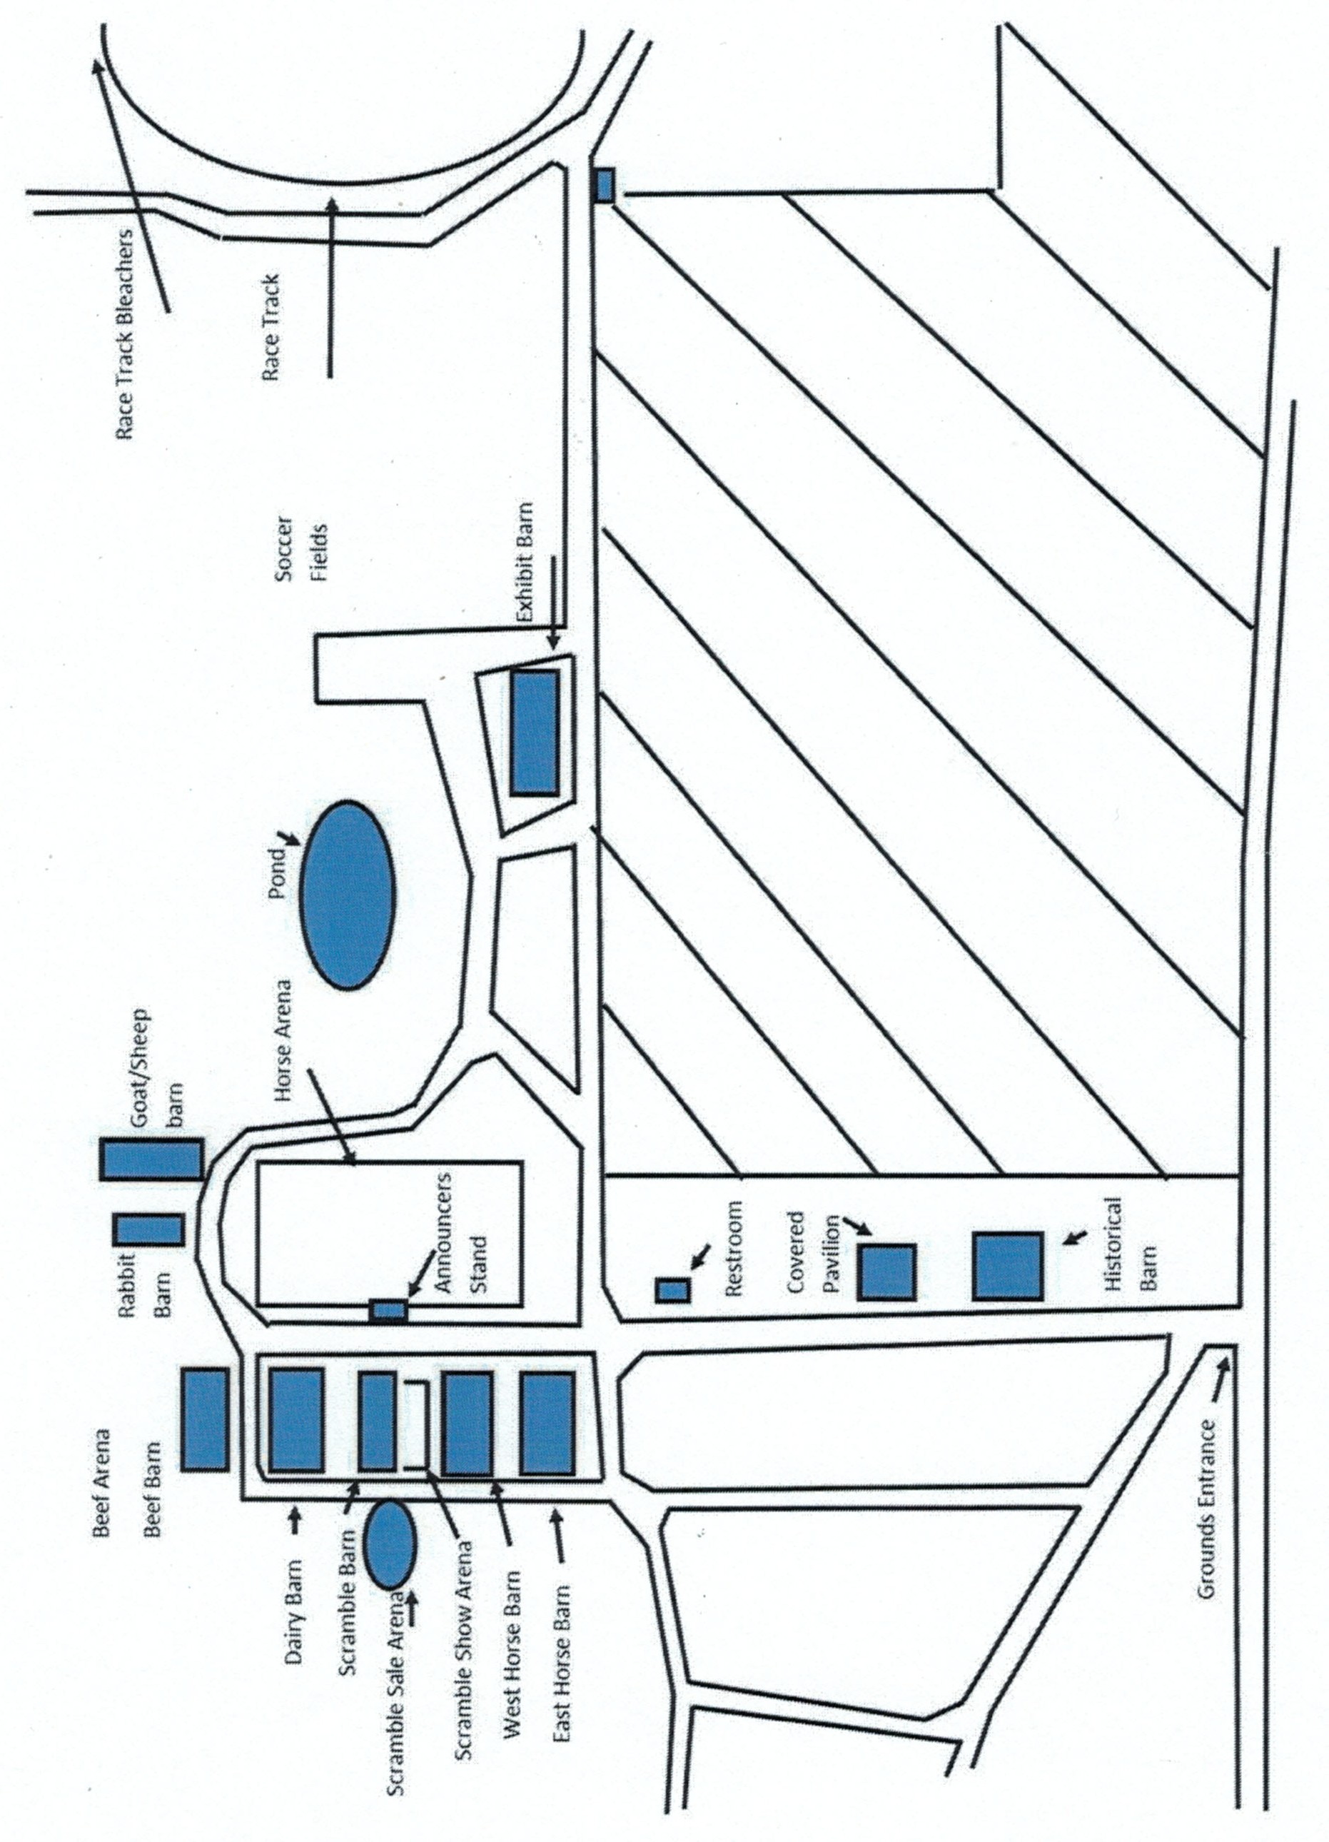**Map of Grounds**



JOHNSON’S

**FARM, HOME & REC., INC.**

1311 E. Center St., Ithaca, MI 48847

**989.875.5117**

Complete Auto • Small Engine • Truck • Farm Parts RV Accessories • Starter, Alternator, Battery Testing Hydraulic Hoses Made While You Wait

Mon.-Fri. 7:00AM - 5:30PM Sat. 8AM-4PM

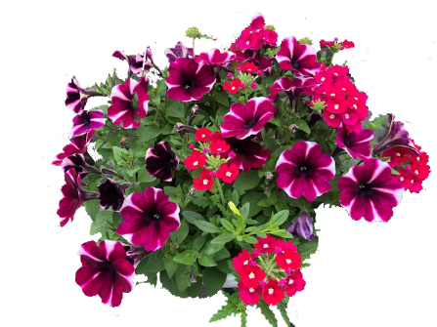

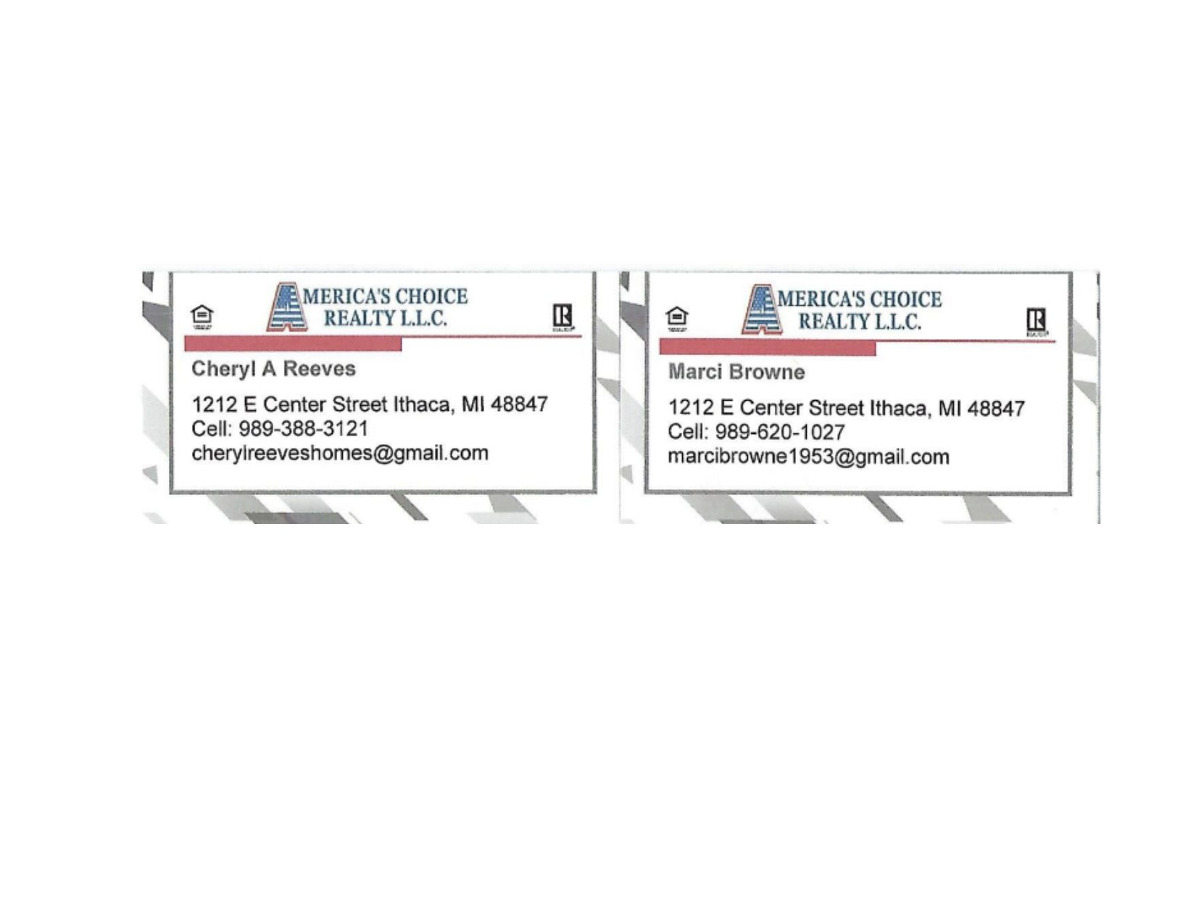





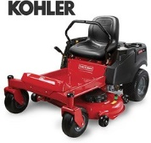

STIHL - EXMARK - GRAVELY - SNAPPER 7750 W. CLEVELAND RD ( M-57 ) MIDDLETON, MI 48856

MARK MARTIN -- SALES

PH 989-236-5700 m a r tin s m alle ngin e@ya hoo.com MARTINSMALLENGINE.COM

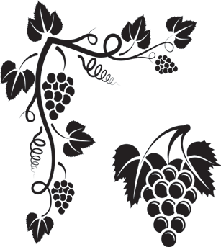

**989-875-4844**

**166 E. Center St. Ithaca, MI 48847 M-F: 9:00-5:30 Sat: 9:00- 3:00**

**downtowndime@gmail**

**DownTown Dime**

**If you would like more information to sponsor please contact Heather Seeley @ 989-331-1640**

**Thank you to the following 2022 Road Sign Buyers**

Akers Waste Removal

Holly Seeley

Tom & Shawyn Sparks

In a Pickle Farms

ABC Fire Sales & Service

Crossroads Organic Farms

In Memory of Bill & Thelma Skinner

Dairlyand Seed

C&C Propane

Larry Coon Farms

Quality Equipment

Gilber Family Farm

Ed & Bonnie Whitaker

Jared & Sara Whitford

**or**

**Nelda Akers @ 517-719-8518**

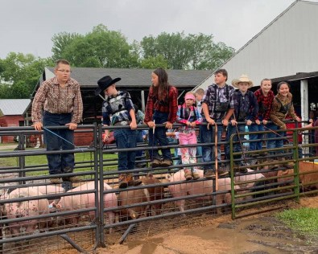 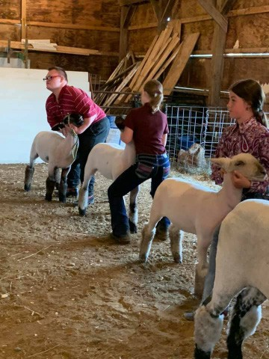

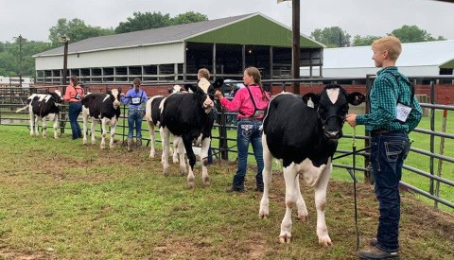

**Supporting Tomorrow’s Farmers Today!**



**225 W Center St Ithaca, MI 48847**

**(989) 875-4715**



**1031 E CENTER**

**Ithaca, MI 48847**

**(877) 844-8504**



**“An Employee Owned Company”**

**PHONE: (989) 875-3988**

**FAX: (989) 875-4015**

**209 WEST SOUTH STREET ITHACA, MICHIGAN 48847**

[**www.dmirar.com**](http://www.dmirar.com/)



Licensed and Insured

Free Estimates

**Burford Plumbing & Heating**

Commercial / Residential New & Remodel Plumbing, Boilers, & HVAC

Phone (989) 875-6601

Fax (989) 875-6602

On Call (989) 436-2200

205 S. Pine River Ithaca, MI 48847

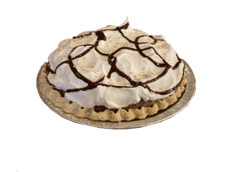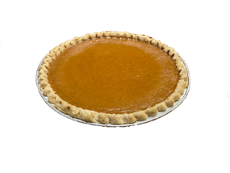

Welcome To

Middleton Diner

“Where the food is homemade and the service is friendly.”

**Since opening in 1948 the Middleton Diner has prided itself in the finest of home cooking! Generous portions and friendly service have established us as a constant at mealtimes for generations of local families.**

**Please visit us on Facebook for our Daily Menu and Everyday Specials.**

**Open Tuesday - Saturday 11am-7pm**

**Closed Sunday and Monday**

**(989) 236-7794**

**125 N. Newton St. Middleton, MI 48856**

**Good Luck To All Exhibitors!**

Arnold Law Offices Smith Concrete Whitmore Farms

Larry & Cindy Whitford Joe Thompson CPA Hub Tire & Repair



**(989) 682-4225 - Saint Johns**

**(989) 465-9577 - Coleman**

**C & C PROPANE**

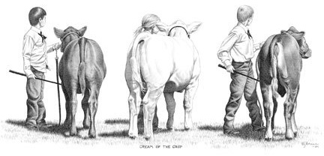

-Cylinders

-Motor Homes

- Bulk

**Phone: 989-838-2361**

*Good Luck to All Fair Participants*

**&**

PRINT • SIGNS • ENGRAVING • DESIGN • PROMOTIONAL

300 Industrial Parkway • Ithaca, MI 48847

(989) 875-2828 or [sales@esgraphics.com](mailto:sales@esgraphics.com)

**Simmet Insurance Agency**



Brad Simmet, Owner-Agent

117 W. Center Street

Ithaca, MI 48847

989-875-3580



**60**

**Gratiot Agricultural Society wishes to extend a heartfelt thank**

**you to JJ Ruby’s for catering our 2018 Farmer’s Day Dinner.**

**Gratiot Agricultural Society invites you to join in our annual Farmer’s Day Dinner. Tickets may be purchased at the door upon arrival.**

**JJ Ruby’s**

2862 North State Road, Ithaca, Michigan 48847 For all your catering needs please call: 989.875.3000

**Farmer’s Day Dinner Menu**

Grilled Steak (made to order) Baked potato

Coleslaw Drink Dessert

Hot Dogs with chips

Gratiot Agricultural Society invites you to join in our annual Farmer’s Day Dinner. Tickets may be purchased at the door upon arrival. The steak meal will be $10, and the hot dog meal will be $5. Dinner will be held in the Exhibit Building at the Ithaca Fairgrounds on June 24th from 2pm – 4pm. We look forward to seeing you

there!

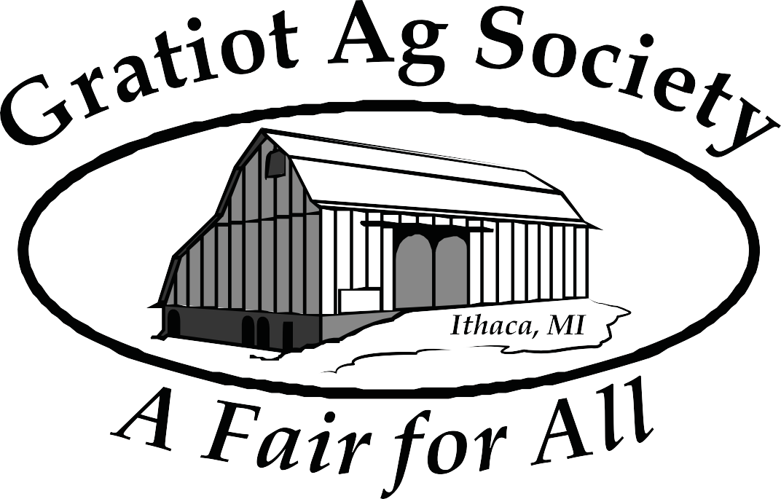**Dinner will be held in the Exhibit Building at the Ithaca Fairgrounds on June 23rd from 2-5PM. We look forward to seeing you there!**