Atmospheric Quality Limited - Modern Slavery Act Policy
1. Introduction
At Atmospheric Quality Limited, we are committed to ensuring that modern slavery does not take place within our business or supply chains. This includes any form of human trafficking, forced labour, or unlawful child labour. We are committed to acting ethically and with integrity in all our business relationships.
2. Objective
This policy aims to outline our commitment to the prevention of modern slavery in line with our obligations under the UK Modern Slavery Act 2015.
3. Policy
3.1 Compliance
We will comply with the provisions of the UK Modern Slavery Act 2015 and all other applicable laws and regulations that prohibit slavery and human trafficking.
3.2 Due Diligence
We will implement due diligence processes for our contractors, suppliers, and other parties in our supply chain to ensure they comply with the requirements of this policy and the Modern Slavery Act 2015.
3.3 Risk Assessment
We will periodically assess our operations and supply chains to identify any risks related to modern slavery and take appropriate action to manage those risks.
3.4 Training
We will provide training to relevant members of staff so they understand the risks of modern slavery and human trafficking in our supply chains and our business.
3.5 Reporting
We encourage all our employees, customers, and other business partners to report any concerns related to the direct activities, or the supply chains of, our organisation.
4. Breaches of This Policy
Any employee who breaches this policy will face disciplinary action, up to and including termination of employment. We will terminate our relationship with suppliers and contractors if they breach this policy or are found to be involved in modern slavery.
5. Review
This policy will be reviewed and updated as necessary to ensure its continuing suitability and relevance.
6. Approval and Implementation
This policy has been approved and authorised by:
Signed:
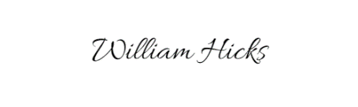
Director
Atmospheric Quality Limited
Date: 01/05/2023

