May 2023

Dear Partners and Friends,

We want to thank you for standing with us. 2 Corinthians 9:8, “God is able to make all grace abound toward you, that you always having all sufficiency in all things…” We need to remember that God is our source and provider, especially in the days that we are living in. Therefore, as Hebrews 10:35 says, “cast not away your confidence which has great reward”.

News from Myanmar:
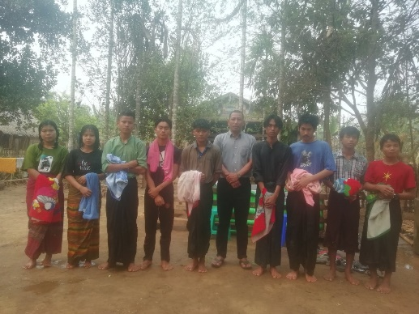
Since returning home from Myanmar, our teams are seeing many people open to receiving the gospel of Jesus Christ. In Rykine State, Elijah baptized nine new believers. We are helping Elijah build a church for them in this remote area.

In Mandalay Daniel baptized 6 new believers since I left there in March. We are helping Daniel and Sophia build a parsonage next to their new church.

Other news: At least 150 people, including civilians, were killed in central Myanmar after the nation's military junta launched an airstrike on an antigovernment ceremony north of the city of Mandalay. Our workers were not involved, and we thank God for divine protection during this time of conflict.

In April I held another week of teaching for Rhema Thailand. The students were all from Myanmar. It is always a joy to teach them even if it had to be by Zoom.

Roger’s mother, Ruth who was a Godly woman has gone to be with the Lord at age 92. Her last few months she had not been able to do anything, so she was ready to meet the Lord. We rejoice that she is in the presence of the Lord. Psalm 116:15- “Precious in the sight of the Lord is the death of His saints.”

Upcoming ministry: Roger will be in Pennsylvania for two weeks before Mary and Roger head back to the UK at the end of May.

Thank you for your prayers and support. We are blessed to have faithful partners who have a heart for missions.

In His service,

Roger and Mary King

