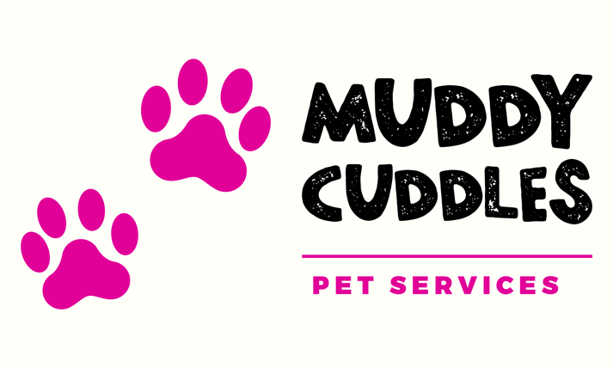

Client Dog Walking Agreement 2022
Dog Walking Agreement
Your Booking
Bookings are subject to these Terms and Conditions. Information given in the initial registration form will be used for all subsequent bookings unless we are notified otherwise.
Dog Walking
Your dog will be collected from your home and walked for the agreed time, on the agreed days. Muddy Cuddles reserve the right to walk other dogs at the same time, but the total number of dogs walked with one person at one time will not exceed 4.
If I am required to hold any keys to your home – purely for the use of collecting and returning your dog. Please be assured that this key will be used for no other purpose and will be kept safe & returned to the customer on demand.
Where a dog flap is fitted, it is the owner’s sole responsibility to ensure that the garden and its fences are secure. It is not Muddy Cuddles’ responsibility to check this before leaving your dog following a walk.
All dogs must have up to date inoculations and be parasite free prior to walking. The owner must
show their dog’s Vaccination Record/Booklet on commencement of dog walking with Muddy Cuddles & must disclose any medical conditions that may affect your animal’s health. All dogs must be micro-chipped.
Please note that under the Control of Dogs Order 1992, all dogs must wear a collar and an identity tag in a public place, with the tag detailing the name and address of the owner

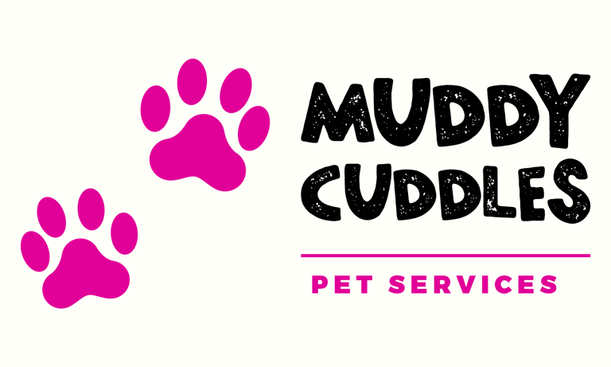

Client Dog Walking Agreement 2022

All owners are required to complete fully and honestly the Pet & Client Form and agree to our Terms and Conditions. Muddy Cuddles must be alerted to any behavioural problems with their pets at the time of booking. Failure to do so may result in additional charges or cancellation of any future contract. Muddy Cuddles will inform the owner of any incident or anything which Muddy Cuddles notices about the dog, which the owner ought to know. Muddy Cuddles will take care, so far as is practicable, that the dog is not a nuisance or danger to anyone, or any other animals, and that no harm comes to it.
Muddy Cuddles recommend that your dog be insured against sickness, accident or injury and for third party liability prior to walking.
Your Dog
I understand and agree that in admitting my dog, that Muddy Cuddles has relied on my representation that my dog is in good health and has not harmed or shown aggression or undue threatening behaviour toward any person or any other dog. I further agree to notify Muddy Cuddles of any unwelcome, aggressive, procreative, or dangerous behaviour of my dog that has potential to cause harm to any other pet or individual.
I understand that whilst my dog is walking with Muddy Cuddles, they will be walked with other owners’ dogs and that Muddy Cuddles will have assessed these in terms of behaviour & temperament. I further understand that during normal dog play, an owner’s dog may sustain injuries. All dog play is carefully monitored at Muddy Cuddles to avoid injury, but scratches, punctures, torn ligaments, or other injuries may occur despite the best supervision. I understand that I am responsible for the medical treatment of any injuries or illness that my dog receives whilst under the care of Muddy Cuddles & I agree to pay all vet care and costs that may arise due to the injury or illness.
I understand that should my dog attack/be involved in a dog fight with another dog/person, causing injury to that dog/ person, that I the owner am responsible for any losses incurred as a result including (but not limited to) payment of vet fees in respect of injuries to another animal caused by the owner’s dog.
I agree for Muddy Cuddles to make any decisions regarding my dog’s health providing they are acting in the best interests of my dog; that they have made every attempt to contact me or the Emergency Contact person first and that it is on the advice of a qualified veterinary surgeon. Vet bills that my dog may incur will be met by myself on my return.

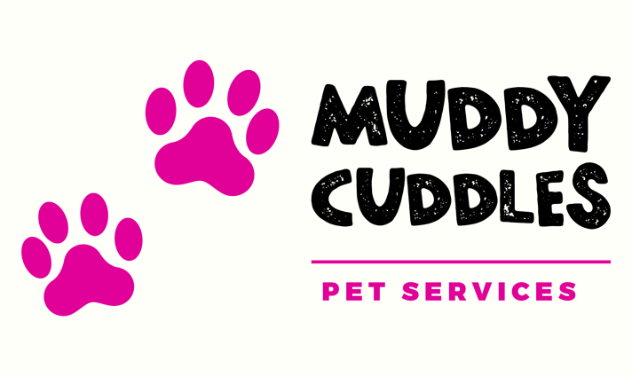

Client Dog Walking Agreement 2022

I understand that should my dog attack/be involved in a dog fight with another dog/person, causing injury to that dog/ person, that the owner is responsible for any losses incurred as a result including (but not limited to) payment of vet fees in respect of injuries to another animal caused by the owner’s dog.
In the highly unlikely event that my dog’s behaviour become uncontrollable, destructive or unreasonable, I accept that he/she could be placed in a dog boarding kennel at my own expense until my return and will be subject to a £25.00 transfer charge.
Muddy Cuddles recommend that your dog be insured against sickness, accident or injury and for third party liability prior to boarding.
Emergencies & Insurance
Muddy Cuddles is covered by business public liability insurance with care custody and control extension liability to animals. Insurance does not cover any costs that may be incurred, either veterinary or other, due to sickness, accident or damage caused to or by any guest dog. Muddy Cuddles will care for your animal as you would, and whilst we will make every effort to ensure your pet is well looked after in your absence, Muddy Cuddles cannot be held liable for any loss, injury or death to a pet either whilst in our care.
Charges & Cancellation Policy
Payments are accepted in cash or BACS. Invoices are sent out at month end.
Should you need to cancel your booking please let me know with as much notice as possible.
Cancellations on the day of walking MAY incur a 100% charge. Cancellations less than 24 hours may incur a 50% charge
I will let you know as soon as possible if there is a problem and I need to cancel.

Client Dog Walking Agreement 2022
Social Media
My pets’ images can be used in photo & video footage and can be used on social media/website/advertising without prior approval by me. All content remains the property of Muddy Cuddles and will be kept by Samantha Wheeler unless requested otherwise. Please indicate below:
Yes, I am happy to have images/videos used on social media.
No, please do not use images/videos of my pet.

Off Lead Walking
If you are happy for your dog to walk off lead (in a safe environment), please sign below.
I am happy for my dog to be allowed off lead, when in a safe environment to do so. I understand that Muddy Cuddles will have less control over my dog/s actions & I therefore accept full liability for any damage caused to or by my dog. I take responsibility for any disappearance of my dog and full actions of my dog whilst off lead.
I hereby authorise my dog to participate in Off Lead Walking.
Signature Date

All animal owners to sign
I certify that I have read and understand the terms and conditions set forth and accept all terms, conditions, and statements of this agreement. I understand that this agreement applies on every occasion where I deposit my dog with Muddy Cuddles..
Name of owner & dog (PLEASE PRINT)

Signature of Owner Date

