Lenny and the DreamMakers
Annual Report 2021

It is easy, in the midst of a pandemic, to want to gently close the door and forget about everything. It feels risky to go out of your house, to give away what you have, to reach out to others. But withholding is a risk, too. How much is enough? How much is too much? It is risky to your well-being to live with these feelings of scarcity.

Life opens and expands when we let go of scarcity and live and give in abundance. So instead of wasting energy withholding what we have, we spend our energy offering a friendly hand, an extra blanket, a happy smile. We find that giving helps us remember we are not alone as we simply offer our abundance to others. In addition, we soon realize there is no reward without a little risk, and this year we took a few little risks along the way.

For 2021, we committed to continuing our once a month Capers to the Stability Site to bring a meal and whatever donations come in each month. Costing about $400 a month, this is a bit of a risk for a small organization like ours.

In addition to the monthly meal, in January we ended up with a gift card for $400 and were able to convert it to $25 gas cards for people living in their cars. We worked with Colin at Strategies to distribute the cards. In return he rewarded our risk with some cases of hand soap, lotion and hand sanitizer.

February brought us Jeffrey Boyle, a friend of Sunshine, who was needing some help cleaning up several encampments where he worked. We bought him brooms, dust pans and garbage bags to help with the cleaning. This also acted as a catalyst for us to bring the same supplies to the Stability Site on one of our monthly visits.

March was a month when we added an additional Caper, this time at Altheimers Family Shelter, where we brought baby items to two expectant moms along with pillowcases, hand sanitizer and masks for everyone else. We took a little risk that we would have enough time and people to go to two places and provide some of their needs, and it worked.

April found us doing a FunDrive with Value Village where we earned over $350.00 by recycling the clothing we could not use along with the leftover clothing from Western State Hospital. Thanks to Kjersten who works there and facilitates the pick-up times. They had a large backlog of clothes from people who left the hospital and their clothing behind. This has turned into an ongoing solution where everyone benefits as they constantly have mountains of clothing that they have no where to store and we can turn it into cash for our programs.

The month of May was filled with lots of activity like delivering a used refrigerator and freezer to the Stability site and setting a shopping day for people at the Women’s Shelter. We dropped off a van full of boxes of women’s and children’s clothing. The workers there did the physical set up for their residents to shop and pick out what they needed. Along with the monthly meal, at the Stability Site this month we planted and delivered 10 huge buckets of flowers.

June was busy as it began with our long-awaited Garage Sale. After two years of saving items to sell, we had our hugest sale ever. The proceeds of the sale were $3800, making our two years of storing and three days of hard work worthwhile. Not only the sale, but throughout the month we had lots of activities. We also contributed fanny packs and stuffed animals to a Teen carnival at the Women’s shelter, diapers to Altheimers, and clothing for a mom fleeing domestic violence. At the end of the month we did another Caper at the Stability Site and a FunDrive with Value Village.

Nativity House asked for and received luggage we collected in July. Our Caper this month was a meal of Sub Sandwiches and a big basket of summer stuff like flip flops, sunscreen, visors, deodorant and lip balm.

In August we took bed pillows and fried chicken dinners to the Caper at the Stability Site. We also held a thank you barbecue for our donors and volunteers. It was a lovely sunny afternoon where we all had a chance to visit and relax.

We took a minor risk in September by bringing chili, and corn bread made by Ron. It was a different kind of meal than what we normally do. A little harder to set up and keep warm, but the residents were pleased. We focused on bringing towels and washcloths.

As the weather started to turn a bit colder, we focused the month of October on bringing warm coats. They were well received along with the pizza we brought for dinner. We were rewarded this month with a $2500 grant from the Cheney Foundation. This allowed us to take advantage of pre-Christmas sales to bolster our inventory in the Welcome Box Warehouse. November brought another FunDrive with Value Village and we again made about $500 for over 3000 lbs. of goods. For the Caper we brought a thanksgiving dinner of turkey sandwiches, cranberry sauce, olives, chips and pumpkin pie. We also brought hats, gloves and scarves to the residents.

December was the crowning glory of giving our abundance for the year. We spent a day wrapping pillowcases and treats for each of the 65 residents at the Stability Site. We also sponsored a family for Catholic Community Services and wrapped their gifts that day as well. In addition, we collected and delivered a van full of children’s toys and clothes for the Women’s Shelter. After bringing a fried chicken meal to the Stability Site we thought we were through for the month. However, due in part to the wintry weather, we next connected with New Hope, an organization that works with people who are homeless and living in their cars. With chilly weather settling in we used the last of our Cheney money to buy forty $25 gas cards and filled small goody bags for each of those people. The weather was not through with us yet! Heavy snow prompted the county to open warming centers around the city. We were able to deliver blankets to one of those spots. We delivered those on New Year’s Eve and so the year of 2021 ended abundantly.

Our financial situation continued to be healthy. We received an unexpected $2500 grant from the Cheney Foundation which moved our total revenues and expenditures higher than we had predicted.

This is what our finances looked like in 2021:

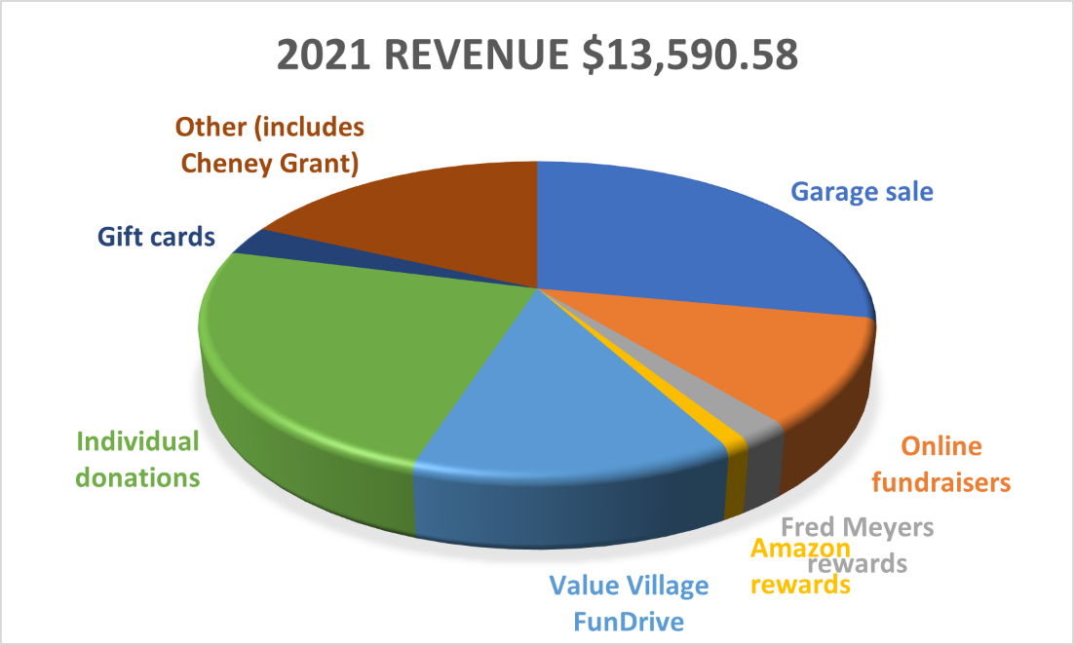

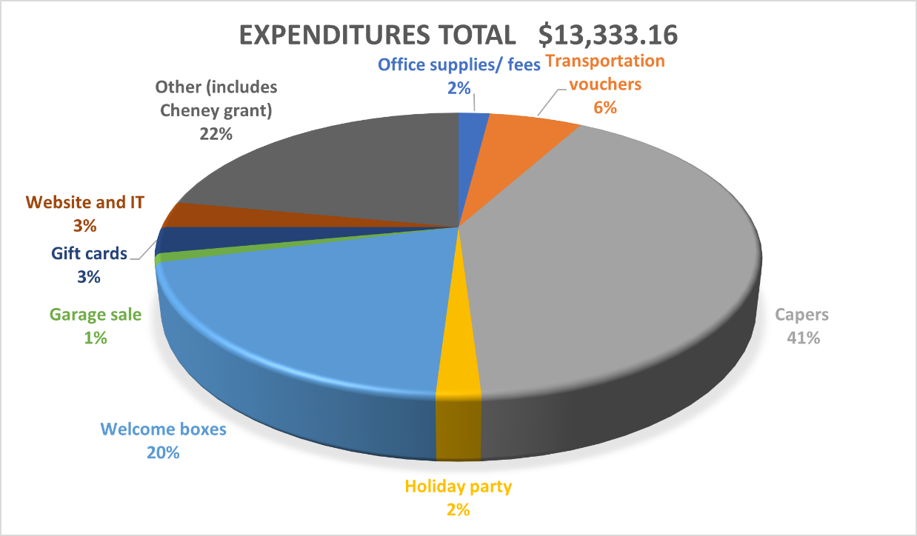

Some of the abundant happenings in 2021 included the following:

- Sadly, our spokes cat Lenny passed this year. We will always remember him.
- Garage Sale proceeds were an amazing $3779!
- Made and delivered over 500 cards to Hospice and St Michael’s Medical Center.
- Made and donated 147 pillowcases and 158 blankets.
- 23 dedicated people logged 1739 volunteer hours throughout the year.
- Delivered 770 meals to shelter sites.
- Projected revenue of $9250 was exceeded by $4340 to total $13,590.
- We had our biggest year ever with 59 Welcome box families which served 129 people.
- Helped to set up an activity tent at the Stability Site with the donation of a TV, phone charging stations, DVD player, DVDs, and a large rug.
- Purchased a microwave and a garage-ready refrigerator for the Stability Site.

Thanks to all the generous donors and hard-working volunteers, this is some of the abundance we were able to share in 2021.

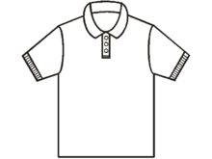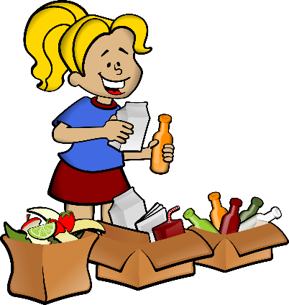

770 meals 8100 pounds of clothing 59 Welcome box families

Doing the best you can at the moment puts you in the best place for the next moment.
Oprah

Having done our best, Lenny and the DreamMakers is ready for all the next moments that 2022 will bring!

