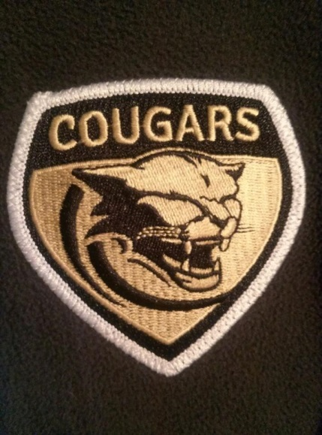
TCHS BOYS SOCCER TEAM
TCYSA
YOUTH NIGHT

Friday, February 16th
The Boys Varsity soccer team will conduct a FREE 40 minute soccer clinic for youth players in the Cougar indoor field. The clinic will be from 6:00p-6:40p. After the clinic, TCYSA players could walk a varsity player onto the field.
- ALL TCYSA players that wear their team jersey will get in free.
- All TCYSA coaches that wear their badges will get in free.
- A $5.00 meal deal will be offered that will include a hot dog, cookie, chips and a bottle water or soft drink.
- RSVP to Yanilsa Griffin 214-783-0687 or Misty Caylor 972-900-9520 by 2/14 4pm
SO BRING YOU WHOLE TEAM AND CHEER ON YOUR BOYS VARSITY COUGAR SOCCER TEAM.

