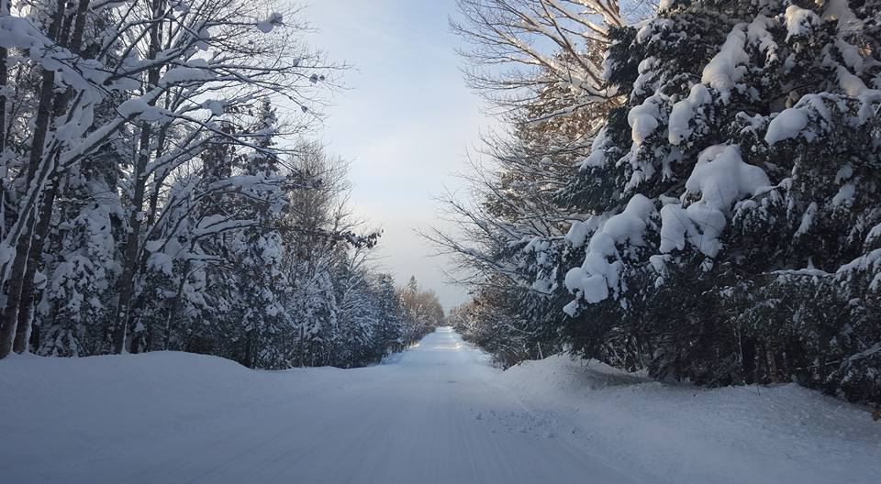
PAID
DATE_____________________
AMT______________________
CASH_____________________
CHECK #___________________

NORHTERN LIGHTS TRAILS MEMBERSHIP FORM
DATE____________________
NAME___________________
ADDRESS_______________________________________
CITY________________ STATE______ ZIP____________
COUNTY_________________
PHONE__________________
E-MAIL_________________________

NLT MEMBERSHIP $5.00
MN USA MEMBERSHIP $30.00
TOTAL DUE $35.00

Do you belong to more than one snowmobile club? Yes_____ No_____
If yes, do you pay your MN USA dues through that club? Yes_____ No_____

Make Checks Payable to: NLT
PO Box 153
Benson, MN 56215

