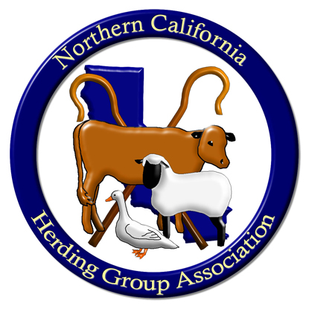
Northern California Herding Group Association, Inc.
AKC-Sanctioned B - CONFORMATION MATCH
For AKC Herding Breeds, Miscellaneous & FSS Herding Breeds Only
Saturday, February 10, 2024

Location: Gold Canal Veterinary Urgent Care
3017 Gold Canal Drive, Rancho Cordova, CA 95670

Judge: Ellen Perlson
Pembroke Welsh Corgis
Multiple show/breed National Specialty placements

Judging to start promptly at 10:00 A.M. – All Judging will be INDOORS

Classes offered: Puppies: 3-6, 6-9 and 9-12 mos. Adults: Bred by Exhibitor and Open
*** All classes shall be divided by dogs and bitches; puppies do not compete with adults. NO Champion of Record NO ear racks or tape - AKC approved collars only

Pre-entries close: Friday, February 2, 2024 at 5:00 P.M.

Mail Entries to: Brenda Wherry, 1538 Faletto Avenue, Sacramento, CA 95835

Match Chairperson: Ruth Colavecchio, 916-477-7221, ruthcola@aol.com
Food: Morning hospitality will be provided.
Raffle: All forms of donations are welcome and appreciated.

Directions: Sunrise Blvd South from Hwy 50. Turn right on Sun Center Drive. Turn left on Gold Canal Drive to address.

Pre-entries: $10; Day of Match entries: $15 at Match between 8:00-9:30am.
ENTRY FORM: Make Checks Payable to: NCHGA PLEASE PRINT LEGIBLY

BREED: ____________________________________________ Sex: ______ Birth date: ________________________

Class Entered: ____________________________________________________

Dog’s Name: ___________________________________________________ AKC # ______________________________

Owner: _________________________________________________________ Phone: _____________________________
_
Address: _______________________________________________________ EMAIL: _____________________________

I agree to hold NCHGA, its members, officers and agents and Gold Canal Veterinary Urgent Care harmless and free from any liability for any alleged act of this dog in connection with this event. I assume all responsibility for all acts of this dog or myself or my family and hold the aforementioned parties harmless from any claims for loss or injury (including death) of this dog, myself or my family. I understand and will abide by AKC Rules and Regulations.

SIGNED: _______________________________________________________ Date: ________________________

