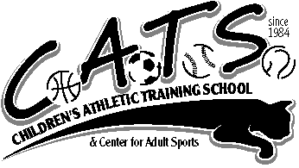
2024 SUMMER CLASS SCHEDULE
JULY 1ST THROUGH AUGUST 30TH

ADULT & ME MULTI SPORT CLASS
AGES 1 & 2 YRS
$250 - 50 MINUTE CLASS
REWARDS CLASSES $5 EACH
WEDNESDAYS & THURSDAYS 3:30-4:20

SPORT DEVELOPMENT MULTI SPORT CLASS
AGES 3 – 7 YRS (CHILDREN ARE SEPARATED BYAGE)
$265 60 MINUTE CLASS
REWARDS CLASSES $5 EACH
MONDAYS – FRIDAYS 1:15-2:15 & 2:30-3:30

USTA QUICKSTART TENNIS
SMALL GROUP, PRIVATE OR SEMI PRIVATE LESSONS
CALL TO SCHEDULE OR TO ARRANGE YOUR OWN GROUP,
SEMI PRIVATE OR PRIVATE LESSONS!

KARATE WITH STEVENS KARATE ACADEMY AGES 3 & UP!
MONDAY, WEDNESDAY & FRIDAY - 1:15-2:00 OR 2:15-3:00
WEDNESDAY & THURSDAY – 4:00-4:45
$280 45 MIN CLASS

188 MAPLE AVE. RVC, NY 11570 516-763-1299
WWW.CATSRVC.COM CATSRVC@GMAIL.COM

