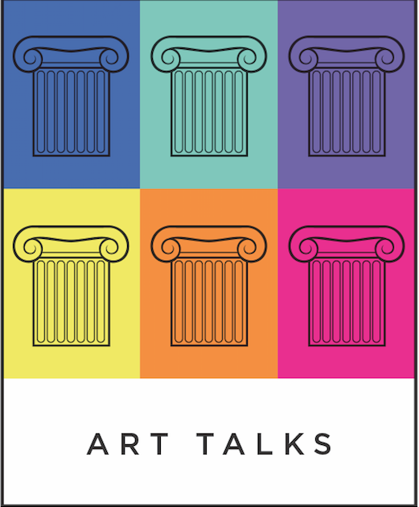 | TIME | PLACE | CATEGORY | TITLE | £  PRICE | Tick this column to book
Tuesday  18th June | 7.30pm -9.30pm | Stitches Haberdashery, Mulgrave Road. Cheam | Art & Bubbles:  evening presentation | A Man’s Best Friend; An Artist’s Best Subject: Canine images in Art | 15 | Book through Stitches website
Tuesday  2nd  July | 7.30pm -9.30pm | Stitches Haberdashery, Mulgrave Road. Cheam | Art & Bubbles: evening presentation | Victorian Art: Innovation in Colour | 15 | Book through  Stitches website
Friday  5th July | 11am- 1pm | Sutton Life Centre,  Corner of A217 and Sutton Common | Slice of Art:  presentation & cake | Oh I do like to be beside the Seaside!: Images of the Seaside in Art | 18
Tuesday  16th July | 7.30pm -9.30pm | Stitches Haberdashery, Mulgrave Road. Cheam | Art & Bubbles: evening presentation | A Style of its Own: Modernism & American Art | 15 | Book through Stitches website
Friday  19th July | 11am- 1pm | Sutton Life Centre,  Corner of A217 and Sutton Common | Slice of Art:  presentation & cake | Victorian Art: Innovation in Colour | 18
Weds  24th July | 12 noon | Tate Britain  Millbank, Pimlico | Gallery Visit | Freedom on the Face: Portraiture in the Tate from the Enlightenment to the Swinging Sixties | 15
Friday  16th August | 11am- 1pm | Sutton Life Centre,  Corner of A217 and Sutton Common | Slice of Art:  presentation & cake | The Impression of Expression: the Impressionists as Portrait Painters | 18

 | TIME | PLACE | CATEGORY | TITLE | £  PRICE | Tick this box to book
Tuesday  20th  August | 7.30pm -9.30pm | Stitches Haberdashery, Mulgrave Road. Cheam | Art & Bubbles:  evening presentation | Satin and Lace: a look at the portrayal of luxurious dress in portraiture from the Renaissance onwards (Moroni to Tissot). | 15 | Book through Stitches website
Tuesday  3rd  September | 7.30pm -9.30pm | Stitches Haberdashery, Mulgrave Road. Cheam | Art & Bubbles: evening presentation | Would you want Leonardo da Vinci working in your home? A look at this polymath’s working practice. | 15 | Book through Stitches website
Friday  6th  September | Leave  Sutton at  9.30am | Ashmolean Museum,  Oxford | Museum tour | A tour of the extensive collection of old masters from the Renaissance onwards, concluding with the Pre-Raphaelites. | 18
Monday  16th  September | Leave Sutton at  10am | Windsor Castle. | Visit | An exciting visit to the prints and drawings room at Windsor. | 22
Tuesday  17th  September | 7.30pm -9.30pm | Stitches Haberdashery, Mulgrave Road. Cheam | Art & Bubbles:  evening presentation | Art and Power. Effective propaganda is usually visually stunning and can be dangerous. | 15 | Book through Stitches website
Friday  20th  September | 12 noon | National Gallery,  Trafalgar Square | Gallery Visit | Blue Art: a look at the use and significance of this colour in art with reference to the paintings on display. This will include works by Leonardo, Constable and George Bellows. | 15

