Causation and Correlation: The Perpetual Debate
By Ashleigh Richardson

When it comes to the narrative of Cannabis and Mental Health, almost all the focus has been placed on the idea that Cannabis can be a, or the, cause of serious mental health issues and illnesses. This belief can be defined as causation; the opinion or understanding that “one event is the result of the occurrence of the other event… also referred to as cause and effect”. (Australian Bureau of Statistics).

While there’s certain contexts in which causation can be proven, for example “the longer you spend in the bath, the more wrinkled your skin becomes” (Venatu), but to apply the uncompromising standard that Cannabis must cause mental health issues is misguided, inaccurate, and frankly false.

Correlation, on the other hand, is defined as simply, “a connection between two or more things” (Cambridge Dictionary), while TechTarget defines it as a “statistical measure that indicates the extent in which two or more variables fluctuate in relation to each other”.
Those who are suffering from severe symptoms may use cannabis for a variety of reasons, including to self-medicate, and that is correlation.

A spurious correlation is when “two factors appear causally related to one another when they are not”. (Investopedia) To express further the need for context when it comes to Cannabis in the debate of causation and correlation, I want to share a website called “Spurious Correlations” (tylervigen.com) put together by a man named Tyler. This website has compiled tens of thousands of spurious correlations as examples of why data that aligns is not always causally linked. Find below some of Tyler’s data:

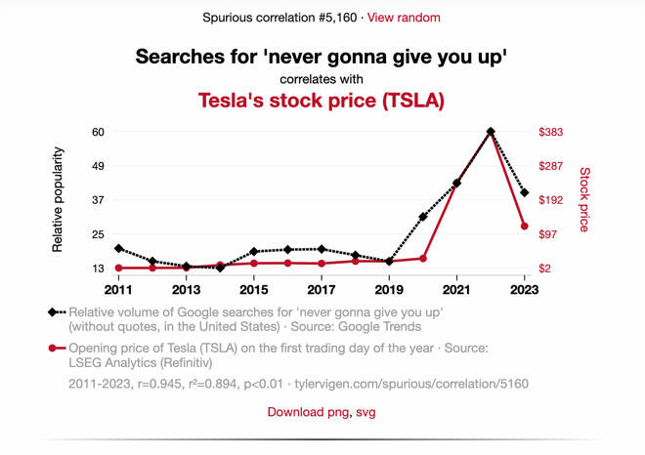
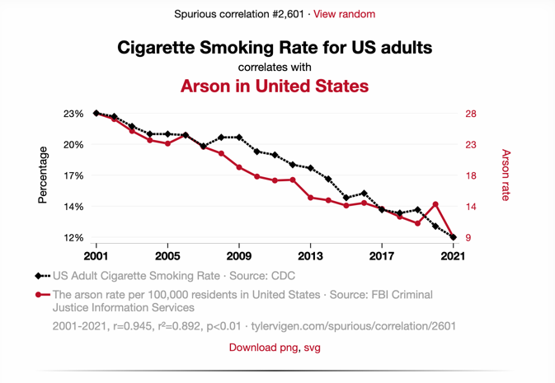

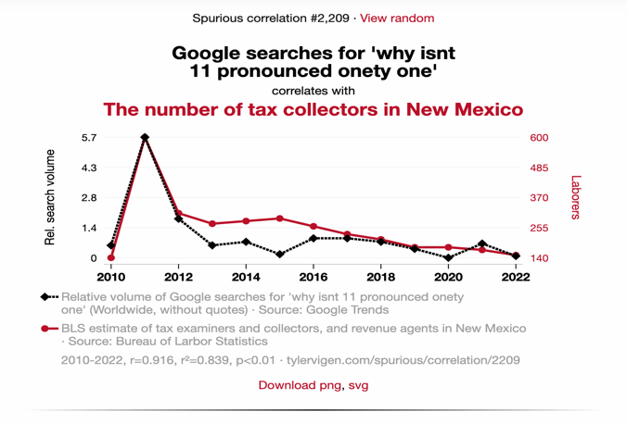
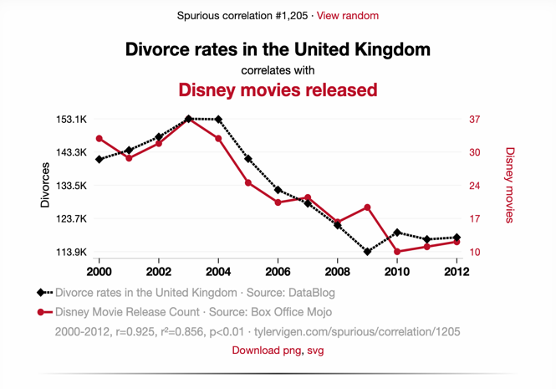

Tyler Vigen himself describes his site as “a project that is fun first, and mildly educational second”, but follows with “you shouldn’t take this project as a warning against believing research. You also shouldn’t take it as an afront on correlations (or P-values). These are useful tools when used correctly”.

I don’t want this article to suggest that seeking information out to understand the effects of Cannabis, is unwarranted or unwise in any context. But when causality is accepted without question in Medical Studies and other sources of information, it misinforms the public and undermines the research that is legitimate in this debate.

To finish, I want to quote Professors Carl L. Hart and Charles Ksir, whose article “Correlation still does not imply causation” we used in our PSA series:
“We are concerned that a misunderstanding of the relation between cannabis use, and psychotic behaviour leads to an oversimplification of the complex developmental nature of substance use and mental disorders. Furthermore, we propose that future studies that limit their data collection to focus only on Cannabis and only on Psychosis will do little to enhance our understanding of the complexity of this comorbidity.”

