Knowing The Difference – Understanding Sources of Information in the Modern Age.
By Ashleigh Richardson

“It is a very sad thing that nowadays there is very little useless information.”
This Oscar Wilde quote frames the content of this article precisely, as the way information, and our access to it, has transitioned throughout history, means we are now in a sea of sources when it comes to knowledge.

However, with the incredible access to, and overflow of, information in the Modern Age, the rise in misinformation has insidiously increased alongside.
The following article is a guide to understanding how to access accurate, impartial, and objective data in the onslaught of subjective material, opinion, and mistruths.

We first must start with understanding the difference between types of academic information, articles, studies and clinical trials. Bridgewater State University broke down these differences as follows:

- “Scholarly or research articles are written for experts in their fields. These articles are often peer-reviewed or reviewed by other experts in the field prior to publication. However, “not all articles are peer-reviewed. For example, an editorial opinion… or other content can be published in a scholarly journal [having] not been peer-reviewed”.
- “Review Article: (Secondary Sources) Article that summarizes the research in a particular subject, area, or topic. They often include a summary, a literature reviews, systematic reviews, and meta-analyses.”
- “Opinion Piece: An opinion piece often includes personal thoughts, beliefs, or feelings or a judgement or conclusion based on facts. The goal may be to persuade or influence the reader that their position on this topic is the best.”
Other means of information (provided by Bridgewater) include Empirical Studies, “based on observation, experimentation, or study”, as well as Clinical Case Studies and Clinical Trials, based on primary and/or original sources. To apply this in the context of the Cannabis debate, we will highlight the differences in the sources of information above through examples of those sources.

Journalistic articles are usually reports in and around current news stories, as well as covering different topics such as politics and economics, as well as general interest stories and articles. What is important to understand when utilising articles from news sources is that language is fundamentally used to influence the reader, and while there is a certain standard that is adhered too, journalistic articles need to be cross-checked against other sources to fully confirm or deny a story.
Find below examples of journalistic articles reporting on Cannabis:
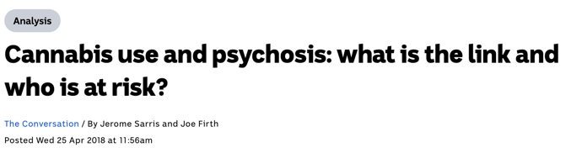

A Scholarly Article is an information source written by Academics in specific fields; these types of articles are used to share new information, theories, findings and/or summaries of current knowledge. Sources used in these types of articles are formed with either Primary or Secondary research.
It is hugely important to know that there is sometimes a difference when it comes to peer-reviewed articles and scholarly articles, as the University of Toronto Library put it:
“all peer-reviewed sources are scholarly, but not all scholarly sources are peer-reviewed”.

Find below The Journal of Cannabis Research, a collaborative and peer-reviewed source for scholarly articles and studies, focussed solely on researching Cannabis in medical, legal and social contexts:

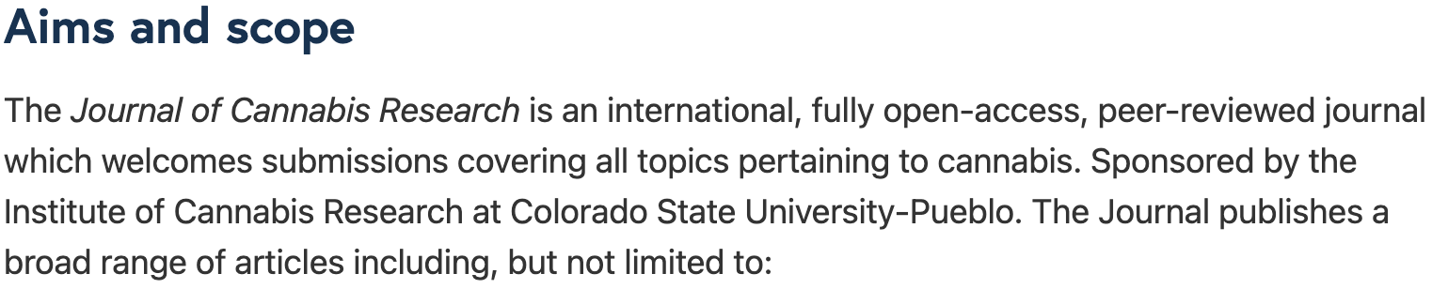

When it comes to Scholarly articles, always confirm that the article has a list of references that have been used to reinforce the study itself, the specific author or authors are named and their qualifications in relation to their study is clearly presented. Researching the institutions in which these articles are being put forward by can also help you uncover whether these articles should be taken with a grain of salt, or not.

So, to interpret Mr Wilde, and the quote that began this article – any form of information, factual and objective or otherwise, can always help point you in the right direction of finding the absolute truth, and that is incredibly useful.

Find a list of all sources used in this article below.
Authorised by The Green Revolution Australia.

