Two new dioramas have been added to the Heritage Centre’s collection for the new 2024 season of Open Days.
The first relates the story of an American B-24D ‘Liberator’, “Reddy Teddy”, based at RAF Holmsley South, which was on anti-submarine duties over the Bay of Biscay in 1943. The Liberator turned for home four hours into its flight but became lost, while returning in heavy rain and poor visibility, and clipped the top of Bossington Hill, on the north coast of Somerset, which was in low cloud.
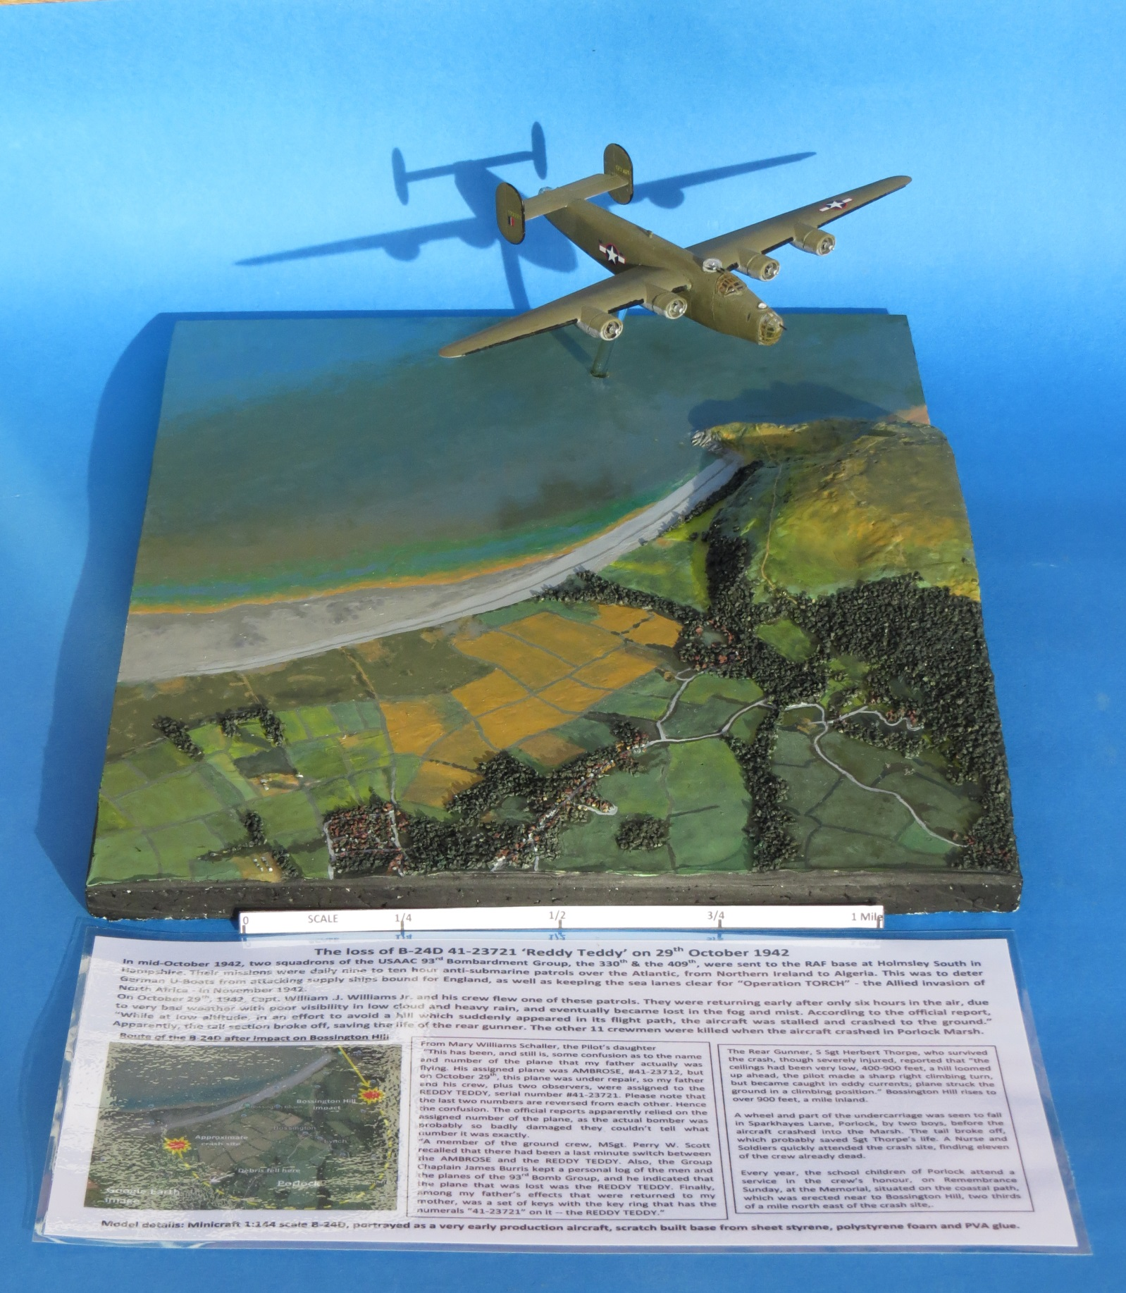
Two local boys, Alan Perkins and Brian Richards, saw the plane swing westwards in a long curve, over the village of Porlock, turning back towards the sea. Debris fell from the stricken plane, a wheel and part of the undercarriage plummeting onto Sparkhayes Lane, before the plane crashed on Porlock marsh. The crew included two extra pilots on a familiarisation trip. Of the twelve on board, only the tail gunner survived the crash. There is a memorial, half a mile east of the crash site, on the nearby coastal path.

The second diorama is a model of the type of Control Tower in place on many of the wartime airfields, which features internal lighting, vehicles, bicycles, a briefing room and a signal trailer, based on the type seen at Ibsley and Beaulieu airfields in the new Forest.
RAF airfield Control Towers, sometimes called ‘watch offices’, were built in several different configurations, mainly one or two storey buildings in brick or concrete, with modifications during construction, to suit local requirements.
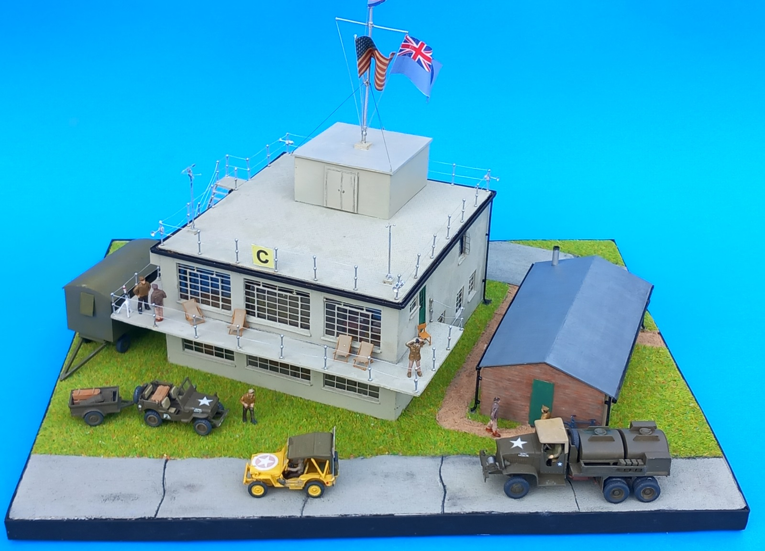
Most were of the ‘three windows’ or ‘two windows’ design, with the height of the ground floor windows being smaller in some cases, as at RAF Stoney Cross. The larger buildings contained, on the ground floor, a meterological office, switch room, duty pilot’s rest room, toilets and a watch office, where squadron deployments were charted, which faced the airfield runway area.
The upper floor comprised a signals office and switch room, a telephone exchange, the controller’s rest room and a large control room, facing the runways, from which operations were directed, with an outside balcony for direct observation, and a signal rocket launch tube.

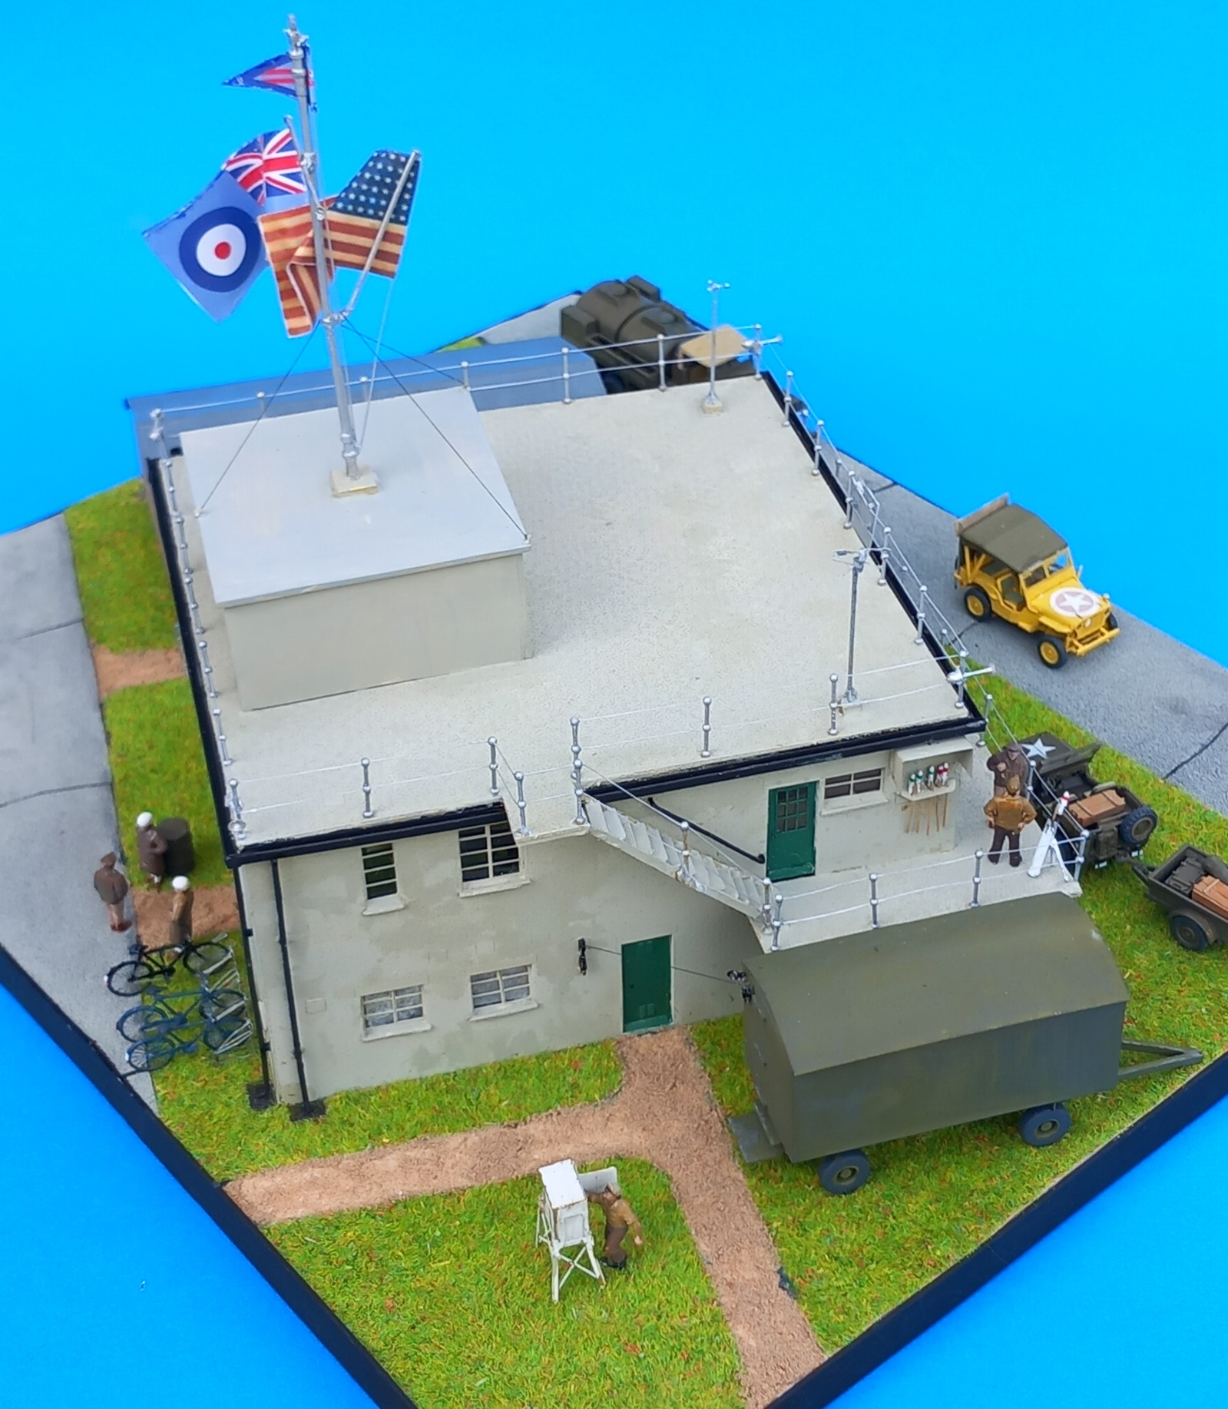
This example is a typical style and shape for the early towers, built in 1937-40, as at RAF Beaulieu and RAF Ibsley, before the modification of the latter’s stairwell, during construction. The diorama shows a typical situation around D-Day in June 1944, when Beaulieu (US Station AAF-408) and Ibsley (US Station AAF-347) were occupied by the 365th Fighter Group and 48th Fighter Group respectively, flying P-47D Thunderbolts.
The black and white Summer 1944 photograph of Ibsley below illustrates its wartime appearance.
