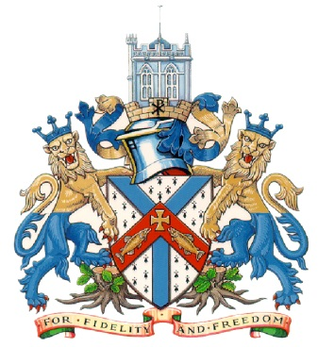 | Christchurch Town Council  Old Town Hall  30 High Street  Christchurch  BH23 1EA

PRESS RELEASE
Exciting D-Day:80 plans unveiled for major anniversary event in Christchurch
Christchurch Town Council is proud to unveil its exciting plans for a commemorative D-Day:80 event, set to take place on Christchurch Quay on Thursday, June 6.
This event marks the 80th anniversary of the historic D-Day landings, honouring the bravery and sacrifices made by those who served during World War II.
The free event aims to create a meaningful, respectful, fun, and educational commemorative celebration while highlighting the critical role Christchurch played throughout the war.
James Atkinson, Acting Town Clerk, said: “With a huge offering for everyone in the community, we are looking forward to hosting this magnificent commemorative event.
“With a focus on bringing the town together, the evening is designed to honour the legacy of our veterans and ensure their stories and the history of Christchurch is remembered for generations to come.”
As part of the national initiative by the Crown to commemorate the D-Day landings, every Council has been invited to participate in several key ‘moments’ on June 6. These include the Town Crier’s Proclamation, Ringing Out for Peace, Last Scots Pipe, Beacon Lighting, and Reading of the International Tribute.
The entire community is encouraged to come along with a picnic blanket and enjoy a beautiful summers evening, refreshments will be available from several food vendors and the Boat House.
Key Highlights of the D-Day:80 Celebration Event:
- The event will commence at 6pm with the Town Crier’s Proclamation, followed by Christchurch Churches ringing out for peace at 6:30pm.
- Attendees will enjoy performances by local choirs and bands, including the Funky Little Choir, British Legion, and headline vintage act The Fifinellas, between 6:30 pm and 9:00 pm.
- A ‘History Hub’ will be set up in collaboration with the Red House Museum, Christchurch History Society, and Friends of New Forest Air Fields, providing insights into the area's role in World War II.
- Community involvement is emphasised, with outreach to schools, Girl Guides and local charities to assist with decorations, the History Hub, and attendance in wartime dress.
- Additional entertainment will include classic cars, the fire brigade and stalls from community groups.
- The event will culminate in a stirring finale with the Last Scots Pipe, Beacon Lighting and reading of the International Tribute.
- This will be followed by a performance from the Christchurch and District Band playing wartime classics, members of the public are encouraged to take part in a torchlight vigil during the performance to pay respects to the fallen.
The event aims to strengthen community ties by fostering links with local schools, businesses, vendors, churches, and historical organisations.
Mandy Polkey, owner of Stir Events, said: “Stir Events CIC are both proud and pleased to be contracted to deliver such a special historical and commemorative D Day anniversary event in Christchurch. We very much enjoy working with the team at Christchurch Town Council and look forward to delivering this community event with them.”
Christchurch Town Council acknowledges the importance of commemorating the historical significance of the D-Day landings and is committed to organising a memorable event that honours the sacrifices of those who served.
With the support of the community and professional event management, the D-Day:80 Celebration Event promises to be a poignant and unifying experience for all attendees.
ENDS

