Please have your registration in before MAY 20th
2024 COLORADO STATE
TAXIDERMY CHAMPIONSHIPS
REGISTRATION FORM

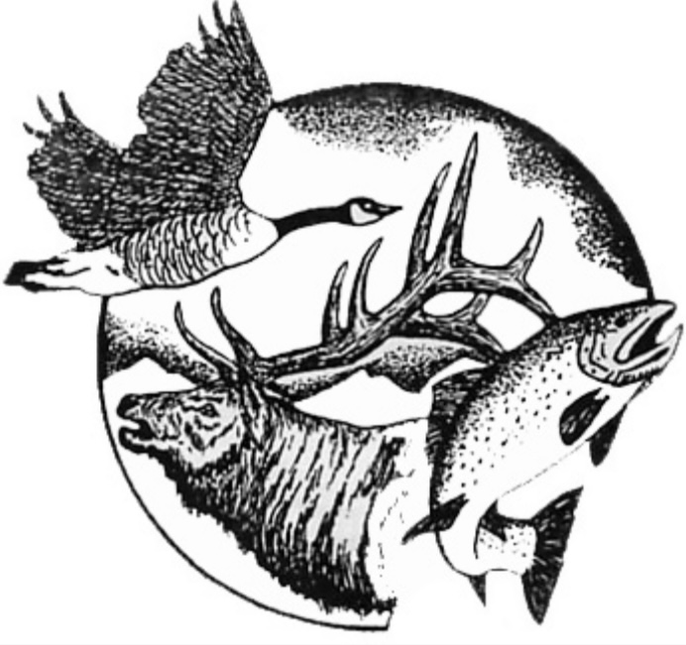
(A SPECIAL DRAWING WILL BE HELD FOR ALL PARTICIPANTS WHO PRE-REGISTER)
Name: _________________________________________________________________________________
Business: ______________________________________________________________________________
Address: _______________________________________________________________________________
City: _________________________________State: ____________________ Zip: ____________________
Phone: ______________________________ Email: ____________________________________________
CTA Membership (required by all competitors, unless already paid) $50.00 __________
Registration Fee includes 1 mount & 1 adult banquet ticket $85.00 __________
(After May 20th - $100)
Additional Mount Entries (# of) ___ mount(s) x $15.00 __________

Seminars: Competing Member & Immediate Family Member(s) $0.00 __________
Non-Competing Members (if 2023 membership fee is paid) $0.00 __________
Non-Member ($80/seminar) (# of) ___ seminars x $80.00 __________
Competitors Award (eligible if at least 4 mounts entered, 70% to winner) $10.00 __________
All Around Taxidermist (Bird, Fish, GH, LS – 70% to winner) $10.00 __________
Conservation Award (Any Category/Species: mount must have a story) $10.00 __________
Mounted In Gunnison Seminar $15.00 __________
Dinner will be a combination plate of Prime Rib and Chicken
Adults($35.00) Kids($15.00) | (# of)___adults x $35 + (# of)___kids x $15 = __________
KIDS ENTRIES - FREE (Add another page if necessary for additional entries)
Name: ______________________________ Entry: ____________________________________
Name: ______________________________ Entry: ____________________________________
If you are entering anything into competition award, please indicate which 4 mounts you would like judged.

DIVISION CATEGORY SPECIES COMP AWARD PRO 1 SPECIFY
(EX: Professional GH/Antlered Deer X wall, table, floor)

If you are entering into competition for awards, please indicate which 4 mounts you would like to enter.
(PLEASE DO NOT SEND PAYMENT, ALL FEES WILL BE COLLECTED AT THE DOOR)
Please mail/email registration to:
Cliff Carney || 121 E 12th St. Delta, CO 81416 (970) 234-0262 || cliffnttaxidermy@gmail.com

