MEDIA ADVISORY

CONTACT: Shyrea Thompson
202-427-8934
media@hela100.org
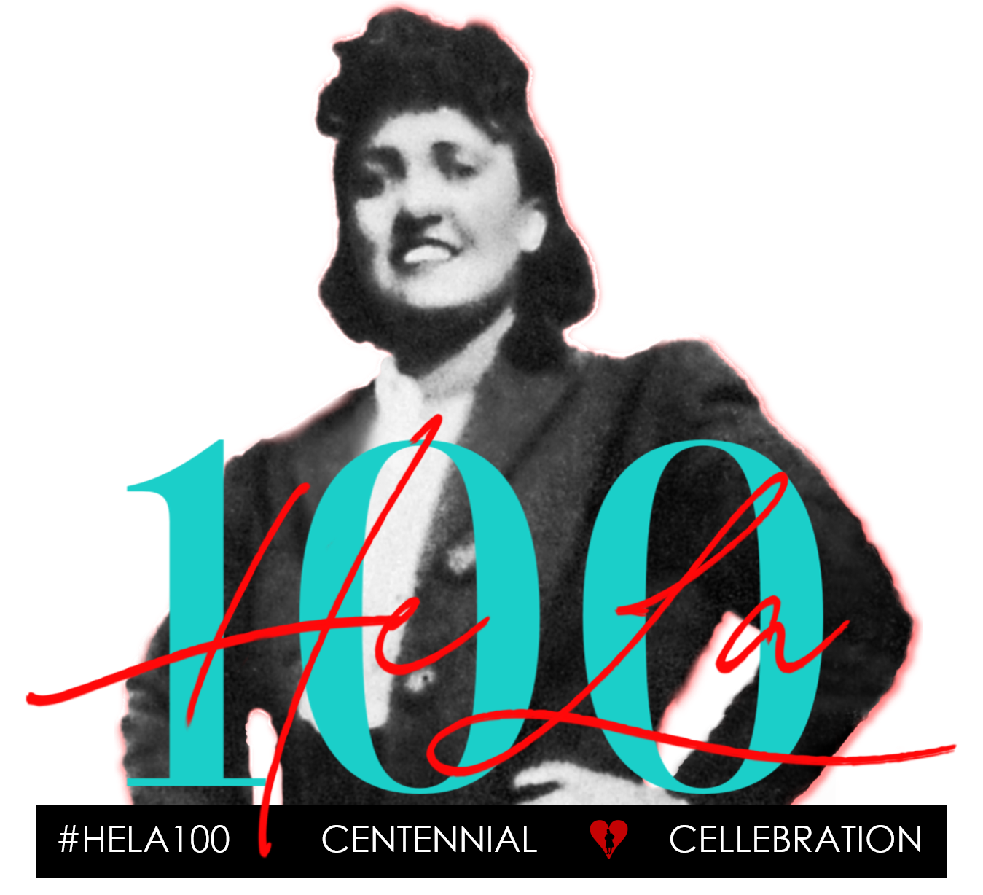

Henrietta Lacks' Family and the World Health Organization
Collaborate to Eliminate Cervical Cancer Worldwide

Baltimore Leaders and The Lacks Family to Light Up City Hall and Turner Station
to Honor Henrietta Lacks' Legacy During Her Centennial Year
BALTIMORE, MD (November 13, 2020) — Media are invited to the Lighting of Baltimore City Hall for the World Health Organization's launch of the Global Strategy to Accelerate the Elimination of Cervical Cancer. On November 17, iconic landmarks worldwide will be lit in teal – the color of cervical cancer awareness. The Lacks Family stands in solidarity to honor Henrietta’s centennial year. In 1951, Henrietta’s life was cut short by cervical cancer at age 31 - leaving behind a husband and five children. Decades later, her immortal HeLa cells are the most prolific cell line in medical research – including contributing to discovering the Human Papilloma Virus (HPV) causes most cervical cancers and creating the HPV vaccine. The Lacks Family collaborates to increase access for all women and girls to ensure no other mothers, sisters, or daughters die needlessly from cervical cancer.
DATE: Tuesday, November 17, 2020

TIME: 6:30 to 7:30 PM EST BEST TIME TO COVER: 6:45 – 7:15 PM EST

WHERE: On Location: Baltimore City Hall, War Memorial Plaza, 101 N Gay St., Baltimore, MD, 21202 (Outdoor plaza between E Fayette St. & E Lexington St.)

OR

Online: Virtually on Zoom (Link to attend https://tinyurl.com/lightupbaltimore)

WHO: On Location Available for Interview, Photo & Video
- Lawrence Lacks, Sr., Henrietta Lacks’ Son, and members of The Lacks Family
- Mayor-Elect Brandon M. Scott
- Alfred Lacks Carter, Jr. Henrietta Lacks’ Grandson; President & Founder, Henrietta Lacks House of Healing
- Veronica Robinson, Henrietta Lacks’ Great-Granddaughter
- David Lacks, Jr., Henrietta Lacks’ Grandson; Co-Founder, CELLebrate Henrietta Lacks

RSVP: To media@hela100.org if you will attend or to schedule an interview

SOCIAL @CELLebrateHeLa #HELA100​ #HenriettaLacks #EndCervicalCancer

About the HELA100: Henrietta Lacks Centennial CELLebration
August 1, 2020, marked Henrietta Lacks’ 100th birthday and the launch of The Lacks Family led “HELA100: Henrietta Lacks Centennial CELLebration” to honor her legacy through yearlong events, collaborations, and initiatives. Born on August 1, 1920, Henrietta was a Black woman, wife, and mother of five, whose HeLa cells - taken unbeknownst to her - would become responsible for some of the greatest scientific advancements of our time.

About CELLebrate Henrietta Lacks and the Henrietta Lacks House of Healing
Jeri Lacks-Whye and her brother, David Lacks, Jr. co-founded CELLebrate Henrietta Lacks to preserve Henrietta’s legacy and educate future generations on the impact of her immortal HeLa cells while promoting health equity and social justice. To implement HELA100, CELLebrate Henrietta Lacks collaborates with the Henrietta Lacks House of Healing, a 501(c)(3), non-profit organization founded by Alfred Lacks Carter, Henrietta Lacks’ grandson. Together The Lacks Family seeks to promote education and community programs to foster a greater appreciation and understanding of Henrietta Lacks’ legacy.

To learn more, visit hela100.org. For media inquires, image clearances, interview or speaking requests email media@hela100.org. View the HELA100 media kit here.

###

