DISHES AND THEIR ALLERGEN CONTENT
(Note – Please state the name of the cereal(s) containing gluten** in that column AND/OR the name of the nut(s)* in that column)
BRUNCH | 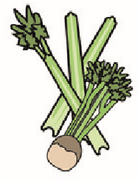 |  | 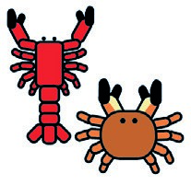 |  |  |  |  |  | 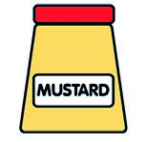
 | Celery | Cereals containing gluten** | Crustaceans | Eggs | Fish | Lupin | Milk | Molluscs | Mustard | Nuts* | Peanuts | Sesame seeds | Soya | Sulphur dioxide
BREAKFAST DONUTS |  | ✓ |  | ✓ |  |  | ✓ |  |  |  |  |  | ✓
- WILD BERRIES |  | ✓ |  | ✓ |  |  | ✓ |  |  |  |  |  | ✓
- MAPLE BACON |  | ✓ |  | ✓ |  |  | ✓ |  |  |  |  |  | ✓
- LEMON CURD |  | ✓ |  | ✓ |  |  | ✓ |  |  |  |  |  | ✓
TROPICAL FRUIT SALAD
OVER NIGHT OATS
- APPLE CINNAMON |  | ✓ |  |  |  |  | ✓
- FOREST FRUITS |  | ✓ |  |  |  |  | ✓
- COCONUT
Review date: 15.1.24 Reviewed by: JOSH PHILLIPS

