✓DISHES AND THEIR ALLERGEN CONTENT
(Note – Please state the name of the cereal(s) containing gluten** in that column AND/OR the name of the nut(s)* in that column)
COUNTER | 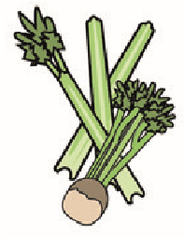 | 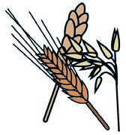 | 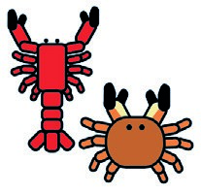 | 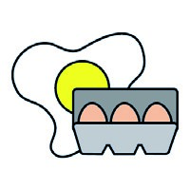 |  | 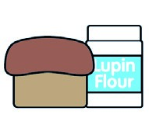 | 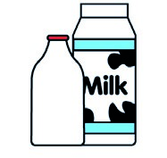 |  | 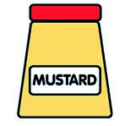 | 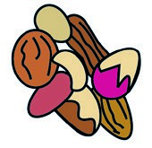 | 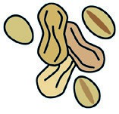 | 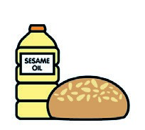 |  | 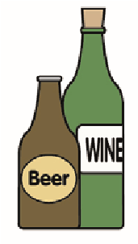
 | Celery | Cereals containing gluten** | Crustaceans | Eggs | Fish | Lupin | Milk | Molluscs | Mustard | Nuts* | Peanuts | Sesame seeds | Soya | Sulphur dioxide
SAUSAGE ROLLS |  | ✓ |  | ✓ |  |  | ✓
FRUIT SCONES |  | ✓ |  | ✓ |  |  | ✓ |  |  |  |  |  |  | ✓
SAVOURY SCONES |  | ✓ |  | ✓ |  |  | ✓ |  | ✓
CAKES |  | ✓ |  | ✓ |  |  | ✓
VEGGIE ROLLS |  | ✓ |  | ✓ |  |  | ✓
Review date: 15.1.24 Reviewed by: JOSH PHILLIPS

