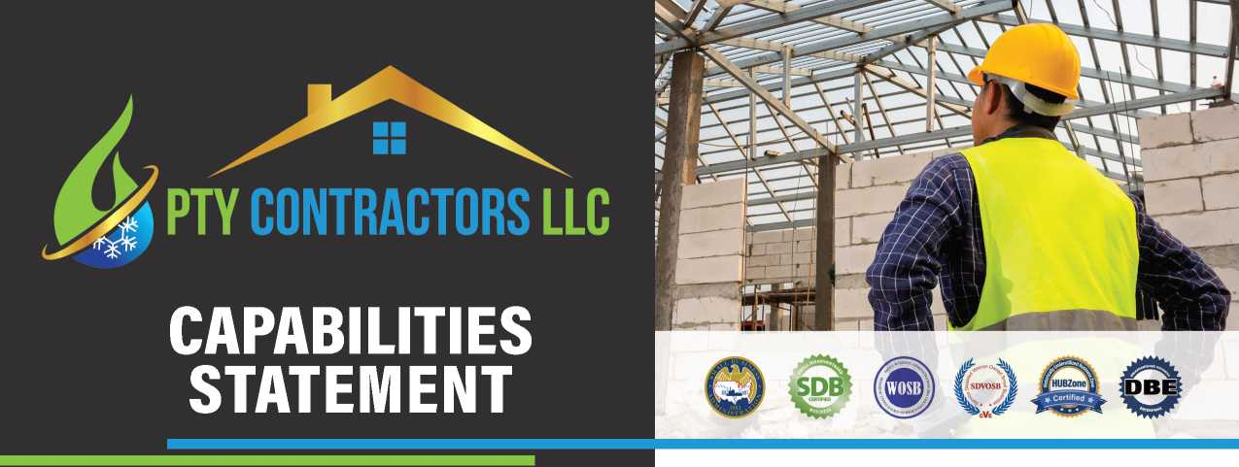

PTY Contractors LLC (PTY) is a Certified Roofing & Residential Contractor located in Northeast Florida specializing in roofing projects in the residential, commercial, and government markets. We offer additional services in the construction field such as new construction, renovation, repairs, bathroom remodel, kitchen remodel, consulting services, cost estimates, painting, flooring, drywall, janitorial, landscaping and finish carpentry.
Our business provides customers with products and services with quality workmanship and professionalism all at a fair and reasonable price. Our staff is skilled and well-trained to work efficiently and safely to complete your project on time and within budget.
CORE COMPETENCIES
COMMERCIAL & RESIDENTIAL ROOFING
NEW BUILD OF RESIDENCY
HISTORIC RENOVATION
RESIDENTIAL REMODELING
PAINTING
FLOORING INSTALLATION
CONSTRUCTION CLEANUP

DIFFERENTIATORS
- Storm Water Erosion and Sedimentation Control Inspector & Safety Management
- HAZWOPER 40 & LEAD Certified
- OSHA 30 Construction & OSHA 30 General Industry
- Licensed Real Estate Agent with NEFAR (2007)
- Network of certified contractors
- Over 60 years of accumulated experience
- Bonding Capability
- Quality workmanship
- Construction Site Safety Orientation (CSSO)
- USACE Construction Quality Management For Contractors #784
- Fall Protection in General Industry
- Aerial Lift Safety Training Course
- Powered Industrial Truck Safety Training Course
- COVID-19 Heath Assessment Training

CONTACT INFO
PTY CONTRACTORS LLC
ERICA POSTWAY
Cell 904.627.7793
Office 904.619.7459
Office Manager 904.318.7025
erica.postway@PTYcontractors.com
www.PTYcontractors.com
2339 West Beaver Street
Jacksonville, FL 32209

COMPANY DATA
CERTIFICATIONS:
FEDERAL: SDB, WOSB, SDVOSB, HUBZONE, DBE
State of FL: WBE, MBE, VBE
City of Jacksonville:
JSEB, SECTION 3 & OEO
NAICS: 238160, 236220, 238120, 238320, 238330, 238350, 561720, 238310, 561730
CAGE:85D06
UEI: WME8K6XQPAQ6
DUNS: 081305189
LICENSE#: CCC1335222
CRC1334380

PAST PERFORMANCES
Over 120 homes remodeled and managed for investors’ properties within
past 6 years.
TIAA STADIUM | Jacksonville, FL
Remove & replace ceiling tiles, vinyl base, carpet, paint walls, doors,
trims and ceiling grids.
ROOFING AND REMODELING:
Avalon Property Management | Jacksonville, FL
Jacksonville Rental Property Management | Jacksonville, FL
Dibo Holding | St. Augustine, FL
Titus Group | St. Augustine, FL
Tinhomme Holding Group LLC | Jacksonville, FL

CONSULTATION:
NEI General Contracting | Orlando, FL

