WOODLAND PARK FARMERS MARKET
VENDOR HANDBOOK
SUMMER 2024

ABOUT TCFMA/WPFM
Teller County Farmers Market Association, (TCFMA) is a 501(c)3 organization which provides a forum for sales of local produce and items associated with agriculture, garden & food. The association, originally formed in 1990 as Woodland Park Farmers Market, is operated by a part-time manager and assistant manager and a dedicated group of volunteers and is administered by a Board of Directors.

Our MISSION is to enhance the quality of life for Teller County residents and visitors by providing access to safe and affordable produce and other food, promoting agricultural land use through a direct market for growers, encouraging organic and pesticide-free growing techniques, and fostering health and well-being through community education. The summer market has been a lively and hugely popular part of Teller County life since 1991.
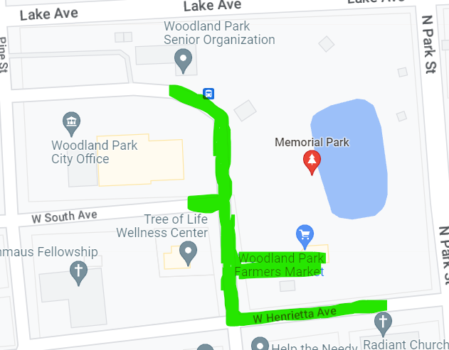

DATES, TIMES, LOCATION
The Woodland Park Farmers Market takes place:
Days: Fridays
Dates: June 7– August 9 and August 23 – September 27. No market on August 16.
Times: 8:00am-1:00pm
Location: Memorial Park, Henrietta Avenue, and Center Street, Woodland Park, CO.

APPLICATION
MarketWurks, WPFM is using MarketWurks, online vendor management system specifically designed for farmers markets and vendors (www.marketwurks.com). MarketWurks streamlines the registration, payment and accounting process for both WPFM and the vendor. Vendors register online, record their products and descriptions, upload required documents and product photos and pay fees via this system. A map and list of all approved vendors will be generated weekly through the MarketWurks system and will be available to the general public through our website, wpfarmermarket.com. In addition, MarketWurks also enables vendors to create a public profile of their business which will be accessible through the market website.

VENDOR SELECTION CRITERIA AND PRODUCT STANDARDS
WPFM is committed to creating a diverse market providing the highest quality, local produce, meats, eggs, specialty food products and prepared foods available, along with a limited selection of artisan crafts related specifically to agriculture and/or food production.

Priority is given to Colorado farmers and ranchers and those creating artisan products from Colorado agricultural goods. Farm products are expected to be grown/produced in Colorado. Exceptions may be made for specialty crops or early in the growing season when Colorado produce is not yet available. Products not grown or produced in Colorado should be marked as such.

WPFM accepts a limited number of Young Entrepreneurs; local youth aged 8-18 who produce an agricultural product, specialty food, or craft. See our Young Entrepreneur section for more information.

WPFM also accepts a limited number of non-agricultural or specialty food vendors including local non-profit organizations, community partner organizations, special exhibitors, and occasionally local merchants providing information about their products and services.

VENDOR CATEGORIES
Using MarketWurks, vendors will designate and apply using a specific vendor category. These categories are:
Agricultural: These include farmers and ranchers selling products grown/raised and processed by the seller; vegetables, fruit, meats and meat products and eggs as well as secondary product like cheeses, yogurt, honey, soap, salsa, cider, or fibers produced from their own produce or animals. The agricultural category may also include produce sellers purchasing directly from a Colorado grower with specific approval from WFMP Manager. NO PRODUCTS SOLD AT THE MARKET MAY BE PURCHASED FROM A MIDDLEMAN SUCH AS A COMMISSION HOUSE, WAREHOUSE (COSTCO, SAM’S CLUB ETC), FOOD BROKER, OR AUCTION.
Specialty Foods: These include freshly made products including yogurts, salsas, cheeses, cider, salad dressings, and baked goods, and herbal products.
Prepared Foods: Freshly made, ready-to-eat hot or cold food and drinks for sale and immediate-consumption at the market.
Food Trucks: Prepared food vendors with licensed trucks.
Artisanal Crafts: Handcrafted items produced by the seller related to agriculture, gardening, or the kitchen.
Health and Wellness: Items created from natural products by the seller for health and wellness purposes such as lotions, soaps, tea blends, and herbal tinctures.
Non-Food/Miscellaneous: Dog treats and other items not covered by other categories.
Non-Profit/Community Partner: Non-profit organizations, community partner organizations.
Young Entrepreneurs: Vendors ages 8-18 are eligible and encouraged to take part in our YE program. See additional YE information below.
Seriously Senior: Vendors aged 70 and over are eligible for a reduced booth fee. A limited number of senior vendors may also be eligible for insurance coverage through TCFMA at an additional charge. If you require assistance with insurance, please reach out to the manager directly to make arrangements.
Merchant at Market: Local, Teller-Country businesses may be approved for one day at the market to share information about their products or services.
Sponsors: Sponsors are eligible for additional days at the market based on sponsorship level.
Musicians/Special Exhibitor Non-Vendor Category: Musicians and other special presenters.

YOUNG ENTREPRENEURS PROGRAM
The Young Entrepreneurs Program encourages youth aged 8 to 18 to develop their entrepreneurial skills through the creation and sale of a product at the Farmers Market. Youth are expected to take the lead in all aspects of creating, marketing, and selling their products. They are expected to complete the online application and manage the financial aspects of managing their booth, with help from adults only as needed. Youth under the age of 12 are required to always have an adult at the market with them. Those students aged 12 to 18 may be without parental supervision during the market at the discretion of their parents. However, should parents choose to leave their child alone at the market, we ask that they inform market staff and be always reachable by phone. Six YE vendors will be allowed to participate each week at the market. YE will be assigned space at the market on a rotating schedule based on the number of YE applications received. YE and their parents will be expected to sign the YE agreement with WPFM outlining all rules and guidelines of their participation. If not signed, YE may not participate in the market.

FEES, DISCOUNTS, & FINES
Application Fee - $15.00 (Sponsors, musicians, and special exhibitors excepted). Charge will be applied only to accepted vendors and will be required prior to coming to market.
Deposit – 1 Week’s booth fee (sponsors, musicians, special exhibitors excepted). Payment will be required of all accepted vendors prior to coming to the market.
Weekly Booth Fees: to be paid online or in person either in advance of, or on the market day.
-Regular Vendor $35
-Young Entrepreneur (ages 8-18) $5
-Seriously Senior (aged 70+) $20 (plus a nominal weekly fee if liability insurance is needed)
-Small Food Trucks (van or small trailer using just one regular vendor space) $35
-Large Food Truck (large trailer, or trailer with truck attached, requiring more than one space) $50.
An additional space to park tow vehicle is $15.
*Food truck sizes and fees are determined based on how truck is able to park, whether or not vehicle can be detached and how many 10’ spaces the trucks require.
Car parked with your booth – $15. Attempts will be made to accommodate senior citizens or the physically disabled by placing your booth closer to a parking area. However, if you require having your car parked on site with your booth, thus taking up a potential vendor spot, you will be charged the additional fee.
Non-Profit Discount - Non-profit organizations get one free week at the market. Application fee required and additional weeks charged at regular rate. Non-profit spaces will be provided based on availability.
Full-Season Discount-$5 off per week when paying for the full-season up front.
Special Discount for Ranchers/Farmers-Ranchers and farmers may request one free space, in addition to their paid space.
No-show, or late cancellation fee – one week’s booth fee will be charged for those who do not cancel by 5:00pm on Tuesday prior to the market or who otherwise fail to show up at a market they are scheduled to attend. Illnesses and emergencies will be considered on a case-by-case basis. Repeated cancellations or absences will be cause for termination from the market.
City of Woodland Park Sales Tax (4.09%) – All vendors are required to pay city sales tax based on gross sales on all Food and Non-Food items. Vendors are encouraged to purchase a Woodland Park City business license and pay the sales tax on your own. You may purchase a city license for $35 https://www.city-woodlandpark.org/213/BusinessSales-Tax-Licensing. WPFM can collect the sales tax along with a small administration fee for YEs and those unable to purchase a city license for a small administration fee at the end of each market day. A list of all vendors, whether city licensed or not is given to the city, per the city’s request.

TELLER COUNTY PUBLIC HEALTH
All food vendors must follow Teller County Public Health Guidelines and have appropriate certifications and licensing based on Vendor Type. All food vendors (including farmers, ranchers, and YE) must complete a screening application from Teller County Department of Public Health for approval. This approved application will need to be uploaded in MarketWurks in order to receive final approval to sell at the market.

INSURANCE
ALL Vendors (except YE) are required to carry liability insurance and must submit a Certificate of Insurance designating TCFMA as an additional insured through MarketWurks. Please list TCFMA as an additional insured as follows:
TCFMA/WPFM
PO Box 464
Woodland Park, CO 80866
There are many different companies through which you can procure vendor insurance. If you would like more information, please reach out to the market managers directly with questions and we can provide you with additional information.

Seriously Senior Vendors may be eligible for coverage under TCFMA insurance but will incur an additional charge for this.

BOOTH INFORMATION/SET-UP & TAKE DOWN
Market-Day Schedule:
6:00am - Market staff/volunteers at park, vendors may arrive to set up no earlier than 6:00am
7:45am – Vendors should be set up and ready to sell.
8:00am – Market opens.
12:45-1:30pm - Check out is open.
1:00pm – Market closes, vendors may begin take-down.
2:15pm - All vendor booths should be cleared by this time

Check-out – At the end of each market day vendors will check-out with market staff. During check-out vendors will turn in any incentive coupons they received during the market day, pay City sales tax (if paying through the market), and any market fees due. Payments can be made through MarketWurks by credit card, or by cash or check.
Tent sizes and requirements - Standard vendor spaces allow for a 10x10 tent/canopy. Larger canopies cannot be accommodated unless vendor is purchasing more than one booth space. Each vendor is required to supply their own tent, table(s), and chair(s) and is responsible for setting up and taking down their tent and booth display on their own (YE excepted). Tent weights are required. We recommend at least 35 pounds per tent leg. Here is a link with instructions to make your own https://www.youtube.com/watch?v=m5L3WYa8up8s. Or you may purchase weights; here are some examples https://www.stylecraze.com/articles/best-canopy-weights/.
Booth Presentation and Signage – All booths must include at least one large sign that clearly shows the business name and can be read easily from several feet away. Vendors are encouraged to create an attractive and professional display and to be actively engaged with market shoppers.
Booth Assignment – Assignment of vendor booths takes place weekly. The manager will attempt to have space assignments finalized by Thursday afternoon but last-minute changes do occur. The market manager will attempt to keep full-season, regular vendors in a regular space however, a specific space is not guaranteed. Please check with the market manager or volunteers for your booth assignment when you arrive for the market each Friday. An online map displaying vendor sites will be available on our website weekly.
Set-up & Take-down - Vendors are responsible for having their own equipment, for securing it appropriately and for both setting up and taking down their booths and tents on their own. Vendors may arrive no earlier than 6:00am per City ordinance to begin setting up their booths for the market. Vendor booths should be set up and vendors should be ready to sell before the opening of the market at 7:45am. Vendors who arrive late disrupt the flow of the market and other vendors and customers around them. Vendors who run into extenuating circumstance should contact the manager by phone 719-400-9986 (not Facebook messenger) to let them know you are running late. If you are late, your space cannot be guaranteed. If you are repeatedly late, you may be asked to discontinue attending the market. The market ends at 1:00pm. Vendors are asked to keep their display set up for the entirety of the market and not tear down until 1:00, even if you have sold out of your product (YEs under 12 may be eligible for shorter booth times). Booths should be completely taken down and cleaned up by 2:15pm. Vendors are responsible for taking care of their own trash.
Electricity – Electricity is available at a limited number of spots throughout the park. Please indicate on your application if you need electricity and WPFM will attempt to place you in one of these spots. If you require electricity you may wish to bring your own generator and inverter. Please note, very loud generators may be disruptive to those around you and may affect where you are placed. Food trucks should plan to provide their own generators.

VENDOR CONDUCT
All vendors are expected to act in a professional, courteous and respectful manner to all customers, vendors, community members, and market staff/volunteers. Inappropriate conduct, language, or threats towards other vendors, customers, or staff, whether in person, by phone or through electronic media, will not be tolerated and may be grounds for immediate dismissal from the market. A separate code of conduct sheet will be given to vendors at the beginning of the market, to be reviewed and signed by vendor and kept on file by the market manager.

VENDOR PARKING
Vendors may park in the parking lots behind City Hall and near the Senior Center as well as behind Radiant Church and in other public parking areas (see areas market in blue on map). Please note, this summer construction MAY be taking place and Lake Avenue and Park Street MAY be closed (see areas marked in pink on map). This will limit our flexibility and mobility. Please be sure to arrive early to be able to park and be set up on time.
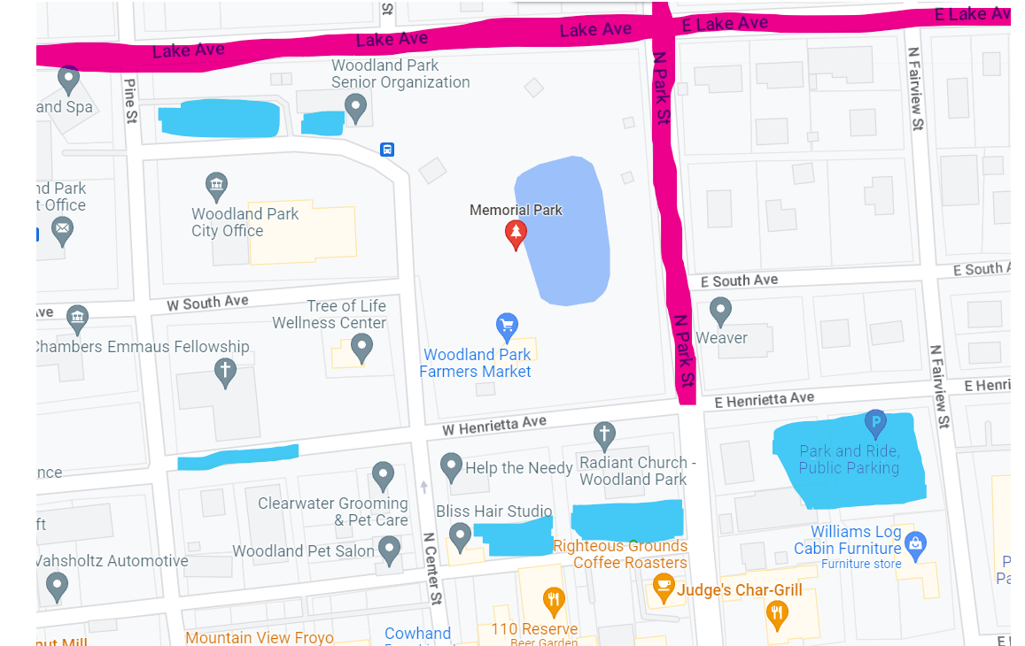

WEATHER
WPFM is a rain or shine market; we operate on a regular schedule even in the rain. We have made a commitment to be open the days and hours we have published, and it is important for all vendors to be present at the market so customers know they can shop the market every Friday during the season. We have chosen the timing of our market (8:00am-1:00pm) considering typical weather patterns for our area. In our market environment, heavy winds and rain generally occur in the afternoons rather than in the morning.

We take the safety of our customers, volunteers, and vendors very seriously. Though we have not had to cancel a market in recent years due to extreme weather, if we have advanced notice of severe weather expected for the morning, we may decide this is the safest option. Please check your emails and/or the market website and Facebook page for an announcement. Should severe conditions (hail, very high winds, lightning) arise during the market we will ask vendors and customers to take shelter in cars, under the pavilion etc. to wait out passing weather conditions before returning to their booths to either continue the market day or to take-down the market early should conditions warrant this.

Vendors must ensure that adequate weights are always attached to their tents due to the possibility of inclement weather, especially winds. In the case of forecasted windy conditions, the market manager and interns may ask vendors to remove the fabric from their canopies and keep the aluminum structure in place.

MARKET BUCKS/SNAP/DOUBLEUP
WPFM utilizes three types of coupon currencies; MarketBucks, SNAP, and DoubleUp Food Bucks All vendors are expected to accept MarketBucks and those vendors who sell SNAP and/or DoubleUp-eligible products are required to participate in these programs per federal and state program rules. MarketBucks and SNAP coupons should be stamped with Woodland Park Farmers Market, do not accept coupons marked with other market names. Vendors will be reimbursed for all coupons collected once per month.

Type | Market Bucks | SNAP | DoubleUp Food Bucks
Appearance | Blue Paper Bill | Light Pink Bill | Green and Orange
Value | $5 | $1 | $1
What can it purchase? | All market products | Most grocery products that can  be taken home to prepare meals  including baked goods, jams,  jellies, honey, salsas, salad  dressings, oils, vinegars,  pasta, cheeses, vegetables,  fruits, mushrooms, meats,  seasonings, herbs, & plant starts. | Colorado-grown  fruits, vegetables,  herbs, vegetable  plant starts,  mushrooms.
What can’t it purchase? | Cannot be used at  WP Arts & Crafts  Fair. | Hot and cold prepared foods  meant for immediate  consumption, alcohol,  flowers, candy, non-food items. | Any prepared foods  Anything that is not a  fresh fruit or vegetable.  Ornamental plants.
Other | Treat as cash and make  change. | Treat like cash, but do not make change. | Treat like cash, but do  Not make change.

THE LONGER TABLE – WPFM has a partnership with the Aspen Mine Center in Cripple Creek, Colorado. The Aspen Mine Center provides a variety of services to meet the needs of seniors, families, and low-income individuals in the Southern Teller County area including hosting a food bank. At the end of each market day our vendors are invited to donate any left-over products that they would like to for distribution through the Aspen Mine Center’s food bank. Customers may also purchase products to donate to this cause.

POLITICS AT THE FARMERS MARKET
The Woodland Park Farmers Market (TCFMA/WPFM) is and must be a politics-free zone. We are a federally tax-exempt nonprofit organization under IRC 501c3 and thus prohibited from political activity. We are specifically prohibited from involvement with any candidate or legislation. The prohibition extends to influencing, engaging, supporting, opposing, or taking any position, on any candidate, campaign, issue, legislation, party, or platform.

In the past, during the hours that the Market occupies city space, that space was deemed to cease being a public forum temporarily and instead deemed a private space during those hours. This policy of the City has changed. Current City policy, which complies with all laws and comports with what other Colorado towns are doing, is that Memorial Park is public space and thus free speech cannot be prohibited but can be regulated. WPFM thus will continue to decline to provide booth space within the Market for political/religious activities. WPFM cannot prohibit political or religious speech on Park sidewalks, provided it does not interfere with or intimidate our vendors and our customers.

CONTACT INFORMATION & MARKET COMMUNICATION
How to Contact Us -On Market days the best way to reach marker staff is by cell phone: 719-400-9986. If your call is not answered right away, please leave a message, or send a text and we will attempt to respond to you ASAP. During the week, in addition to the market phone, we can be reached via email at info@wpfarmersmarket.com.

How We Contact You - We will make every attempt to keep vendors updated and informed about any news pertinent to market operations. Our preferred method of communication will be to speak to vendors directly at the market on Thursdays. However, we may also reach out to you via email, by text or phone, or through announcements via the website or notices in your weekly envelopes. To that end, please be sure to include info@wpfarmersmarket.com as one of your recognized email senders so that you do not miss communications from the market managers. We have found that often our emails end up in vendor junk or spam folders.

WHAT’S NEW FOR 2024
We will have a vendor Zoom call prior to the first market to go over the Rules and Regulations and some new changes.
- A City mandated Traffic Control Pattern for Set-up and Tear-down. Where vendors park to unload will be based upon their space on the map. Ingress and egress directions to pull in and out of the streets.
- Barricades – vendors who arrive late will not be allowed to park inside the market once the barricades are in place at 7:45 a.m. They will have to park and walk their product and tents into their spaces.
- Inclement weather changes to ensure the safety of vendors, customers, and market staff. The market manager is solely responsible for closing, continuing the market, or cancelling based upon weather conditions and emergency evacuation plans. Vendors are responsible for checking the weather forecast the days prior to the market to determine whether they will attend.
- Reimbursements for SNAP, DoubleUp, and MarketBucks will go through a payment system called Melio and will be reimbursed through an ACH directly to your account.

FINAL THOUGHTS
We are very excited to have you as part of the Woodland Park Farmers Market! Together we not only provide the people of Teller County with increased access to healthy, local produce, specialty foods, and other products, we also create an important opportunity for the entire community to come together to learn about community programs and resources, strengthen ties with one another, and simply revel in our spectacular mountain setting. On behalf of the board of directors of TCFMA, thanks for being a part of the journey.

Sincerely,

Marietta

