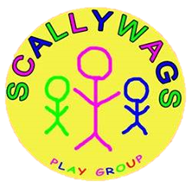

Acceptable Use Agreement

Staff
As a user of the Scallywags network resources/ equipment I agree to follow the rules (as per our acceptable use policy) on its use. I will use the network/ equipment in a responsible way and observe all the restrictions explained in the Acceptable Use policy. If I am in any doubt, I will consult the Designated Safeguarding Lead.
• I agree to report any misuse of the network to the Designated Safeguarding Lead
• I agree to report any websites that are available on the nursery devices that contain
inappropriate material to the Designated Safeguarding Lead

• I agree to ensure that portable equipment such as IPADS or laptops will be kept
secured when not in use and to report any lapses in physical security to the Designated Safeguarding Lead

If I do not follow the rules, I understand that this may result in loss of access to these resources as well as other disciplinary action. I realise that staff under reasonable suspicion of misuse in terms of time or content may be placed under retrospective investigation or have their usage monitored.

Signed …………………………………………………. Date ………………..

Print name ……………………………………………………………………..

