
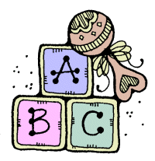

Pregnancy Education Classes

Classes | 2023-24 | Content
Breast Feeding | November 11, February 10, May 11 | Breast or Bottle--Which is the Better Choice?
Labor & Delivery | December 9, March 9, June 8 | Breathing & relaxation techniques
Caring for the New Baby | January 13, April 13, July 13 | Circumcision care, baby bath, crying, swaddling

All Classes are held on Saturdays from 10 AM "Sharp" to 12:30 PM

Classes are FREE -- Refreshments Served

Please Call to Register: (301) 423-0063
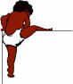

Classes are being held at:
Forestville Pregnancy Center
3611 Branch Ave. Suite 201
Temple Hills, MD 20748

