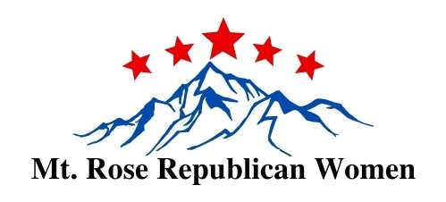
MRRW - Membership Application 2024

Only one member on each form please (couples need to each have their own application and their own email address)

Check one: / New Member OR / Renewing Member

Check one: / $50 Full Regular Member Dues OR / $25 Associate Member Dues

/ Are you a veteran? / Add $12 for a permanent magnetic MRRW name badge

/ Check here if you DO NOT want to be included in the Membership Directory (regular members only)

Name: ______________ _______________

Street Address: ___

City, State, Zip: ___

Best phone # _________________________________/ Cell / Home / Work

Email Address ____________________________________________________________________

Birthday (month and day only, we do not need the year): _________________

Referred by:

Comments: ____________________________________________________________________

- I am interested in getting information about working on a committee.
- I certify that I am a registered Republican.
- I authorize MRRW to post any club photos that include me on the MRRW website, Newsletter, PowerPoint, or social media sites when the photo pertains to club events.

Signature _______________________________________________Date ___________

Mail this form and check (payable to MRRW) to: MRRW Membership
P.O. Box 18446
Reno, NV 89511

Benefits of Mt. Rose Republican Women (MRRW) Membership

- Reduced fee for Dinner Meetings for both Regular and Associate members
- Meet like-minded people, share information, and exchange ideas with other Republicans
- Receive updates on local and national political activities, educational seminars, and conferences
- Membership in both the Nevada and National Federation of Republican Women for Regular Members

