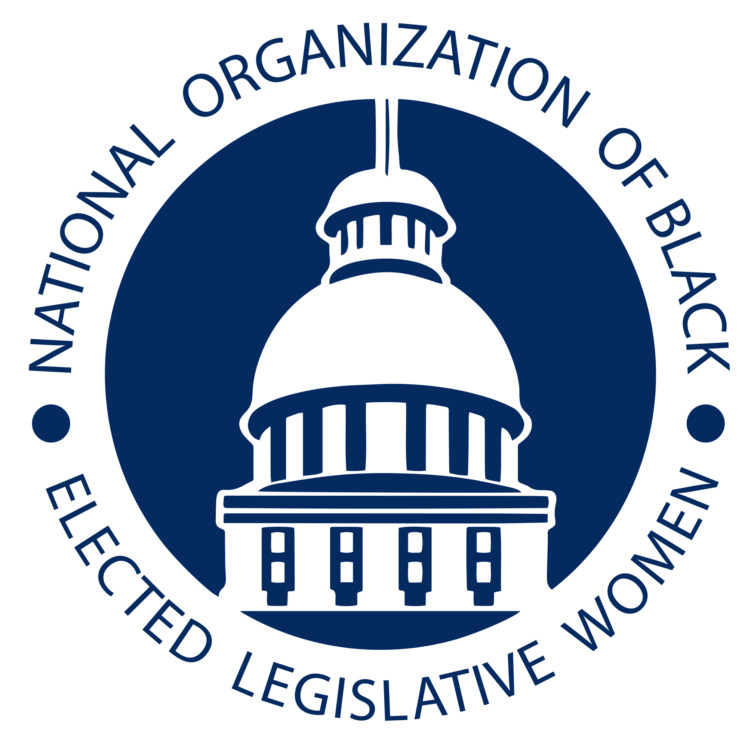
A Resolution Declaring There is No Democracy Without Black Women

Committee: Women's Issues Resolution: WMN-21-01

- WHEREAS The National Organization of Black Elected Legislative Women and the
- State Innovation Exchange co created a report called NO Democracy Without Black
- Women
- WHEREAS Today, just 4.82% of state legislators are Black women, 356 out of 7,383
- Legislators
- WHEREAS It is crucial for Black women to be represented in state legislatures, which
- consider over 100,000 bills nationwide each year.
- WHEREAS The people who most intimately know the true impact of structural racism
- and sexism—Black women—know best how to dismantle those systems and move to a
- just and equitable democracy and society.
- WHEREAS There remain 8 states without a single Black woman in their legislature,
- despite the Black population in each state ranging from 2-6%: Vermont, South Dakota,
- Hawaii, Arizona, Idaho, Nebraska, Montana, and North Dakota.
- WHEREAS States with large Black populations are not immune from
- under-representation either. In fact, Mississippi, the state with the highest Black
- population in the country, has a staggering disparity in representation—Black women
- make up approximately 19.36% of the population but just 7.47% of the legislature.
- WHEREAS President Karen Camper shared that “When Black women and girls see
- Black women rising up and being put in these positions of power, it gives them hope. We
- have the power to bring change to our communities and I don’t take that for granted.”
- WHEREAS Congresswoman Joyce Beatty shared that ““All politics are local, so it is
- imperative more Black women run for public office. Black women helped fuel change up
- and down the ballot during the 2020 Election; just imagine the transformational power
- ‘Black Girl Magic’ can have in city councils and state legislatures.”
- WHEREAS Congresswoman Robin Kelly shared that “Having worked at every level of
- government—community, county, state, and federal—I can unequivocally say that the
- work of local and state governments present the greatest opportunity to have a direct
- impact on the lives of our constituents. And now, with the relentless assault on voting \
- rights in state legislatures across America, more Black women are needed in state elective
- offices to preserve our most precious Constitutional right.”
- WHEREAS Representative Attica Scott shared “As one of two Black women in our
- legislature, I face threats from people filled with racial hatred, I face erasure from my
- colleagues, and I face institutional racism. Despite all of this, I serve because my
- community deserves a racial justice champion.”
- WHEREAS Representative Sandra Scotts shared “I stand when I need to stand, I speak
- up when I need to speak, and I protest when I need to protest. But most of all, I create
- meaningful legislation that has a positive impact on my community. Being an outspoken
- Black female legislator in Georgia is not an easy job but I love it.\
- WHEREAS MAryland Speaker Adrienne Jones shared that “Black women continue to
- broaden the reach and impact of our state, local and federal policies that improve our
- communities. As Maryland’s first Black and first woman to serve as Speaker, I am also
- the only one to introduce a statewide plan for racial & economic justice. Diverse
- leadership – at every level of government – is the vehicle that drives us closer towards \
- Progress.”
- WHEREAS Krystal Leaphart shared that “Black Women have earned a seat at the table,
- the right to lead the table and set the menu. Only then will Black women begin to see
- radical returns on our social, financial and political investments!”
- WHEREAS Lauren Bealore shared that “Lasting progressive change must begin with
- removing the barriers of entry for Black Women.”
- THEREFORE, BE IT RESOLVED that the National Organization of Black Elected
- Legislative Women will continue to recruit and train black women to get involved in
- publix service.
- BE IT FINALLY RESOLVED that the National Organization of Black Elected
- Legislative Women will push to solve the issues of misogyny in the political process.

Introduced by The Honorable Tonya Anderson
Georgia General Assembly

