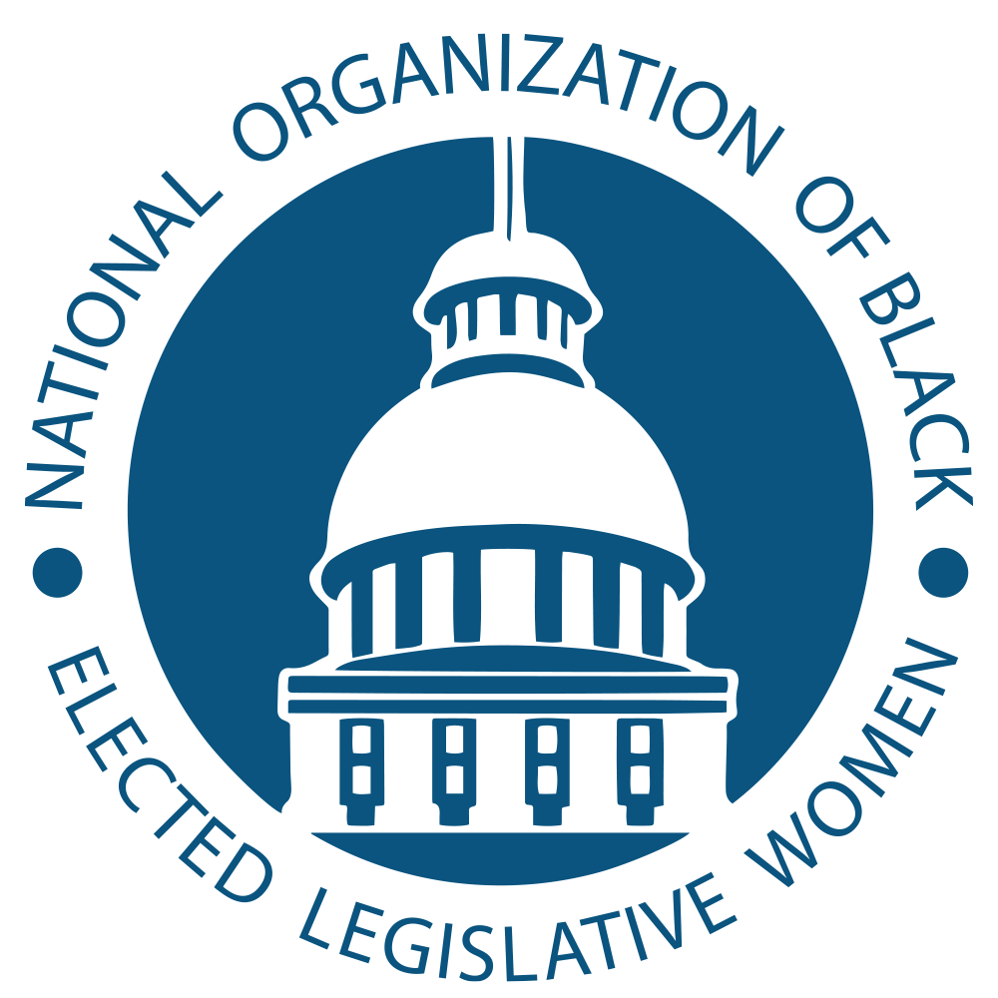

A Resolution Urging NOBEL to Adopt a Legislative Agenda to Attack Systemic Racism

Committee: Social and Economic Justice Resolution: SEJ-21-03

Committee: General Resolution: 1. WHEREAS, The National Organization of Black Elected Legislative Women 2. (NOBEL Women) is a non-profit (501c3), non-partisan organization primarily 3. composed of current and former Black women legislators and many 4. appointed officials.
5. WHEREAS, The Illinois Legislative Black Caucus (ILBC) passed the historic 4 6. Pillars legislative agenda during the 101st General Assembly of the Illinois 7. Legislature to attack systemic racism that harms and dehumanizes the Black 8. community.
9. WHEREAS, The Illinois Legislative Black Caucus passed the 4 Pillars to attack 10. systemic racism in (1) Criminal Justice Reform, Violence Reduction & Police 11. Accountability; (2) Education & Workforce Development; (3) Economic Access, 12. Opportunity & Equity; and (4) Healthcare & Human Services.
13.WHEREAS, The criminal justice reform pillar was written to increase public 14. safety for everyone while dismantling the systems that hold Black people 15. back from achieving their full potential, as well as increasing trust between 16. law enforcement and the Black community. It focuses on police accountability, 17. including police training, limits on the use of force, and increased 18. transparency and accountability regarding officer misconduct.
19. WHEREAS, It modernizes sentencing laws; replaces the cash bail system with a new 20. system that detains all dangerous defendants, regardless of their ability to pay;
21. institutes certification & decertification system statewide for police officers; requires 22. the use of body cameras statewide by 2025; reforms crowd control response; 23. amplifies law enforcement training standards; prevents destruction of law 24. enforcement misconduct records; connects substance abuse treatment programs with 25. first responder duties; increases and improves de-escalation and mental health 26. training for law enforcement; creates two police misconduct databases for public 27. viewing and transparency; requires police to develop a plan to protect children during 28. search warrant raids; empowers the attorney general to investigate deaths occurring in 29. police custody; addresses officer wellness and mental health awareness and 30. screenings; and bans use of chokeholds and other extreme measures. 31.WHEREAS, The education and workforce development pillar is meant to 32. dismantle systemic racism within Illinois’ education system – from early 33. childhood through adult learning.
34.WHEREAS, It expands access to Early Childhood Intervention services, 35. creates a uniform kindergarten readiness assessment, matches high school 36. graduation requirements with basic entrance requirements at Illinois’ flagship 37. public university, creates commissions to address how schools teach the 38. history of marginalized groups and addresses students who have experienced 39. trauma, strengthens university programs meant to help get more minority 40. teachers in the classroom, creates freedom schools throughout the state and more. 41.WHEREAS, The Illinois Legislative Black Caucus Economic Access, 42. Opportunity and Equity Pillar is made up of nine parts: banking and
43. investment, economic mobility, small business and entrepreneurship, 44. procurement, industry specific equity, environmental justice, housing and 45. gentrification, wage equity and worker protections, and capital investments. 46. WHEREAS, This pillar focuses on banking and investment by addressing the 47. shortage of lending institutions making investments in Black communities and 48. providing opportunities for Black financial institutions and Community Development 49. Financial Institutions (CDFIs) with new investments from the state Treasurer’s office. 50. It gives Black businesses the tools they need to succeed and compete in our global 51. marketplace.
52. WHEREAS, It addresses procurement and the Business Enterprise Program (BEP) 53. by growing the number of opportunities for Black vendors to do business with the 54. state by creating the Commission on Equity & Inclusion creating new standards to 55. ensure state agencies meet Business Enterprise Program goals. This pillar focuses on 56. industry specific equity by addressing the barriers to entry people of color continue to 57. face in the Beauty Supply Industry and protects the social equity components and 58. state investments in communities harmed by the War on Drugs with the creation of 59. the Cannabis Equity Commission. The pillar also creates a Black Farmer Disparity 60. Study to increase support for black farmers and address land loss. 61. WHEREAS, It prioritizes housing, land use & gentrification by remedying 62. redlining and predatory lending, increasing low income, permanent and affordable 63. housing for families, individuals, people with records and young people, and ensuring 64. quality economic development and housing where needed without displacement of
65. current residents.
66. WHEREAS, The Payday Loan Prevention Act caps interest rates at 36%. This 67. applies to any loans made or renewed after the effective date of this Act by any 68. person or entity offering or making loans to a consumer in Illinois, except for banks, 69. savings banks, savings and loan associations, credit unions, and insurance companies 70. chartered under the law of the United States. This ensures that vulnerable consumers 71. are protected from predatory and exploitative loans that would otherwise permanently 72. entrap them in debilitating financial debt.
73. WHEREAS, It ensures fair wages for Black workers on the job, end wage disparities 74. for Black women, men and people with records and ensure diversity as well as the 75. equitable retention and promotion of Black workers by fining companies a percentage 76. of their profits for not closing wage gaps based on race or gender. 77.WHEREAS, The health care and human services pillar is primarily focused on 78. creating a more equitable and inclusive health care system in Illinois. 79.WHEREAS, It places a temporary halt to hospital closures, reforms 80. Medicaid managed care organizations, takes steps to reduce maternal and 81. infant mortality, improve access to mental health care and substance abuse 82. treatment, and train medical providers to recognize and overcome implicit 83. bias.
84. WHEREAS, It creates a safety net hospital grant program of $50 million, subject to
85. appropriation, to preserve or enhance OB/GYN services or other specialty services at hospitals.
86. WHEREAS, It requires the Department of Human Services to update the Child Care 87. Assistance Program Eligibility Calculator to include a question on whether the family 88. is applying for child care assistance for the first time or for redetermination. In 89. addition, it requires prenatal doula services and evidence-based home visiting 90. program services to be covered under Medicaid.
91. THEREFORE BE IT RESOLVED, that the National Organization of Black Elected 92. Legislative Women will adopt similar agendas in state legislatures nationwide and 93. create a national agenda to attack systemic racism.
Introduced by The Honorable Sonya M. Harper
Illinois General Assembly

