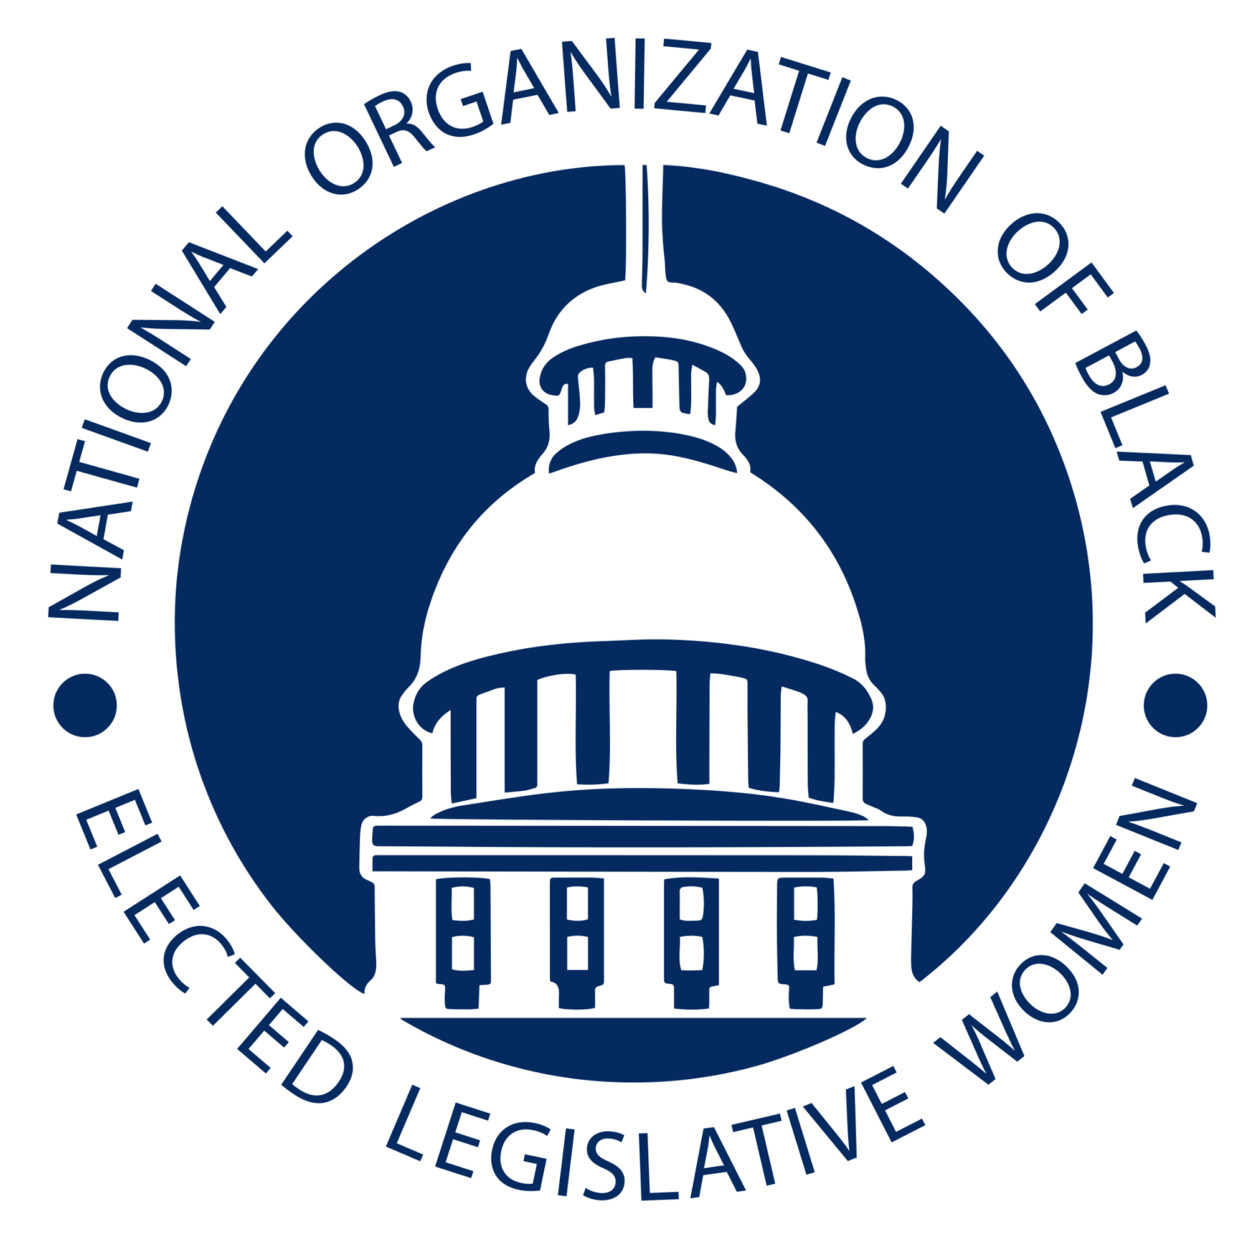
Clarifying the Purpose and Mission of Critical Race Theory
Committee: Social and Economic Justice Resolution: SEJ-21-01

WHEREAS Critical race theory (CRT) is a body of legal scholarship and an academic movement of US civil-rights scholars and activists who seek to critically examine the intersection of race and US law and to challenge mainstream American liberal approaches to racial justice.

WHEREAS CRT originated in the mid-1970s in the writings of several American legal scholars, including Derrick Bell, Alan Freeman, Kimberlé Crenshaw, Richard Delgado, Cheryl Harris, Charles R. Lawrence III, Mari Matsuda, and Patricia J. Williams.

WHEREAS It emerged as a movement by the 1980s, reworking theories of critical legal studies (CLS) with more focus on race. CRT is grounded in critical theory and draws from thinkers such as Antonio Gramsci, Sojourner Truth, Frederick Douglass, and W. E. B. DuBois, as well as the Black Power, Chicano, and radical feminist movements from the 1960s and 1970s.

THEREFORE, BE IT THEREFORE RESOLVED that the National Organization of Black Elected Legislative Women will help lift the history and vision of Critical Race Theory.

BE IT FINALLY RESOLVED that NOBEL Women will encourage their membership to study and defend the work of black scholars and black feminist theory like Critical Race Theory.

Introduced by The Honorable Raumesh Akbari
Tennessee General Assembly

