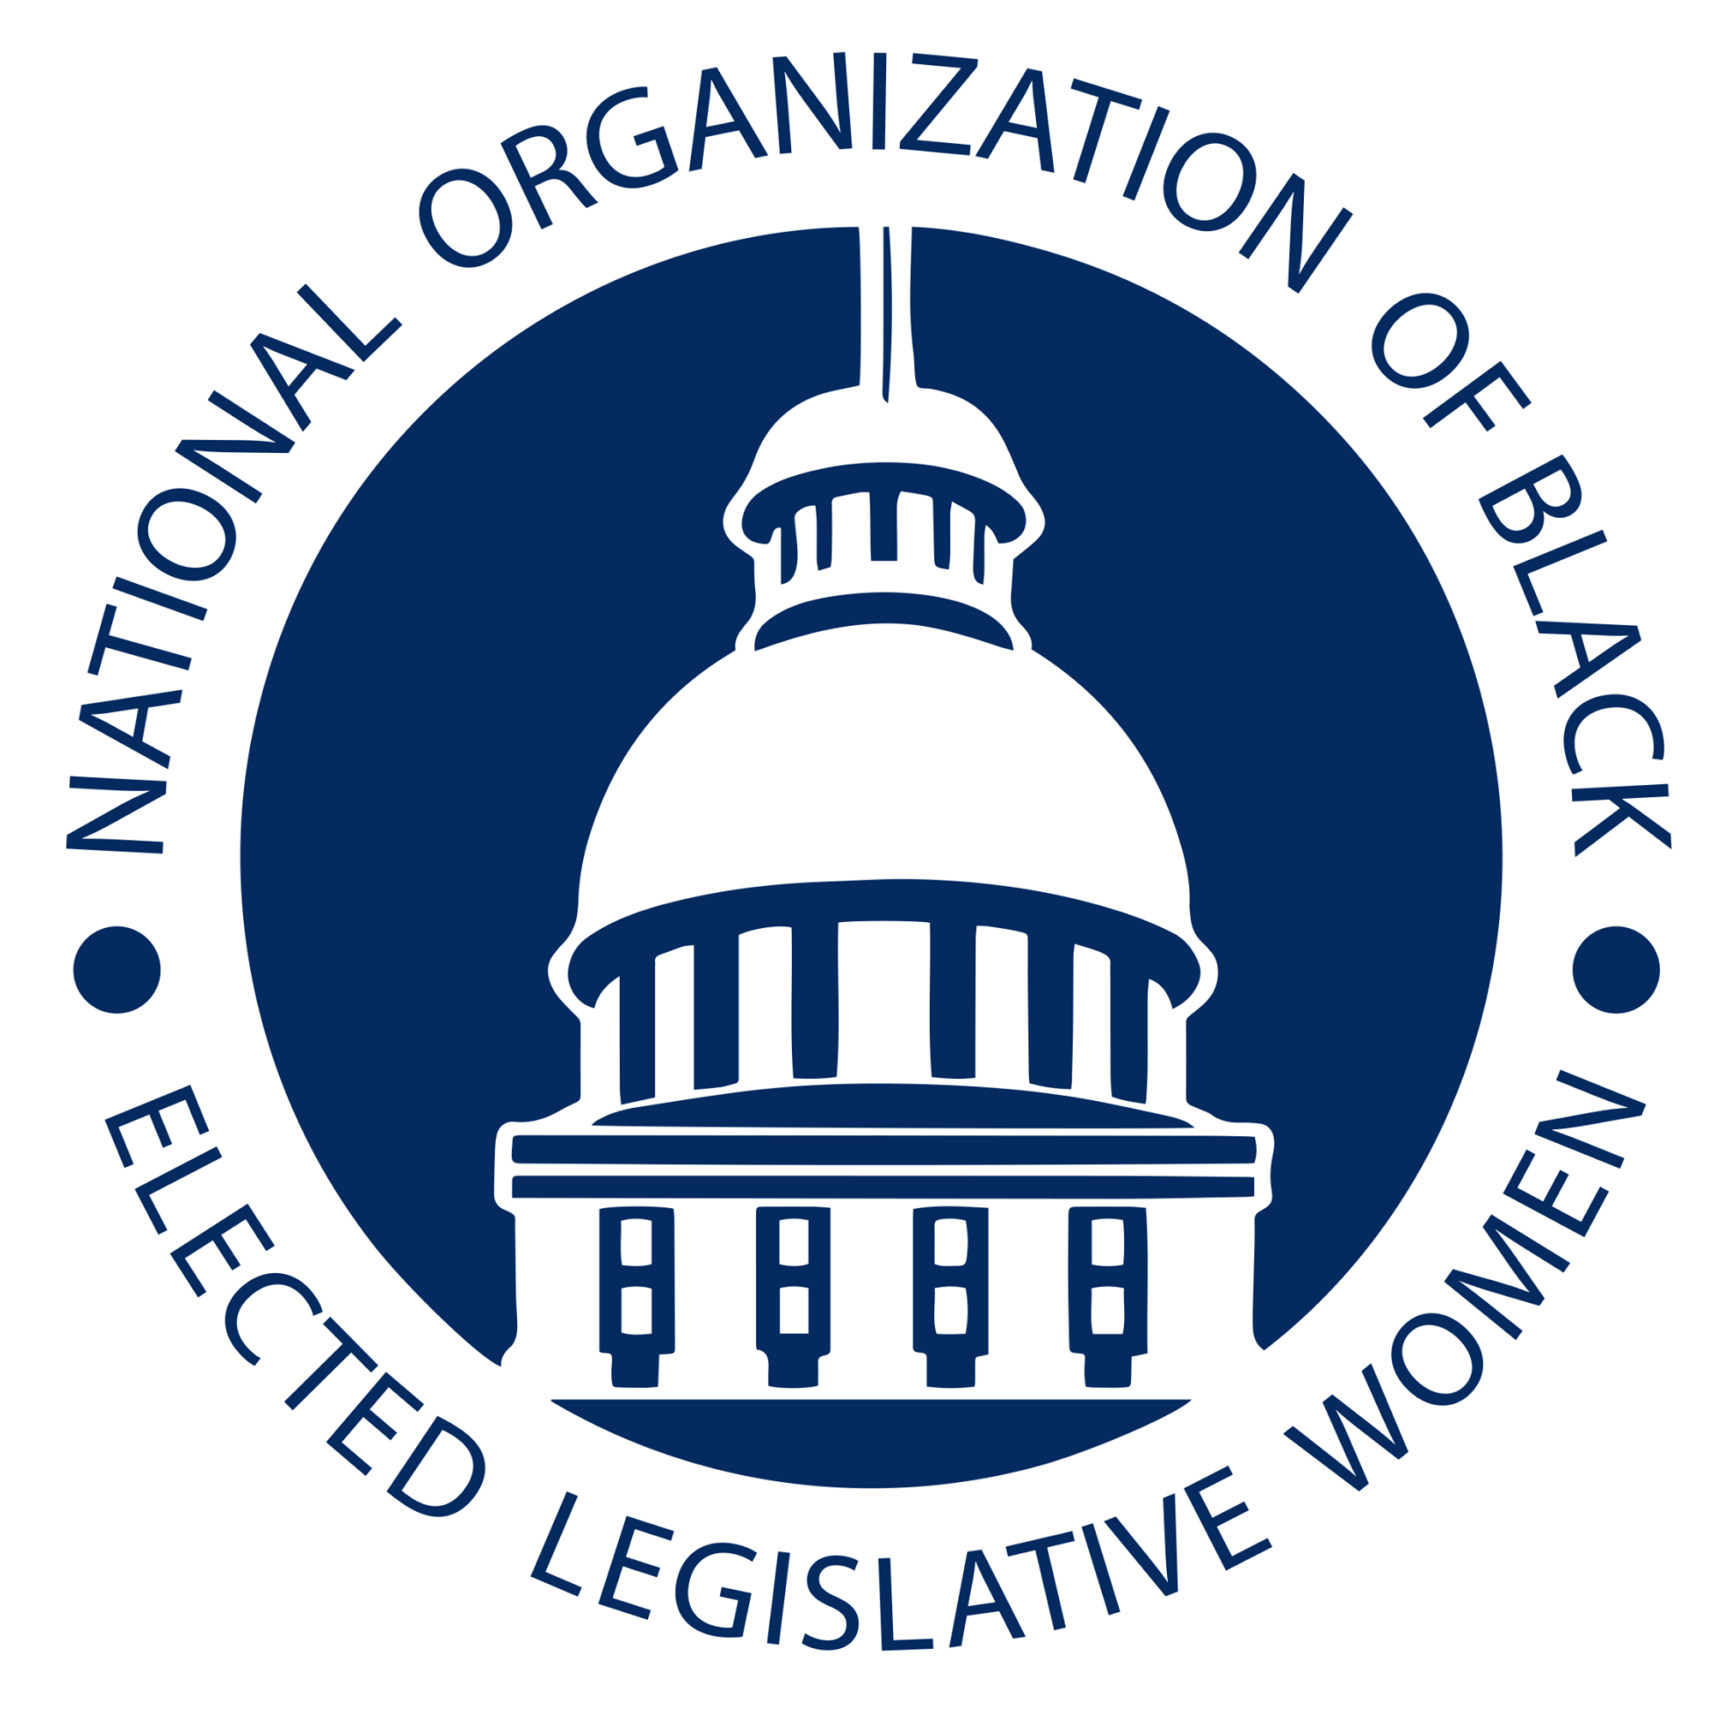
Eliminating Deserts by Making Resources Available to African-American Communities

Committee: Social and Economic Justice Resolution: GEA-21-02

- WHEREAS African Americans have experienced inferior access to critical resources
- like high-quality healthcare, education, food, and credit,
- WHEREAS data mapping has shown conclusively that food, healthcare, and credit
- deserts remain common in areas populated by African Americans;
- WHEREAS there can be no real social justice without the equitable distribution of these
- critical resources;
- WHEREAS, NOBEL Women has signed a Memorandum of Understanding with the
- Equitable Growth Fund to help identify and address health care, food, and credit deserts;
- WHEREAS, one cannot eliminate deserts by further restricting access to water; nobody
- chooses to drink bad water where good water is plentiful;
- WHEREAS, the challenge faced by minority and (Low to Moderate Income) LMI
- communities is not the availability of unhealthy fast food as much as it is the lack of
- access to healthy alternatives; it is not the availability of bad health care as much as it is
- the lack of access to good healthcare, and it is not the availability of bad credit as much
- as it is the lack of access to sources of beneficial Credit;
- WHEREAS, there is an urgent need to enact a national plan to address the availability
- and equitable distribution of critical resources in all fifty states and territories;
- BE IT THEREFORE RESOLVED, that model legislation be developed to promote
- social justice, as was introduced this year in Illinois, but amended to avoid further \
- restricting access to credit, working instead to widen and promote the availability of
- beneficial sources of credit.
- BE IT FURTHER RESOLVED, that NOBEL Women work with the Equitable Growth
- Fund to identify and address health care, food, and credit deserts;
- BE IT FURTHER RESOLVED, that the result of this comprehensive study will be the
- development of model legislation that uses data to identify and address these deserts;
- BE IT FURTHER RESOLVED, that NOBEL Women will encourage every state
- legislature to adopt the model legislation, which shall promote a data-centric approach to
- address social justice issues;
- BE IT FURTHER RESOLVED, that the NOBEL Women urges the development and
- implementation of state- and community-based programs to support “Desert
- Improvement" initiatives, to bring healthier options into underserved communities across
- America; and
- BE IT FINALLY RESOLVED, that a copy of this resolution be transmitted to the \
- President of the United States, the Vice President of the United States, members of the
- United States House of Representatives and the United States Senate, and
- other federal and state government officials as appropriate.

Introduced by The Honorable Karen Camper
Tennessee General Assembly

