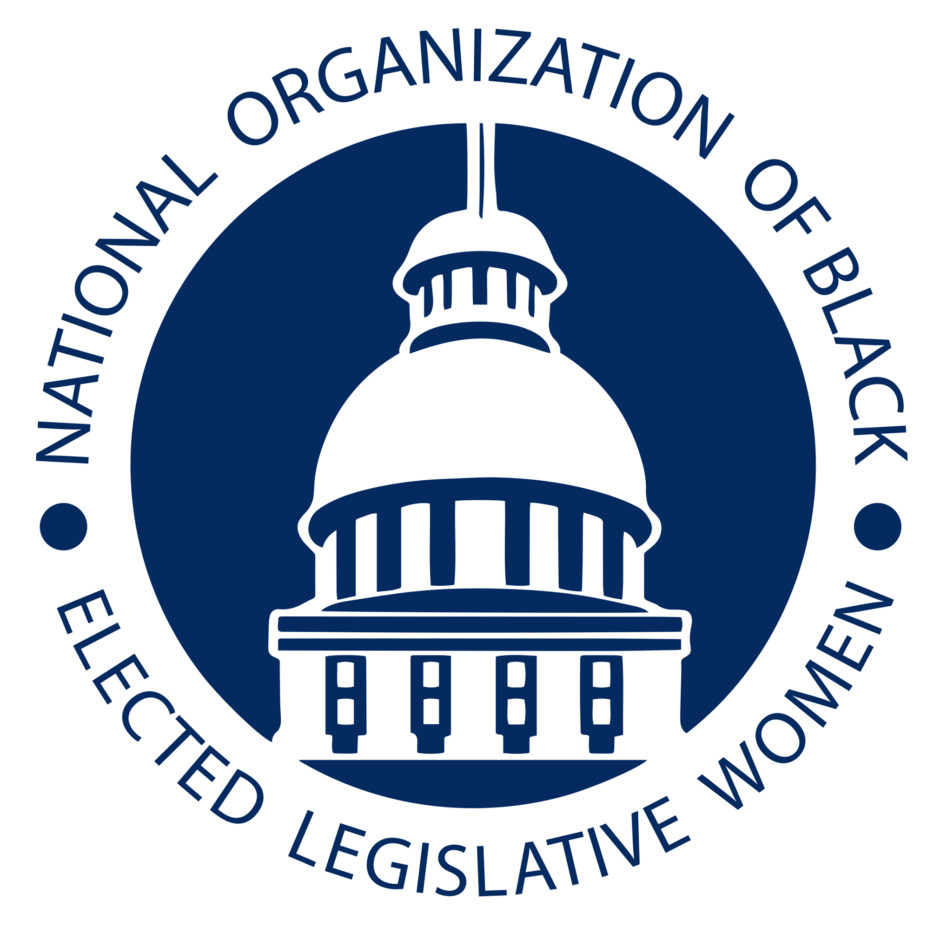
Resolution on the Importance of Beyond Visual Line of Sight (BVLOS) for Drone Operations in Maintaining Public Safety

Committee: Telecommunications Resolution: TEL-21-01

- WHEREAS the National Organization of Black Elected Legislative Women (NOBEL
- Women) maintains that natural disasters affect human lives and living conditions and
- often have a more direct and adverse impact on low-income and communities of color,
- and
- WHEREAS state officials have a significant role to play in ensuring natural disaster risk
- reduction, including the areas of science and technology; and
- WHEREAS utilities are responsible for inspecting, protecting, and maintaining the
- critical infrastructure for the provision of electric, gas, water, and telecommunications;
- and
- WHEREAS investments in infrastructure is making America technologically innovative
- for the purpose of creating a better quality of life for citizens, providing for the health,
- safety, and welfare of all our communities; and particularly, fixed income, low-income,
- under-served and communities of color; and
- WHEREAS utilities invest significant resources in protecting the nation’s public and
- private infrastructure through ground and aerial inspections, including the use of drones
- or unmanned aerial systems (“UAS”); and
- WHEREAS UAS can provide improved safety inspections necessary to promote public
- safety; and
- WHEREAS UAS can provide operational benefits to utilities and their customers,
- including but not limited to improved safety for utility workers, other personnel,
- contractors, and customers resulting from the ability of UAS to reach remote areas and
- be deployed in poor weather conditions, as well as during and after storms when ground
- crews may have limited mobility; and
- WHEREAS most utilities using UAS are limited to line-of-sight operations, in which the
- UAS pilot must be able to see the aircraft without additional visual aids; and
- WHEREAS using UAS for outdoor visual line-of-sight operations or specifically
- authorized BVLOS operations would greatly improve operational efficiency, reduce
- safety hazards for utility employees and contractors, and ultimately lower costs to
- customers; and
- WHEREAS companies seeking permission to fly UAS BVLOS currently must submit a
- waiver application to the Federal Aviation Administration (“FAA”); and
- WHEREAS the FAA has jurisdiction and, as of late 2019, has received more than 1,200
- BVLOS waiver applications and has denied approval for an overwhelming majority of
- waiver applicants; and
- WHEREAS electric utilities (through representatives of the Edison Electric Institute) and
- the FAA have begun exploring a pathway to a framework for BVLOS activities that \
- would increase transparency of what is needed for a waiver application without \
- sacrificing the FAA’s safety responsibilities. This collaboration should allow owners of
- linear infrastructure to prepare applications that have a greater likelihood for approval of
- BVLOS waivers; and
- WHEREAS many utilities and state regulatory authorities have expertise with manned
- and unmanned aerial systems, demonstrating that these entities’ use of BVLOS flights
- can be done while protecting the safety and security of FAA air space; and
- WHEREAS the FAA has initiated an important Aviation Rulemaking Committee
- (“ARC”), to develop a regulatory framework for BVLOS operation, within the next 2-3
- years, that will facilitate greater future use of BVLOS UAS operations by utilities; and
- WHEREAS there is an immediate need for BVLOS waiver to be approved during the \
- pendency of the ARC’s work.
- THEREFORE, BE IT RESOLVED that the National Organization of Black Elected
- Legislative Women (NOBEL Women) supports and encourages the FAA to use its
- authority to approve BVLOS waivers during this critical interim period before there are
- final rules in place that facilitate BVLOS operations by utilities; and
- BE IT FINALLY RESOLVED that the NOBEL Women encourages utility and utility
- regulators knowledge sharing and development of industry best practices concerning
- BVLOS activities, including support for the development of a common utility BVLOS
- waiver.

Introduced by The Honorable Barbara Ballard
Kansas House of Representatives

