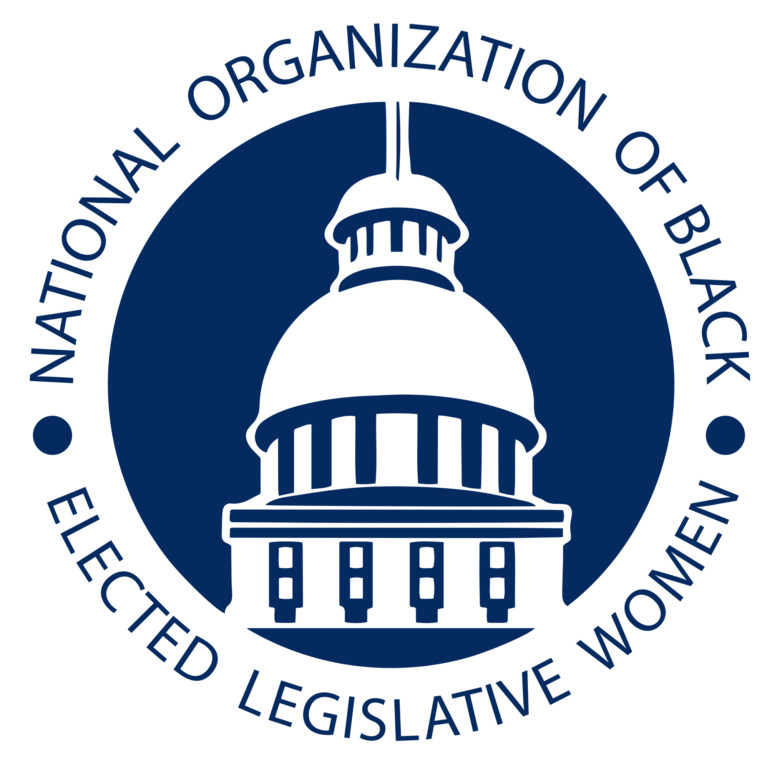
National Organization of Black Elected Legislative Women (NOBEL Women)
Equal Rights Amendment Resolution

Committee: Women's Issues Resolution: WMN-21-02

- WHEREAS the advancement of gender equality is fundamental to the democracy of the
- United States;
- WHEREAS the Declaration of Independence states “We hold these truths to be
- self-evident that all men are created equal, that they are endowed by the Creator with
- certain unalienable Rights, that among these are Life Liberty and the pursuit of
- Happiness”;
- WHEREAS the ERA was first introduced in Congress in 1922, one year after the 19th
- Amendment, which gave women the right to vote was enacted and it has been introduced
- in every session of Congress since then;
- WHEREAS simply put, the Equal Rights Amendment (ERA) amends the U.S.
- Constitution to prohibit discrimination on account of sex;
- WHEREAS the first Black woman elected to Congress, Shirley Chisholm speaking in
- support of the ERA in August 1971 declared, “It [Equal Rights Amendment] provides a
- legal basis for attack on the most subtle, most pervasive, and most institutionalized form
- of prejudice that exists”;
- WHEREAS Pauli Murray stated, “As a constitutional lawyer, a woman and a [Black
- person], I can say with conviction that [Black] women as a group have the most to gain
- from the adoption of the Equal Rights Amendment. All that has been said about the
- frustrations and deprivations of American women generally because of discrimination by
- reason of sex can be said with special force about the position of Black women”;
- WHEREAS Congress passed the ERA in 1972 with major bipartisan support in the
- House and Senate, provides that “Equality of rights under the law shall not be denied or
- abridged by the United States or by any State on account of sex”, thereby ensuring the
- same constitutional protections for both men and women;
- WHEREAS women’s groups, including strong support among Black women’s
- organizations, along with unions and other allies led solid a national campaign to have
- three fourth of states ratify the Amendment by the arbitrary 1982 deadline, falling short
- of putting women and men in the Constitution by a mere three states;
- WHEREAS today, the ERA is enjoying renewed interest at a moment when several
- progressive Black women-led movements, like Black Lives Matter, The Women’s March,
- #Me Too; and #Times Up, are drawing widespread support and defining equality and
- social justice for groups that are marginalized;
- WHEREAS in 2017 Nevada became the first state in roughly 35 years to ratify the ERA
- when the Legislature’s upper Chamber narrowly approved the Joint Resolution under the
- watchful eye of its chief sponsor, Senator Pat Spearman who represents one of the state’s
- most diverse communities;
- WHEREAS Illinois ratified the ERA in 2018, followed by Virginia in 2020, thus
- meeting the requirement for 38 states or three fourth of all states;
- WHEREAS the U.S. House of Representatives passed a Joint Resolution on two separate
- occasions to remove the deadline set by Congress in 1977, with the most recent being
- March 2021 and the companion bill S.J. Resolution 1 is currently before the U.S. Senate;
- WHEREAS recent polling show that the ERA enjoys strong support by the public --
- with as much as 80 to 90 percent of women and men supporting it;
- WHEREAS Representative Bonnie Watson Coleman, one of the conveners of the
- Congressional Caucus on Black Women and Girls, was inspired to organize monthly
- Special Order sessions on the floor of Congress to gather support for the ERA;
- WHEREAS the ERA would protect Black women against the enormous wage gap they
- experience when compared to non-Hispanic white men, make them safer from sexual and
- domestic violence, and create opportunity for parity in corporate leadership and elected
- positions, and adds protection against pregnancy discrimination in the workplace;
- WHEREAS some point to existing civil rights laws such as the Title IX of the Education
- Amendments of 1972 (prohibits sex discrimination in education), Title VII of the Civil
- Right Amendments 1964 (prohibits race discrimination in education and employment),
- and the Violence Against Women’s Act (VAWA) as existing protection for Black women
- and girls from discrimination and bias -- both subtle and overt, the ERA provides added
- safeguards;
- WHEREAS the Constitution is the foundation from where all else flows that defines
- fairness and “liberty and justice for all”. Black women -- and women in all our diversity
- -- belong in the Constitution.
- THEREFORE BE IT RESOLVED that NOBEL Women affirms its support and
- advocacy for the ratification, certification and implementation of the ERA.
- THEREFORE BE IT FURTHER RESOLVED that a copy of the resolution be
- transmitted to the President of the United States, Vice President of the United States,
- Members of the U.S. Congress and other federal and state officials as appropriate.

Introduced by The Honorable Tonya Anderson
Georgia General Assembly

