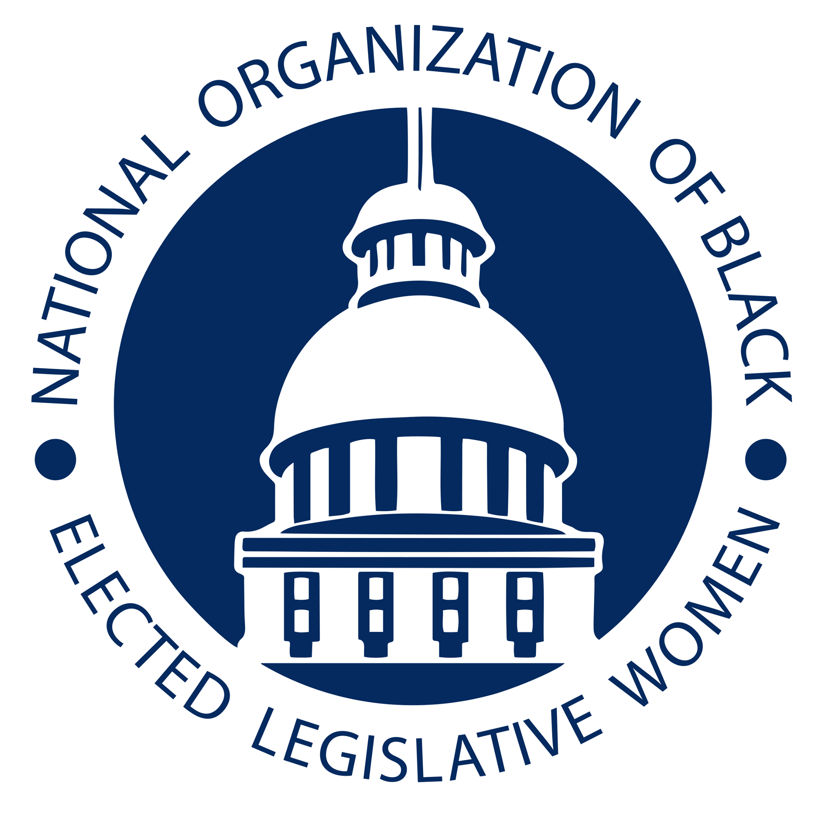
Encouraging HIV Detection and Ensuring Appropriate Treatments in Medicaid Recipients and the Uninsured
Committee: Health Resolution: HEA-21-04

- WHEREAS, in 2018, an estimated 37,968 Americans tested newly positive for HIV;
- and,
- WHEREAS, of those, Black/African American people are most affected by HIV, In
- 2019, Black/African American people accounted for 42% (15,340) of all new HIV
- diagnoses. 47.5% were Black/African Americans, despite Blacks/African Americans
- being 18%
- of the U.S. population, In 2019 in the United States, Black/African American female
- adults and adolescents made up 13% of the female population but accounted for 55% of
- diagnoses of HIV infection among females; and,
- WHEREAS, even more troublingly, In 2019, young people accounted for 21% (7,648) of
- all new HIV diagnoses. Young Black/African American gay and bisexual men (13 to 24
- yo) are even more severely affected, as they represented 50% (3,209) of new HIV
- diagnoses among young gay and bisexual men.; and,
- WHEREAS, From 2015 through 2019 in the United States and 6 dependent areas,
- Black/African American female adults and adolescents accounted for the largest numbers
- of diagnoses of HIV infection each year although the number decreased from 4,262 in
- 2015 to 3,812 in 2019; and,
- WHEREAS, these disparities in HIV health, detection and treatment are driven by a
- broad range of factors, such as language barriers, concerns about disclosing immigration
- status, mistrust of the healthcare system, poverty, racism, homophobia, stigma,
- discrimination and other social determinants of health; and,
- WHEREAS, for example, Hispanic/Latino Americans account for nearly one-third of all
- Medicaid enrollees across the United States, a very disproportionate share that reflects
- the income disparities that affect our communities; and,
- WHEREAS, people without health insurance or enrolled in Medicaid may experience
- health literacy barriers due to the disproportionate impacts of the social determinants of \
- health, limiting their ability to recognize, and demand, necessary medical care, including
- treatment that is best suited for their health needs; and,
- WHEREAS, these barriers also adversely affect the ability of patients to engage in a
- shared decision-making approach with their providers; and,
- WHEREAS, while certain utilization management practices in Medicaid are meant to
- help control healthcare costs, prior authorizations or other limitations may in some cases
- inhibit or delay access to necessary medical care, including prescription drugs, thereby
- further negatively affecting health outcomes; and,
- WHEREAS, prior authorizations and other limitations may interfere with clinically
- appropriate patient-centered choices for medical treatments and create barriers for
- doctors, nurses, and other healthcare providers serving the Medicaid population; and,
- WHEREAS, for example, state agencies may have selected preferred drugs based on the
- medicines' effectiveness within the general population, without sufficient regard to
- considerations specific to certain populations, such as Hispanic Americans and African
- Americans; and,
- WHEREAS, the uninsured and Medicaid patients may be discouraged from beginning,
- or continuing, clinically appropriate treatments by delays in access that may occur when
- health care providers and patients must navigate the Medicaid or other state
- prior-authorization or appeals procedures; and,
- WHEREAS, treatment delays while providers obtain required approvals also may \
- adversely affect the plans in place across the country to help end the HIV epidemic.
- THEREFORE, BE IT RESOLVED, that the National Organization of Black Elected
- Legislative Women supports legislation to ensure patient access to clinically appropriate
- prescription drugs and related health care services by recognizing the importance of open
- access to all FDA-approved HIV medications; and,
- BE IT FINALLY RESOLVED, that additional legislative provisions should be
- examined to safeguard affordable, preventative, and continuous patient access to HIV \
- related health care services and treatments.

Introduced by The Honorable Laura Hall
Alabama Legislature

Data from Centers for Disease Control and Prevention https://www.cdc.gov/hiv/basics/statistics.html (Visited 10/20/20)
Data from AIDSVu https://aidsvu.org/national-latinx-aids-awareness-day-2020/; (Visited 10/22/20)
Data from AIDSVu; https://aidsvu.org/national-latinx-aids-awareness-day-2020/ (Visited 10/22/20)
Id.
Id.
See Medicare and Medicaid Are Important to Hispanic Americans, The National Committee to Preserve Social Security and Medicare, https://www.ncpssm.org/documents/medicare-policy-papers/medicare-and-medicaid-are-important-to-hispanic-americans/ (Visited 10/22/20).
See Healthy People 2020, Social Determinants of Health, https://www.healthypeople.gov/2020/topics-objectives/topic/social-determinants-health/interventions-resources/health-literacy (Visited 10/22/20).
American Medical Association, “Prior Authorization and Utilization Management Reform Principles”. Available at: https://www.ama-assn.org/system/files/2019-06/principles-with-signatory-page-for-slsc.pdf
Stretching State Health Care Dollars: Pooled and Evidence-Based Pharmaceutical Purchasing. See section entitled, “Substitutions, Evidence-Based Preferred Drug Lists, and Supplemental Rebate”. Available at: https://www.commonwealthfund.org/sites/default/files/documents/___media_files_publications_fund_report_2004_oct_stretching_state_health_care_dollars__pooled_and_evidence_based_pharmaceutical_purchasing_782_silow_carroll_stretching_pooledrx_pdf.pdf
“Racial and ethnic differences in response to medicines: towards individualized pharmaceutical treatment”. Available at: https://www.ncbi.nlm.nih.gov/pmc/articles/PMC2594139/
National Institute for Health Care Reform (NIHCR), “Impacts of Prior Authorization on Health Care Costs and Quality”. Available at: https://www.nihcr.org/wp-content/uploads/Altarum-Prior-Authorization-Review-November-2019.pdf

