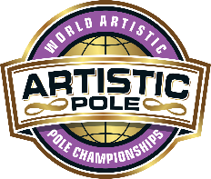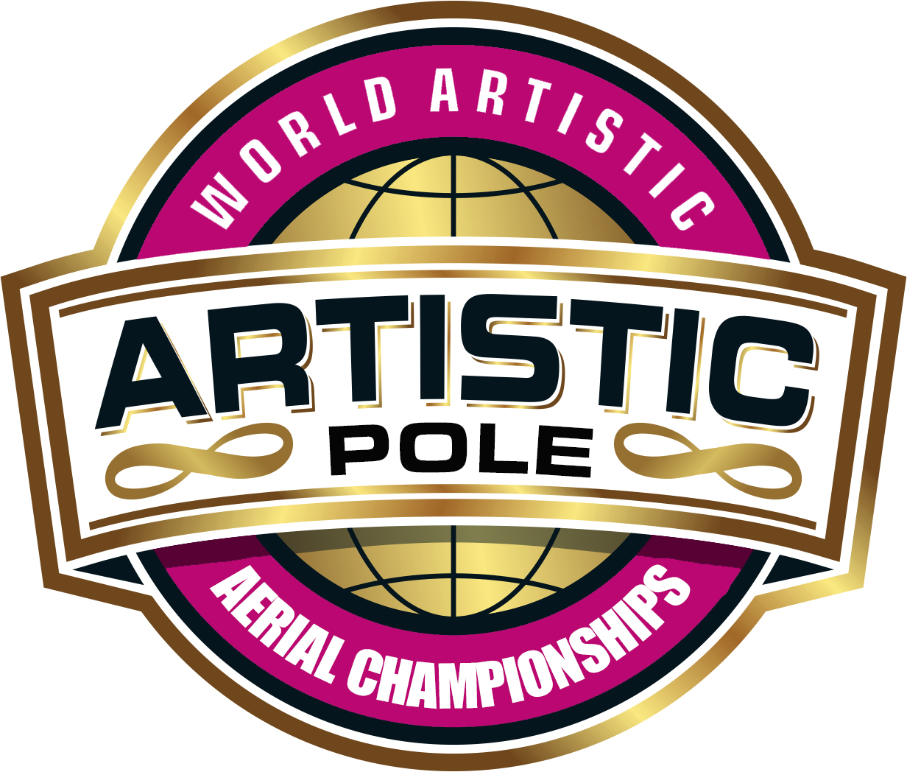
ARTISTIC THEME / TECHNICAL SHEET
DISCIPLINE: |  | Artistic Pole ☐ |  |  |  | Artistic Aerial Hoop ☐ |  | Artistic Aerial Pole ☐
Performer(s): |  |  |  |  | Date:
Country |  |  | Region: |  |  |  | Federation:
Division: |  |  |  |  | Category:
THEME: Please give a brief overview of your performance theme
PROPS (other than human props):
Please give full details including prop size, time to install and remove, assistance required, storage needs
HUMAN PROPS: Please give full details how it adds to your story, how many people will be used as human props and their costumes (with photos)
If you are removing part of your costume, please explain how and why
LIGHTING: Please state your wish for lighting:
INTRODUCTION: Please indicate how you would like for your piece to be introduced:
IF ARTISTIC POLE:
POLES: Please confirm the configuration of your poles (spinning or static) FROM THE VIEW OF THE JUDGES/AUDIENCE
Left pole: |  |  |  |  |  | Right pole:
IF ARTISTIC AERIAL HOOP:
Please confirm the specifications of your Hoop (height, size of hoop)
90cm Hoop ☐ | 95cm Hoop ☐ |  | 100cm Hoop ☐ |  |  | 140cm Height ☐ | 170cm Height ☐ |  | 200cm Height ☐
By ticking the boxes I/we confirm that: |  |  |  | By ticking the boxes I/we confirm that my/our performance:
☐ I/we added photo(s) of my / our costume  ☐ I/we added photo(s) of props  ☐ I/we added music |  |  |  | ☐ does not contain any nudity  ☐ does not contain weapons or the simulation of weapons  ☐ does not contain anything sexist, racist or homophobic  ☐ does not contain any violence or religious connotation  ☐ is suitable for family viewing
Athletes’ signature(s): |  |  | IPSF-Recognised Coach’s signature: |  |  |  | Parent Signature(s) (u/18 ONLY):

