Tomball Memorial Choir Booster Club
19100 Northpointe Ridge LN, Tomball, TX 77377
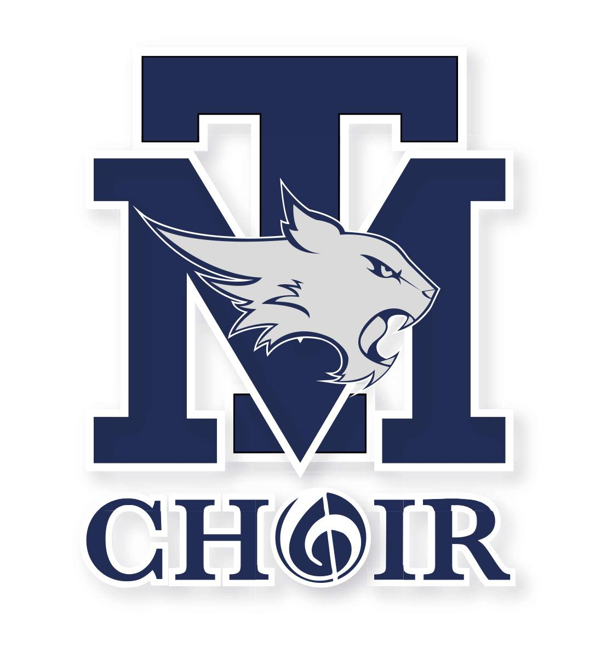
February 5, 2024

Call to Order 7:15
January Minutes were approved from the last meeting

Financial Report - Katrina Carroll
- January Financials were reviewed

Old Business

- Flag Report - Jill Kabrich & Renee Teague
  - President’s Day Flags 2/10 & 2/25 - we had enough kids sign up!
  - Mr. Sherman will unlock the door
- Interdepartmental Musical
  - Thanks to volunteers & directors - very successful!

- POP SHOW 2/15 - 2/17
  - Lobby decor - red carpet/ NYC theme - by Xanath Thomson
  - Break a Leg concessions - popcorn & cake pops (Thank you B. Tripp for making the popcorn!)
Program - Thank you Rob Pinkasavage - Sending to printer 2/6/24
  - Ticket Sales (with seat map) NHS students to scan tickets; use their phones; Ms. White adds their email to the account.
  - Dinner for rehearsals & show nights - Ms. White will give a head count of how many students we need to feed each night.
  - Advertise in the neighborhoods - Social Media
  - Let’s reserve a seat for HEB and Kolache sponsors

- New York, New York:
NYC Trip Shirts - vote $1, 650 choir & orchestra shirts combined. Orchestra will pay the choir for their shirts. Made by Ms. Tripp! Voted YES unanimously.
Trip Meeting Feb 29, in the cafeteria at 7pm
Send off concert on Monday, March 11th at 7pm

- Senior Scholarships -email reminder coming out 3/1

New Business
- Middle School UIL @ TMHS (2 days) donuts in the morning; pizza in the afternoon
Judges - coffee and water
- JH Region Clinic - we are all good
- Pre UIL @ TMHS 3/26/24
- Leadership for the next year…reach out to parents! Get the word out that we will need booster club members!

Director’s Report
Order a Banner for Choir - 2 Banners (Discuss in May)
Opera Night 1/6/24
TMEA dinner at Saltgrass
Mad Fest in San Antonio for Chamber competition

Other Business
Adjournment 7:53

