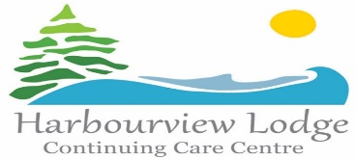

Harbourview Lodge is an Eden Philosophy based Nursing Home located in Sheet Harbour, accommodating 32 Elders. As our Vision states “Harbourview Lodge is a community where people can thrive with respect, dignity and self worth through meaningful relationships and activities in a place we call home.” The Eden Philosophy strives to eliminate the three plagues of loneliness, boredom and helplessness.

Harbourview Lodge Continuing Care Center Board of Directors in conjunction with Harbourview Lodge Management establishes processes and policies to ensure Resident safety as well as to protect all human, material and financial assets. The Board of Directors work as a volunteer governance board and meet on a monthly basis.

If you are interested in joining The Board of Directors please submit a letter and a resume to our site secretary. You will be contacted as the need arises. The Recruitment Committee will conduct an informal interview at that time.

Send request to Natasha Sharpe Site Secretary, Harbourview Lodge Continuing Care Centre,
Telephone: 902-885-3678 email: natasha.sharpe@nshealth.ca

Thank you
Harbourview Lodge Recruitment Committee

