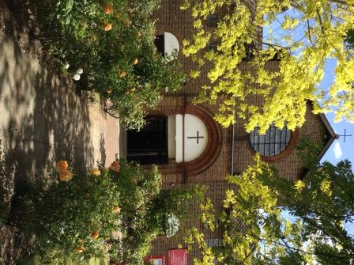

St. Barnabas, Downham
Catford (Southend) and Downham Team Ministry
Rev’d Stuart Leck, 1 Churchdown, Bromley, BR1 5PS Tel: 020-8698-0283
www.stbarnabasdownham.co.uk

February 2018

Dear Brothers and Sisters,

I am writing this in the period that the Church calls Ordinary Time – that period between the end of our Epiphany celebrations and the start of Lent – Ash Wednesday this year falls on 14th February – although our God is far from ordinary.

Recent weeks have been overshadowed by the stroke suffered by Franz and we continue to hold him and his family in our prayers at this time. He is now receiving end of life care at Kings College Hospital.

I am conscious that this has been a shock to all of us as Franz is a very active member of both our church and the wider community and his absence is keenly felt.

Our life together continues although there will be changes to some of our services and our worship in the short-term. If you would like to contribute to our worship please do speak to me.

Lent Programme

We have a full programme of services, study and events to support the Bishop’s Lent Call. Please do consider what you will do during Lent to spend time reflecting on your own Christian journey and faith and ensure that you have the Lent leaflet that gives full details of the programme.

Church Cleaning

A reminder that on the 2nd and 4th Saturdays from 10.00 a.m. we meet to clean and tidy the Church.

Please do consider coming along to help – if no-one turns up nothing will be done – and we do need to ensure that we keep our Church clean and tidy for those who come through the doors and to prepare the space for our worship on Sunday.

Finances

Our finances remain tight and I am grateful for the generosity of everyone here at St. Barnabas to enable God’s work to continue and grow in Downham.

However we do need to continually keep our giving under review. The Church of England encourages tithing – 10% of our income to the mission of the Church and charitable works and this should be our aim and intention.

If you are new to St. Barnabas there are planned giving schemes that you can join – either by regular bank transfer (standing order) or weekly envelopes. If you pay tax please do Gift Aid your giving – it costs you nothing extra but provides the Church with an additional 25p for every £1 you give.

If you wish to find out more about how you can give to support the mission of the Church please speak to Joan Cooke or Gloria Cox-Augustine.

DCC Membership

On April 15th we hold our annual meeting when we will hear about our life together and our plans for the year ahead. We will also elect members to our Church Council and please do consider whether you would like to join the Council and help to guide our life together. Please speak to me or the Churchwardens if you would like to find out more about the role.

Rangefield School

It has been great to welcome the pupils, staff and parents of Rangefield School into the Church over the past few weeks and I am grateful to all those who have helped with the practical arrangements. This arrangement will continue until at least Easter and we continue to hold the school in our prayers at this time.

We have much to be thankful for here at St. Barnabas and each of us needs to continue to reflect on what we can offer, both here and also in the wider community.

Thank you for all that you contribute to our life together here at St. Barnabas.

Fr. Stuart

