Making Yourself Whole After Conflict

L
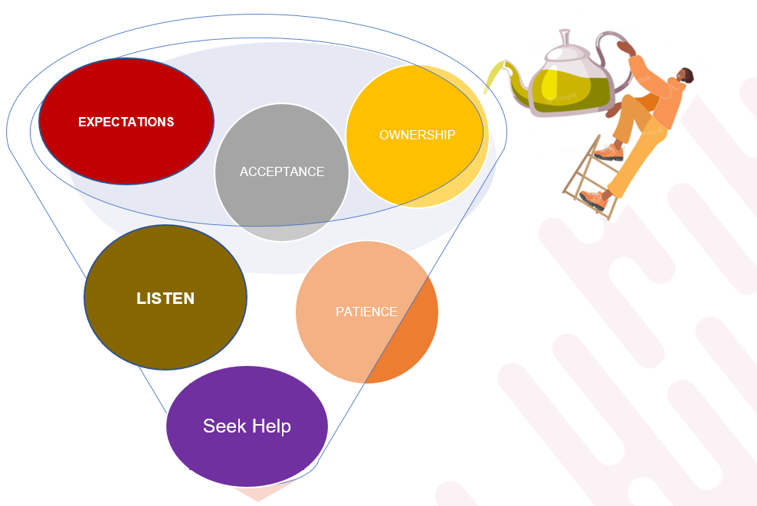
Here are some measures we suggest you consider making yourself whole following a conflict situation:

- Ownership: Following a conflict your emotions may still be a bit unsettled. You may even feel your efforts are not appreciated or valued. Take ownership of your role in a conflict situation. Acknowledge, reflect, and apologize if necessary.
- Patience: In the heat of a conflict moment, it’s hard not to react negatively. Stop to take a few deep breaths. Give yourself and others permission to take a break and revisit the discussion when tensions are not as high.
- Acceptance: Try to remember that the other person in conflict with you or another is coming into the situation with a totally different background and set of experiences. Try to put yourself in the other person’s shoes. Allow them to explain their perspective and accept it for what it is.
- Expectations: Manage your expectations. Don’t assume that you come into the situation with the same expectations as another. Ask others to clarify their expectation in any scenario.
- Listen: Listen to the music playing in your head when you see a conflict emerging, during the confrontation stage. This is going to have a tremendous impact on how you handle a conflict situation and the outcome.
- Seek help when you need it: Get help when you need it: The Flint Ready Set Succeed team is here to assist.

