Acne Facial
1 hour

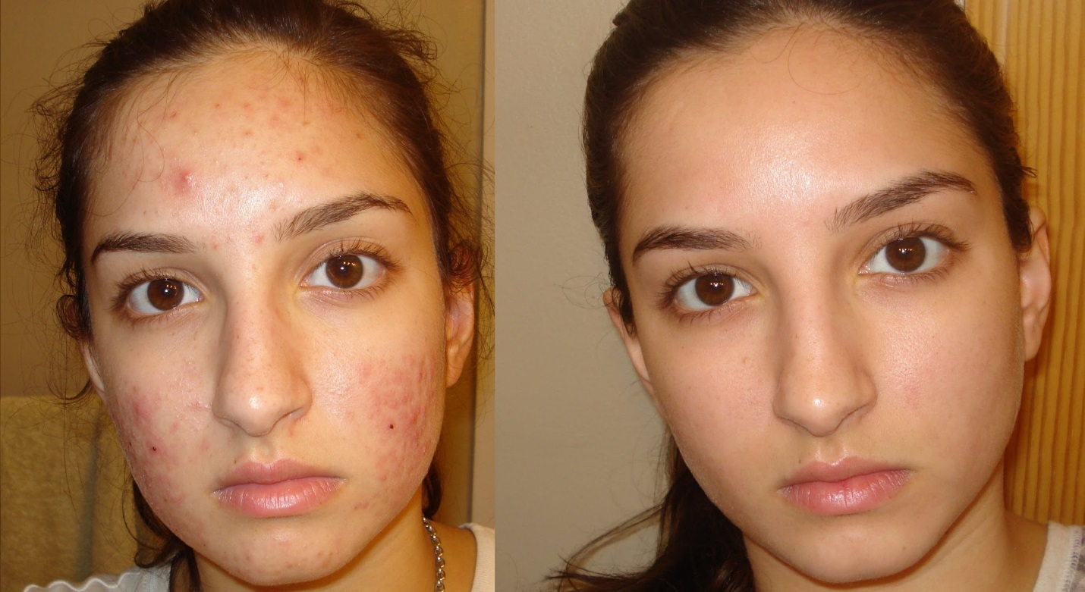

Acne treatments are not just for teenagers anymore, many people in their 20's, 30's, and beyond are dealing with this potentially embarrassing condition. Treatments for acne may include visits to a dermatologist or a visit to a spa. At a spa, treatments for acne usually employ deep-pore and deep-tissue cleansing to rid the skin of excess oils and stimulate circulation. Antibacterial ingredients are often utilized in a deep cleansing facial to prevent acne breakouts.

