Sauna | Body Treatments | Whirlpool | Hydrotherapy
PLEASE PRINT LEGIBLY

Name _________________________________________ Email_________________________________
Address ______________________________________ City/State/Zip ___________________________
Phone: ______________Work: _______________Cell: _______________ Birthday ___/___/___
Occupation ________________________________ Referred _________________
In Case of Emergency Please Contact ______________________________Phone________________

General | Medical Information

Y N Have you ever had a Body Treatment? If yes, what type?
Y N Are you pregnant? If yes, how far along are you? (Females only)
Y N Are you sensitive to heat in any area? If yes, Temperature?
Y N Are you allergic or sensitive to any oils (essential oils, nut oils, scents)? If yes, please list:

List of current medications and reason:

List of surgeries (type and date):

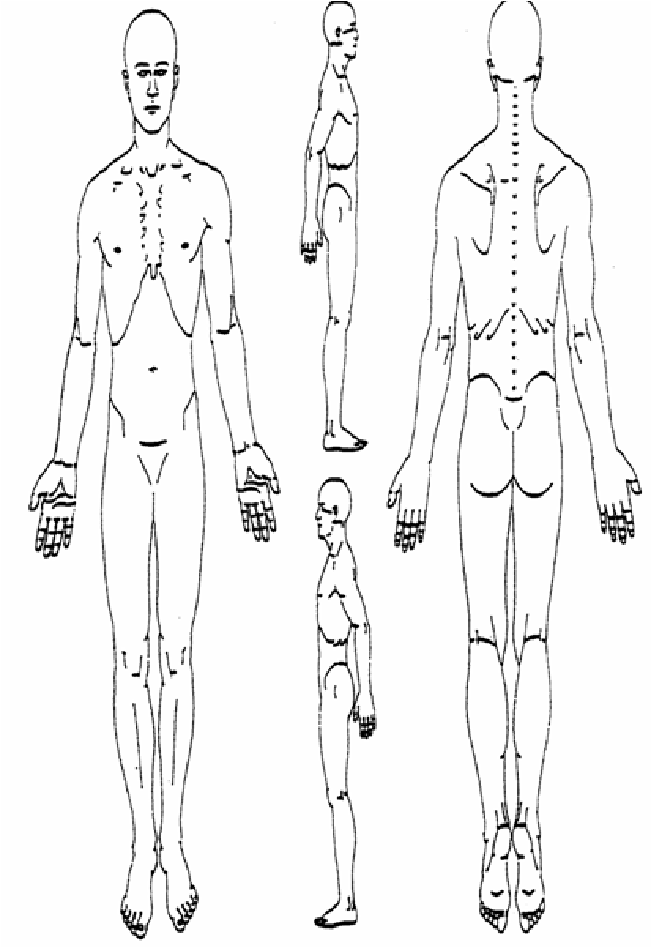
Indicate Areas of Concern/Pain/Tension
(Turn over)

Waiver
Please take a moment to read and initial all the following statements:

If I experience pain or discomfort during the treatment, I will at once inform my body specialist so that pressure/strokes can be adjusted to my level of comfort. I will not hold my body specialist responsible for any pain or discomfort I experience during or after the treatment.
_____

I understand that the services offered today are not a substitute for medical care. I understand that my body specialist is not qualified to perform spinal or skeletal adjustments, diagnose, prescribe, or treat physical or mental illness.
_____

I affirm that I have notified my body specialist of all known medical conditions and injuries.
_____

I agree to inform the body specialist of any changes in my health and medical condition. I understand that there shall be no liability on the body specialists’ part should I forget to do so.
_____

I understand that this and future body treatments are entirely therapeutic & non-sexual in nature.
_____
Information & Suggestions

- Prior to your treatment, please remove contact lenses and all jewelry. Pull long hair back with a clip or band. Please communicate effectively with Spa regarding any concerns.
- In general, body treatments are given while you are unclothed. However, you may choose to wear undergarments or a swimsuit. Certain Body treatments require minimal clothing to only underwear. This is your time, and you should be as comfortable as possible.
- Feel free to ask your therapist any questions before, during, or after the session. Your Body Specialist is a highly trained professional and will be happy to make you feel informed and comfortable.

I have received the policy statement and have read and agree with the policies therein. I understand that by receiving services from California Skin Care & Day Spa, I am responsible for any financial obligation towards all treatments provided. There are no refunds on services and all sales are final.

Client: ______________________________________________________________________
Signature: ___________________________________________________________________
Date: _______________________________________________________________________

Body Specialist: ___________________________________________________________________________

