New Client Questionnaire | Massage
PLEASE PRINT LEGIBLY

Name ________________________Date_____________Email_________________________________
Address ______________________________________ City/State/Zip ___________________________
Phone: ______________Work: _______________Cell: _______________ Birthday ___/___/___
Occupation ________________________________ Referred ________________________________
In Case of Emergency Please Contact ______________________________Phone________________

General | Medical Information

Y N Have you ever had a professional massage? If yes, how often?
Y N Are you pregnant? If yes, how far along are you? (Females only)
Y N Are you sensitive to touch/pressure in any area? (Ticklish?)
Y N Are you allergic or sensitive to any oils (essential oils, nut oils, scents)? If yes, please list:

List of current medications and reason:

List of surgeries (type and date):

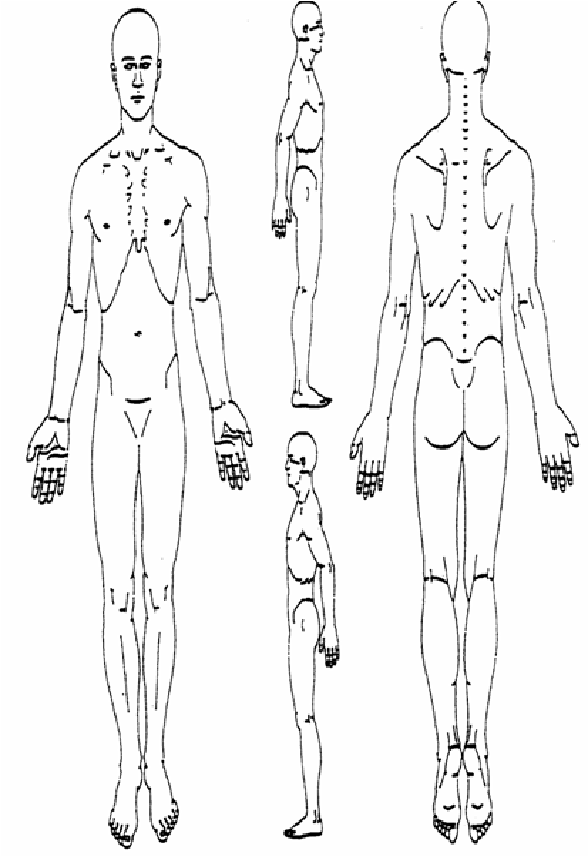
Indicate Areas of Pain/Tension
(Turn over)

Waiver
Please take a moment to read and initial all the following statements:

If I experience pain or discomfort during the session, I will at once inform my therapist so that pressure/strokes can be adjusted to my level of comfort. I will not hold my therapist responsible for any pain or discomfort I experience during or after the session.
_____

I understand that the services offered today are not a substitute for medical care. I understand that my therapist is not qualified to perform spinal or skeletal adjustments, diagnose, prescribe, or treat physical or mental illness.
_____

I affirm that I have notified my therapist of all known medical conditions and injuries.
_____

I agree to inform the therapist of any changes in my health and medical condition. I understand that there shall be no liability on the therapist’s part should I forget to do so.
_____

I understand that massages and/or body treatments are entirely therapeutic & non-sexual in nature.
_____
Information & Suggestions

- Prior to your treatment, please remove contact lenses and all jewelry. Pull long hair back with a clip or band. Please communicate effectively with Spa regarding any concerns.
- In general, massages/body treatments are given while you are unclothed. However, you may choose to wear undergarments or a swimsuit. You will be covered with a top sheet throughout your massage session. Certain Body treatments require minimal clothing to only underwear. This is your time, and you should be as comfortable as possible.
- Feel free to ask your therapist any questions before, during, or after the session. Your therapist is a highly trained professional and will be happy to make you feel informed and comfortable.

I have received the policy statement and have read and agree to the policies therein. I understand that by receiving services from California Skin Care & Day Spa, that I am responsible for any financial obligation towards all treatments provided. There are no refunds on services and all sales are final.

Client: ______________________________________________________________________
Signature: ___________________________________________________________________
Date: _______________________________________________________________________

Therapist Signature: ___________________________________________________________________________

