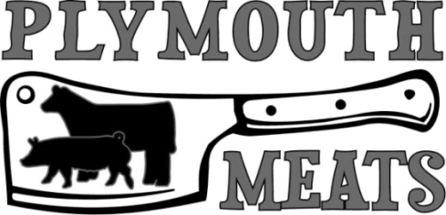
6 Allread Dr, Terryville CT 06786
860-582-1500 plymouthmeats@gmail.com
www.plymouthmeats.com

PORK CUTTING GUIDE

Name: _____________________ Phone: ________________ Date: ______

SMOKING – Choose One: With Nitrates No Nitrates

Lower Shoulder Picnic Roast Weight ____
Country Style Ribs Number per pkg ____
Upper Shoulder Boston Butt Roast Weight ____
Blade Steak Thickness ____ Number per pkg ____

Hock Fresh Smoked Ground

Bacon Fresh Smoked
Slab _________ Sliced ________

Sparerib Whole Cut ½

Loin Roast Weight ____
Chops Thickness ____ Number per pkg ____

Ham Fresh Smoked
Whole Cut ½
Steak Thickness ____ Number per pkg ____

Trim Ground Weight per pkg ____
Sausage Weight per pkg ____
Breakfast Sweet Hot
*Sausage will be Loose unless Noted*

Other Jowl ______ Leaf Lard ______ Back Fat ______
Feet ______ Bones ______
*Cut Sheet due within two days of animal being delivered or will be cut to industry standard*
*Product needs to be picked up within two weeks of notification or weekly storage will be charged*

