p

|  |  |  |  |  |
| --- | --- | --- | --- | --- |
| Prayer Requests | |  | Announcements | |
| Kyle Rutter | Chemo and numbers aren’t good | * VBS is scheduled for August 4th & 5th , 6-8pm | |
| Sue Morgan | Sleep study | * Somerset VBS this week, 6-8pm | |
| Sophia McCandlish | Starting 3rd week in pain mgt clinic |  | |
| Jason Eveland | Treatments have him down | Happy Birthday & Anniversary to: | |
| Ruth Starlin | Health Issues | **Lesley Jones** | **Tuesday, July 8** |
| World Issues | All conflicts need prayer regardless of side, opinion or politics | **Rick Kimes** | **Tuesday, July 8** |
| Texas Flooding | Families of those lost in the flood | **Nate & Keely Bateson** | **Tuesday, July 8** |
| Joey Smith | Home | **Charlotte McMichael** | **Thursday, July 10** |
| Danny Klingler | Fell from roof; in hospital | **Tucker McMichael** | **Thursday, July 10** |
|  |  |  | **Kevin & Amy Culbertson** | **Thursday, July 10** |
|  |  |  | **Mark & Wendy Aichele** | **Saturday, July 12** |

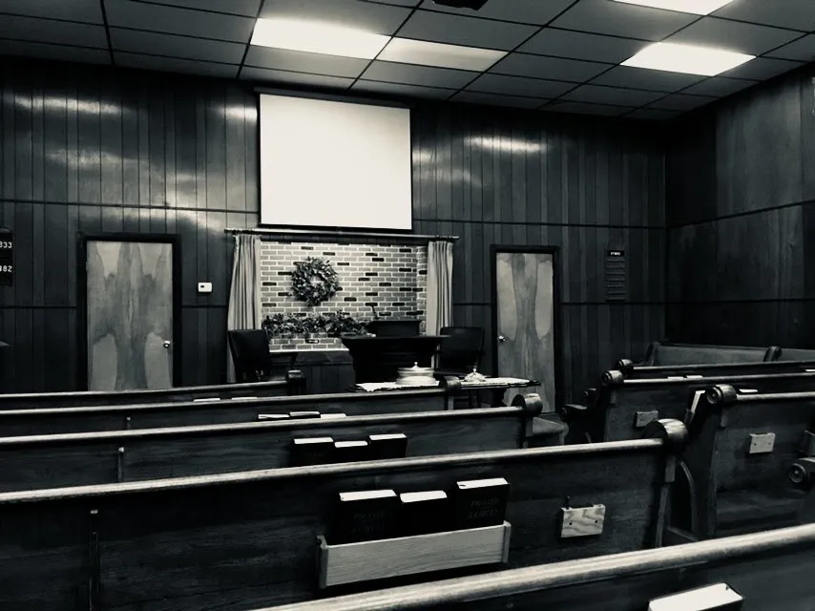

Preacher

David McCandlish | 740-415-7069

preacher@walnutstchurchofchrist.org

AM SERVICE

Greeter (AM/PM): Rick Gottke

Song Leader: Bruce Morgan

Opening Prayer: Jerry Tucker

Table (AM/PM): Hunter Starlin

Ann./Closing Prayer: Aron Davis

PM SERVICE

Song Leader: David McCandlish

Opening Prayer: Mike Roberts

Ann./Closing Prayer: Rick Gottke

Walnut Street

**Church of Christ**

**Children’s Page**

**Sunday 07/20/2025**