|  |  |  |  |  |
| --- | --- | --- | --- | --- |
| Prayer Requests | |  | Announcements | |
| Kyle Rutter | Chemo and numbers aren’t good | * **VBS** is scheduled for August 4th & 5th , 6-8pm | |
| Bruce’s Brother | Affected by the flood | * **Potluck** next Sunday, July 27, following service | |
| Janice Peyton |  | * **Men’s Meeting**, August 3rd @ 4:30PM | |
| Flood Victims |  | Happy Birthday & Anniversary to: | |
| John Harvey |  | **Sydney Jones** | **Tuesday, July 22** |
| Jaime Banik |  | **Jacob McMichael** | **Tuesday, July 22** |
| Kate Summers’ nephew | In Iraq, prayers for his safety | **Chloe Thompson** | **Tuesday, July 22** |
| Lauren Thompson |  | **Riley Anthony** | **Sunday, July 27** |
| Danny Klingler | Home | **Phil & Tana Merckle** | **Sunday, July 27** |
| Jaime’s nieces | Lost everything in house fire |  | **Blaine Needham** | **Tuesday, July 29** |
|  |  |  |  |  |

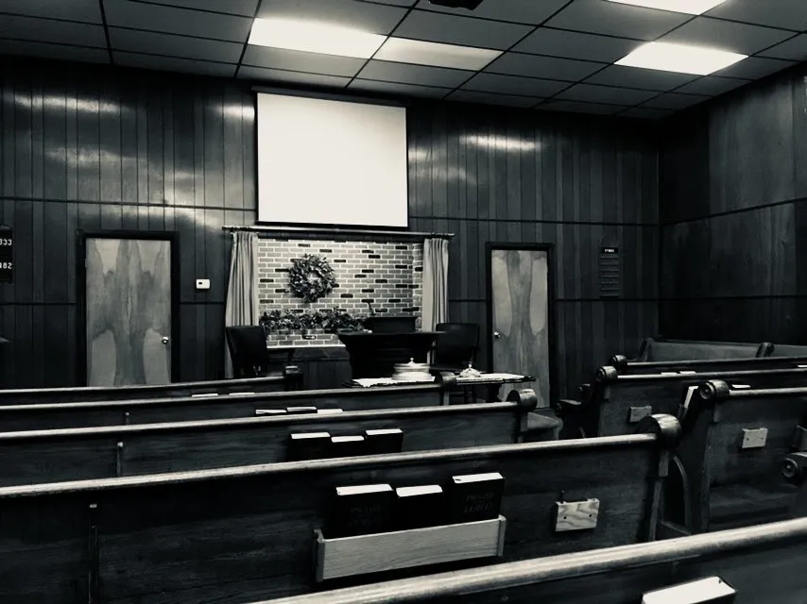

Preacher

David McCandlish | 740-415-7069

preacher@walnutstchurchofchrist.org

AM SERVICE

Greeter (AM/PM): Rick Gottke

Song Leader: Bruce Morgan

Opening Prayer: Jerry Tucker

Table (AM/PM): Hunter Starlin

Ann./Closing Prayer: Aron Davis

PM SERVICE

Song Leader: David McCandlish

Opening Prayer: Mike Roberts

Ann./Closing Prayer: Rick Gottke

Walnut Street

**Church of Christ**

**Children’s Page**

**Sunday 07/20/2025**